

**Department of Mechanical and Mechatronics Engineering**

**Mechanical Engineering Design Workshop**

**(ME380)**

**TILTING ALARM BED**

**Prepared For**

**Professor Oscar Nespoli**

**December 4th, 2015**

**Group 12 – The Blue Clock**

**Kelvin Chow - 20466985**

**Ragib Chowdhury - 20472003**

**Ryan Lam - 20473262**

**Jame Sun - 20464953**

**Nicholas Tham - 20481593**

**Alan Wu – 20421526**

**Table of Contents**

List of Figures iii

List of Tables vii

1. Abstract 1

2. Needs Analysis 2

2.1. Motivation 2

2.2. Background 3

2.3. Existing Benchmarks 4

2.3.1. Laser Target Gun Alarm Clock[3] 4

2.3.2. Nanda Home Clocky Moving Alarm Clock [4] 5

2.3.3. High Voltage Ejector Bed[5] 6

2.4. Need Statement 7

2.5. Design Specifications 8

2.6. Research 9

3. Conceptual Design and Planning 10

3.1. Conceptual Designs 10

3.1.1. Design A 11

3.1.2. Design B 12

3.1.3. Design C 13

3.1.4. Design D 14

3.1.5. Evaluation of Designs 15

3.2. Preliminary Design 16

3.2.1. Preliminary Design 1 16

3.2.2. Preliminary Design 2 18

3.2.3. Preliminary Design 3 20

3.3. Prototype 22

3.4. Final Design 24

4. Design Implementation and Verification 26

4.1. Structural Frame 27

4.2. Release Mechanism 29

4.2.1. Release Pin 31

4.2.2. Release Mechanism Assembly 32

4.2.3. Roller Assembly 33

4.3. Safety Design Implementation 36

4.4. Electrical-Mechanical System 40

4.4.1. Pressure Supply 41

4.4.2. Solenoid Valve 41

4.4.3. Signal Amplification 43

4.4.4. Actuator 44

4.5. Control Structure 45

4.5.1. Solenoid Valve 48

4.5.2. Final Control Design Implementations 48

4.6. Analysis 50

4.5.1 Hand Calculations 51

4.5.2 Excel Calculations 52

4.5.3 FEA Simulations 53

4.7. Machining, Assembly 61

4.7.1. Release Mechanism 61

4.8. Assembly 64

5. Project Management 70

5.1. Schedule 70

5.2. Budget and Resources 72

5.2.1. Labor Budget 73

5.2.2. Material Budget 76

5.3. Risk & Mitigation 77

5.3.1. Technical Risks 78

5.3.2. Non-Technical Risks 79

6. Conclusion 80

7. Recommendations & Future Work 81

References 82

Appendix A – Engineering Data 83

Engineering Design Specification Documents 83

CAD Drawings 97

Part Specification Sheets 165

Arduino Code 173

Assembly Procedure 174

Appendix B – Design Project Management Data 181

Scheduling and Work Breakdown Structure (WBS) 181

Team Organizational Chart and Roles 182

Budget 182

Risk Register 182

Appendix C – Conceptual Design Sketches Generated and Developed 184

Appendix D – Engineering Calculations, Analyses, Simulations, Testing 189

Appendix E – Lessons Learned 203

# **List of Figures**

Figure 1: Team member sleeping through morning alarm, from Live the Need Video 2

Figure 2: Gun Alarm Clock [3] 4

Figure 3: Nanda Home Clocky Moving Alarm Clock [4] 5

Figure 4: The High Voltage Ejector Bed in use [5] 6

Figure 5: Earthquake destroying a house 11

Figure 6: Dump truck bed being raised by vertical hydraulic rods 12

Figure 7: Treadmill device in motion 13

Figure 8: C-5 Military Transport Plane Loading an LAV 14

Figure 9: Release Action of Bed 17

Figure 10: Initial Proof of Concept Prototype 17

Figure 11: Transparent View of Head/Foot Board 19

Figure 12: Release Mechanism Relocation 20

Figure 13: Bottom Frame, Design 3 21

Figure 14: Model of Design 3 Lowering 22

Figure 15: Floor Supports of Bed Frame 23

Figure 16: Foot Board, Design 4 23

Figure 17: Model of Prototype 24

Figure 18: Prototype Component Map 26

Figure 19: Weight Bearing Cross Beam 28

Figure 20: Top Frame Isolated View 29

Figure 21: Underside view of release mechanism 30

Figure 22: Release mechanism assembly 32

Figure 23: Roller assembly under loading from release pin 34

Figure 24: Roller Assembly 35

Figure 25: Hard Stops Fixed on the Bottom Frame 36

Figure 26: Offset distance of 9 inches 37

Figure 27: Temporary Cardboard Cover for Footboard 38

Figure 28: Sketch of Cardboard Hinge Cover Mount 38

Figure 29: Sketch of Piston Enclosure 39

Figure 30: Drop Height of 16 Inches 40

Figure 31: NFPA Diagram from 5/2 directional solenoid valve 41

Figure 32: Airtac 4V310-10 5/2 solenoid valve 42

Figure 33: Signal Amplification Circuit 43

Figure 34: Microcontroller Programming Flowchart of the Prototype 45

Figure 35: Limit Switch Mounted on Top Frame at Horizontal Position 46

Figure 36: Full Schematic Diagram of Electrical Components. 47

Figure 37: Screenshot of the Preliminary Mobile Application 49

Figure 38: Equilibrium total centred mass vs bed tilt angle 53

Figure 39: 3D view of bed geometry in COMSOL 54

Figure 40: Dynamic simulation showing maximum von mises stress in strut 56

Figure 41: Gas strut displacement vs time, showing a descent time of 5 seconds 57

Figure 42: 3D top frame geometry in COMSOL 58

Figure 43: Static deflection of first loading scenario 59

Figure 44: Static loading of second loading scenario 60

Figure 45: Assembly drawing of all parts in release assembly 61

Figure 46: Release Assembly 62

Figure 47: Bushing pressed into bushing block 63

Figure 48: Assembly drawing of roller mechanism 64

Figure 49: All Sub-Assemblies 67

Figure 50: Foot Board Underside View - Prototype 68

Figure 51: Foot Board View - Prototype 68

Figure 52: Underside View - Prototype 69

Figure 53: Top View - Prototype 69

Figure 54: Planned vs. Actual Time, WBS 75

Figure 55: Isometric Preliminary CAD Model of Bed Frame Assembly 97

Figure 56: Preliminary CAD Model of Latch Assembly 98

Figure 57: Latch Assembly v1, Assembly Drawing 100

Figure 58: Bed Frame Assembly v1, Assembly Drawing 100

Figure 59: Bed Frame Assembly v2, Assembly Drawing 101

Figure 60: Bed Frame Assembly v3, Assembly Drawing 104

Figure 61: Bed Frame Assembly v4, Assembly Drawing 107

Figure 62: Bottom Frame Assembly, v1 Assembly Drawing 108

Figure 63: Bottom Frame Assembly, v2 Assembly Drawing 109

Figure 64: Bottom Frame Assembly, v3 Assembly Drawing 110

Figure 65: Bottom Frame Assembly, v4 Assembly Drawing 111

Figure 66: Top Frame Assembly, v1 Assembly Drawing 112

Figure 67: Top Frame Assembly, v2 Assembly Drawing 113

Figure 68: Top Frame Assembly, v3 Assembly Drawing 115

Figure 69: Lambda Stop, v1 Assembly Drawing 116

Figure 70: Head Board Assembly, v1 Assembly Drawing 117

Figure 71: Head Board Assembly, v2 Assembly Drawing 118

Figure 72: Head Board Assembly, v3 Assembly Drawing 119

Figure 73: 2x4x82.5 Bracket, v1 Drawing 120

Figure 74: 2x4x82.5 Gas Strut Mount Holes, v1 121

Figure 75:2x4x82.5 Gas Strut Mount Holes, v2 122

Figure 76: 2x6x84.5 Side Beam, v1 123

Figure 77: 2x2x12 Angle Strut, v1 124

Figure 78: 2x2x19 Angle Strut, v1 125

Figure 79: 2x6x36.5 Head Board, v1 126

Figure 80: 2x3x40 Gas Strut Mount, v1 127

Figure 81: 2x3x8 Lambda Stop Short, v1 128

Figure 82: 2x3x14.5 Lambda Stop Long, v1 129

Figure 83: Release Assembly v1, Assembly Drawing 130

Figure 84: Release Assembly, v2 Assembly Drawing 131

Figure 85: Main Plate, v1 132

Figure 86: Back Plate, v1 133

Figure 87: Back Plate, v2 134

Figure 88: Release Pin, v1 135

Figure 89: Bearing Assembly, v1 Assembly Drawing 136

Figure 90: Sleeve Bearing Block, v1 137

Figure 91: Sleeve Bearing Block, v2 138

Figure 92: Foot Bracket, McMaster-Carr 6498K33 139

Figure 93: Double-Acting Cylinder, McMaster-Carr 6498K634 140

Figure 94: Oil-Embedded Sleeve Bearing, McMaster-Carr 1688K23 141

Figure 95: Roller Assembly v1, Assembly Drawing 142

Figure 96: Roller Assembly v2, Assembly Drawing 143

Figure 97: Roller Backplate, v1 144

Figure 98: Roller Mainplate, v1 145

Figure 99: Roller Mainplate, v2 146

Figure 100: Track Roller, McMaster-Carr 6461K13 147

Figure 101: Controls Panel, v1 148

Figure 102: Pneumatics Panel, v1 Assembly Drawing 149

Figure 103: 2x2 Master Drawing 150

Figure 104: 2x3 Master Drawing 151

Figure 105: 2x4 Master Drawing 152

Figure 106: 2x6 Master Drawing 153

Figure 107: Socket Head Cap Screw M6x1x55, McMaster-Carr 91290A342 154

Figure 108: Hex Nut M6x1x5, McMaster-Carr 94223A101 155

Figure 109: Socket Head Cap Screw M5x0.8x15, McMaster-Carr 91290A231 156

Figure 110: Socket Head Cap Screw M6x1x12, McMaster-Carr 90128A262 157

Figure 111: Cap Screw M8x1.25x120, McMaster-Carr 91280A567 158

Figure 112: Hex Nut M8x1.25x6.5, McMaster-Carr 94223A102 159

Figure 113: Cap Screw 5/16-18x1-3/4, McMaster-Carr 92620A589 160

Figure 114: Hex Nut 5/16-18x5/16, McMaster-Carr 95036A016 161

Figure 115: Cap Screw 5/16-18x2-1/2, McMaster-Carr 90201A231 162

Figure 116: Cap Screw 5/16-18x4, McMaster-Carr 91236A599 163

Figure 117: Cap Screw M8x1.25x60, McMaster-Carr 90854A180 164

Figure 118: Airtac 5/2 Solenoid Valve Specifications Datasheet 165

Figure 119: Fairchild Semiconductor TIP120 Specification Datasheet 168

Figure 120: Arduino Microcontroller Program for the Prototype 173

Figure 121: All Sub-Assemblies 174

Figure 122: Floor Beams 174

Figure 123: Attaching Boards to Floor Beams 175

Figure 124: Spine Fastening - A: Board View, B: Angle View 175

Figure 125: Mounting Locations for Floor Cross Beams/Gas Struts Circled in Red 176

Figure 126: Top Frame Hinge Bolt Location 176

Figure 127: Fastening Top Frame to Bottom Frame 177

Figure 128: Fastening Gas Strut Mounts to Top Frame 177

Figure 129: Pneumatic Wiring on Spine Beam 178

Figure 130: Pneumatic Wiring on Underside of Top Frame 178

Figure 131: Pneumatic Wiring - Underside, Side View 179

Figure 132: Pneumatic Hookups to Cylinder 179

Figure 133: Arduino Wiring 180

Figure 134: Overall Work Breakdown Structure Estimate 181

Figure 135: Team Organization and Roles 182

Figure 136: Conceptual Design Sketches 187

Figure 137: Preliminary Sketch 188

Figure 138 Hand calculation: number of cycles per air tank charge 189

Figure 139: Hand calculations of deflection of shaft 190

Figure 140: Hand calculation: gas strut force angle 191

Figure 141: Hand calculation: upright position equilibrium calculation 192

Figure 142: Hand calculation: gas strut dynamic force 193

Figure 143: Hand calculation: static top frame support integrity – scenario 1 194

Figure 144: Hand calculations: static top frame support integrity – scenario 2 195

Figure 145: Hand calculation: roller friction 196

Figure 146: Excel spreadsheet of equilibrium calculation 197

Figure 147: Bed geometry - Ideal mesh density / 20000 elements 198

Figure 148: Mesh independent study 199

Figure 149: Timestep independent study 200

Figure 150: Loading scenario 1 201

Figure 151: Loading scenario 2 201

Figure 152: Zero acceleration graph 202

# **List of Tables**

Table 1: Design Decision Matrix 15

Table 2: Projects Milestones 71

Table 3: WBS Time Detailing 74

Table 4: Complete BOM 76

Table 5: Risk Assessment 78

Table 6: Engineering Design Specification, Rev1 83

Table 7: Engineering Design Specification, Rev2 85

Table 8: Engineering Design Specification, Rev3 87

Table 9: Engineering Design Specification, Rev4 89

Table 10: Engineering Design Specification, Rev5 91

Table 11: Engineering Design Specification, Rev6 93

Table 12: Engineering Design Specification, Rev7 95

Table 13: Risk Register 182

Professor O. Nespoli

Department of Mechanical and Mechatronics Engineering

University of Waterloo

200 University Avenue West,

Waterloo, Ontario

N2L 3G1

Dear Professor Nespoli,

This report, titled **“Tilting Alarm Bed”,** was prepared as a Final Design Report for the ME 380 Mechanical Engineering Design Workshop Course. The purpose of this report is to summarize the application and implementation of the engineering design and creation process behind the solution to a self-proposed problem space.

This report was written through the collaborative efforts of Kelvin Chow, Ragib Chowdhury, Ryan Lam, Jame Sun, Nicholas Tham, and Alan Wu and has not received any previous academic credit at this or any other institution. The design team would like to thank Professor Nespoli, Rohit Verma, Alex Strong, and Edward Cyr in their instruction and guidance regarding the engineering design and creation process. The team unanimously agrees that they have extensive knowledge and experience regarding the engineering design and creation process through your thorough guidance.

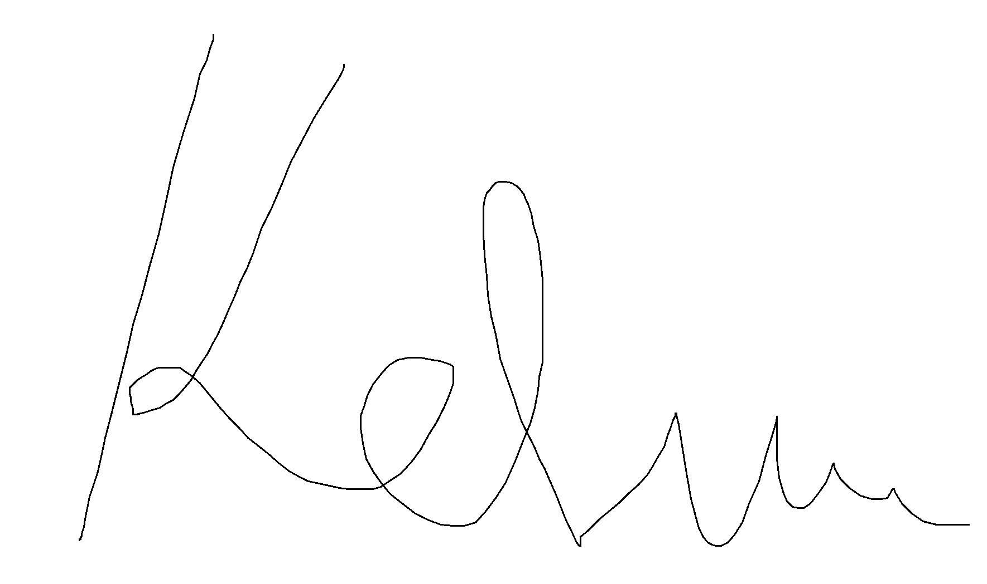

Sincerely,

Kelvin Chow



Ragib Chowdhury



Ryan Lam

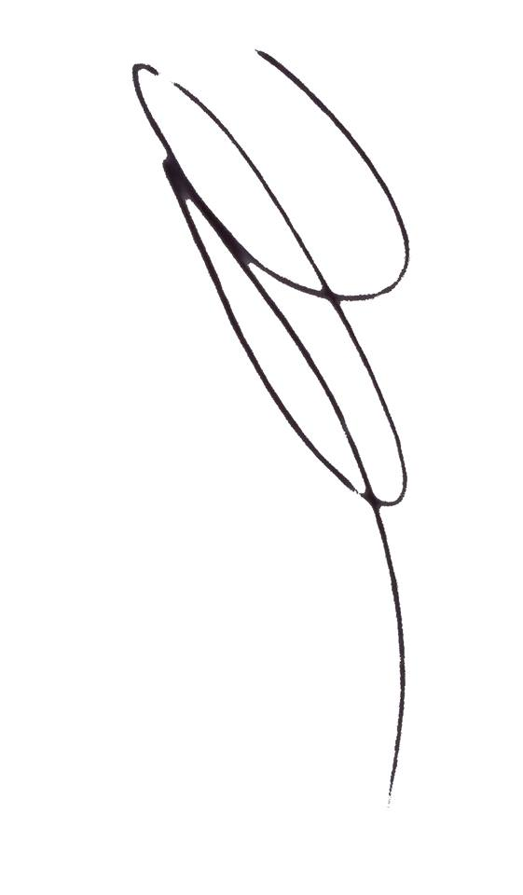

Nicholas Tham

Jame Sun

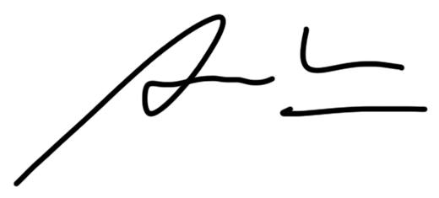Alan Wu

# **Abstract**

The objective of this project was to learn and implement the steps that make up the engineering design and creation process. As a result, a problem in need of an engineering solution was selected and a solution was constructed to solve this problem using the design process.

The first step of this project was comprised of identifying the engineering opportunity, a problem in need of an engineering solution. The best way to do this was to live the need, the group performed extensive needs analysis using their everyday lives as the primary source of the need. After identifying a need of strong importance, the need was expressed through an appropriate need statement which was followed by an elaborate set of design specifications.

Once the frame of the study was known, the project moved onto the project management phase. The group planned out the project timeline in great detail, and set forth a list of deliverables corresponding with the timeline.

Once the aforementioned components were completed, the group continued onto solving the problem itself. The first step in this process involved generating as many potential solutions to the identified need as possible. The next step was to narrow down to the list of potential solutions before selecting the best option based on its feasibility. The feasibility of each shortlisted option was based on a set of factors relevant to the project and to the group’s situation; each feasibility factor was weighted accordingly to ensure the final score of each shortlisted option accurately reflected its feasibility.

# **Needs Analysis**

# Motivation

The motivation of this project came from the group members’ common struggle to get out of bed each morning for their 9:30 AM classes (Shown in Figure 1). Even in the presence of a conventional alarm clock, multiple group members found themselves either conditioned to, and thus ignoring the alarm tune, or chose to snooze or turn off the alarm clock. Some even reported that they sometimes would get up and turn off the alarm clock in order to go back to sleep, and had no recollection of their actions after.

The consequences of not being able to wake up at designated times through the use of an alarm clock could often be severe. One group member reported to have missed multiple flights, while other members said they have often missed important occasions like exams, presentations, and performances.

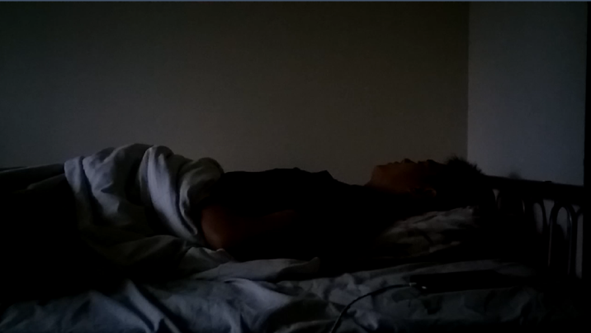

Figure 1: Team member sleeping through morning alarm, from Live the Need Video

The objective of the project is therefore to design and introduce a mechanical device that provides the users with a reliable method of waking up on time.

# Background

Alarm clocks are the current standard method of waking up in the morning; however, their reliability is questionable, especially when the user is in a time sensitive situation such as catching a flight, attending an important meeting, or writing an exam. In such cases a reliable and consistent method of waking up is necessary to ensure that no losses of any kind are incurred by the user, especially in a time sensitive situation.

Furthermore, it is very common for people to simply snooze their alarms when they hear it. The shrill noise of the alarm clock shocks the user into a state of consciousness and puts the user in discomfort. Turning off the alarm allows the user to return to the comfort of their bed and sleep again; however, going back to sleep right after waking up may return the sleeper into a deeper state of sleep. The body naturally wakes up via a sleep-wake rhythm that the body develops and during the hours before sleep, there are many bodily functions that act to ease the sleeper into lighter and lighter sleep, eventually waking them up. By going directly back to sleep, the rhythm is disrupted and the sleeper may even return to deep sleep when their body has already prepared for waking up, leaving a groggy feeling when actually waking up minutes or even hours later [1], [2]. The team can attest, as other constantly sleep deprived students can, that this phenomenon is all too real.

# Existing Benchmarks

Several commercial products exist to help people in the common struggle of waking up and staying up. Similar to an alarm, they introduce some disturbance to the sleeper to wake them up. Some force the user to engage of something mentally challenging in order to stimulate mental cognition and thus, wake the person up. Some examples are as follows:

# Laser Target Gun Alarm Clock[3]

This product (Figure 2) acts like a normal alarm clock, except in order to turn it off, the user is required to aim and shoot a gun at a target to turn off the alarm. The expectation is that the user will engage in this stimulating activity and cause themselves to stay awake after having turned off the alarm.



Figure 2: Gun Alarm Clock [3]

This product, however, has been reported to have poor hit detection when it comes to aiming at the target and can turn off the alarm even when the gun is not accurately aimed at the clock, defeating the purpose of the product. Even if the receiver on the alarm clock were improved, someone using the bed could still easily go back to sleep after turning off the alarm. It’s also entirely plausible that the person sleeps through the alarm altogether. The Laser Gun Alarm Clock costs $CAD 34.65 + tax.

# Nanda Home Clocky Moving Alarm Clock [4]

The Nanda Home Clocky Moving Alarm Clock (Figure 3) is an alarm clock on wheels that will roam around the room randomly while blaring alarms play. The alarm can only be turned off manually, forcing the user to get out of bed to chase the robot and turn off the alarm.



Figure 3: Nanda Home Clocky Moving Alarm Clock [4]

Although more reliable than the previous benchmark, the Nanda Alarm Clock suffers from similar faults. This clock costs $CAD 83.38 + tax.

# High Voltage Ejector Bed[5]

This product is not a commercially sold product, but is an example of a creative way of getting out of bed. While conventional methods would have the sleeping person wake up and voluntarily remove themselves from the bed, Colin Fruze has created a bed that will involuntarily remove the sleeper from the bed and wake them up in the process. At a high pressure setting, the bed is capable of launching the sleeper off the bed, as seen in Figure 4. This homemade project likely cost somewhere in the magnitude of several hundred dollars. As evident by Figure 4, there are serious safety concerns in regards to the use of the bed, but it is nonetheless, an effective and wild solution, and one that the design team will draw inspiration from in order to help conceive the final product.

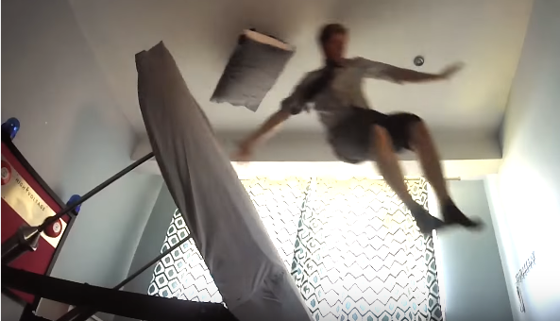

Figure 4: The High Voltage Ejector Bed in use [5]

Something that these commercial products and alarm clocks have all in common is that once the alarm and disturbances are turned off, there is nothing stopping the user from returning to sleep, a problem that is commonplace with many people, especially students.

# Need Statement

The central problem this project addresses is the difficulty of waking up on time and exploring solutions to help people wake up more reliably than an alarm clock or other commercial methods. From the examination of the existing benchmarks, the denominating problem with the existing methods of waking someone up is that no product addresses the common issue of returning to sleep after turning an alarm off. An established need statement is as follows:

***A need exists is to consistently and safely wake up a***

***person from sleep and keep them awake.***

The primary function of the product is to, via some mechanical method, force a person to safely wake up from sleep. Other functional requirements of the device include allowing the user to comfortable sleep with it, allow the user to program the time they would like to be awoken, and to prevent the user from returning to sleep after waking up. Non-functional requirements of the device include being easy to maintain, durable throughout its operating life, and non-intrusive to someone’s sleep, until the pre-determined alarm time is reached. Since this device is meant for use by students, it was agreed upon by the group that the device should be constrained to be operational with twin sized mattresses; this also helped keep the scope of the project reasonable. Other constraints include the degree of assembly of the device, it must fit in a standard sized bedroom, and it must be portable to suit the nomadic student life. The ideal product would be one that replaces the user’s bed and serves the function of both bed and alarm clock.

# Design Specifications

To elaborate on the primary and tertiary functions and constraints listed in Section 2.4, an initial Engineering Design Specification (found in AppendixA **–** EngineeringData) was developed during the second week of this project. This design specification is meant to compile requirements of the product and express relative criteria that must be met for each requirement in order to consider the specification of the product to be compliant. The design specification also indicates how each specification will be verified. This document is meant to be continuously revised and updated as the project progresses and new or unknown developments or risks occur that change the relevance of certain specifications, and can be found in AppendixA **–** EngineeringData.

As the project progressed, the specifications listed in the Engineering Design Specifications naturally became more specific. In the very first revision, no design for the device had been decided upon yet and many of the specifications were left vague and in terms of function or non-functional requirements, and constraints determined in Section 2.4. By the final revision, a design had been created and specifications could be catered to reflect relevant details of the device in specific terms of functional or non-functional components and constraints. For example, the first characteristic of “Wake up user” had changed to “Bed frame tilting angle”, based on the preliminary design chosen for the project whereby the method of waking up the user was to tilt the bed frame and roll the person out of bed.

# Research

Vestibular stimulation is the input that your body receives when you experience acceleration due to movement or gravity, therefore, any force applied to your body which causes movement will result in vestibular stimulation. Vestibular stimulation does not have a minimum threshold, movement can mild, such as nodding your head, or it can be much more intense, such as a rollercoaster ride [6]. As stated in Peggy Bosch’s “Schizophrenia, Sleep and Acupuncture”, "The brain system that mediates arousal and wakefulness is called the midbrain reticular formation (MRF), and stimulation of the MRF leads to wakefulness, and this stimulation can in turn occur when the vestibular system is activated, this can occur through vestibular stimulation” [7]. Cardiac acceleration usually accompanies arousal and is indicative of it [8]. It was confirmed that vestibular stimulation caused an onset of cardiac acceleration thus proving that vestibular stimulation causes arousal [8].

Our objective is to cause sudden vestibular stimulation through the downward motion of the bed, and by doing so render the user into a high state of arousal. This ensures the user’s sleep cycle is broken. Following on from this, the user will be deposited from the bed, and due to the bed being unable to return to a horizontal position during the lock-down period, the user will not be able to physically return to the bed and remain in it.

Furthermore, hypnic jerks, which are triggered by a sudden bodily movements or jerks induces a sense of falling which wakes the user up. Since the brain induces muscle paralysis during deep sleep, hypnic jerks are not intrinsically possible during deep sleep, since there is no trigger. However, if we can trigger bodily movements through the motion of the bed, this can cause the user to experience a falling sensation. This, coupled with an actual falling – i.e. vestibular stimulation – will cause the user to wake up from sleep.

# **Conceptual Design and Planning**

Conceptual designs were generated both individually and collaboratively among the members of the team. Designs were drafted using intuitive, conventional, and logical methods. Feasibility of conceptual designs were also important considerations; since time is an important constraint on the progress of this project, it would not be effective to spend time considering an exceptional design that is out of the scope of this project.

# Conceptual Designs

On the topic of waking someone up, there are plenty of ways to do it, from using acoustic disturbances, to physically annoying the user into a state of consciousness. Secondly, there is the issue of keeping the user out of bed after having woken up. Ultimately, the group agreed that the required design must introduce something to the user that is uncomfortable enough to wake them up and to will continue to cause discomfort if the user attempts to go back to bed. A simple method of preventing someone from going back to bed was to eliminate that option altogether, giving motivation to design in and around solutions that involved the entire bed frame. Conceptual sketches can be found in Appendix A – Engineering Data.

# Design A

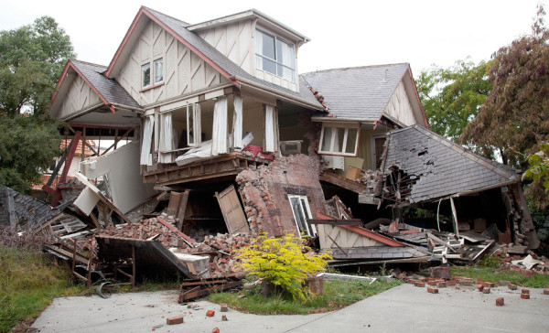

Figure 5: Earthquake destroying a house

In many countries around the world, earthquakes are a common occurrence. When a strong enough earthquake occurs at night, people will feel uncomfortable and encouraged to get out of bed. Drawing these analogies, it was proposed to design a bed that simulates earthquakes in order to wake up the user. One of the preliminary ideas was to utilize two sets of pneumatic linear actuators at each foot of the bed: one in the x-axis, and one in the y-axis. Using Arduino, random signals of varying time steps would be sent to each solenoid and each pneumatic cylinder. The user will be able to adjust wake-up power, from a scale of 1 to 8 on the Richter scale by adjusting a potentiometer knob connected to Arduino. It is expected that the discomfort and randomness of the bed’s motion will make sleeping on the bed uncomfortable and force the user out of bed. The two main factors that prevented this idea to go forward were time and money. With only a short four months to complete the project, the scope of this proposal will exceed the allotted time frame. There will be a significant amount of programming, along with significant dynamic calculations to design the bed. Furthermore, having so many pneumatic cylinders will be expensive, and out of financial range.

# Design B

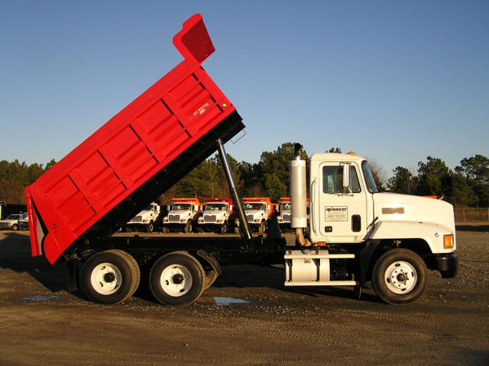

Figure 6: Dump truck bed being raised by vertical hydraulic rods

The inspiration for this preliminary design came about from dump trucks, and how the truck bed is raised by a vertical hydraulic ram to deposit the garbage (Figure 2). This design aimed to deposit the user from the bed to floor using a pneumatic air cylinder or a pulley system. However, rather than the head portion of the bed being raised up and the user being deposited feet first off the end of the bed, this design aimed to deposit the user off the side of the bed. The two main factors that influenced this decisions were safety and the required actuation power. It is decidedly safer to deposit the user off the side of the bed since he/she will have much potential energy while they are being deposited from the bed. This will reduce the scope for potential injury to the user and will require less roll space around the bed. The second factor that was taken into account was the actuation power required to deposit the user off the foot of the bed as opposed to the side of the bed. The stroke length required to deposit the user off the side of the bed is much less than the stroke length required to deposit the user off the foot of the bed.

# Design C



Figure 7: Treadmill device in motion

The desire for a reliable method of removing and preventing the user from getting back on the bed led to the creation of this design. The inspiration for this conceptual design came from treadmills (Figure 7).

To remain on a moving treadmill, the user is required to be moving at a constant speed against the motion of the treadmill. If one was to stop moving, the user would be transported to the edge of the treadmill and fall off.

The treadmill concept can be implemented into the form of a bed. The width of the treadmill mechanism would cover the length of a bed and would employ a custom mattress padding that would wrap and enclose the entire belt surface. With the sleeping user remaining stationary, the treadmill mechanism would move the user off the side of the bed. If the user tries to get back onto the bed, the user would just be removed again since the mechanism would still be running.

Unlike the other designs that involve large moving components, this design comes in a very compact package that guarantees removal of the person from bed.

# Design D

Exploring conventional methods of transporting objects from one altitude to another, cargo planes were examined, in particular, military aircraft used to transport massive equipment. These aircraft utilise a ramp on the rear end of the plane which tilts downwards towards the ground, allow vehicles like tanks or Humvees to be driven into or out of the plane. See Figure 8. Similarly, this same mechanism can be used to tilt the mattress of a bed and roll the sleeping person out of bed and as a result, wake them up.

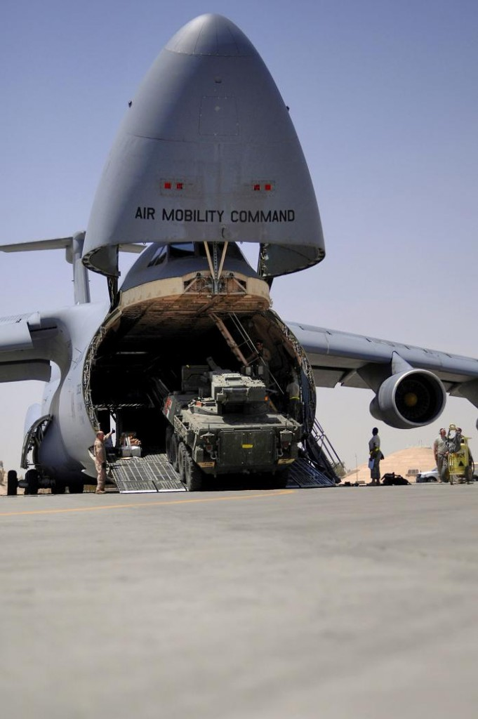

Figure 8: C-5 Military Transport Plane Loading an LAV

Similar to the previous designs, this designs attempts to remove the user form the bed. This design is safer because instead of pushing someone off the bed or raising them upwards so drop them off from a height, the bed will tilt towards the ground, decreasing the effective height difference between the person and the ground.

# Evaluation of Designs

In total, the team explored three different mechanism that could be used to wake someone up and derived conceptual designs to elaborate and express those ideas. To avoid design fixation, the designs were evaluated based only on their individual operating principles that would be used to wake up the user (tilting, shaking, and pushing). The following table expresses the decision process used to determine which operating method would be best.

Table 1: Design Decision Matrix

|  |  |  |  |  |
| --- | --- | --- | --- | --- |
| ***Method*** | Tilting | Shaking | Pushing | **Winner** |
| ***Feasibility*** | 4 | 3 | 2 | **Tilting** |
| ***Cost*** | 3 | 1 | 2 | **Tilting** |
| ***Effectiveness/ Consistency*** | 4 | 2 | 5 | **Pushing** |
| ***Safety*** | 2 | 3.5 | 2 | **Shaking** |
| ***Personalization*** | 3 | 4 | 2 | **Shaking** |

Each method was ranked based on feasibility, cost, effectiveness, safety, and personalization and given a score from 1 to 5, 1 being the worst and 5 the best. *Feasibility* took into account what was needed to implement the action specified, such as using pistons, motors, pulleys, etc. *Cost* was as estimate of how much the whole project might have costed with respect to the established budget. *Effectiveness/Consistency* is a measure of how well and efficiently the specified action would wake up a person. *Safety* referred to any potential hazards or risks from using the specified method. *Personalization* expresses the degree of customizability in the product, such as alarm timing, the tilting angle or shaking intensity or pushing speed, or height of the bed. The team did their best to judge the criteria in Table 1 in as objective a manner as possible. This, of course, does not guarantee that the given scores reflect purely objective perspectives, but are simply a result of the team’s judgement. From the decision matrix, it was concluded that a tilting method would be used, since within the scope of the project, personalization was not a critical criteria if it meant increased costs and reduced feasibility. Safety would need to be improved.

# Preliminary Design

# Preliminary Design 1

The initial design of the bed was meant to capture the overall concept of the final product. It was designed to establish the skeleton of the device and introduce the various mechanisms of the project and how they interact with one another. The design comprises of two main subassemblies, the top frame and the bottom frame. They are connected to one another on one side by hinges. The top frame is free to rotate about the hinged end which provides the tilting motion that is used to get the user out of bed. There are also gas struts mounted between the top and bottom frame at an angle to dampen the speed of the top frame’s descent (CAD Drawing found in Appendix A – Engineering Data).

The design relies on a release/latch mechanism that causes the bed to start tilting when it receives a signal from an Arduino to tilt the bed. It is achieved with the use of pneumatic cylinders attached to shafts that support the unhinged end of the top frame when in locked position and retract when the bed is to be tilted. This action can be seen in Figure 9.

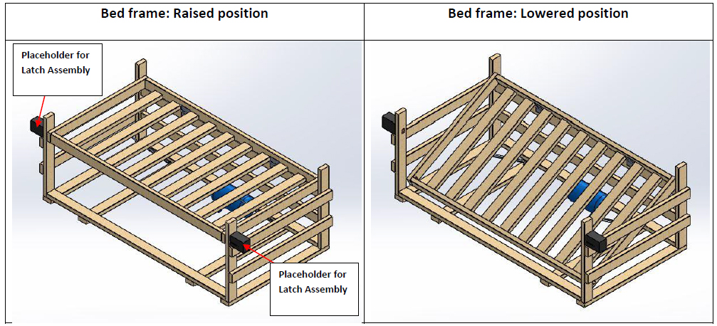

Figure 9: Release Action of Bed

This design sets the framework for future design iterations by establishing the general size of the device to achieve the desired tilt angle. It also ensures that the gas struts have a complete range of motion with no interference when using the defined mounting locations. An initial proof of concept prototype of this design was created out of popsicle sticks to analyze the bed frame structure (Figure 10).

i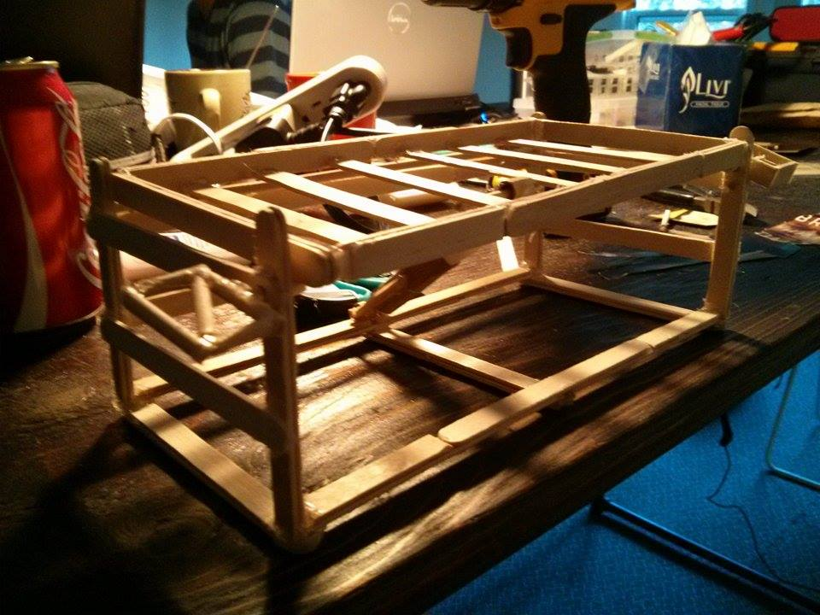

Figure 10: Initial Proof of Concept Prototype

A few key points could be taken from creating the prototype. First, the bed frame looks like a crate with many gaps for body parts to get trapped. The most significant gap is the one at the bottom where the bed tilts down. Also, the mounting of the pistons on the outside of the bed frame could be quite difficult and the mated holes need to have a latch mating holes need to be significantly bigger than the latch to avoid the latch hitting the frame.

# Preliminary Design 2

Upon overall inspection of the initial design, concerns were raised regarding the exposed pinch points at the head and foot of the bed. The initial design also required a lot of wood; some of which were not necessary.

The second design aims to create a frame with a minimalistic approach catered for easy assembly and low material cost while being structurally sound. It also addresses the finer details regarding methods of connecting the pieces together and ways to eliminate pinch points. The top frame remains unchanged from the initial design; most of the changes are evident in the bottom frame assembly.

The new bottom frame comprises of mirrored headboard and footboard subassemblies that are simply connected by a few wooden beams. Each subassembly is made of a square frame with hidden supports embedded within. Its sides are covered with thin plywood to eliminate major pinch points and to conceal the structural components for a refined appearance. Slots are made in the plywood face to access the interior for fastening purposes. Figure 11 shows a view of the head/foot board with the plywood transparent.

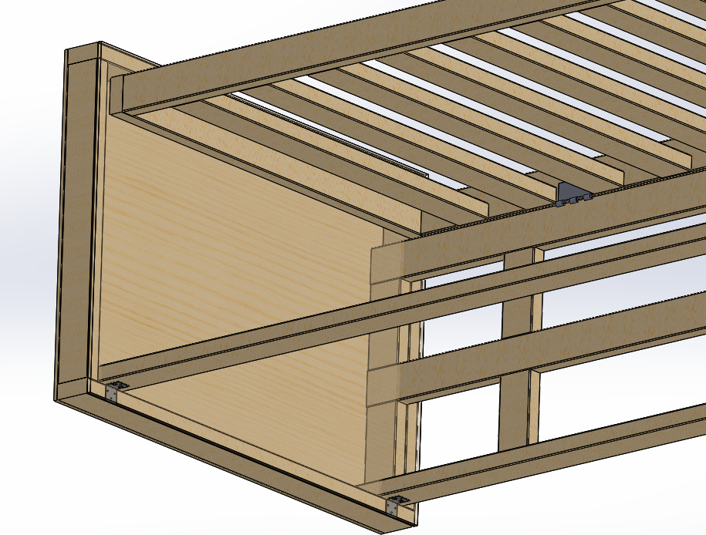

Figure 11: Transparent View of Head/Foot Board

The connecting wooden beams are simply inserted in these slot and bolted to the headboard/ footboard through counter bored holes to form sturdy lapped joints. CAD drawings of this bed frame can be found in Appendix A – Engineering Data.

Finally, the mounting locations of the release mechanisms were revised. Originally attached to the exterior of the bottom frame, it proved to be an inconvenience due to its protrusion. As such, they were relocated to the underside of the top frame. This not only helps to conceal the pneumatic components but also does a better job of keeping the user away from its moving components for safety reasons. See Figure 12.

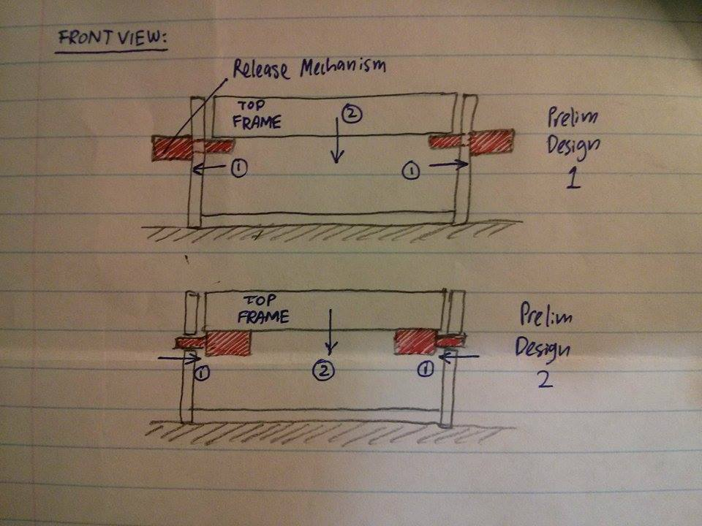

Figure 12: Release Mechanism Relocation

# Preliminary Design 3

From observing the second design of the bed frame, concerns were raised regarding the overall mass of the structure and its aesthetic appeal. Although the frame successfully made the bed much more modular and portable, the foot and head boards were still rather heavy and the lapping of joints made the bed unappealing.

The third design was meant to address these two concerns, but maintain the bed’s disassembly potential. The head and foot boards were replaced with mirrored components that resemble conventional bed frame styles. The bottom frame is shown in Figure 13.

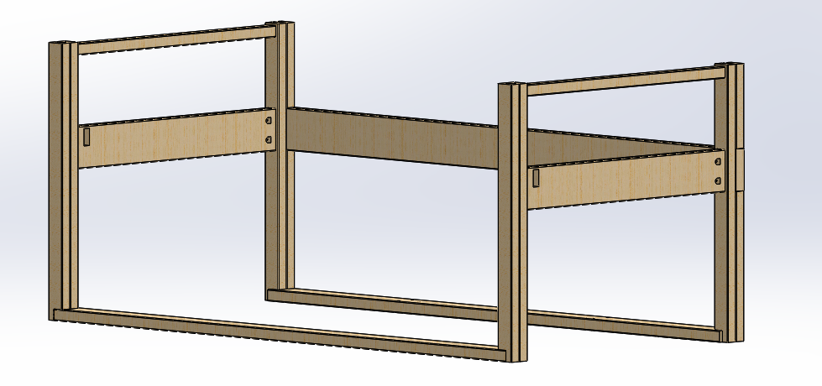

Figure 13: Bottom Frame, Design 3

Slots were cut into the sides of the head and foot boards to allow for flush joining of the beams that run length wise. The larger beam would be joined via two bolts and nuts through the columns of the head and foot board. The beams along the floor are to be mounted to the head and foot boards via right angle brackets and are intended for giving the bed stability and for mounting of the gas springs that will be used to damp the bed’s descent. Once again, the top frame of the bed remains the same and is hinged onto the bottom frame of the bed in a similar manner. A full model of the bed in action is shown in Figure 14 (coloured parts are coloured purely for reference when working with the CAD models).

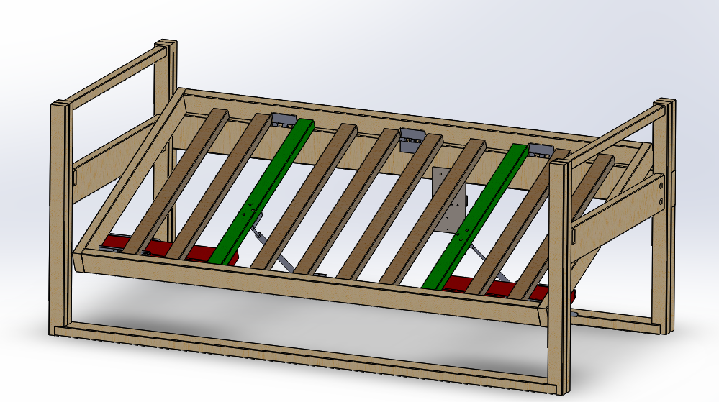

Figure 14: Model of Design 3 Lowering

# Prototype

The prototype design of the bed was an elaboration on the third iteration of the design. Aesthetically, it looks very similar, but has several added features to improve its stability and rigidity. Firstly, is the introduction of three cross beams that run along the floor, connecting the two lengths of the bed. Mechanical stops (dubbed λ Stops, from their resemblance to the Greek letter, λ) were also added to these beams that would be used to restrict the rotating motion of the top frame (See Figure 15).

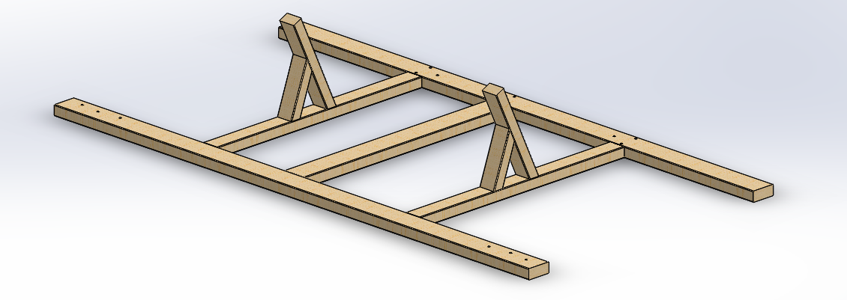

Figure 15: Floor Supports of Bed Frame

During testing, it was found that the force of the gas springs tended to flex the feet of the head and foot boards outward. By connecting the floor supports together like this (Figure 15).

Secondly, during testing, it was found that the foot and head boards tended to twist into a parallelogram shape due to lack of angled supports. To counter this, the head and foot boards were redesigned to improve its rigidity. This helps to stabilize the cantilevered end of the foot and head boards during operation of the bed and to reduce the wobble caused by disturbing the tops of the boards. See Figure 16.

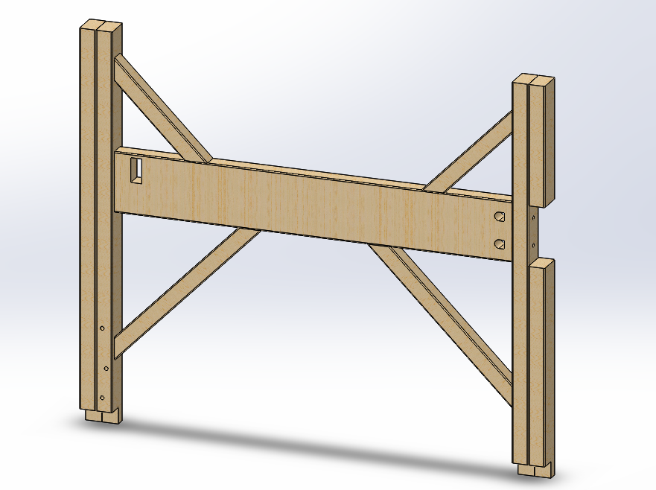

Figure 16: Foot Board, Design 4

The final prototype is shown in the following figure:

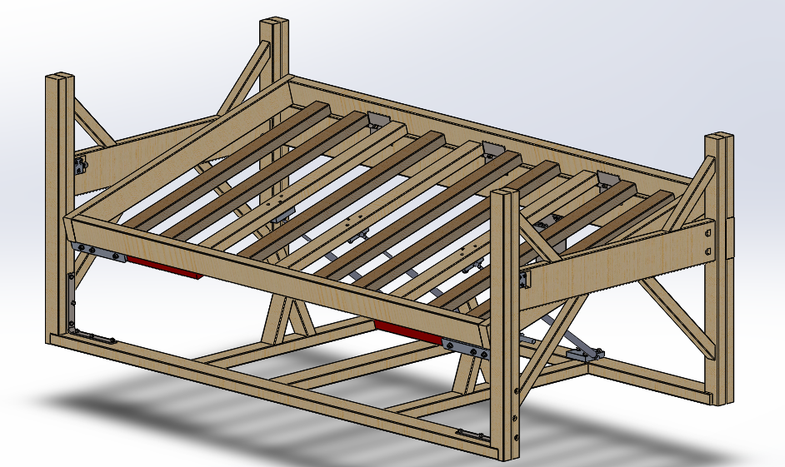

Figure 17: Model of Prototype

# Final Design

Some essential design changes need to be made to transition from the prototype to a final design that could potentially be marketable. Many of these changes were developed and consolidated through the construction and testing of the prototype.

Firstly, a more rigid construction can be attained from making the bed frame out of steel rather than wood. Its high strength and desirable material properties would allow further simplification of frame geometry for better manufacturability and ease of assembly; less support beams required to hold the entire frame together. In the prototype, it was apparent that the wooden frame undergoes a lot of deflection at its joints; using steel weldments to assemble a frame would mitigate the risk of frame failure.

Adjustable gas struts can also be implemented to cater this device to a wide range of body mass. With the existing prototype, gas struts have a fixed force rating which might not provide a desirable descent rate if one was too heavy. Having adjustable gas struts would allow the user to adjust the force of the gas strut based on their weight.

The current release mechanism incorporates the use of pneumatic cylinders. The issue with pneumatics is that it either has to be supplied by a compressor that produces a lot of noise when running or a compressed gas tank that would have to be refilled occasionally to maintain the required pressure for operation. Furthermore, compressed gas is a safety hazard that could cause potential harm to the user. As such, the pneumatics could be replaced with an electric actuator system to provide more reliable performance. It allows the user to simply plug the device into the wall without having to worry about a compressor or having to refill the gas tank.

With regards to safety, more reliable guarding will be added to eliminate any pinch points. For fail safe mechanisms, more sensors could be implemented to address the issues of one of the cylinders failing

# **Design Implementation and Verification**

After going through design iterations and arriving at a final design concept, the final prototype build was initiated. The design had three main components: the structural frame, the release mechanism, and the control structure. Material for the frame was bought and manually put together according to the design. The pneumatic components had to be analyzed for desirable specifications and correctly sourced. The control structure needed to be created to regulate the pneumatic system. All three sub-sections are needed to be connected within. In order to implement these three components, design calculations, material selection, and manufacturing were considered. See Figure 18 for a simplified prototype component map of how all parts are connected with each other.

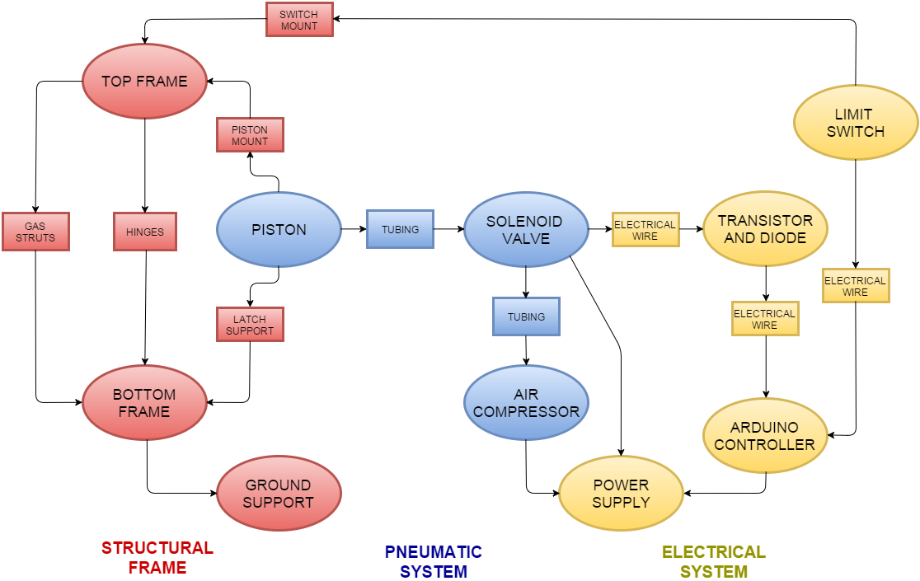

Figure 18: Prototype Component Map

# Structural Frame

For the design of the bed frame, it was decided by the group that the frame would be constructed out of structural lumber (SPF), since the vast majority of beds are made from wood. Another factor into this decision is the fact that it is much easier and more cost effective to customize parts out of wood rather than steel or aluminum. Furthermore, if any mistakes in the construction were to occur, the cost of new wood is fairly cheap when compared to that of steel or aluminum.

Design calculations were done using a factor of safety of two (user weight of double the average weight). This factor of safety was chosen based on cumulative experience in mechanical design, as well as to act as an additional failsafe. Firstly, geometry of the frame was analyzed to ensure that the wood would not yield or greatly deflect when under load. The critical beam that would bear this weight was the cross beam that joined the foot and head boards of the bed, shown in Figure 19.

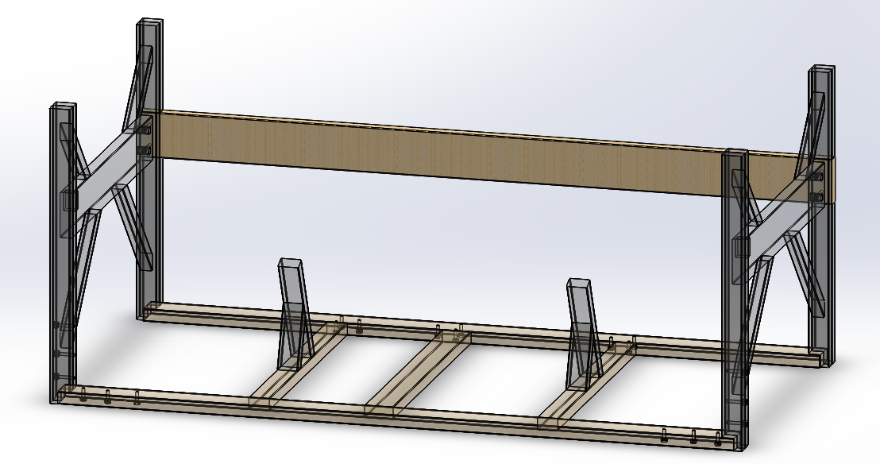

Figure 19: Weight Bearing Cross Beam

Analysis was also done on the gas struts that would dampen the rotating motion of the top frame of the bed, as seen in Figure 20. With the use of FEA, an appropriate descent time was calculated and corresponding gas struts were chosen. Moreover, the complex loading of the top frame was also modelled using finite element methods and its deflection and rotation were analyzed. The expectation of this analysis was to find the appropriate gas struts for the proposed user mass and to ensure that the top frame was structurally sound if those struts were to be used and that any deflections or force imbalances in the top frame would not result in any structural failure. When performing the analysis on the top frame, a safety factor of one was used for the user mass, since changing the user mass would ultimately yield results that would not be catered to the intent of this bed’s function. The FEA method is further elaborated in Section 4.6.

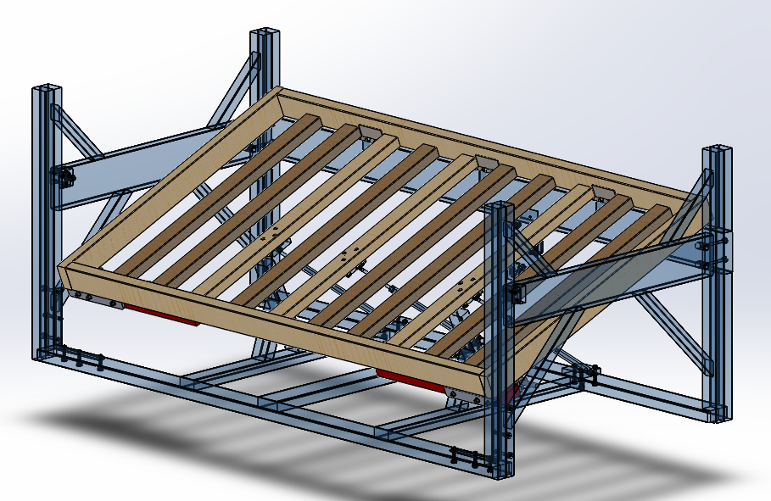

Figure 20: Top Frame Isolated View

# Release Mechanism

Gravity is the main driving force behind the tilting alarm bed, and an appropriate release mechanism was necessary to activate the tilt. Drawing analogies from a dump truck latch release system, the final design of the release mechanism included of two main components: release pin, and the roller assembly. There are two release mechanisms on the tilting bed: one on the footboard, and another on the headboard.

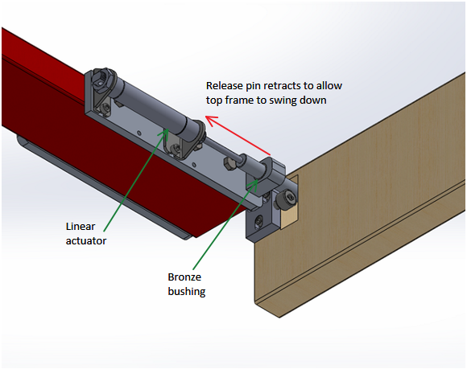

Figure 21: Underside view of release mechanism

The release pin mechanism (Figure 21) is powered by a single double acting cylinder, and guided with a bronze bushing. When a signal is sent from Arduino to the solenoid (see Section 4.3), the solenoid allows compressed air at 110psi to actuate the 40lbs linear pneumatic cylinder, which pulls the release pin out of the roller assembly, allowing the top frame to tilt downwards with gravity.

# Release Pin

The choice of 6061 aluminum for the release pin was due to coefficient of friction and cost. The full weight of the user will be transferred from the top frame into the release pin, which will then be transmitted into the head and footboards through the roller assembly. It is important to note that the pull force generated by the pneumatic cylinder must be strong enough to overcome the frictional force. Thus it is important to reduce the coefficient of friction between the roller and shaft contacts as much as possible.

The cost of the 5/8” aluminum shaft was significantly lower than the cost of a 5/8” steel shaft. Furthermore, machining costs of the aluminum shaft are much lower than the machining costs of a steel counterpart.

Aluminum is considerably weaker than steel, and will have a larger deflection when compared to steel. To ensure deflection will not cause problems to the shaft retraction by the pneumatic cylinder, deflection calculations were performed (**Error! Reference source not found.**) in order to see how much deflection under normal loading was expected. A factor of safety of 2.0 yielded deflection of around 6/1000th’s of an inch, which is smaller than the proposed bearing tolerance of +10/1000th’s of an inch.

Noting that the gas springs will be providing upward force to help reduce the normal force at the pin, engineering calculations were performed (**Error! Reference source not found.**) to determine that aluminum will suffice, and the overall cost will be lower than that of using steel.

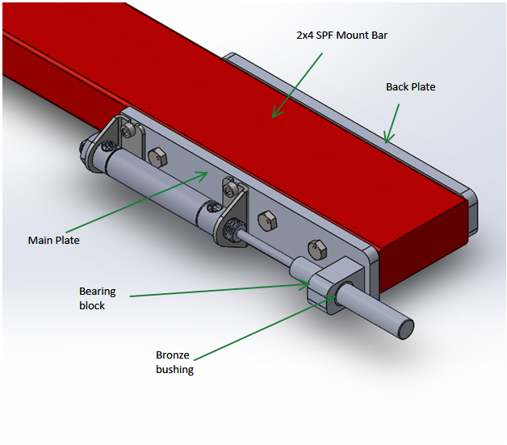

Figure 22: Release mechanism assembly

# Release Mechanism Assembly

The release mechanism assembly (Figure 22) is mounted on a 2 x 4 piece of SPF lumber, which is then mounted to the bottom-side of the top-frame assembly. The machined components were machined with 6061 aluminum, a cheap and easily machined material that is readily available. The main plate (Figure 22) holds together the bearing block, pneumatic actuator, and release pin.

The bearing block is used to guide the release pin in order to ensure straightness. A bronze bushing was pressed into a reamed cavity of the bearing block in order to ensure smooth sliding of the release pin. When fabricating the bearing block assembly, the bushing was reamed to ensure uninterrupted slide fit between the shaft and the bronze bushing. Ideally, the shaft diameter should be -0.001” from the diameter of the bearing block. Due to the inability of the lathes at the student machine shop to achieve such tolerances, tolerances of -0.005” from the diameter of the bearing block was used to ensure slide fit.

The back-plate and the main-plate grip the 2 x 4 lumber with the use of three M8 bolts, with spring washers on the back-plate. The use of spring washers is a form of a fail-safe, where the spring washers prevent the bolts from loosening under the vibrations that the assembly may endure during the lifespan of the Tilting Alarm Bed.

# Roller Assembly

Initially, concerns were surrounding the thought that frictional force between the release pin and the wooden head/foot boards would exceed the rated force of the pneumatic cylinder. To mitigate this possibility, a roller assembly was implemented into the head and footboards, bearing the weight transferred from the top frame, as shown in (Figure 23). The release pin will be able to retract smoothly, rolling off of the cam follower bearing. In the unlikely event that there is no slip between the release pin and the roller, calculations in **Error! Reference source not found.** show that the force required to overcome static frictional forces for both steel-steel and steel-aluminum are much lower than the rating of the linear actuator.

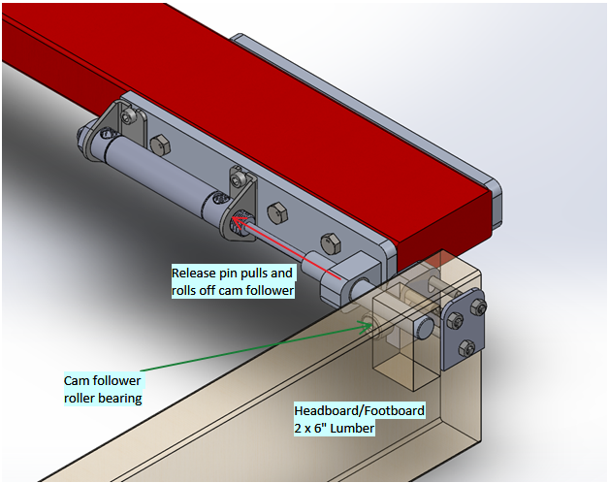

Figure 23: Roller assembly under loading from release pin

A standard ¾” diameter cam follower was used due to convenience in both assembly design and availability. Rated for up to 2065lbs of radial loading, the cam follower is more than sufficient for the purpose of this Tilting Alarm Bed.

Figure 24 shows the roller assembly, consisting of three main parts: main plate, back plate, and cam follower. The main plate features counter-bores so that the three M6 socket head cap screws can be installed without protrusion and interference with the motion of the top frame during actuation. The back plate allows the bolts to grip the plates together with the 2 x 6” lumber in between, ensuring that there will be no slip under regular loading. Both plates were machined using 6061 aluminum flats, due to machinability and low material cost.

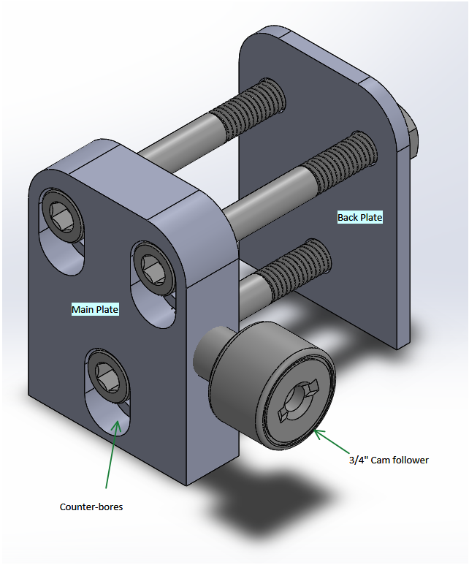

Figure 24: Roller Assembly

# Safety Design Implementation

**Pinch Points**

The priority of the design was creating a structurally sound bed. Once the design was created, the next priority was identifying the pinch points. This was determined to be the key primary safety hazard. Since a sleeping user has no control over their body, it is essential that pinch points are removed.

The main pinch point in the preliminary designs was the pinch point at the bottom where the user rolls off the bed. For instance, if a body part is hanging off the side of the bed, it could get caught under the bed when tilted. Thus, hard stops were mounted on the bottom frame (Figure 25) to create an offset of 9 inches from the bottom frame beam to the top frame (Figure 26).

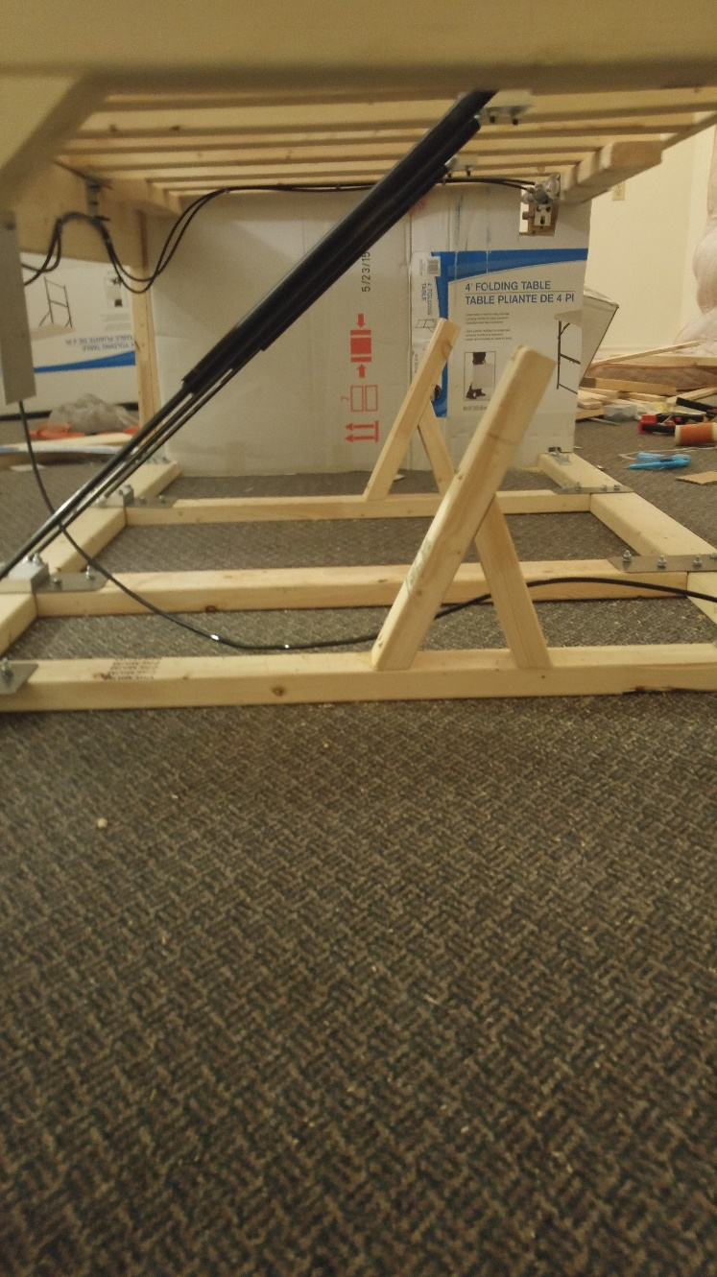

Figure 25: Hard Stops Fixed on the Bottom Frame

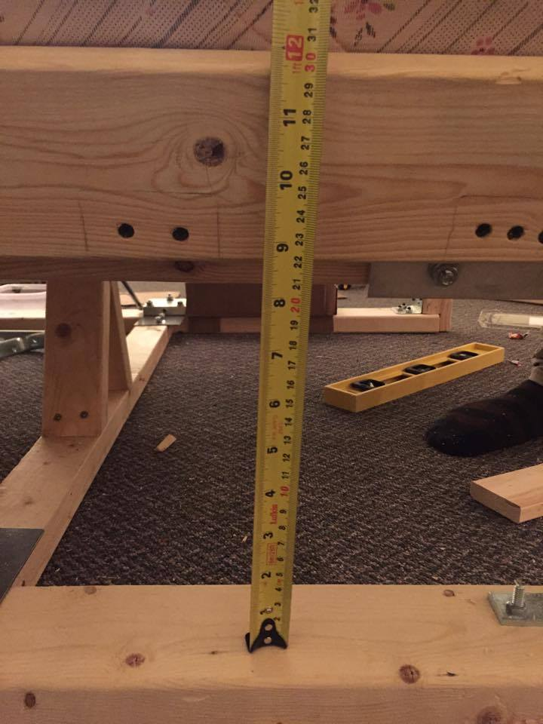

Figure 26: Offset distance of 9 inches

In the prototype, there are temporary pinch point blockers which would be replaced by other material. The headboard and footboards are covered with a piece of cardboard to eliminate the small gap between the top frame and the ends of the bed (Figure 27). The cardboard would be replaced by a stiffer material such as a sheet of plywood.

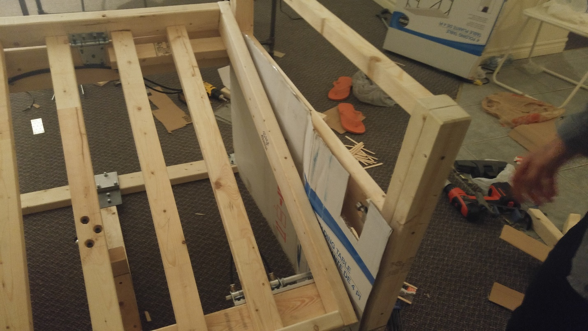

Figure 27: Temporary Cardboard Cover for Footboard

The hinge pinch point is dangerous when the bed returns from tilt position to horizontal. A rough sketch of a temporary cardboard cover is shown in Figure 28. In the final design, the cardboard cover would be replaced by an elastic material that would be stretched when the bed is tilted to cover the pinch point.

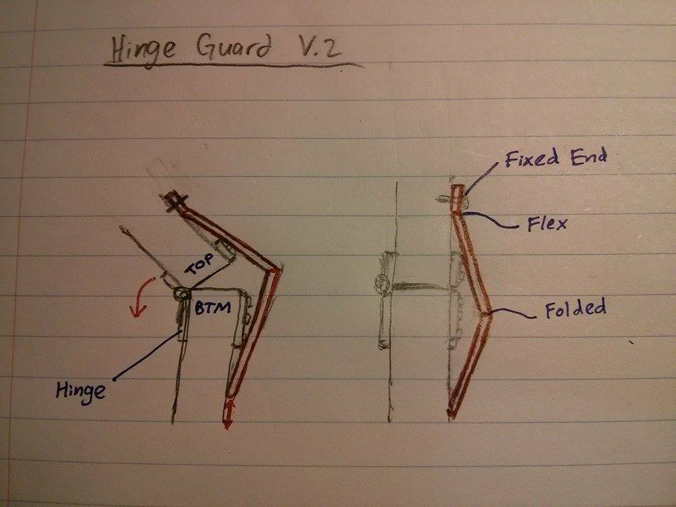

Figure 28: Sketch of Cardboard Hinge Cover Mount

The piston actuation creates another pinch point. The piston head is encapsulated by a plastic cover, which would be replace by sheet metal in a final design (Figure 29).

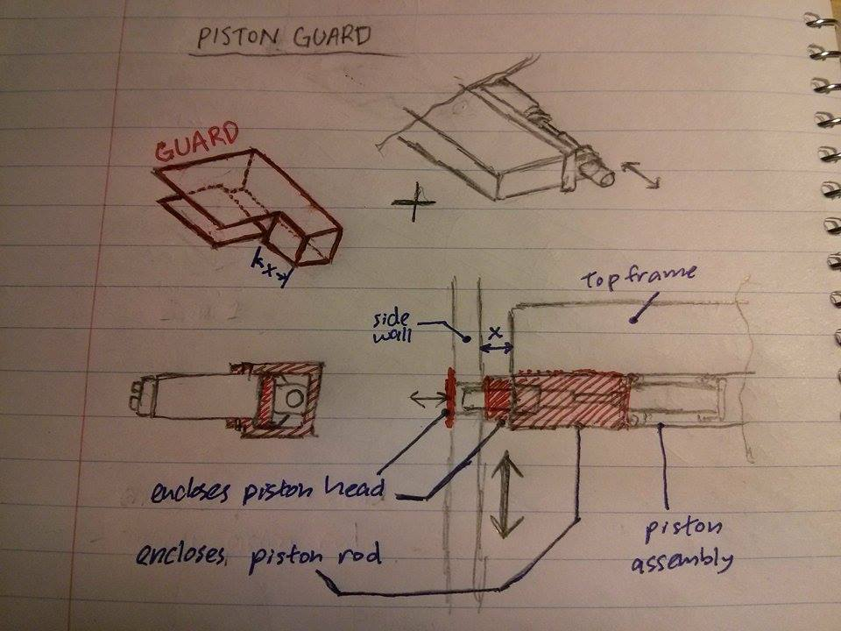

Figure 29: Sketch of Piston Enclosure

**Drop Height**

Since the priority was focused on pinch points, the eliminated pinch point of the bottom beam to top frame in (Figure 30) created a secondary safety hazard. This offset created a user drop height of 16 inches in the prototype. This increased height results in a higher impact force felt by the user once the bed tilts. The drop height is dependent on the fixed 9 inch offset from (Figure 26), which should be kept at that distance. Thus, the drop height cannot be varied since the offset is more critical. To mitigate the impact, a soft landing pad can be placed in the drop area. A potential concept for a final design is a thin inflatable mattress pad that would deflate upon impact. The mattress pad would deflate to reduce the likelihood the user would fall back to sleep on the pad.

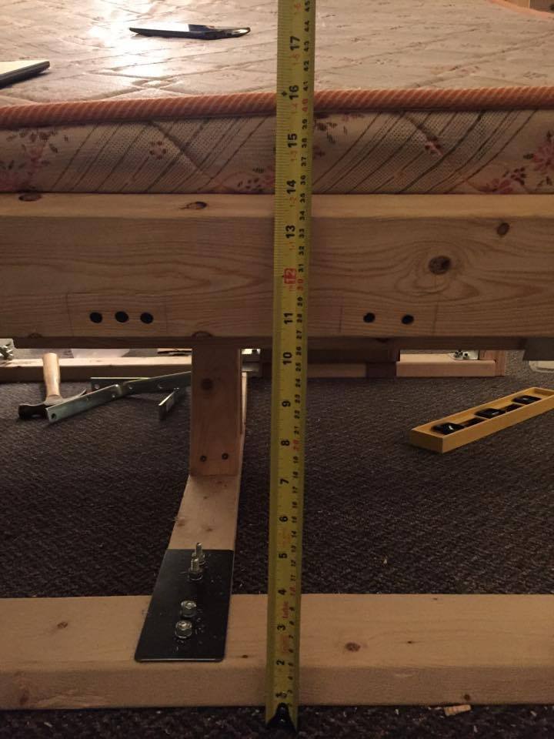

Figure 30: Drop Height of 16 Inches

# Electrical-Mechanical System

The electro-mechanical system consists of three main parts: compressor, actuator, and the solenoid. Generally, the electro-mechanical system takes an output signal from the Arduino microcontroller to actuate the cylinder and drop the bed. As far as the electro-mechanical system is concerned, it will only act on a high signal (signal received from Arduino). A fail-safe mechanism has been designed into the tilting bed frame. Under the event of a failure such as power outage or sudden depressurization of the system, the pneumatic cylinder will stay extended until actuated by a high signal again. The release pin will be normally extended, and so a power outage or a depressurization of the system will not jeopardize the user’s safety.

# Pressure Supply

The Tilting Bed requires an air pressure supply of 100psi to operate. For prototyping purposes, a 2-gallon Campbell-Hausfeld 110psi compressor was used. The final product will include a 3000psi rechargeable high pressure air (HPA) air cylinder, attached to a 100psi regulator. Under normal operating conditions (one wake up cycle per day), the air tank is expected to last up to 814 days between refills (calculations shown in **Error! Reference source not found.**). Each refill will cost $2.00 - $5.00 at the local paintball arena or scuba shop.

# Solenoid Valve

To connect the signal with a pressure output, a solenoid valve was used. Hobby solenoid valves are not rated to withstand up to 100psi, so an industrial solution was required. In the event of the failure of the system, such as a power failure or a sudden depressurization, it is important to keep the cylinder in the extended position to ensure user safety. A 5/2 directional solenoid valve with spring return (Figure 31) will guarantee that when not energized, the solenoid valve will send pressure to the cylinder, which will then extend the release pin.

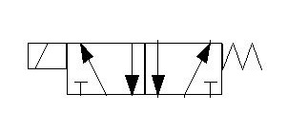

Figure 31: NFPA Diagram from 5/2 directional solenoid valve

A 5/2 solenoid valve (Figure 118) was sourced locally from a pneumatics supplier with the following key specifications: 12VDC, 2.5W, 21-114psi, 4 cycles/s.

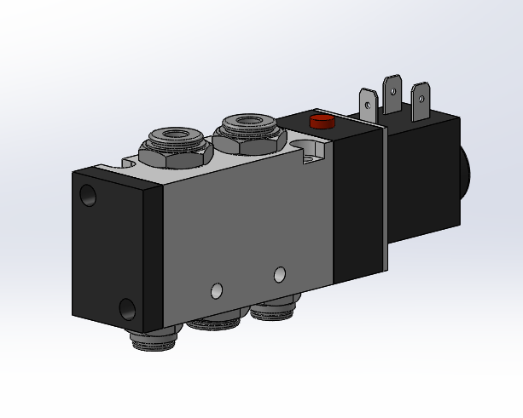

Figure 32: Airtac 4V310-10 5/2 solenoid valve

Due to the low output from the Arduino (5VDC, 50mA), it was beneficial to spec the solenoid valve to be as low-power as possible, to reduce the amount of signal amplification required. As stated above, the solenoid valve requires 2.5W at 12VDC to operate. Calculations show:

$$P=IV$$

$$I=\frac{2.5W}{12VDC}=0.2083A$$

As seen in the above calculation, the current required for the solenoid to operate exceeds the current outputted by Arduino. To amplify the signal, a TIP-120 NPN transistor was used.

# Signal Amplification

The TIP-120 Darlington NPN transistor (Figure 119) has three pins, and acts as a switch, where a relatively small current can switch on the flow of much higher current. It is capable of a maximum signal voltage of 5V at a maximum of 120mA, and a maximum output voltage of 60V at 5A. The circuit diagram is shown below:

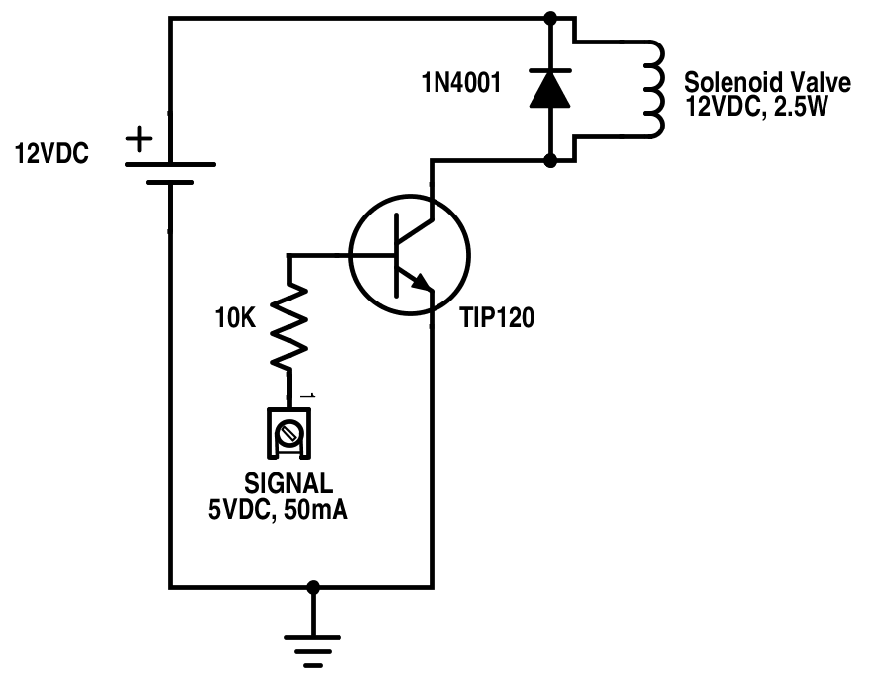

Figure 33: Signal Amplification Circuit

The 5VDC, 50mA signal is the pin-out from the Arduino. The signal passes through the base pin on the TIP120 transistor, which then allows flow to pass through the collector into the emitter, closing the circuit and firing the solenoid. Noting that the solenoid valve is a coil, and will store charge after the current has been switched off, a 1N4001 diode (Figure 33) was placed in between the solenoid leads to prevent backflow of current into the Arduino microcontroller and frying the board.

# Actuator

By performing engineering calculations to determine the frictional force required to actuate the release pin against frictional force, it was determined that a 40lbs double acting linear actuator will suffice. Furthermore, the 40lbs ¾” bore diameter linear actuator is readily available. A 2” stroke length was chosen due to availability and price. ¼” push-to-connect polyethylene tubing and fittings were chosen to connect the pneumatic system due to availability and convenience.



# Control Structure

The control logic behind this prototype has the primary function of controlling the latching mechanism through the extension or retraction of the piston. There are additional functions to improve the user interface of the design. This is all implemented with an Arduino Uno microcontroller See Figure 34 for the microcontroller program flowchart. For reference, refer to Figure 120 for the code.

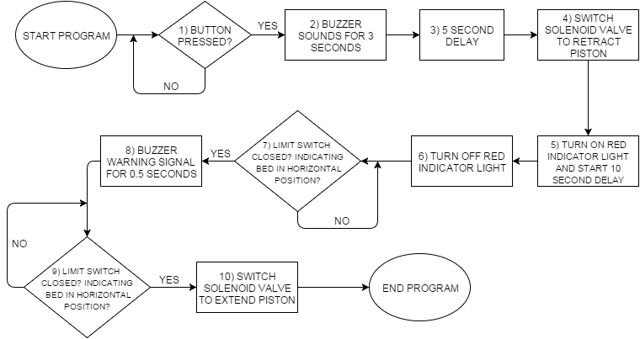

Figure 34: Microcontroller Programming Flowchart of the Prototype

The program has three outputs and two inputs: a solenoid valve, an LED indicator, a piezo speaker, a push button, and a limit switch. The steps below walkthrough the control flowchart in Figure 34.

1. The program is started once the user presses a push button to simulate a timer going off.
2. A piezo speaker outputs an alarm, which is intended to mimic an alarm clock.
3. There is a user programmable time delay which is the time between the sound alarm and the physical tilt alarm.
4. After this time passes, the solenoid will be switched, the piston will retract, and the bed will tilt down if the user is still in bed. If the user is out of bed, the piston will still retract, but the bed frame will not tilt due to the lack of weight.
5. A red indicator light is turned on to indicate there is a lockdown period in effect. This lockdown period is user programmable and during this time, the piston will not be able to extend and lock the bed at horizontal position.
6. After this lockdown period is over, the light is turned off to signal the bed can be locked back at horizontal position.
7. This is dependent on the input signal of the limit switch. The limit switch needs to be closed for the program to continue. See Figure 35 for a reference of how the limit switch is mounted to the bed frame. The limit switch is closed if the bed is at horizontal position, and open if it the bed is tilted.

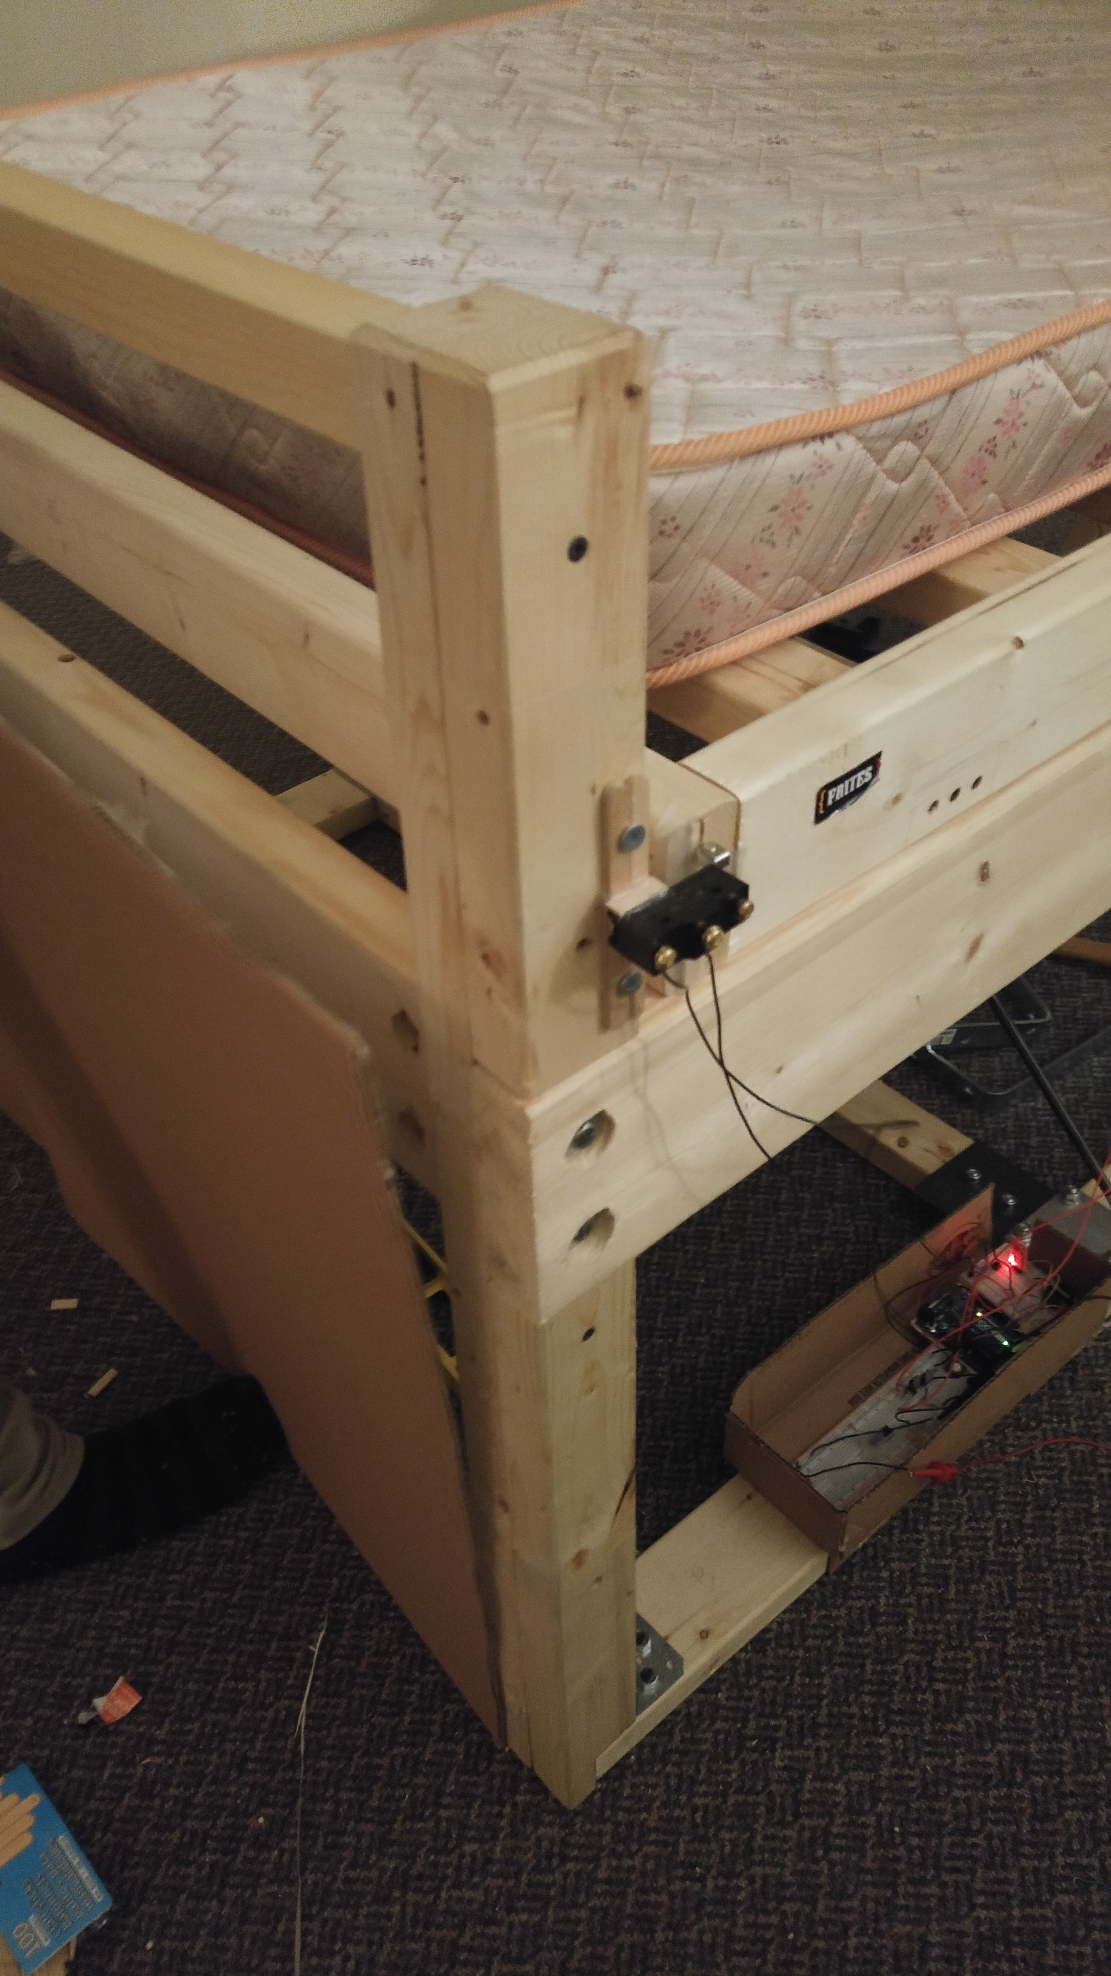

Figure 35: Limit Switch Mounted on Top Frame at Horizontal Position

1. Then, the buzzer will operate and send a short safety warning to the user indicating the piston is about to extend.
2. Step 7 is repeated. Steps 8 and 9 are not a functional requirement, but is an added safety feature to the design.
3. The solenoid valve is switched to extend the piston and lock the bed back at horizontal position.

See Figure 36 for the electrical schematic diagram.

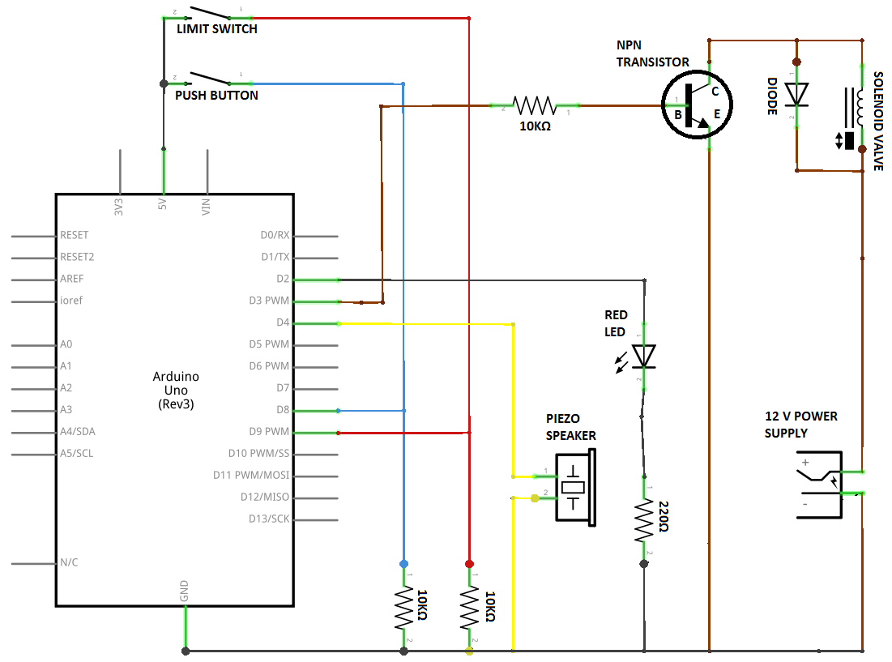

Figure 36: Full Schematic Diagram of Electrical Components.

# Solenoid Valve

Most of the electrical components are easy to understand, with the exception of the solenoid valve. The solenoid control system is shown on the right side of the schematic diagram. It consists of an external 12 V power supply, a solenoid valve, a transistor, and a diode.

The TIP-120 Darlington NPN transistor has three pins, and acts as a switch when a relatively small current applied to the base can switch on the flow of much higher current. It is capable of a maximum signal voltage of 5V at a maximum of 120mA, and a maximum output voltage of 60V at 5A. Refer to Figure 119 for the specifications of the transistor. When called upon, the Arduino either outputs a current to the transistor (as in step 4 of Figure 34) or does not output current (step 10 of Figure 34). When there is a small current from the base, it allows the transistor circuit to be completed from the collector to emitter, equivalent to a closed switch. If there is no current, the transistor is an open switch. This switch controls the solenoid valve states. Since the solenoid valve stores charge after the current has been switched off, a diode is required in parallel with the solenoid to prevent backflow of a high current into the Arduino microcontroller, which would potentially fry the board.

# Final Control Design Implementations

The final design will replace the push button with a Bluetooth module that can communicate with an external device such as a smartphone application. The device would be set off by a timing mechanism controlled by a mobile device.

The time delays for the snooze period and the lockdown period are hardcoded in the current system, but would be user controllable through the external device. A working Bluetooth communication interface can be seen in Figure 37, which allows the user to set delay times. The app would closely replicate the alarm clock which would replace the time delays and allow the user to set times for the alarm to set off.

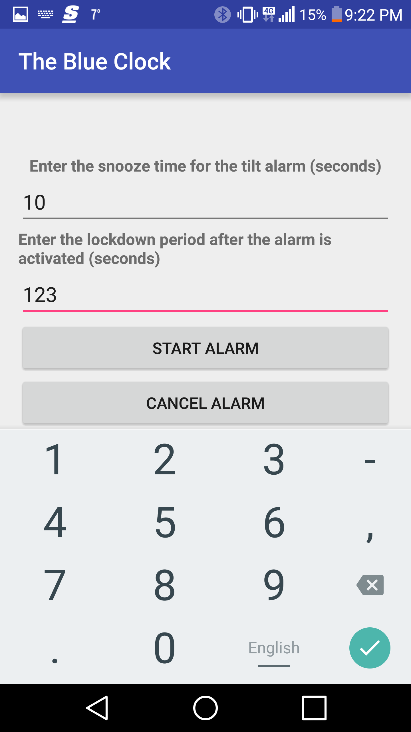

Figure 37: Screenshot of the Preliminary Mobile Application

A final design would also implement more sensors to increase the safety of the mechanism. Proximity sensors could help detect the bed frame surroundings. This is to check for potential hazards on the ground when the bed tilts. The sensors should be activated when the user sets the alarm before going to sleep and also right before the bed tilts.

The final design would also replace the Piezo speaker with sounds coming from the smartphone instead. Overall, an introduction of a Bluetooth technology would allow for a more sophisticated design and improved user interface, but this is out of the scope of this project. The wiring would be cleaned up by removing the breadboard with a PCB and the extended electrical wires would be securely connected. All the electrical components would be enclosed to surroundings.

# Analysis

Extensive engineering analysis was performed in order to validate the structural integrity of the design and to determine the strength of gas strut, pistons, as well as other appropriate parts as required.

The engineering analysis was performed in 3 iterations, first, rough order of magnitude calculations were used to calculate the static loading of proposed designs during conceptual design phase. Once the final design was chosen, precise hand calculations were derived based on the RoM calculations to calculate the static loading experienced by important members in the proposed system, as well as to derive critical relations that govern the physics of the proposed alarm bed system.

Using the physical relations derived from hand calculations, the quasi-static performance of the bed was further analysed using Microsoft Excel in order to determine the dimensions of the gas strut required, as well as a better estimate of the ideal operating weight range. Furthermore, it was realized that Excel was incapable of performing accurate transient analysis based on Euler’s approximation.

Last, finite element analysis simulations were performed to investigate the dynamic performance of the proposed system, as well as to conveniently determine the individual beam deflection in the top frame of the bed due to various loading scenarios. The parameters of interest in the transient simulation were the dynamic loading on the gas struts, the descent time of the bed under various loading and damping scenario, and the integrity of the pistons under impact to imitate someone jumping on the bed suddenly.

# 4.6.1 Hand Calculations

Hand calculations (found in Appendix D) were performed to validate the feasibility of the proposed design via static analysis of the top frame. The top bed frame was modelled as a thin, rigid plank fixed on one end by a rotational hinge joint, and was supported by gas struts as well as a pair of pistons on the other end. The bases of the two gas struts were fixed 25 [in] below the bed hinge, while the other pair of points of attachment is hinged to a point on the bed that is 25[in] away from the bed hinge.

First and foremost, the force angle of the gas struts must be computed as a function of the bed’s tilt angle to form the basis for quasi-static hand calculations planned for later on. By dividing the internal polygon formed by the strut, bed frame, and bed legs into triangles, an expression of gas strut force angle is developed as a function of bed tilt angle (see Figure 140) through use of Pythagorean’s theorem.

Using the force angle relation, an expression for required equilibrium gas strut force as a function of user mass and position and angle of tilt was derived for future use in Excel computation (see Figure 141). Furthermore, two models for compressed gas strut force were developed to be able to more robustly estimate operating user mass range (see Figure 142). In short, the first model assumed the gas strut exerted a constant force throughout its compression, the second model “K-factor” model defined the gas strut force increased through compression using a factor K, where the maximum compression force is K times the maximum extension force.

The order of magnitude calculations were performed to verify that the top bed frame supports (hinge, piston, and gas struts) will remain rigid under the worst loading scenarios. The maximum loading on the piston was estimated by assuming a 250lb person was sitting on the piston-end of the bed and it was found that the resultant bending moment was much less than the strength of the material (see Figure 143). The maximum loading scenario on the hinges was constructed by moving the person to the hinge-end of the bed and the hinges were found to be able to withstand the mass of the person with considerable safety factor (see Figure 144). The gas struts static loading was not investigated as the loading would be limited to the struts’ force ratings.

Furthermore, the static friction acting on the pistons are calculated to compute the piston strength required for them to retract (see Figure 145).

# 4.6.2 Excel Calculations

In Excel, based on previously determined design parameters, the ideal retracted and extended lengths for the gas strut are calculated, sorted, and documented with input from AutoCAD drawings. The strength of the gas strut were chosen to be 200 lbf in total based on speculation, but is confirmed later in calculations done in Microsoft Excel.

Then, using previously developed expressions for gas strut force angle and moment equilibrium, the total centred mass required for the bed to remain equilibrium when supported by 200 lbf gas struts were computed as a function of bed tilt angle (see Figure 146). This study confirmed that 200 lbf was a very reasonable gas strut strength as the resultant equilibrium centred mass (assuming total mass is located at the centre of the bed) is very close to mass sum of a single mattress and an adult male, for the sole purpose of prototyping. Furthermore, the operating range for user mass can be approximated using the generated range of total mass subtracting the mass of the sample single mattress to be used in the prototype. For instance, the sample mattress weighed approximate 40 lbs, and it could then be deduced from the Excel results that the range of operating user mass should be between 130 to 180 pounds for a tilt angle of 20 degrees.

Figure 38: Equilibrium total centred mass vs bed tilt angle

# 4.5.3 FEA Simulations

To assess the dynamic performance of the proposed design, extensive Finite Element Analysis simulations were performed in order to calculate the descend time of the bed, and to perform dynamic strength analysis on critical members of the system. Furthermore, the individual beam deflection under various loading modes are also investigated using a steady state simulation. The simulation software chosen was COMSOL Multiphysics 5.0.

In order to fully model the transient response of the design accurately, it was recognized that a full 3D transient simulation needed to be performed. In geometry, a simplified model of the alarm bed system was created with most of its more detailed features removed. The simplified model consisted of two rigid rectangular bodies representing the bed and the person resting on the bed, two deformable gas struts made of two hollow and two solid cylinders (though later on the strut number was increased to 3, but does not hinder the validity of this simulation), as well as a rigid hinge system to align and connect the gas struts and bed. The hinge system was ignored for the purpose of strength analysis since it did not accurately depict the connection joints that would be implemented.

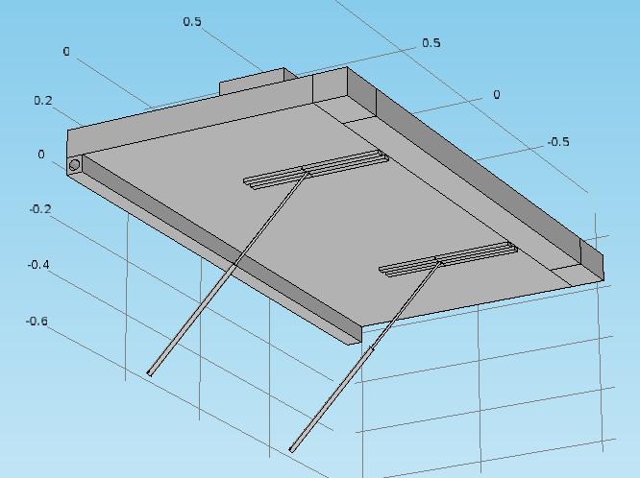

Figure 39: 3D view of bed geometry in COMSOL

A 3D mesh was created using the COMSOL Multiphysics meshing engine. The mesh quality/density was first defined arbitrarily and based on experience. However, mesh independent study was performed later in the simulation process to ensure the quality of the mesh was sufficient to prevent any mesh-related computation errors (see Figure 148).

Appropriate hinge, prismatic, and fixed joints were created so that the assembly of bodies behaved like the proposed alarm bed system. A locking condition is imposed on the hinge joint connecting the bed frame to a fixed reference to limit the range of tilt of the bed to within 27 degrees. Gravity is applied to bed. The mass of the bed frame is set to 80 lb via density settings of the bed material. The mass of the person is set to 148 lb and remains adjustable via density setting. In addition, the position of the person was also adjustable through translational motions of the block geometry that represented the person.

Within the prismatic joint between the hollowed and solid cylinders that represented gas strut movements, a spring and damper node was created to simulate the function of the gas struts. Through previous hand calculations, it was determined that two 100 lb gas struts were to be purchased from McMaster-Carr. Therefore, the spring function was identified such that each gas strut exerted 100 lbf in its extended position, and 120 lbf in its compressed position, assuming a k factor of 1.2 which was common for small gas struts. The damping effect was defined by damping coefficient, which was adjusted as required for the system to reach critically damped position for fair comparison between different setups.

Since the transient behavior of the alarm bed system was of interest, a time-dependent step was implemented in the solver. A time-step dependent study was performed to determine the maximum time step that could be used (see Figure 149).

Once the setup was validated. The structural integrity of the gas struts were investigated by assuming the worst case scenario. The location of the user was moved to the edge of the bed, and their mass set to 300 lb, which corresponded to a safety factor of approximately 2 with respect to the design specifications. Appropriate damping conditions were applied to smooth out the descent. The maximum stress in the gas strut member was found to be trivial.

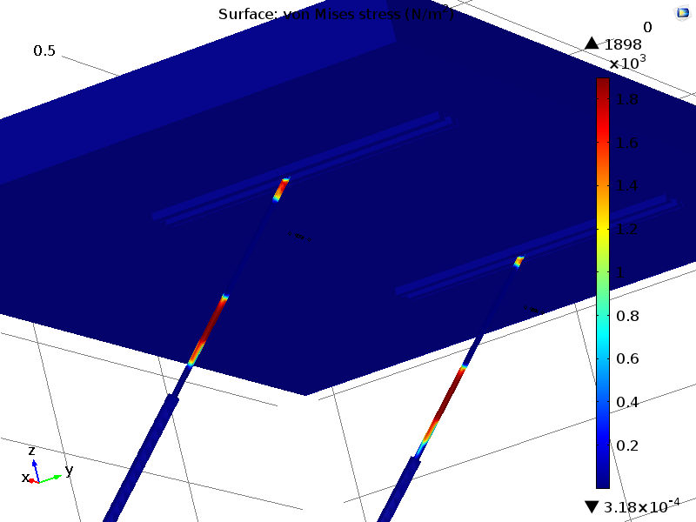

Figure 40: Dynamic simulation showing maximum von mises stress in strut

Furthermore, the descent time for each of the possible setup was investigated. The person lying on top of the bed was assumed to be 130 lbs, and it was assumed that the gas strut systems provided enough damping so that the system became critically damped. The total descent time was found to be 5 seconds for a critically damped system.

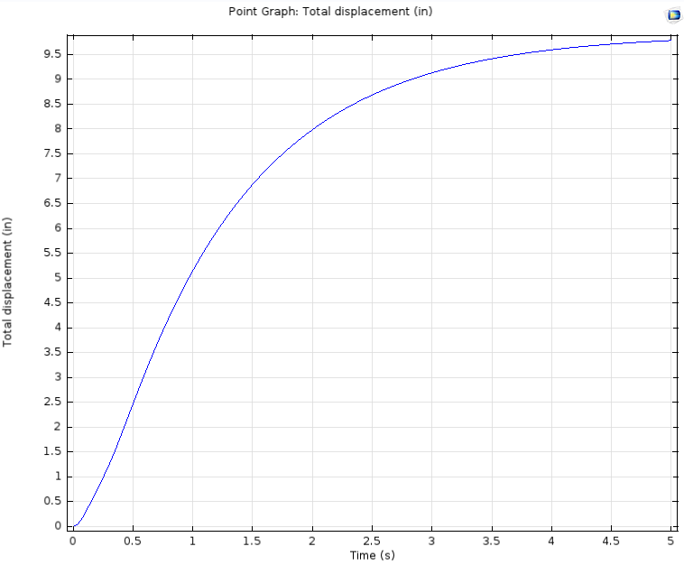

Figure 41: Gas strut displacement vs time, showing a descent time of 5 seconds

The transient study validated that the system was structurally sound under dynamic loading, and that the descent time fits well within the descent time specification at the time. It was predicted that the actual descent time could well range from 30% to 80% of the computed descent time depending on the quality of the gas struts.

Next, another 3D model was constructed based on existing CAD drawings of the top frame to investigate the static deflection of the top frame beams. Only the top frame was modelled in this study. A 3D geometric model was constructed, where the beams are divided into sections to apply supports, boundary conditions, and loading scenarios.

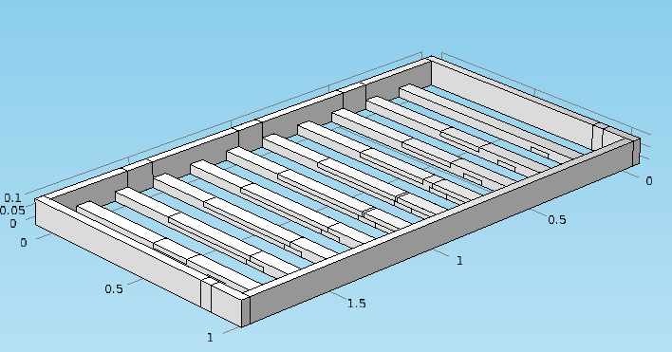

Figure 42: 3D top frame geometry in COMSOL

The mesh quality of the top frame geometry was defined by setting the mesh-controlling parameters to the converging parameters discovered in the previous mesh independent study. The material of the bed was set to wood. Gravity was applied to the bed, which was supported by 3 fixed constraints to represent hinges, and 2 rollers to represent pistons.

Two different loading scenarios were implemented to compute the beam deflections inside the top frame. The first scenario assumed the user is sleeping in the centre of the bed. The mass of the user was distributed according to the approximate body shape and body mass distribution of an adult male (see Figure 150).

The second loading scenario assumed the user was standing or sitting in the corner of the bed, where the piston is. This study aimed to show the twisting of the bed frame to uneven and asymmetric load (see Figure 151).

The first loading scenario produced a maximum static deflection of 1.35mm, while the second showed a maximum static deflection 0.78mm. The results fit well within the design specification with a safety factor of at least 2.

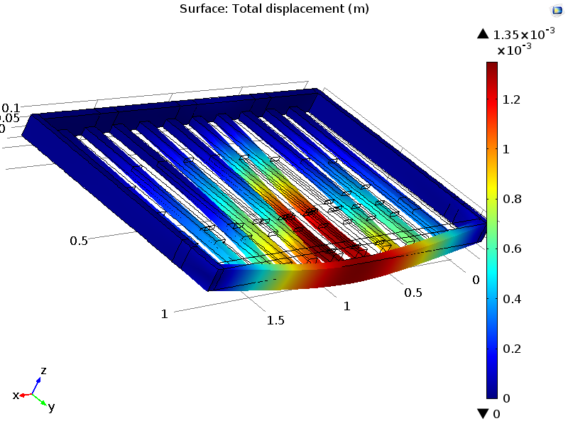

Figure 43: Static deflection of first loading scenario

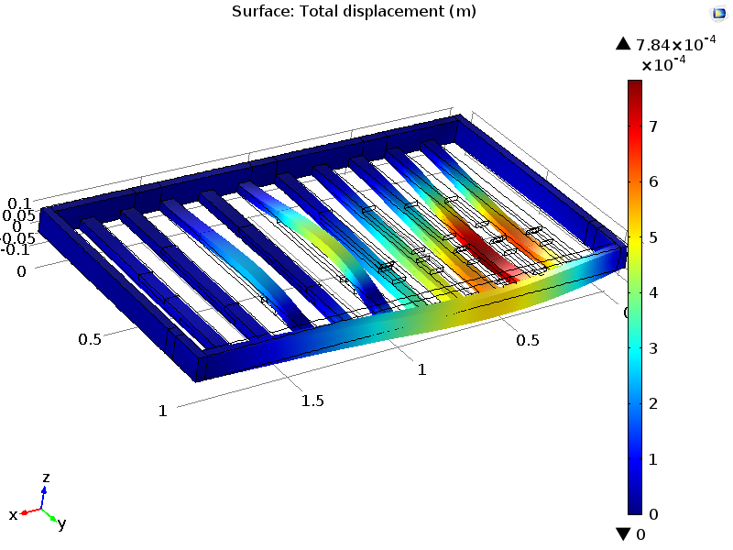

Figure 44: Static loading of second loading scenario

Last, to verify whether the bed stays stationary when the user is resting, a transient simulation is added where the user the mass is suddenly added to the bed at time equals to zero. The result acceleration graph of the top bed frame showed that the bed was subject to a very small disturbance when the user supposedly got onto the bed. The top frame then remained static where the acceleration of the bed frame is shown to be a constant zero (see Figure 152)

# Machining, Assembly

# Release Mechanism

There is two release mechanisms on the tilting alarm bed, and each of them has three main components: main and back plate, bearing block, cylinder, and bearing assembly (See Figure 45 below):

Macintosh HD:Users:wuman02:Documents:alan.wu Dropbox:Dropbox:ME380:Final Report:Drawings:Release Assembly:Approved:RLSE-ASY-02.PDF

Figure 45: Assembly drawing of all parts in release assembly

For the most part, there were no major concerns when machining the components of the release assembly. The main plates and back plates were easy to machine, as the plates were designed with manufacturability in mind. Simple tapped and clearance holes were machined into the plates in order to secure the brackets and bearing block (see Figure 46).

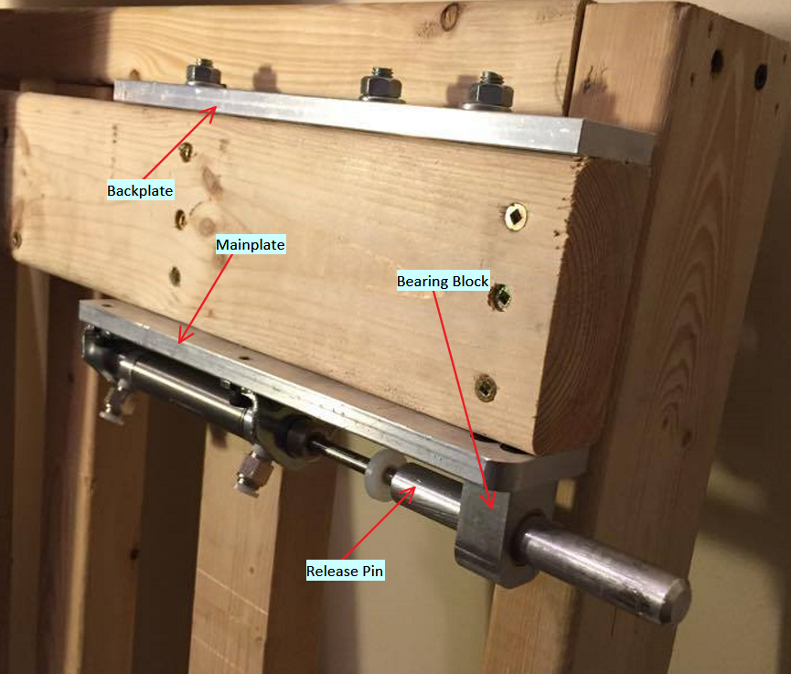

Figure 46: Release Assembly

Machining of the shaft proved to be the most difficult, as lathe accuracy was not originally planned for during the design phase. The lathe in the student machine shop has many limitations, including tolerance errors and the 3-jaw limitations. When the aluminum shaft was gripped in the 3-jaw chuck, significant (relative to the bushing tolerances) fluctuations were observed, and so the concentricity of the shaft was not fully ensured. To counteract this, and ensure a smooth slide fit between the bushing and release pin, it was decided to lathe down the shaft in increments of 0.01” (minimum detectable increments on lathe) until a slide fit was obtained (verified by sliding bearing block on shaft).

When machining the bearing block, it was important to ensure accurate hole diameters to ensure a press fit of the bushing. In order to ensure this, a hole 1/64” was first drilled, followed by reaming the hole to the desired ¾” diameter. The bushing was then pressed into the bushing block, with the use of a 2-ton shop press. After pressing in the bearing, small diameter decreases were observed in the bushing due to press fit compression. To ensure slide fit between the release pin and the bushing, the inner diameter of the bushing was reamed to its spec’d size – 5/8”, allowing smooth slide fit of the release pin. Below (Figure 47) shows an exploded view of the bushing being pressed into the bearing block.

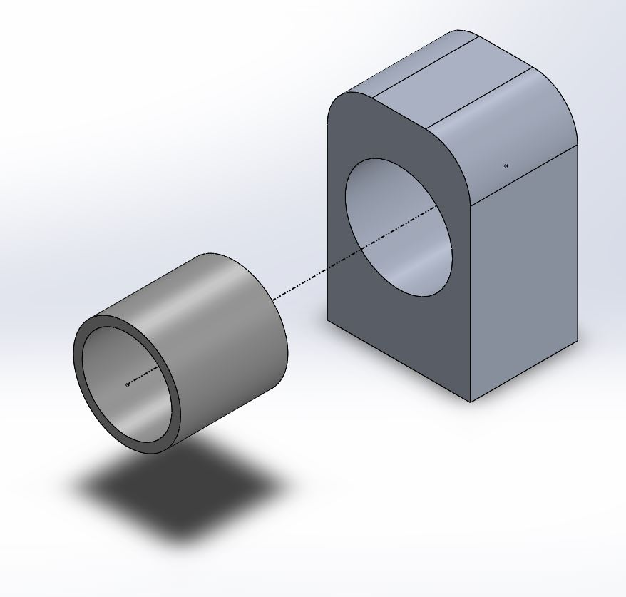

Figure 47: Bushing pressed into bushing block



Figure 48: Assembly drawing of roller mechanism

Figure 32 above shows an exploded assembly drawing of the roller mechanism. The mechanism consists of two plates, and a cam follower. On the thicker of the two plates, a hole was drilled on the side and tapped to match the threads of the cam follower. The 3 mounting holes for the plates were slotted to allow for adjustability of the roller height to account for any bed assembly variations. Furthermore, these slots were counter-bored, in order to hide the bolt-head extrusion, eliminating the possibility of a pinch point between the top frame assembly and the bolt heads.

# Assembly

To assemble the final prototype, the sub-assembly components were first assembled according to the engineering drawings shown in CAD Drawings in Appendix A – Engineering Data. Once all sub-assemblies were complete, the bed frame was built from the bottom up, beginning with the support beams and cross beams (with λ stops and gas struts) on the floor, then bolting on the head and foot boards and connecting them via the spine beam. The top frame was then bolted on via the hinges on the spine beam and finally, the gas strut mounts were bolted onto the designated locations on the top frame, thus completing assembly of the bed**.** Figure 49 shows all sub-assemblies used in the assembly of the prototype. Detailed assembly instructions are found in Arduino Code

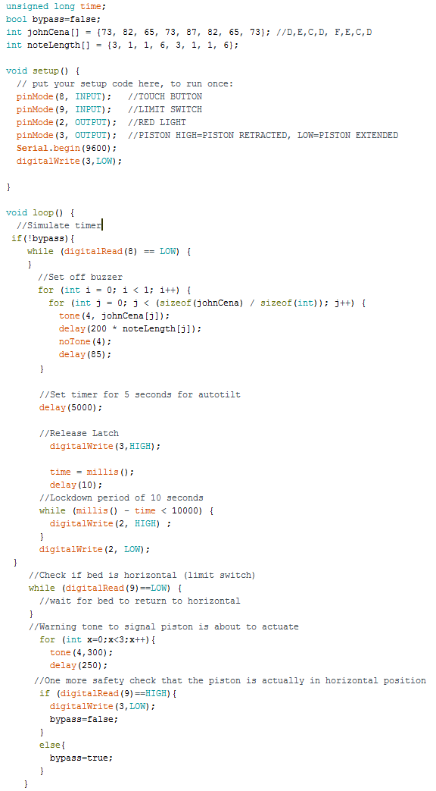

Figure 120: Arduino Microcontroller Program for the Prototype

Assembly Procedure, found in Appendix A – Engineering Data.

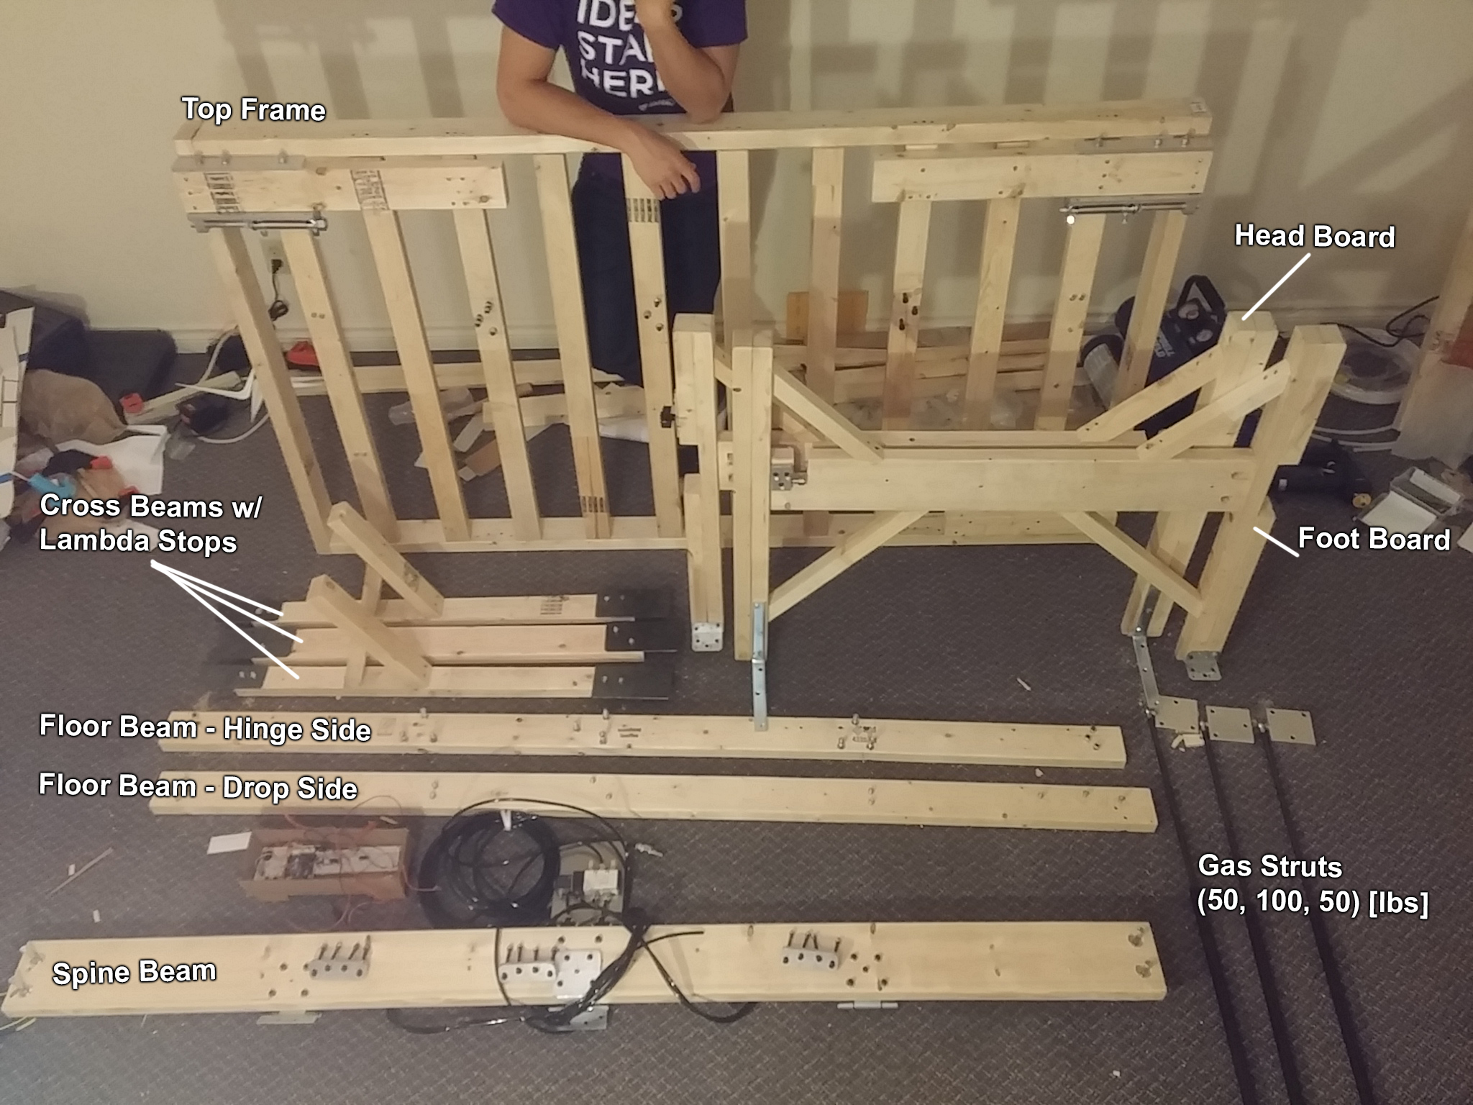

**Figure 49: All Sub-Assemblies**

The final prototype after assembly is shown in Figure 50, Figure 51, Figure 52, and Figure 53.

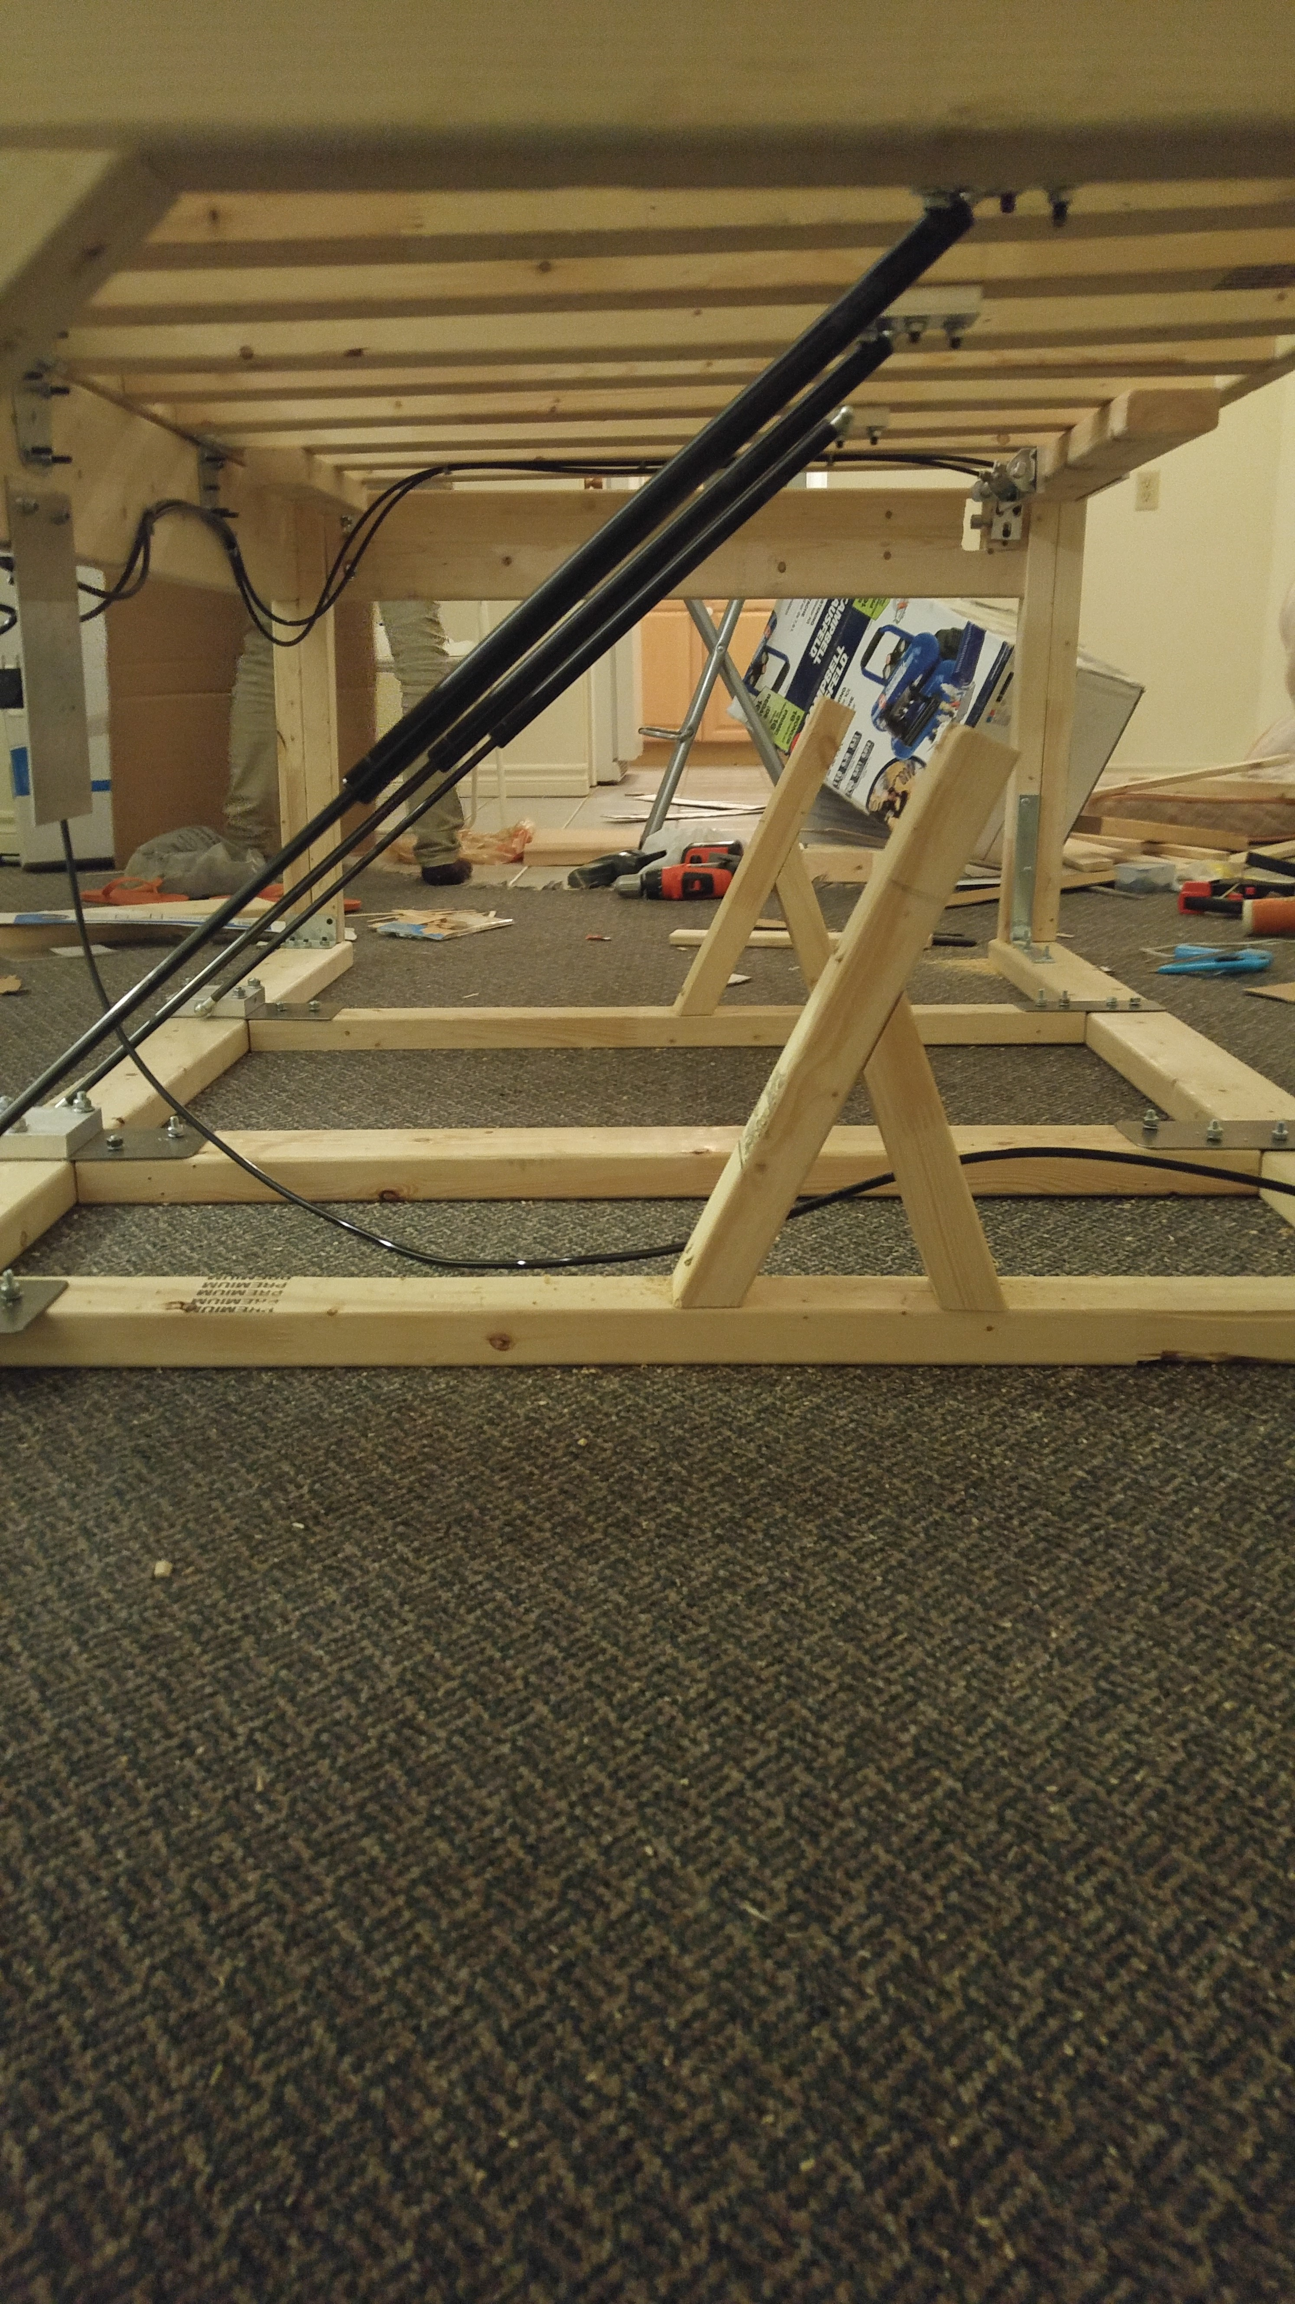

Figure 50: Foot Board Underside View - Prototype

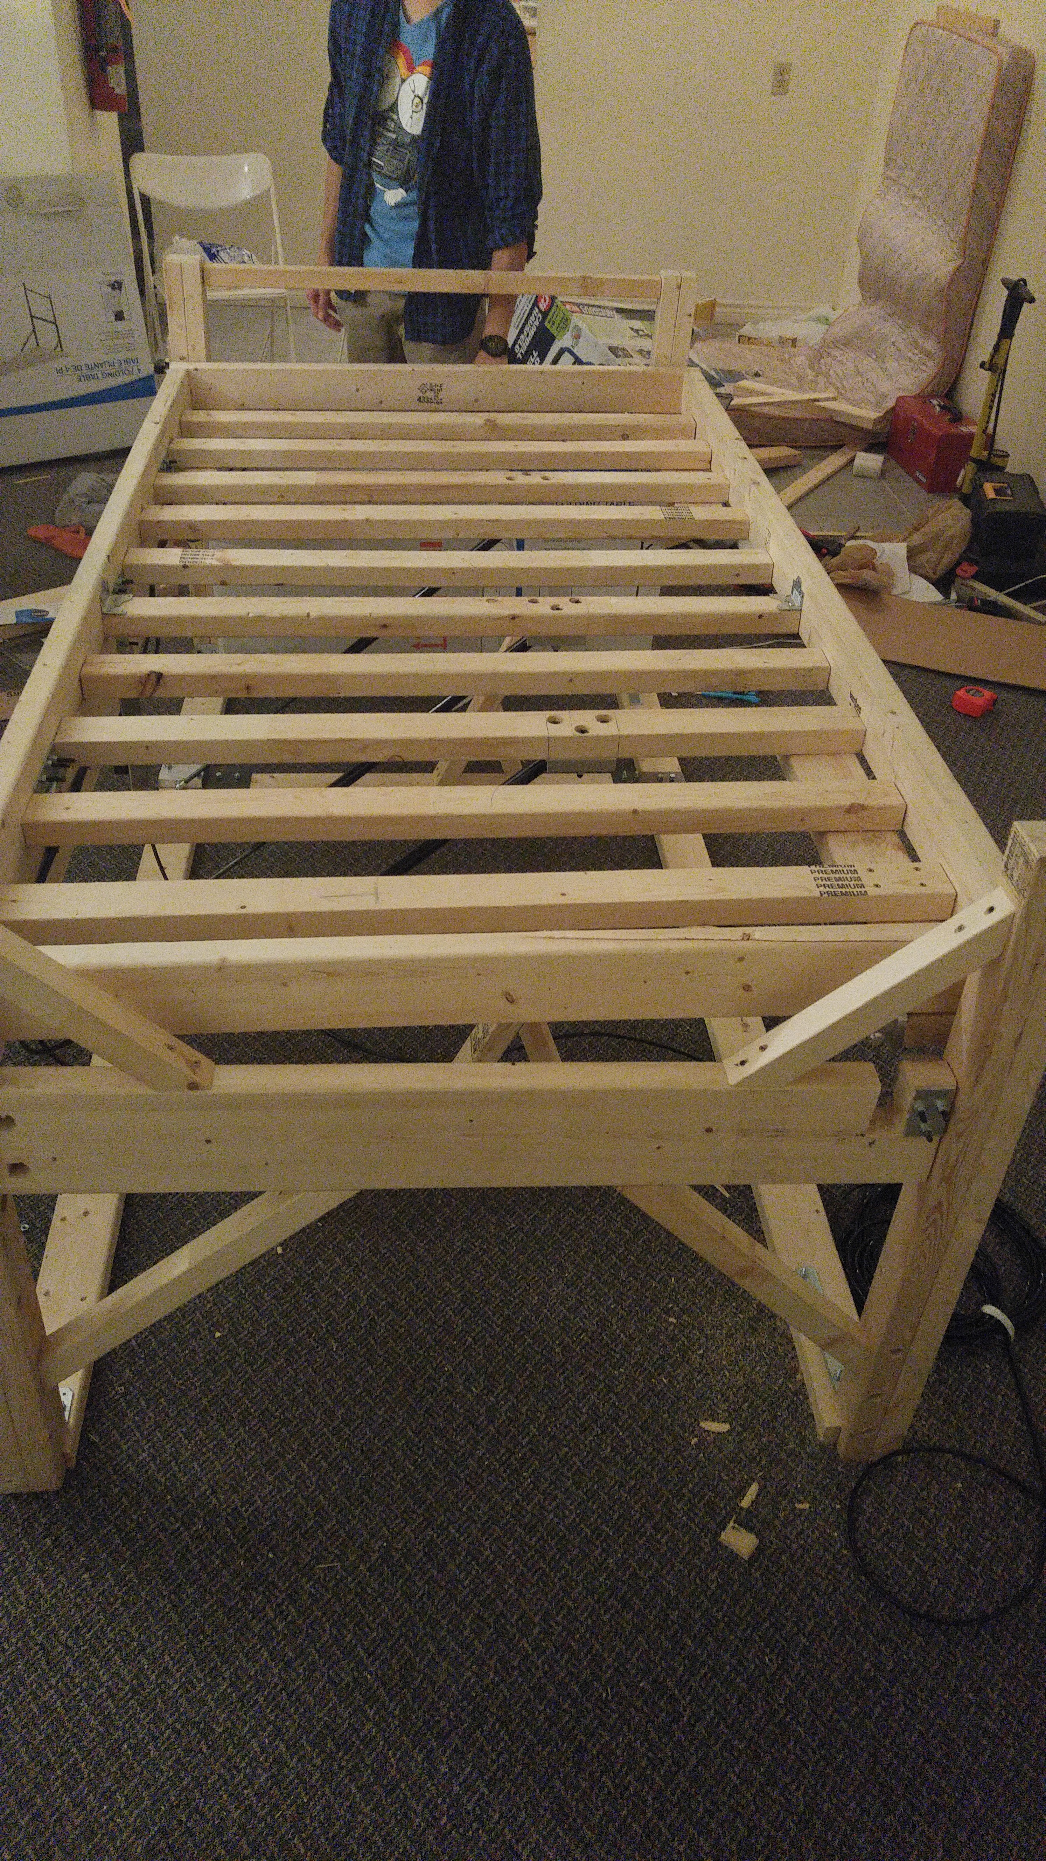

Figure 51: Foot Board View - Prototype

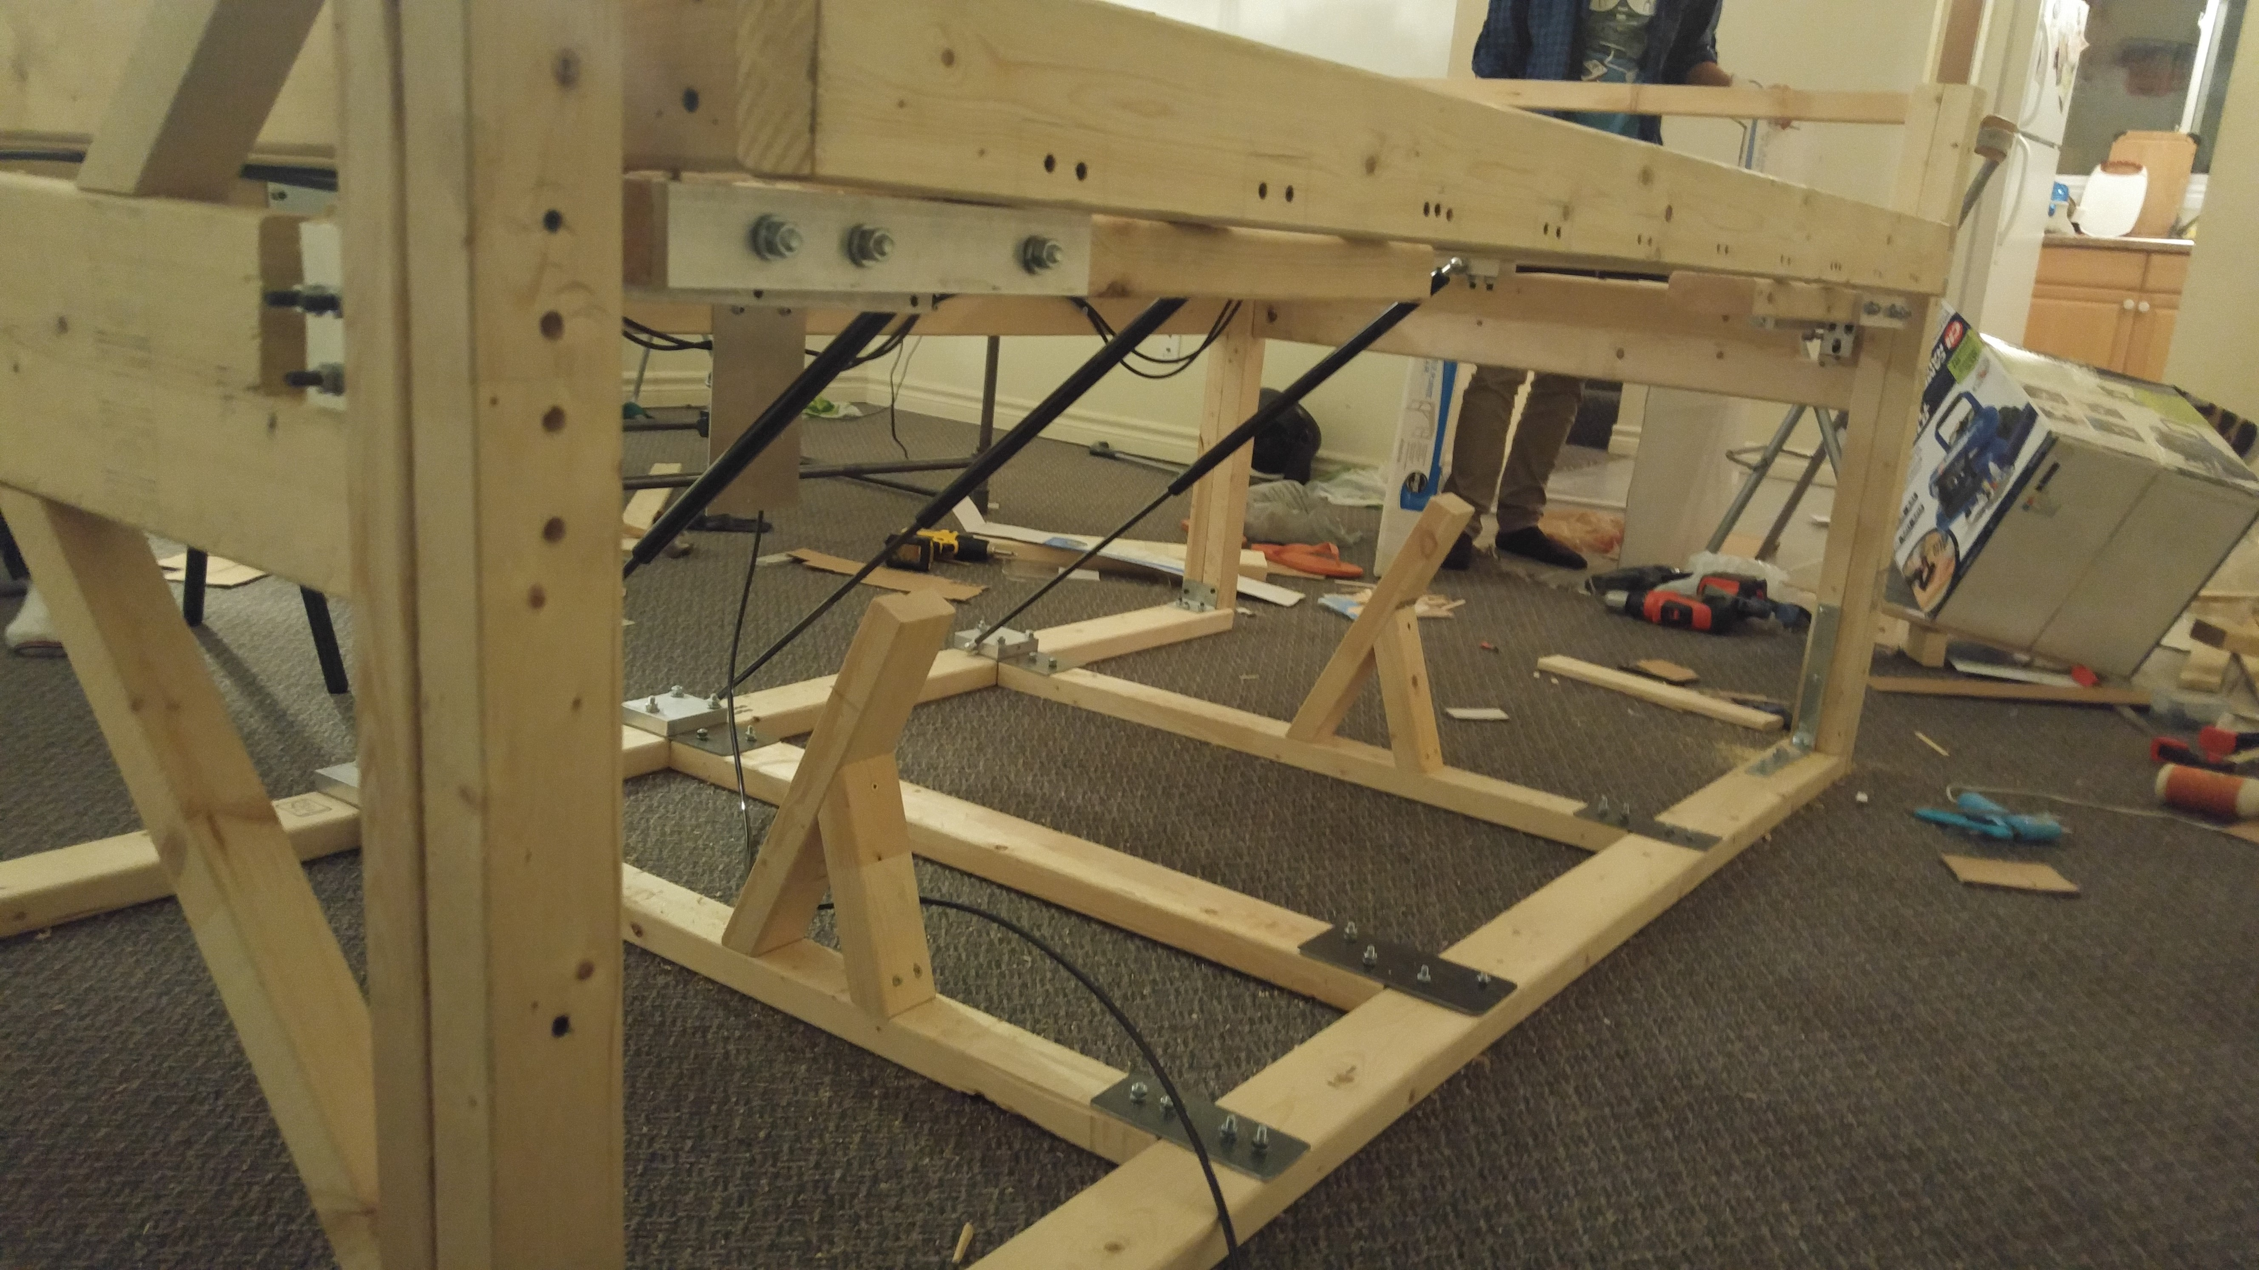

Figure 52: Underside View - Prototype

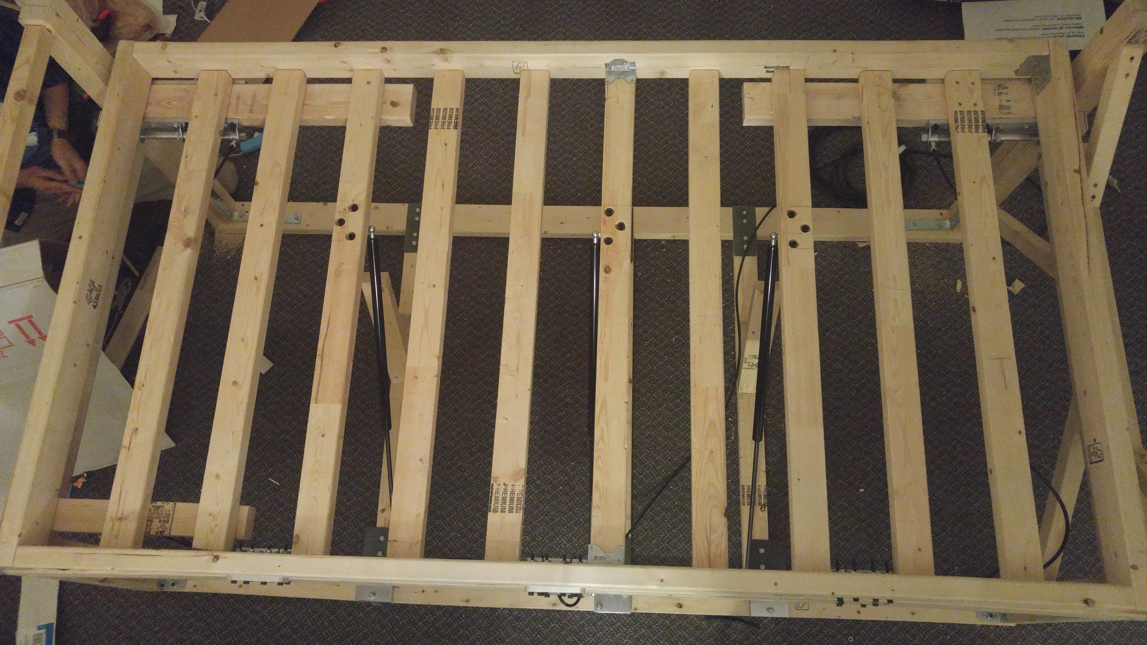

Figure 53: Top View - Prototype

# **Project Management**

The project objective is to design and verify a mechanical device that provides the user with a reliable method of waking up on time. For this project, there were several key deliverables, which include:

* Needs Analysis
* Work Breakdown Schedule (WBS)
* Conceptual Designs
* Embodiment Design
* Engineering Analysis
* Low/Medium Fidelity Prototype
* Final Prototype
* Design Verification

# Schedule

Scheduling of this project was divided over a twelve week period (September 14th to December 4th). Being a shorter term (typically 12 to 14 weeks), a well-organized schedule was necessary to maintain on task and adhere to deadlines and milestones. A complete breakdown of the projects workload is shown in Appendix A. The following table lists all major milestones over the span of this project.

**Table 2: Projects Milestones**

|  |  |
| --- | --- |
| ***Week*** | ***Milestone*** |
| 1-3 | **Problem Definition**  Needs analysis, Problem statement |
| 3-6 | **Initial Project Planning and Conceptual Design**  Project planning/delegation (Work Breakdown Structure), Conceptual design evaluations |
| 5-8 | **Prototyping and Preliminary Design**  Proof of Concept prototype, Design elaboration |
| 7-9 | **Design Embodiment**  Low/Medium fidelity prototype, Design revisions from prototype testing, Procurement |
| 9-12 | **Final Prototype**  Final Prototype build, Final report |

Within the first three weeks, a need and problem space was addressed. An embodying function for the project was established. Other requirements and constraints would be specified in the engineering design specification throughout the term and duration of the project. The first revision of the engineering design specification was required to be completed in week three.

Project planning begun after week three. This involved setting deadlines for deliverables, delegating tasks, creating a work schedule, and assessing associated risks and their respective mitigation plans. Conceptual designs were also drafted during this time. Designs were conceived through various methods, such as analogies, conventional methods, and intuitive methods. Stronger and more robust designs were examined more in-depth. Between week five and six, an evaluation of all proposed conceptual designs was used to select a final design for the prototype.

After a final design was selected and a preliminary model was created, a proof of concept prototype was constructed to demonstrate the desired function of the project. Completing this milestone on time was crucial to allowing the team to begin and understand limitations and complications that may present themselves in the construction of the medium fidelity prototype and the final prototype. The feasibility of the project was also put into perspective through this proof of concept prototype. The final design of the prototype was also revised several times, keeping design for manufacturability and assembly in mind. Engineering calculations were also complete here to help determine what materials were necessary and what designs were feasible for the purpose of the project.

The embodiment design and medium fidelity prototype were constructed in week eight. This prototype, like the proof of concept prototype, would be used to adjust considerations and final design of the final prototype. Between weeks eight and ten, procurement of materials was finalised and by week nine, construction of the final prototype had begun. During this time, all finalised CAD and assembly drawings for custom parts and assemblies were drafted. Build plans were made to streamline the build process and to complete it as efficiently as possible. A final verification of design was scheduled for December 2nd, 2015, meaning the construction of the final prototype, testing of it, and any possible adjustments or revisions to the prototype needed to be complete before then. In the final weeks of the project timeline, a final report documenting the entirety of the project was completed.

# Budget and Resources

Regarding budget, there were two categories in which a budget was required: labor and materials. The two corresponding budgets for labor and materials were managed separately since the labor budget was calculated from the number of hours spent on the whole project by the team members while the materials budget came from actual financial funding provided by the Mechanical Engineering Department and the members of Team 12.

# Labor Budget

The breakdown of the labor budget was as follows: 8 hours/week/member*12 weeks*6 members. The total number of available man hours came to approximately 576. At the rate of approximately $15.50/hour, our total labor budget was calculated to be approximately $10,000.

With the above information in mind all design project work was presented in the form of a WBS (Work Breakdown Structure), which was revised and updated as necessary. In Table 3 below, the WBS can be seen detailing the exact categories and sub-categories of the project and the total number of labor hours allocated to each project component, as well as the assigned contingency. Furthermore, a comparison between planned hours and actual hours spent is also shown in Figure 54.

Table 3: WBS Time Detailing

|  |  |  |  |
| --- | --- | --- | --- |
| **Project Categories** | **Sub-Categories** | **Planned** | **Actual** |
| **Problem Definition** | Brainstorming | 30 | 55 |
| Research | 15 | 15 |
| Scoping | 18 | 10 |
| LTN Video | 6 | 0.5 |
| Problem Statement | 6 | 8 |
|  | | **75** | **88.5** |
| **Initial Planning/Conceptual Design** | Brainstorming | 18 | 22 |
| Research | 12 | 8 |
| Sketching | 12 | 16 |
|  | | **42** | **46** |
| **Prototyping/ Preliminary Design** | Work delegation | 6 | 3 |
| ROM Calculations | 12 | 10 |
| Sketching | 16 | 24 |
| Preliminary CAD/Design | 12 | 25 |
| Funding Presentation | 9 | 5 |
| Funding Pres. Prototype | 16 | 18 |
| VOD Prototype | 30 | 45 |
|  | | **101** | **130** |
| **Report and Analysis** | Precise Calculations | 20 | 20 |
| FEA Modelling | 10 | 12 |
| Report writing/formatting | 70 | 85 |
|  | | **90** | **117** |
| **Final Prototype** | Procurement | 20 | 22 |
| CAD/Design Revisions | 15 | 45 |
| Construction/Testing | 90 | 120 |
|  | | **80** | **187** |
|  | **Total Hours** | **388** | **568.5** |
|  | **Contingency Used:** | **180.5** | |

Figure 54: Planned vs. Actual Time, WBS

As seen in the WBS, out of the 578 total hours available for the project, approximately 33%, 190 hours, was assigned to contingency to ensure that in the event that things did not go exactly as planned, the project would still be finished on time. The importance of this contingency is evident in the fact that 180.5 hours out of the total available 190; 95%, was used in this project. The main reason such a large quantity of the contingency hours were used up was because the group severely underestimated the time required to CAD, construct, and test the final prototype. This can be once again be seen in the Figure 54, where the actual hours spent on the final prototype is 187 as opposed to the 80 hours initially allocated to it.

# Material Budget

In addition to the $150 granted to us by The Mechanical Engineering Department, through a unanimous group decision, an additional $600 were put forth by the group for the whole project, with each group member paying $100. The final BOM (Bill of Materials) is shown below in Table 4, detailing the quantity, unit and extended costs of each item, the date they were purchased and their tax rate. The final total cost of the project was well within the total allocated costs, with there being $27.23 left over in the budget.

Table 4: Complete BOM

|  |  |  |  |  |  |
| --- | --- | --- | --- | --- | --- |
| **Date** | **Item** | **Qty** | **Unit Cost [CAD]** | **Tax Rate** | **Extended Cost [CAD]** |
| 16-Oct-15 | Popsicle Sticks | 2 | 1.00 | 0.13 | 2.26 |
| 16-Oct-15 | Glue | 1 | 1.25 | 0.13 | 1.41 |
| 16-Oct-15 | Dowels | 1 | 1.00 | 0.13 | 1.13 |
| 6-Nov-15 | Gas | 1 | 8.85 | 0.13 | 10.00 |
| 6-Nov-15 | ARO Cylinder | 2 | 30.18 | 0.13 | 68.21 |
| 6-Nov-15 | Cylinder Bracket | 4 | 5.30 | 0.13 | 23.96 |
| 6-Nov-15 | Cam Follower | 2 | 13.50 | 0.13 | 30.51 |
| 6-Nov-15 | Bed Frame (Lumber) | 1 | 47.84 | 0.13 | 54.06 |
| 6-Nov-15 | Bed Hardware | 1 | 55.60 | 0.13 | 62.83 |
| 11-Nov-15 | Solenoid + Fittings | 1 | 89.38 | 0.13 | 101.00 |
| 16-Nov-15 | 6061 Rounds - 5/8" | 1 | 2.99 | 0.13 | 3.38 |
| 16-Nov-15 | 6061 Flats - 3/8" x 2" | 2 | 2.71 | 0.13 | 6.12 |
| 16-Nov-15 | Pneumatic Fitting: 3/8"Hose x 1/4"NPT | 3 | 3.50 | 0.13 | 11.87 |
| 17-Nov-15 | Misc Material? | 1 | 2.85 | 0.13 | 3.22 |
| 17-Nov-15 | 6061 Flats - 3/4" x 3-1/2" | 1 | 10.77 | 0.13 | 12.17 |
| 18-Nov-15 | 6061 Flats - 3/8" x 1-1/2" | 4 | 1.80 | 0.13 | 8.14 |
| 19-Nov-15 | Pneumatics | 1 | 23.01 | 0.13 | 26.00 |
| 20-Nov-15 | 6061 Flats - 1/4" x 3-1/2" Nuts/Bolts | 1 | 11.43 | 0.13 | 12.92 |
| 23-Nov-15 | 6061 Flats - 3/4" x 3-1/2", nuts | 1 | 5.05 | 0.13 | 5.71 |
| 23-Nov-15 | Pneumatics | 1 | 33.00 | 0.13 | 37.29 |
| 24-Nov-15 | McMaster Stuff | 1 | 144.25 | 0.13 | 163.00 |
| 26-Nov-15 | SHCS, M6x1.0x65 | 1 | 5.40 | 0.13 | 6.10 |
| 27-Nov-15 | Fasteners + Brackets | 1 | 53.10 | 0.13 | 60.00 |
| 30-Nov-15 | Floor plates + Fasteners | 1 | 9.67 | 0.13 | 10.93 |
| **Grand Total** | | | | | **722.20** |
| **Surplus** | | | | | **27.80** |

# Risk & Mitigation

Throughout the project management process, several project risks were identified. These include both technical and non-technical risks. Three technical and three non-technical risks were identified and were each given respective risk probabilities and impact severities. Together, these two levels allow for an overall risk assessment of each identified risk. Mitigation plans were made for each risk involved. Each risk is listed in the following table. Probability and Severity scores range from Low (L), Medium (M), and High (H).

Table 5: Risk Assessment

|  |  |  |  |  |  |
| --- | --- | --- | --- | --- | --- |
| ***Risk*** | ***Description*** | ***Risk Type*** | ***Probability*** | ***Severity*** | ***Mitigation Plan*** |
| Safety | Drop of the bed must be safe for person sleeping | Technical | M | H | Strict analysis to ensure drop meets appropriate specification |
| Manufacturing | Manufacturing of parts may go wrong or be too difficult for us to complete | M | M | Allow more time in the WBS for machining and manufacturing of parts |
| Testing Failure | Parts may break during testing | M | L | Contingency time to allow for repairs or rebuilding |
| Parts Delivery Late | Ordered parts may arrive late due to circumstances | Non-Technical | L | L | Order parts early; readjust timeline/redistribute work if parts are late |
| Personal Emergency | Group members may have higher priorities | M | L | Contingency hours; other members will take over extra work if one member is absent |
| Over-budget | Expenses may exceed established budget | H | L | Ensure materials are exactly what is needed before purchasing |

# Technical Risks

*Risk:* ***Safety***

This risk must be addressed and the entire prototype effectively fails if the safety criterion is not met. Testing was iterated to help with redesign for improved safety.

*Risk:* ***Manufacturing***

Manufacturing of parts was more time intensive than anticipated in the work schedule. Many contingency hours were used to complete all the necessary construction and machining.

*Risk:* ***Testing Failure***

No parts broke during the testing of the prototype.

# Non-Technical Risks

*Risk:* ***Parts Delivery Late***

There was one instance during this project where the group was unable to order parts through the University of Waterloo’s Engineering Machine Shop Stores due to the Machine Shop Stores contact being sick. Fortunately, only one day was lost and work was redistributed to work around of the ordered parts for one day.

*Risk:* ***Personal emergencies (sickness, interviews, electives, grievance, etc.)***

There were occasions where group members were absent during scheduled work periods due to personal priorities, such as job interviews, elective midterms, and academic deadlines. Their roles were transferred to other members to keep the work flow going.

*Risk:* ***Over-Budget***

The budget was not exceeded during this project. At a total expenditure of $722.20 CAD, the budget for this project was not surpassed and there was a surplus of $27.80 CAD.

# **Conclusion**

A product was created to meet the need of waking up on time when conventional methods, such as alarm clocks fail to work. The product was validated using the Engineering Specification (TBC-07) found in Appendix A – Engineering Data. The primary function of the product is to, via some mechanical method, force an averaged sized person to safely wake up from sleep. The primary constraint of the project was safety. Verification of design was done through real testing, calculations and analysis, and through demonstration.

The budget of this project was accommodated by both the University of Waterloo’s Mechanical and Mechatronics Engineering Department ($150 CAD) and by the members of the team ($600 CAD or $100 CAD/person). The budget was not exceeded throughout this project.

The project was successful in that the need was addressed and the final prototype was able to demonstrate the solution envisioned. Implementation of needs analysis, project planning, design process, testing were thoroughly thought through and executed within the time constraints imposed.

# **Recommendations & Future Work**

The final prototype created gives guidance and vision to new iterations of a final product. The final prototype satisfies a range of specifications that were set for use by a single person of constant mass. Verifying that this design works for one particular mass of person and that the structure remains sound across the range of masses of sleepers intended for the final product, it is fair to conclude that a dynamic approach to controlling tilt descent time and loading will succeed in meeting specifications for varying masses in the final product.

Some changes for next generation iterations would be to replace the current pneumatic system with a more reliable electronic method, such as using motors and to actuate the release mechanism. This was an unknown in this project, as the group was unsure about the specifics of using a motor/gearbox versus pneumatics to actuate the release mechanism.

As well, the gas struts would also be replaced to suit a wider need. Fluid-damped gas struts would be used in replacement of ordinary gas struts to provide improved dynamic damping, which would widen the range of user mass while still satisfying the proposed descent specifications.

Furthermore, a more robust frame would be ideal. It was discovered during testing that the wood would sometimes twist under point loading at the edge of the top frame. This could be mitigated by using stronger material, such as steel for framing, or by increasing the mass of the lower portion of the bed.

Overall, had more time been allowed, further analysis may have been done to include fatigue life of the wood and the group may have had time to improve material selection and parts sourcing.

# **References**

|  |  |
| --- | --- |
| [1] | C. Lambert, "Hands off the snooze button!," 29 August 2011. [Online]. Available: http://www.dailymail.co.uk/health/article-2031502/Hands-snooze-button-Wake-tired-Heres-bounce-bed.html. [Accessed 2015]. |
| [2] | L. Reilly, "Why Do I Always Wake Up 5 Minutes Before My Alaram Goes Off?," 19 November 2013. [Online]. Available: http://mentalfloss.com/article/53710/why-do-i-always-wake-5-minutes-my-alarm-goes. [Accessed 2015]. |
| [3] | Amazon, "Laser Target Gun Alarm Clock with LCD Screen," Amazon, 11 February 2013. [Online]. Available: http://www.amazon.ca/Laser-Target-Alarm-Clock-Screen/dp/B00563O8T0. [Accessed 2015]. |
| [4] | Amazon, "Nanda Home Clocky Moving Alarm Clock," Amazon, 14 May 2011. [Online]. Available: http://www.amazon.ca/Nanda-Home-Clocky-Moving-Alarm/dp/B004MSMUGI/ref=pd_sim_201_1?ie=UTF8&dpID=41-HQ22tp9L&dpSrc=sims&preST=_AC_UL160_SR160%2C160_&refRID=1HJ8M7DV1YTNK1PB177X. [Accessed 2015]. |
| [5] | C. Furze, "The High Voltage Ejector Bed - YouTube," YouTube, 30 June 2015. [Online]. Available: https://www.youtube.com/watch?v=EVzn1pl4nlo. [Accessed 2015]. |
| [6] | ConnectABILITY, "Vestibular Stimulation Tip Sheet," [Online]. [Accessed 1 December 2015]. |
| [7] | P. Bosch, "Schizophrenia, Sleep, and Acupuncture," Hogrefe, Cambridge, 2008. |
| [8] | R. Romand, "Development of Auditory and Vestibular Systems," Academic, New York, 1983. |

# **Appendix A – Engineering Data**

## Engineering Design Specification Documents

**Engineering Design Specification**

Title: The Blue Clock Engineering Design Spec

Number: 100215-01 Revision Level: TBC-01

Originator: Team Twelve Date: October 2, 2015

**Intended Application:** Consistently and safely wake up person from sleep.

**Requirements Specification:**

Table 6: Engineering Design Specification, Rev1

|  |  |  |  |  |  |  |
| --- | --- | --- | --- | --- | --- | --- |
| **No.** | **Characteristic** | **Relation** | **Value** | **Units** | **Verification**  **Method** | **Comments** |
| 1 | Wakes up user | = | Yes | N/A | Real test |  |
| 2 | Allows user to sleep with it | = | Yes | N/A | Real test |  |
| 3 | Ensure user stays awake when woken up | = | Yes | N/A | Real test |  |
| 4 | Wake up time will be user-programmable | = | Yes | N/A | Will program into device |  |
| 5 | Works with a twin-sized mattress | > | 39x75 | Inch | Real test | Standard twin sized mattress is 39”x75”. Device must hold this |
| 6 | Non-intrusive | = | Yes | N/A | Real test |  |
| 7 | Cost | < | 750 | $CAD | Receipts | Production cost: not including R&D |
| 8 | Mass | < | 200 | Lbs | Scale |  |
| 9 | Size | < | TBD | M3 | Measuring tape |  |
| 10 | Safe operation | = | Yes | N/A | Real test |  |

**Engineering Design Specification**

Title: The Blue Clock Engineering Design Spec

Number: 100215-02 Revision Level: TBC-02

Originator: Team Twelve Date: October 23, 2015

**Intended Application:** Consistently and safely wake up person from sleep for the average consumer.

**Requirements Specification:**

Table 7: Engineering Design Specification, Rev2

|  |  |  |  |  |  |  |
| --- | --- | --- | --- | --- | --- | --- |
| **No.** | **Characteristic** | **Relation** | **Value** | **Units** | **Verification**  **Method** | **Comments** |
| 1 | Hinge tilts bed frame | < | 30 | ° | Real test | Up to max angle of 30 |
| 2 | Bed cannot be returned to raised position | ≥ | 0.5 | hours | Real test |  |
| 3 | Wake up time will be user-programmable | = | Yes | N/A | Real test |  |
| 4 | Works with a twin-sized mattress | > | 39x75 | Inch | Real test | Standard twin sized mattress is 39”x75”. Device must hold this |
| 5 | Non-intrusive (no movement) | = | 0 | lbf | FEA |  |
| 6 | Cost | < | 750 | $CAD | Receipts | Production cost: not including R&D |
| 7 | Mass | < | 300 | Lbs | Scale |  |
| 8 | Disassembled parts smaller than doorway | < | 3x8 | Feet | Measuring tape |  |
| 9 | Pinch Points | = | 0 | Points | Observation |  |
| 10 | Time for bed to descend | between | 2-5 | Seconds | Real test | need to control speed of descent |
| 11 | User lifting force | < | 40 | lbs | Real test |  |
| 12 | Top frame motion | = | 1 | dof | CAD/FEA |  |
| 13 | Withstand user mass | < | 250 | lbs | real test/FEA |  |
| 14 | Recoil | < | 1 | cm | real test/FEA |  |

**Engineering Design Specification**

Title: The Blue Clock Engineering Design Spec

Number: 100215-003 Revision Level: TBC-03

Originator: Team Twelve Date: October 23, 2015

**Intended Application:**

Consistently and safely wake up person from sleep. Intended to help students wake up on time for class or other priorities and prevent the user from going back to sleep

**Requirements Specification:**

Table 8: Engineering Design Specification, Rev3

|  |  |  |  |  |  |  |
| --- | --- | --- | --- | --- | --- | --- |
| **No.** | **Characteristic** | **Relation** | **Value** | **Units** | **Verification**  **Method** | **Comments** |
| 1 | Bed frame titling angle | < | 30 | ° | Real test | Up to max angle of 30 |
| 2 | Lock does not engage after activation | ≥ | 0.5 | hours | Real test |  |
| 3 | Wake up time will be user-programmable | = | Yes | N/A | Real test |  |
| 4 | Works with a twin-sized mattress | > | 39x75 | Inch | Real test | Standard twin sized mattress is 39”x75”. Device must hold this |
| 5 | Non-intrusive (no movement) | = | 0 | lbf | FEA | Won’t cause disturbances unless needed (when activated) |
| 6 | Cost | < | 750 | $CAD | Receipts | Production cost: not including R&D |
| 7 | Mass | < | 150 | Lbs | Scale |  |
| 8 | Disassembled parts smaller than doorway | < | 3x8 | Feet | Measuring tape |  |
| 9 | Pinch Points | = | 0 | Points | Observation |  |
| 10 | Time for bed to descend | between | 2-5 | Seconds | Real test | need to control speed of descent |
| 11 | Top frame motion | = | 1 | DoF | CAD/FEA |  |
| 12 | Withstand user mass | >, < | 75, 250 | lbs | real test/FEA |  |
| 13 | Recoil | < | 1 | cm | real test/FEA |  |

**Engineering Design Specification**

Title: The Blue Clock Engineering Design Spec

Number: 100215-04 Revision Level: TBC-04

Originator: Team Twelve Date: November 24, 2015

**Intended Application:**

Consistently and safely wake up person from sleep. Intended to help students wake up on time for class or other priorities and prevent the user from going back to sleep

**Requirements Specification:**

Table 9: Engineering Design Specification, Rev4

|  |  |  |  |  |  |  |
| --- | --- | --- | --- | --- | --- | --- |
| **No.** | **Characteristic** | **Relation** | **Value** | **Units** | **Verification**  **Method** | **Comments** |
| 1 | Bed frame titling angle | < | 30 | ° | Real test | Up to max angle of 30 |
| 2 | Lock does not engage after activation | ≥ | 0.5 | hours | Real test |  |
| 3 | Wake up time will be user-programmable | = | Yes | N/A | Real test |  |
| 4 | Works with a twin-sized mattress | > | 39x75 | Inch | Real test | Standard twin sized mattress is 39”x75”. Device must hold this |
| 5 | Non-intrusive (no movement) | = | 0 | lbf | FEA | Won’t cause disturbances unless needed (when activated) |
| 6 | Cost | < | 750 | $CAD | Receipts | Production cost: not including R&D |
| 7 | Mass | < | 150 | Lbs | Scale |  |
| 8 | Disassembled parts smaller than doorway | < | 3x8 | Feet | Measuring tape |  |
| 9 | Pinch Points | = | 0 | Points | Observation |  |
| 10 | Time for bed to descend | between | 2-5 | Seconds | Real test | need to control speed of descent |
| 11 | Top frame motion | = | 1 | DoF | CAD/FEA |  |
| 12 | Withstand user mass | >, < | 75, 250 | lbs | real test/FEA | Final product will incorporate entire range, prototype is mean to demonstrate feasibility of this for a single user mass setting. Final product will have actively adjustable damping and force to accommodate different weights of people |
| 13 | Recoil | < | 1 | cm | real test/FEA |  |

**Engineering Design Specification**

Title: The Blue Clock Engineering Design Spec

Number: 100215-05 Revision Level: TBC-05

Originator: Team Twelve Date: December 1, 2015

**Intended Application:**

Consistently and safely wake up person from sleep. Intended to help students wake up on time for class or other priorities and prevent the user from going back to sleep.

**Requirements Specification:**

Table : Engineering Design Specification, Rev5

|  |  |  |  |  |  |  |
| --- | --- | --- | --- | --- | --- | --- |
| **No.** | **Characteristic** | **Relation** | **Value** | **Units** | **Verification**  **Method** | **Comments** |
| 1 | Bed frame titling angle | < | 30 | ° | Real test |  |
| 2 | Lock does not engage after activation | ≥ | 0.5 | hours | Real test | Prototype will demonstrate a shorter lockdown period |
| 3 | Wake up time will be user-programmable | = | Yes | N/A | Real test |  |
| 4 | Works with a twin-sized mattress | > | 39x75 | Inch | Real test | Standard twin sized mattress is 39”x75”. Device must hold this |
| 5 | Non-intrusive (no movement) | = | 0 | m/s | FEA/hand calculations | Will not cause disturbances until activation. |
| 6 | Cost | < | 750 | $CAD | Receipts | Production cost: not including R&D |
| 7 | Mass | < | 150 | Lbs | Scale | Does not include the mattress |
| 8 | Disassembled parts smaller than doorway | < | 3x8 | Feet | Real test/CAD |  |
| 9 | Pinch Points | = | 0 | Points | Observation |  |
| 10 | Time for bed to descend | between | 2-5 | Seconds | Real test |  |
| 11 | Top frame motion | = | 1 | DoF | CAD/real test |  |
| 12 | Withstand user mass | between | 75-250 | lbs | real test/FEA | Final product will incorporate entire range, prototype is mean to demonstrate feasibility of this for a single user mass setting. Final product will have actively adjustable damping and force to accommodate different weights of people |
| 13 | Latch friction force | < | 40 | lbf | hand calcs/real test | Friction force must be less than piston force of 40 lbf under normal operating assumptions to tilt bed. |
| 14 | Deflection of top frame beams | < | 3 | mm | FEA | Maximum deflection of all beams should be minimal. |
| 15 | Bed Return angle | between | 0-5 | ° (above) | Real test | Bed frame should return to or above horizontal position. |
| 16 | No more disturbance to surroundings than an alarm clock | = | YES | N/A | Real test | The device should have minimal effects to surrounding environment at all times |

**Engineering Design Specification**

Title: The Blue Clock Engineering Design Spec

Number: 100215-06 Revision Level: TBC-06

Originator: Team Twelve Date: December 2, 2015

**Intended Application:**

Consistently and safely wake up person from sleep. Intended to help students wake up on time for class or other priorities and prevent the user from going back to sleep.

**Requirements Specification:**

Table : Engineering Design Specification, Rev6

|  |  |  |  |  |  |  |
| --- | --- | --- | --- | --- | --- | --- |
| **No.** | **Characteristic** | **Relation** | **Value** | **Units** | **Verification**  **Method** | **Comments** |
| 1 | Bed frame titling angle | < | 30 | ° | Demonstration |  |
| 2 | Time delay before locking mechanism activates | ≥ | 0.5 | hours | Demonstration | Prototype will demonstrate a shorter lockdown period |
| 3 | Works with a twin-sized mattress | > | 39x75 | Inch | Demonstration | Standard twin sized mattress is 39”x75”. Device must hold this |
| 4 | Non-intrusive (no movement) | = | 0 | m/s | Analysis | Will not cause disturbances until activation. |
| 5 | Cost | < | 650 | $CAD | Receipts | Final Product Cost (not project cost) |
| 6 | Mass | < | 150 | Lbs | Analysis | Does not include the mattress |
| 7 | Disassembled parts smaller than doorway | < | 3x8 | Feet | Testing/Analysis | CAD Drawings will show major dimensions |
| 8 | Pinch Points | = | 0 | Points | Demonstration |  |
| 9 | Time for bed to descend | > | 0.5 | Seconds | Demonstration |  |
| 10 | Top frame motion | = | 1 | DoF | Demonstration |  |
| 11 | Withstand user mass | ~ | 175 | lbs | Demonstration | Product targeted at the typical mass of student male in Canada |
| 12 | Latch friction force | < | 40 | lbf | Analysis | Friction force must be less than piston force of 40 lbf under normal operating assumptions to tilt bed. Hand calculations |
| 13 | Deflection of top frame beams during use | < | 5 | mm | Analysis | Maximum deflection of all beams should be minimal. FEA |
| 14 | Bed Return angle | between | 0-5 | ° (above) | Demonstration | Bed frame should return to or above horizontal position. |
| 15 | No more disturbance to surroundings than an alarm clock | = | YES | N/A | Demonstration/Testing | The device should have minimal effects to surrounding environment at all times |
| 16 | Safety Factor | >= | 2 | N/A | Analysis | Calculations done using safety factor of 2. Hand Calculation. FEA |

**Engineering Design Specification**

Title: The Blue Clock Engineering Design Spec

Number: 100215-067 Revision Level: TBC-07

Originator: Team Twelve Date: December 8, 2015

**Intended Application:**

Consistently and safely wake up person from sleep. Intended to help students wake up on time for class or other priorities and prevent the user from going back to sleep.

**Requirements Specification:**

Table : Engineering Design Specification, Rev7

|  |  |  |  |  |  |  |
| --- | --- | --- | --- | --- | --- | --- |
| **No.** | **Characteristic** | **Relation** | **Value** | **Units** | **Verification**  **Method** | **Comments** |
| 1 | Maximum bed frame titling angle | < | 30 | ° (below) | Demonstration | Angle measured with respect to horizontal axis. Higher than 30° is deemed unsafe |
| 2 | Minimum bed frame titling angle | > | 20 | ° (below) | Demonstration | Angle measured with respect to horizontal axis. Lower than 20° will not be effective to wake the user. |
| 3 | Bed return angle | > | 0-5 | ° (above) | Demonstration | Angle measured with respect to horizontal axis. Bed frame should return to or above horizontal position. |
| 4 | Minimum time for bed to descend | < | 0.5 | Seconds | Demonstration | Lower than 0.5 seconds is deemed unsafe |
| 5 | Maximum time for bed to descend | > | 2 | Seconds | Demonstration | Higher than 2 seconds will not be effective to wake the user. |
| 6 | Time delay before locking mechanism activates | ≥ | 0.5 | hours | Demonstration | Prototype will demonstrate a shorter lockdown period |
| 7 | Bed frame supports mattress length | > | 75 | Inch | Demonstration | Standard twin sized mattress is 39”x75”. Device must hold this |
| 8 | Bed frame supports mattress width | > | 39 | Inch | Demonstration | Standard twin sized mattress is 39”x75”. Device must hold this |
| 9 | Non-intrusive | = | 0 | m/s | Demonstration | Will not cause disturbances until activation. |
| 10 | Operational unit cost | < | 500 | $CAD | Analysis | The operational cost of one bed frame. |
| 11 | Bed frame mass | < | 150 | Lbs | Analysis | Does not include the mattress |
| 12 | Sub-assembly maximum length | < | 8 | Feet | Testing/Analysis | All sub-assemblies must fit through a standard 3’x8’ door. |
| 13 | Sub-assembly maximum width | < | 3 | Feet | Testing/Analysis | All sub-assemblies must fit through a standard 3’x8’ door. |
| 14 | Top frame axis of rotation | = | 1 | DoF | Demonstration | The axis of rotation should only be about the hinge. |
| 15 | Withstand user mass | < | 175 | lbs | Demonstration | Product targeted at the typical mass of student male in Canada |
| 16 | Latch friction force | < | 40 | lbf | Analysis | Friction force must be less than piston force of 40 lbf under normal operating assumptions to tilt bed. |
| 17 | Deflection of top frame beams during use | < | 5 | mm | Analysis | Maximum deflection of all beams should be minimal. FEA |
| 18 | Sound disturbance | ≤ | 80 | dB | Demonstration | The noise disturbance created by the device should be less than or equal to a standard alarm clock |
| 19 | Safety Factor | ≥ | 2 | N/A | Analysis | Calculations done using safety factor of 2. Hand Calculation. FEA |
| 20 | Unspecified pinch points | = | 0 | Points | Demonstration |  |

## CAD Drawings

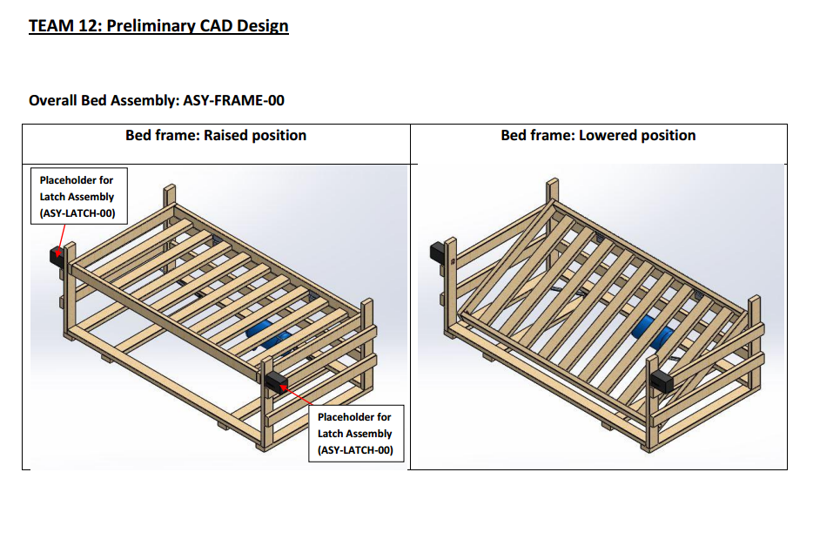

Figure 55: Isometric Preliminary CAD Model of Bed Frame Assembly

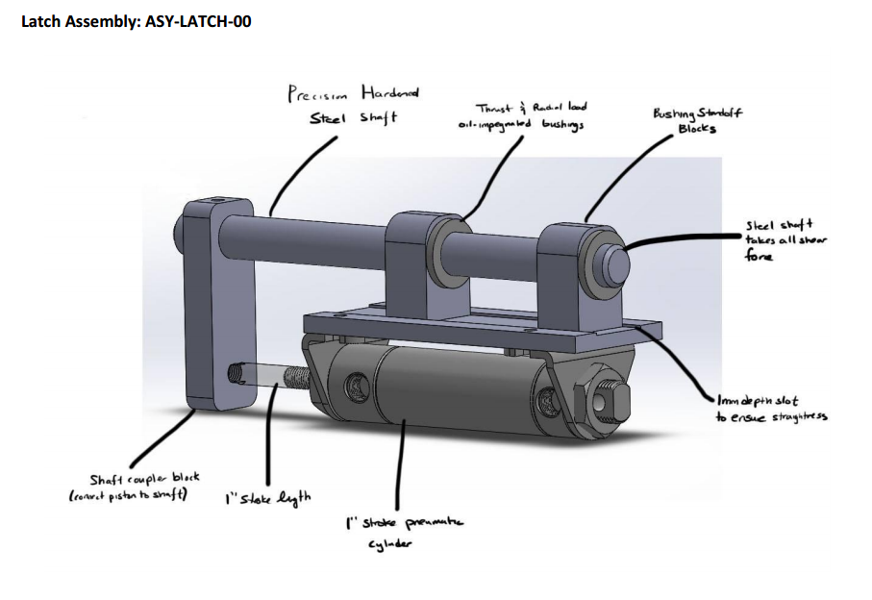

Figure 56: Preliminary CAD Model of Latch Assembly



Figure 57: Latch Assembly v1, Assembly Drawing



Figure 58: Bed Frame Assembly v1, Assembly Drawing

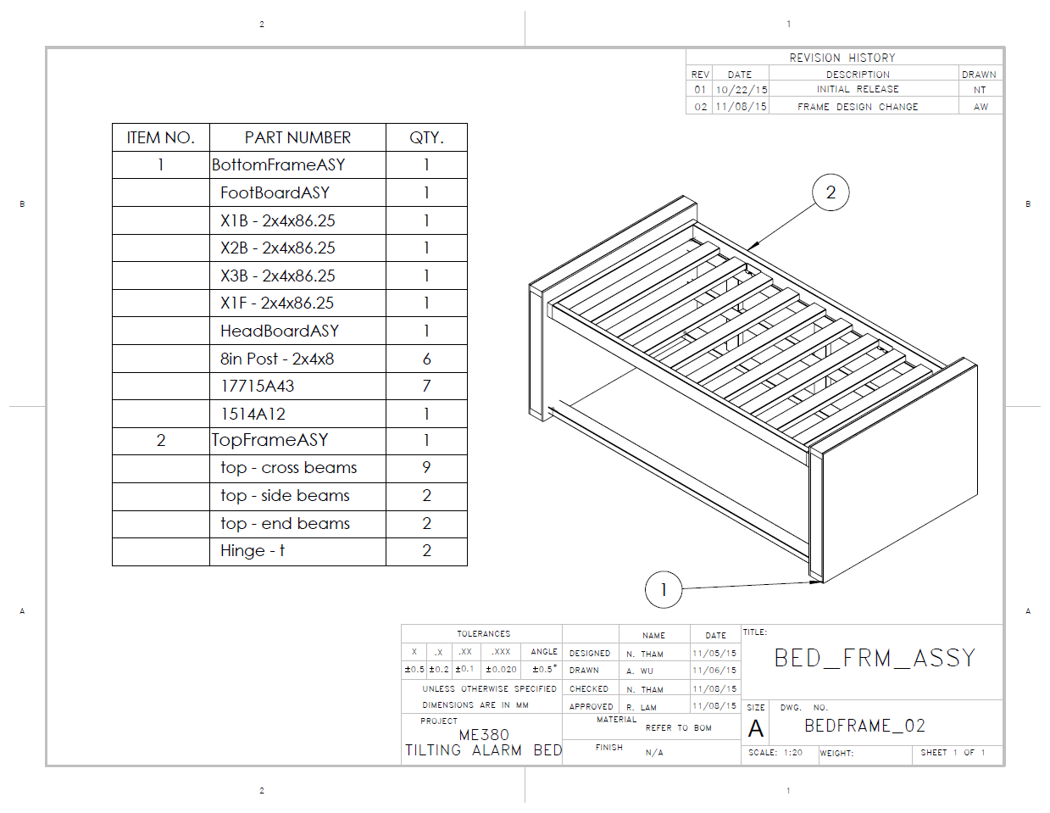

Figure 59: Bed Frame Assembly v2, Assembly Drawing

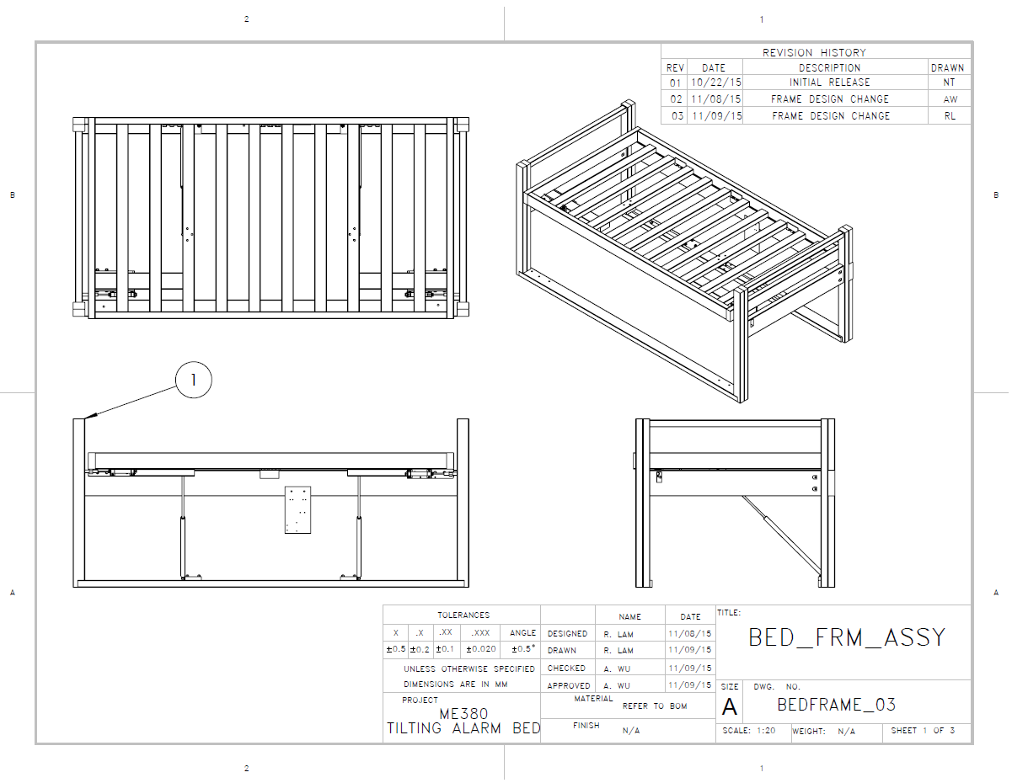

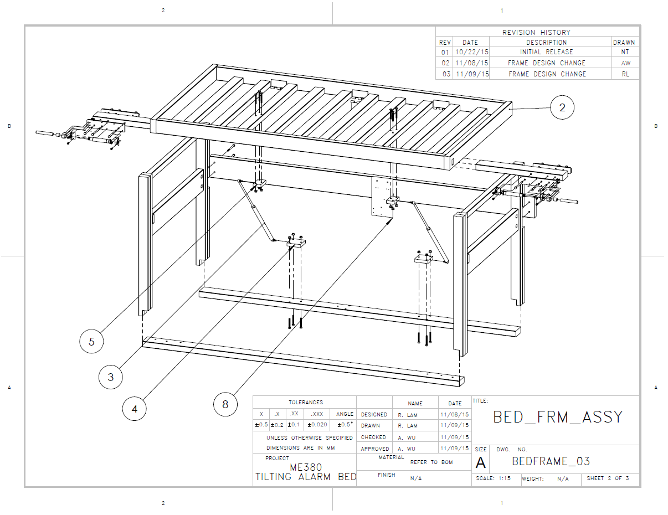

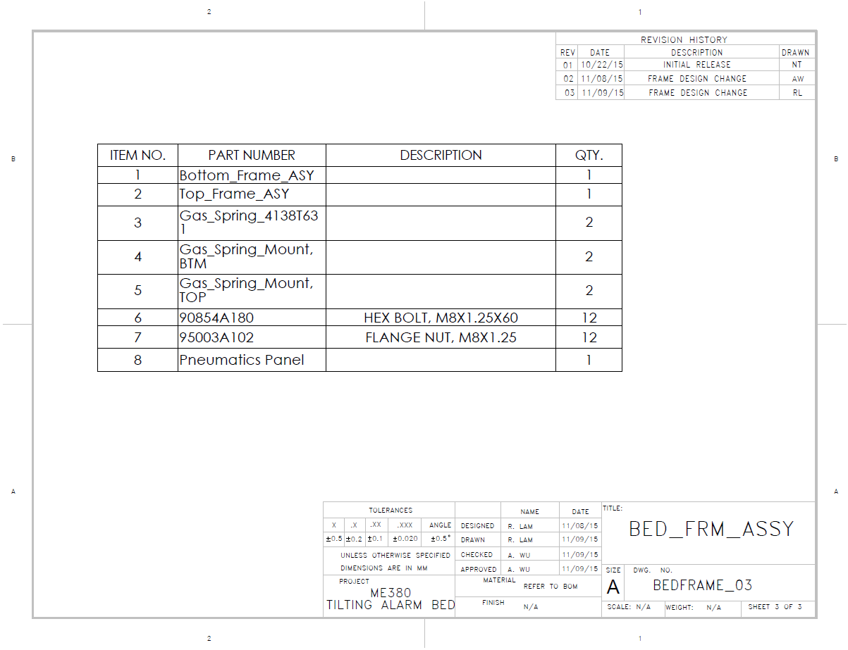

Figure 60: Bed Frame Assembly v3, Assembly Drawing

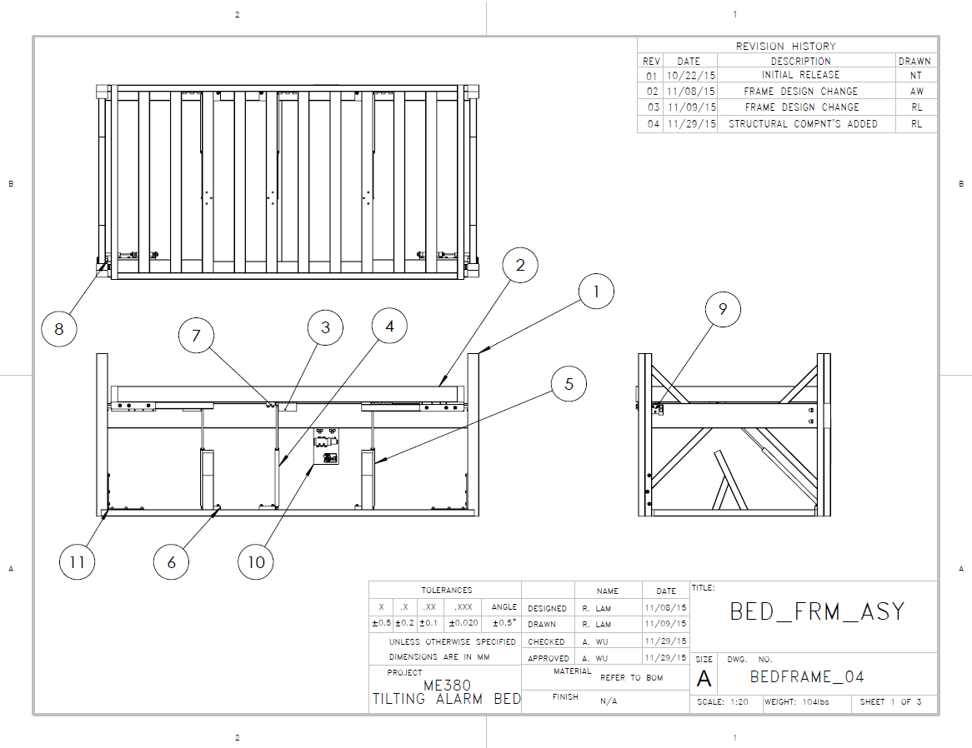

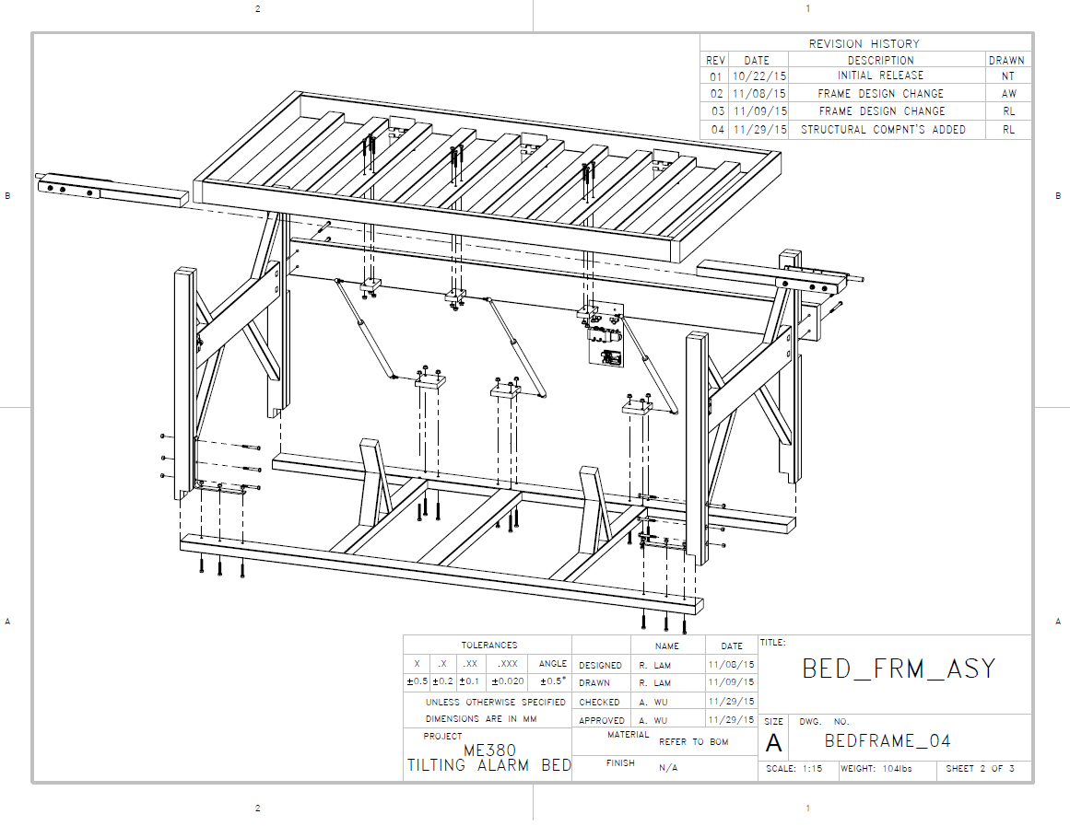

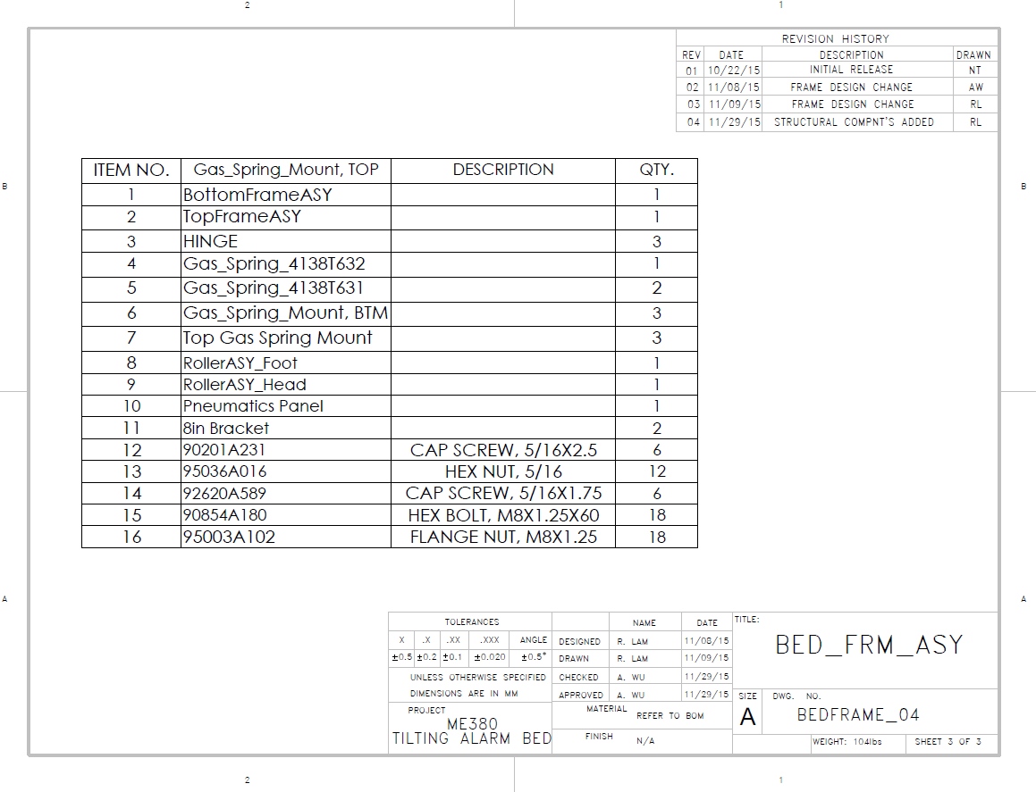

Figure 61: Bed Frame Assembly v4, Assembly Drawing

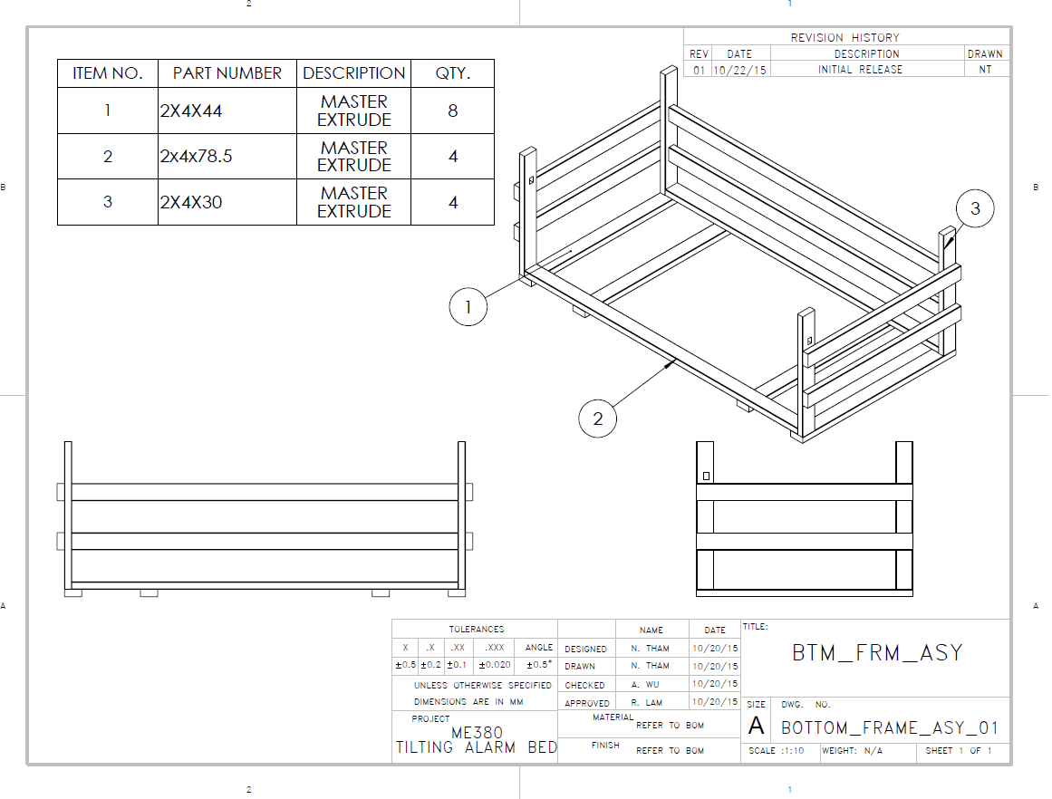

Figure 62: Bottom Frame Assembly, v1 Assembly Drawing

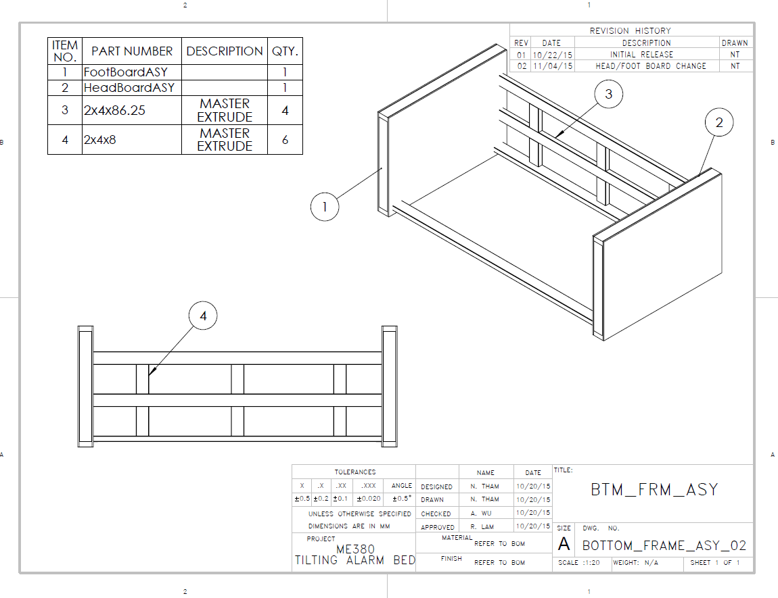

Figure 63: Bottom Frame Assembly, v2 Assembly Drawing

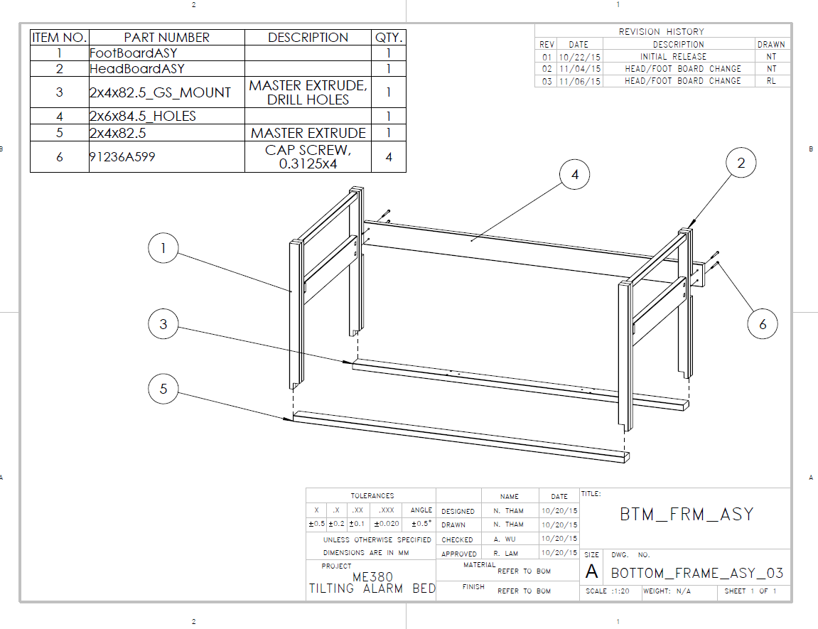

Figure 64: Bottom Frame Assembly, v3 Assembly Drawing

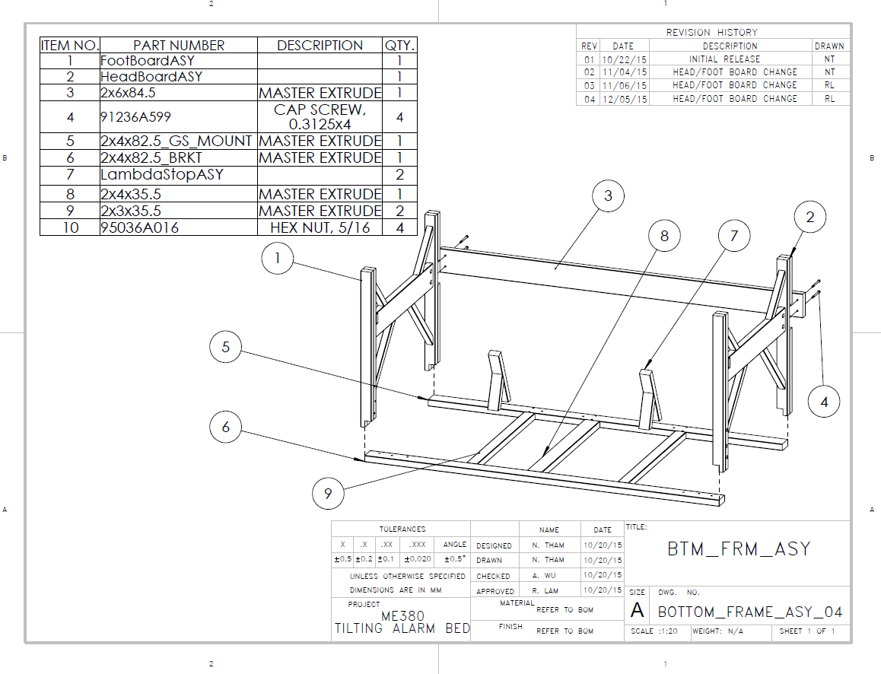

Figure 65: Bottom Frame Assembly, v4 Assembly Drawing

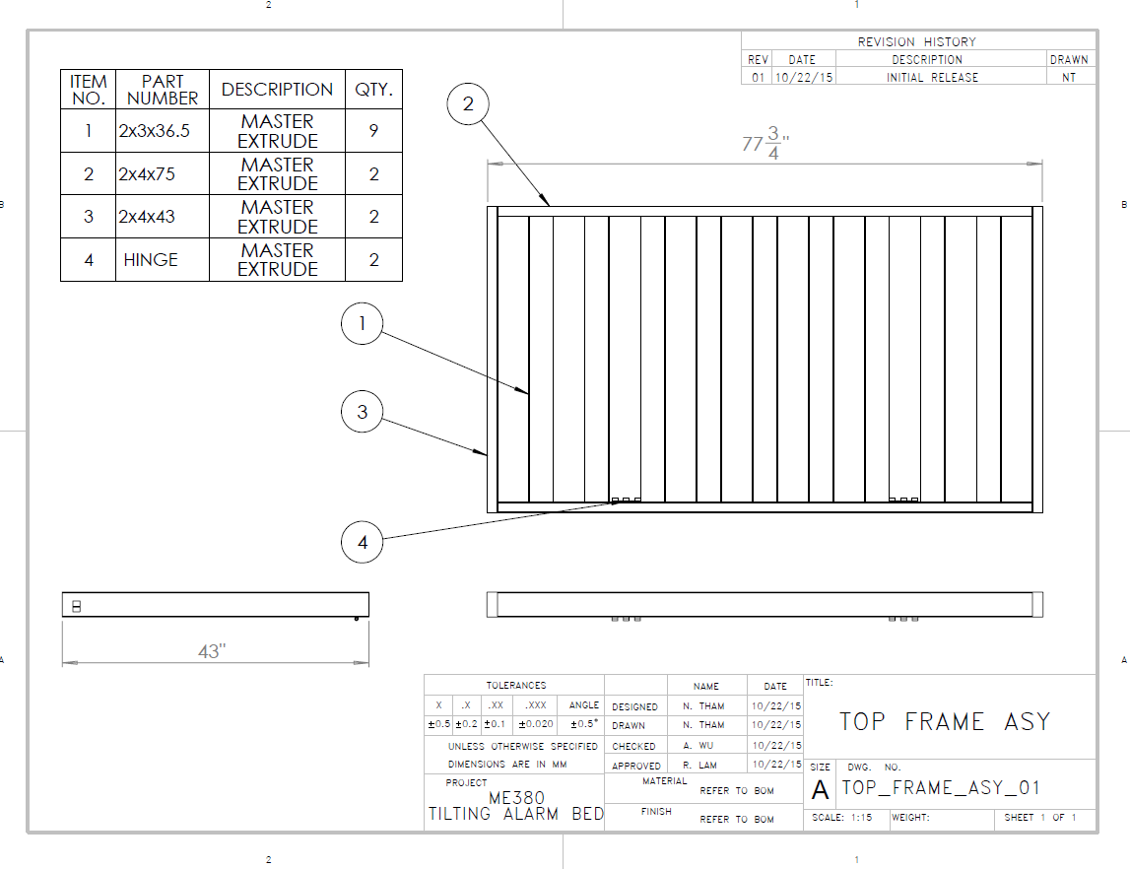

Figure 66: Top Frame Assembly, v1 Assembly Drawing

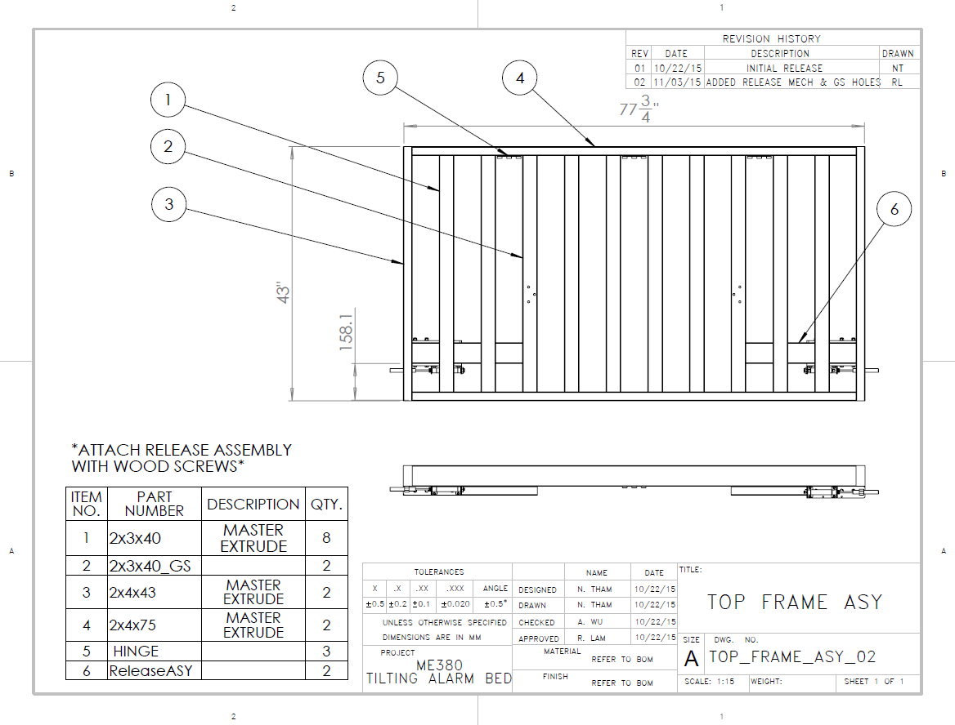

Figure 67: Top Frame Assembly, v2 Assembly Drawing

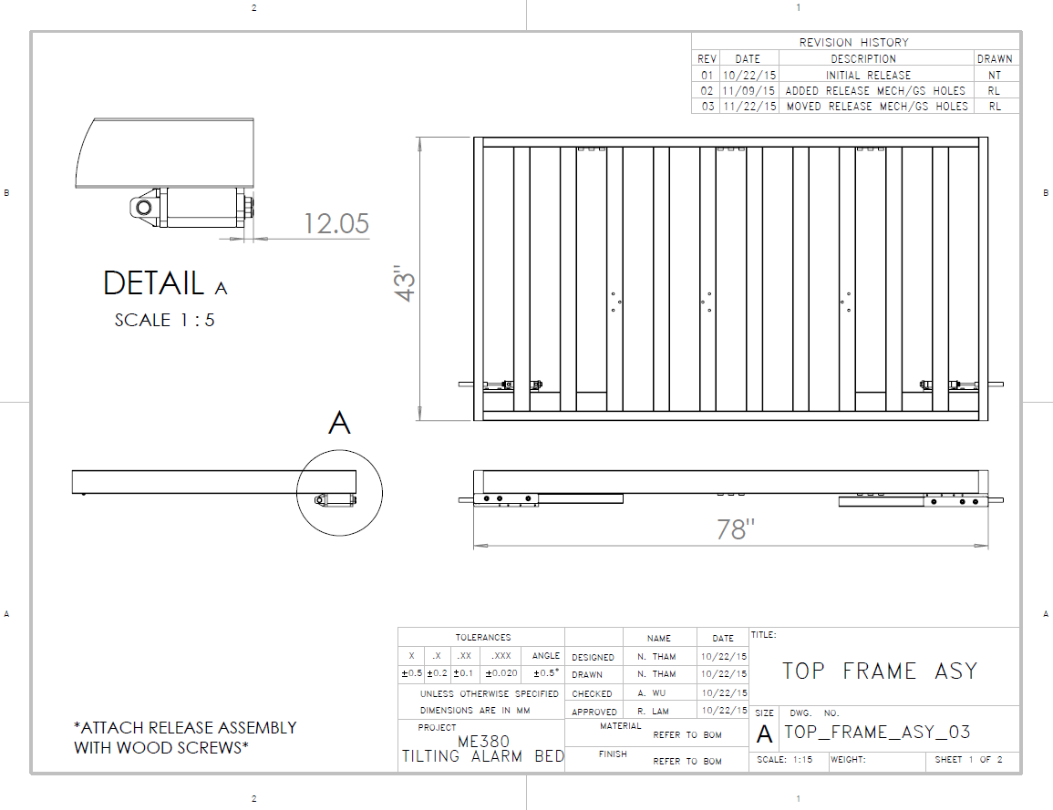

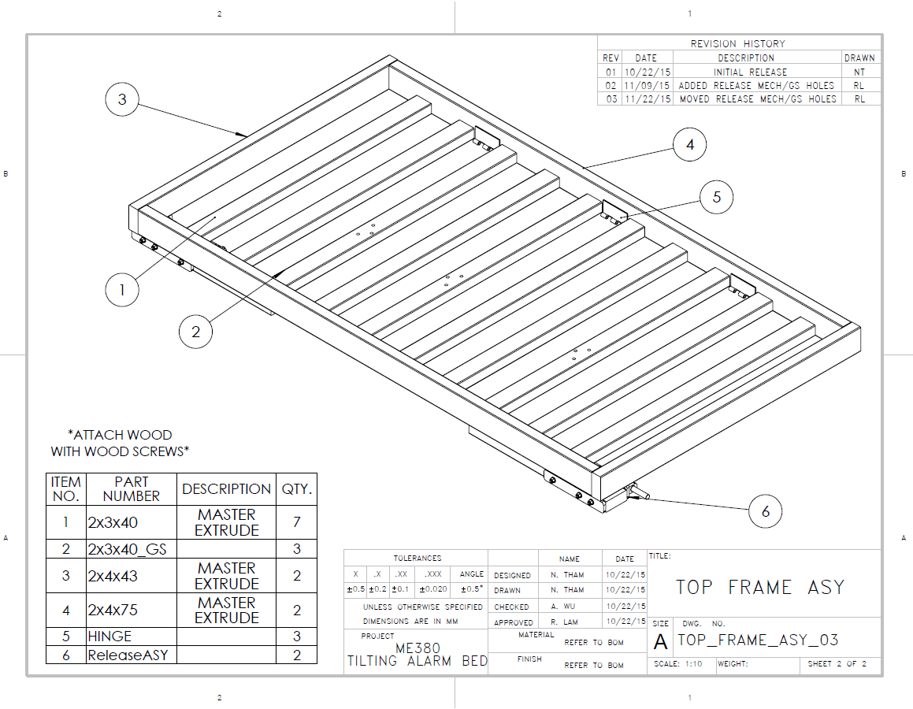

Figure 68: Top Frame Assembly, v3 Assembly Drawing

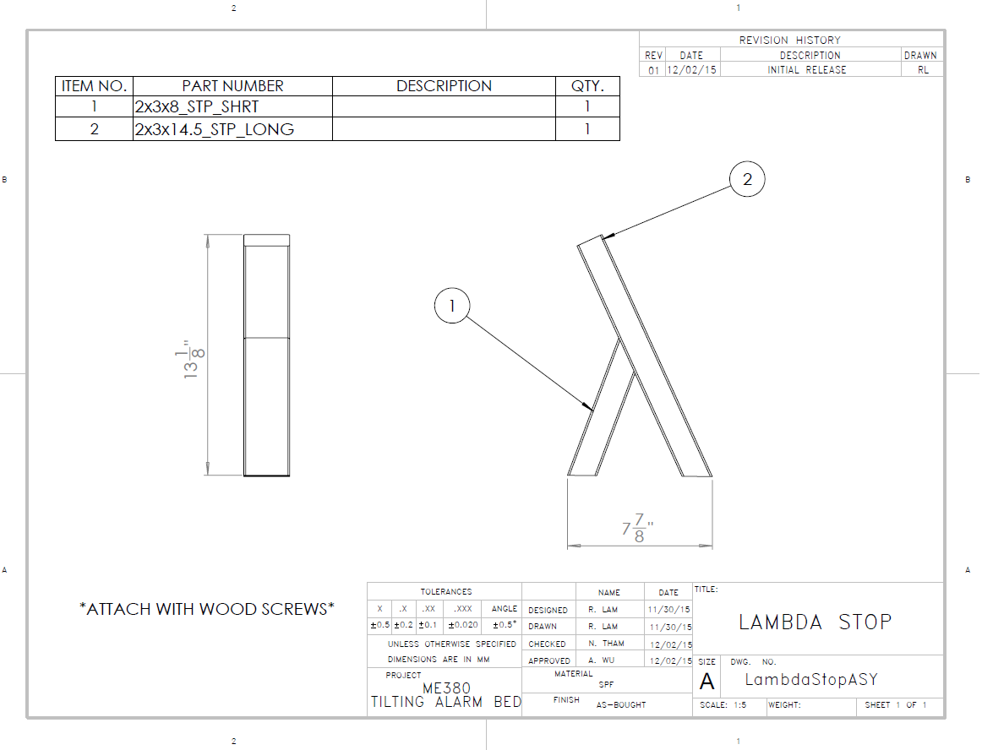

Figure 69: Lambda Stop, v1 Assembly Drawing

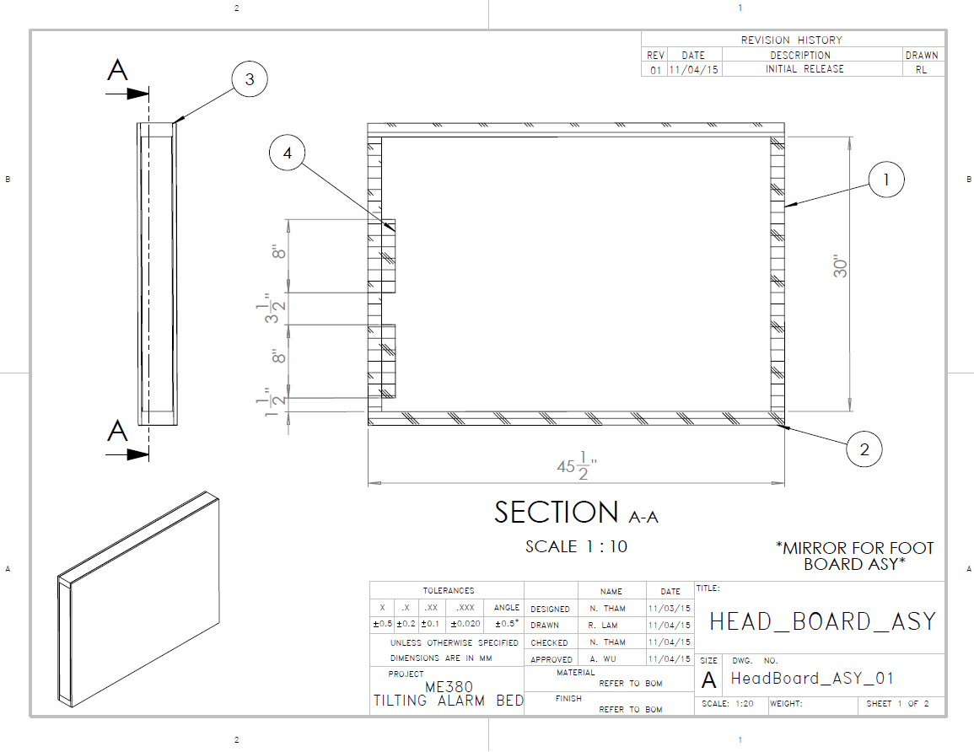

Figure 70: Head Board Assembly, v1 Assembly Drawing

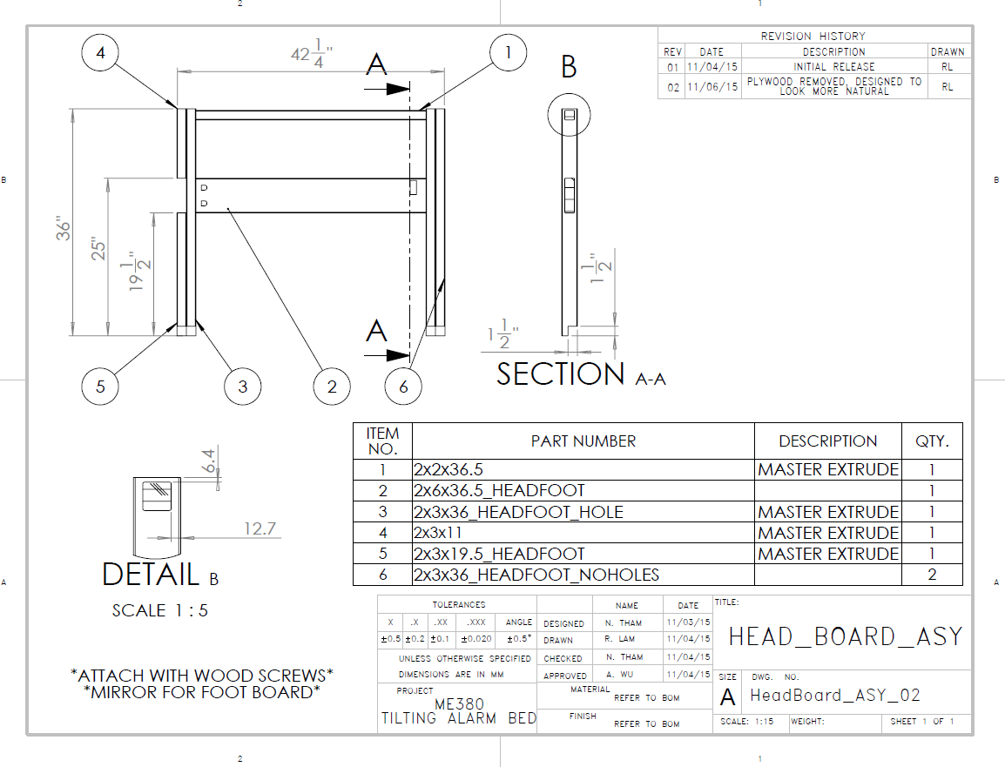

Figure 71: Head Board Assembly, v2 Assembly Drawing

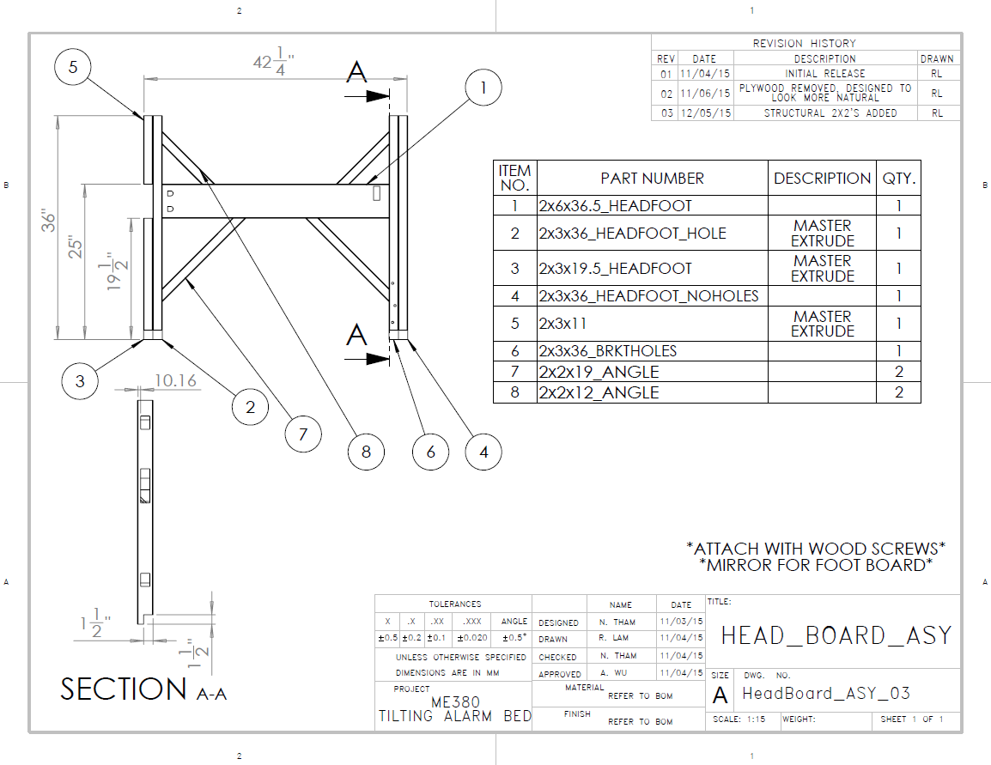

Figure 72: Head Board Assembly, v3 Assembly Drawing

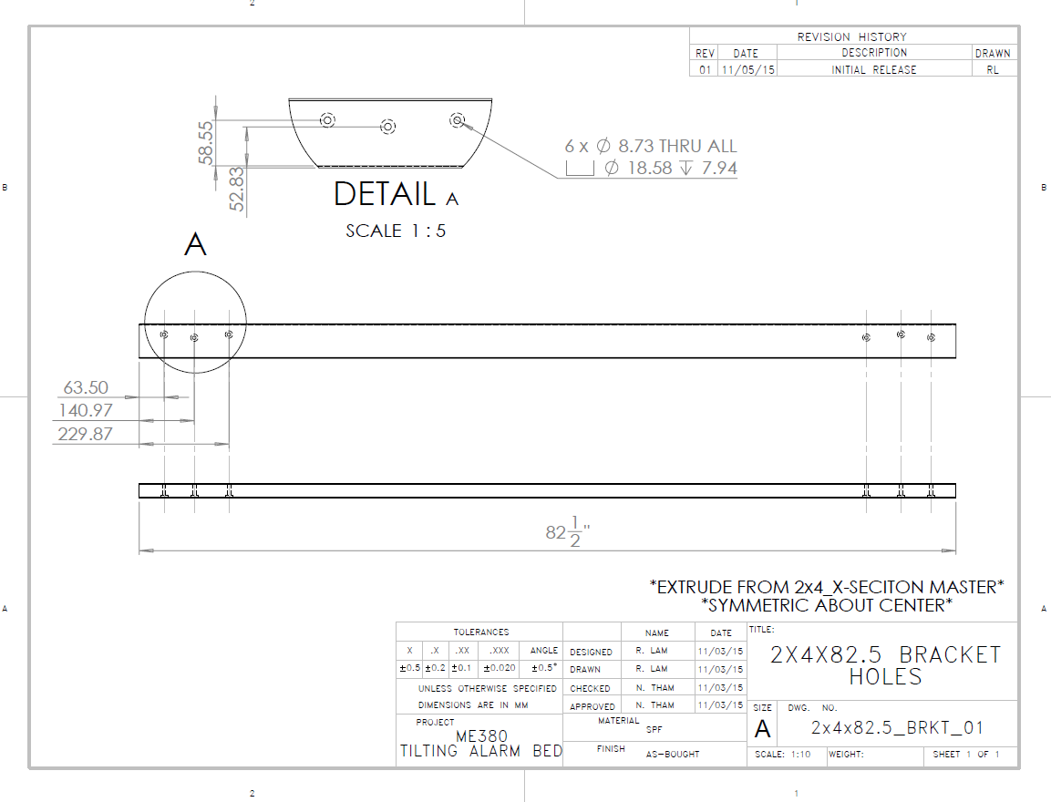

Figure 73: 2x4x82.5 Bracket, v1 Drawing

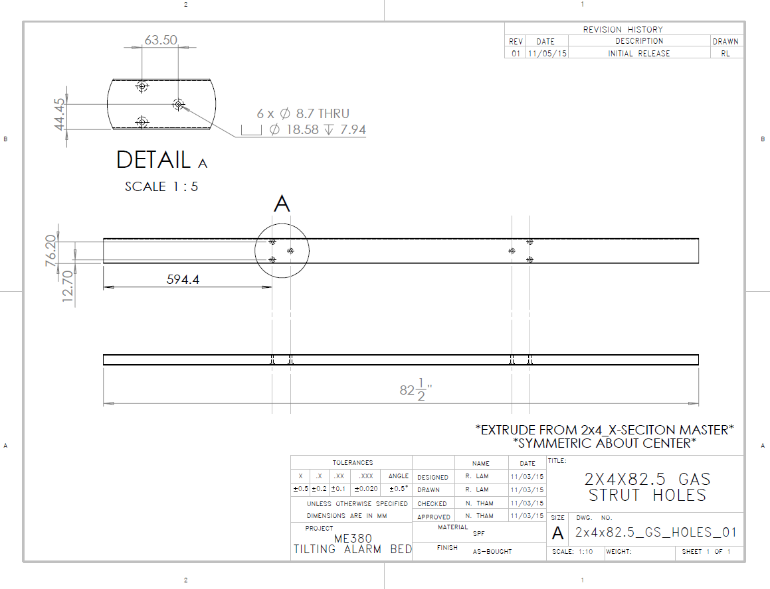

Figure 74: 2x4x82.5 Gas Strut Mount Holes, v1

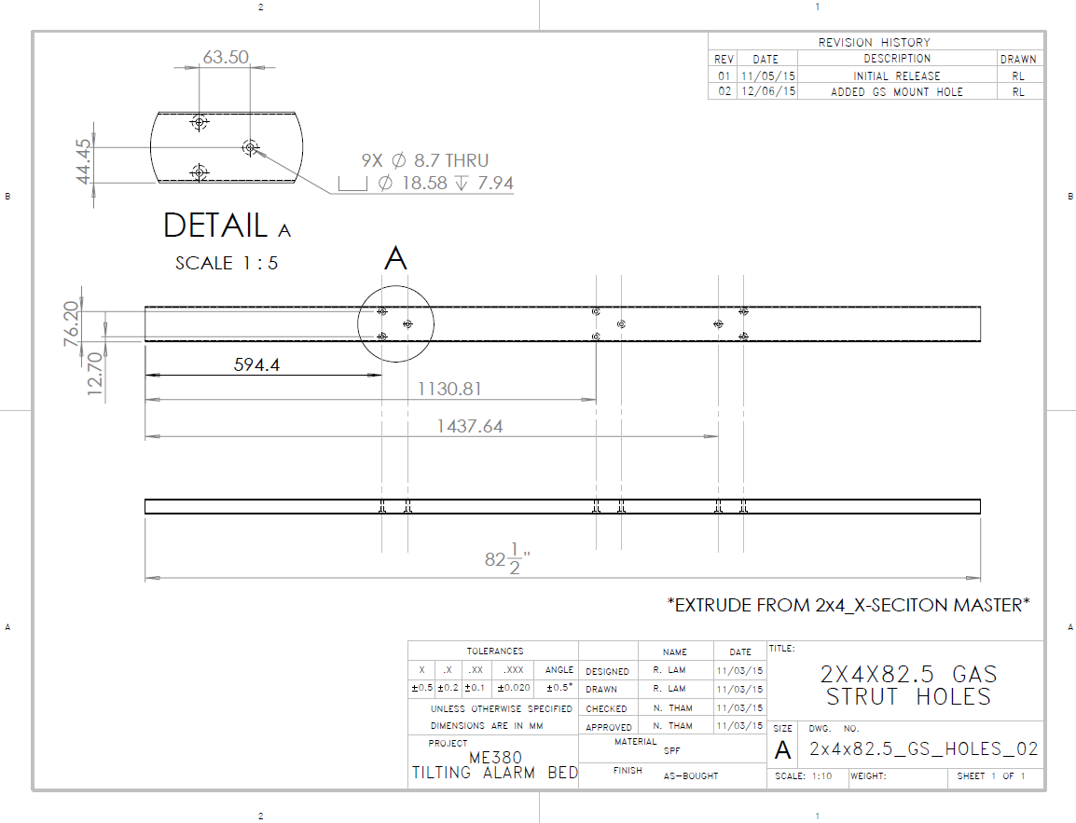

Figure 75:2x4x82.5 Gas Strut Mount Holes, v2

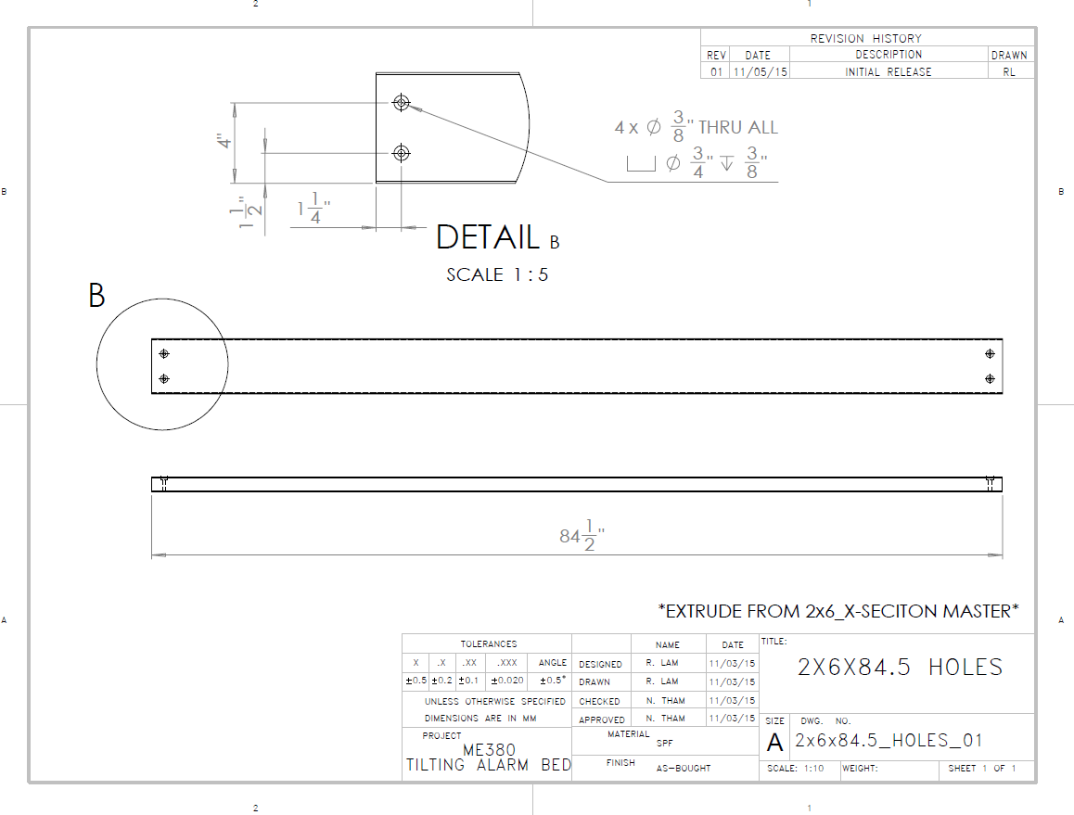

Figure 76: 2x6x84.5 Side Beam, v1

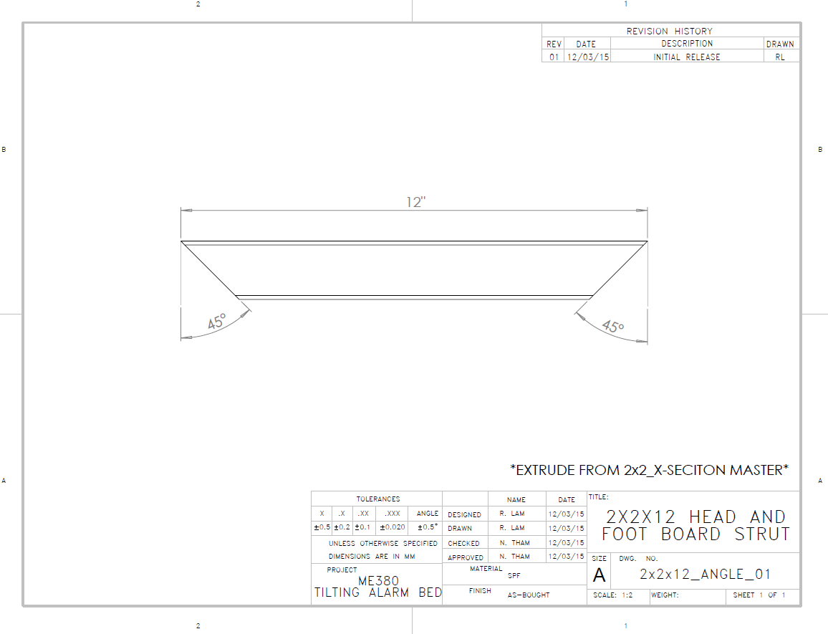

Figure 77: 2x2x12 Angle Strut, v1

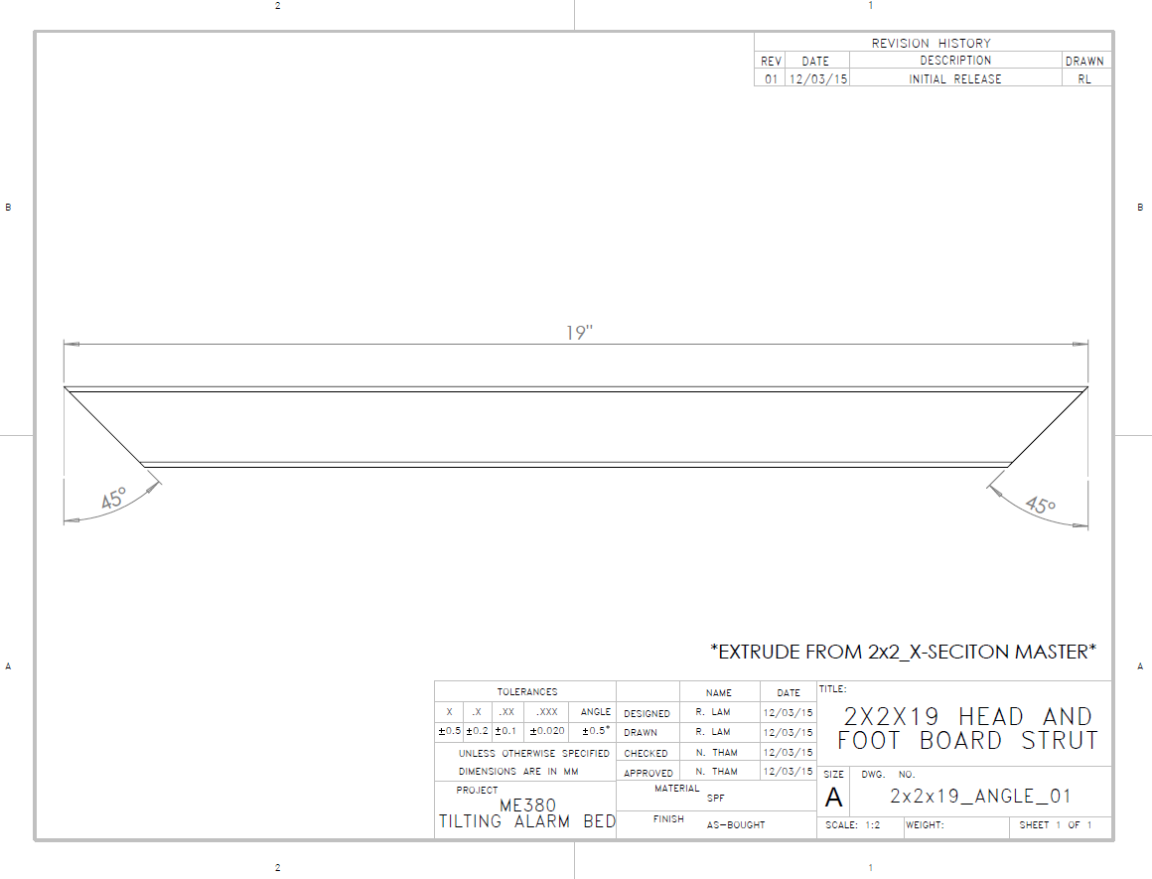

Figure 78: 2x2x19 Angle Strut, v1

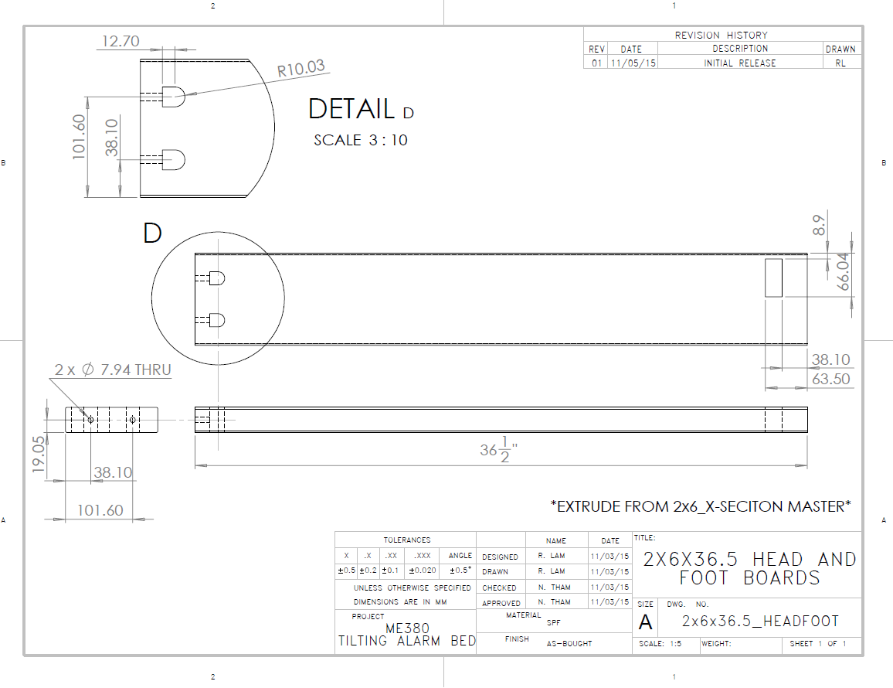

Figure 79: 2x6x36.5 Head Board, v1

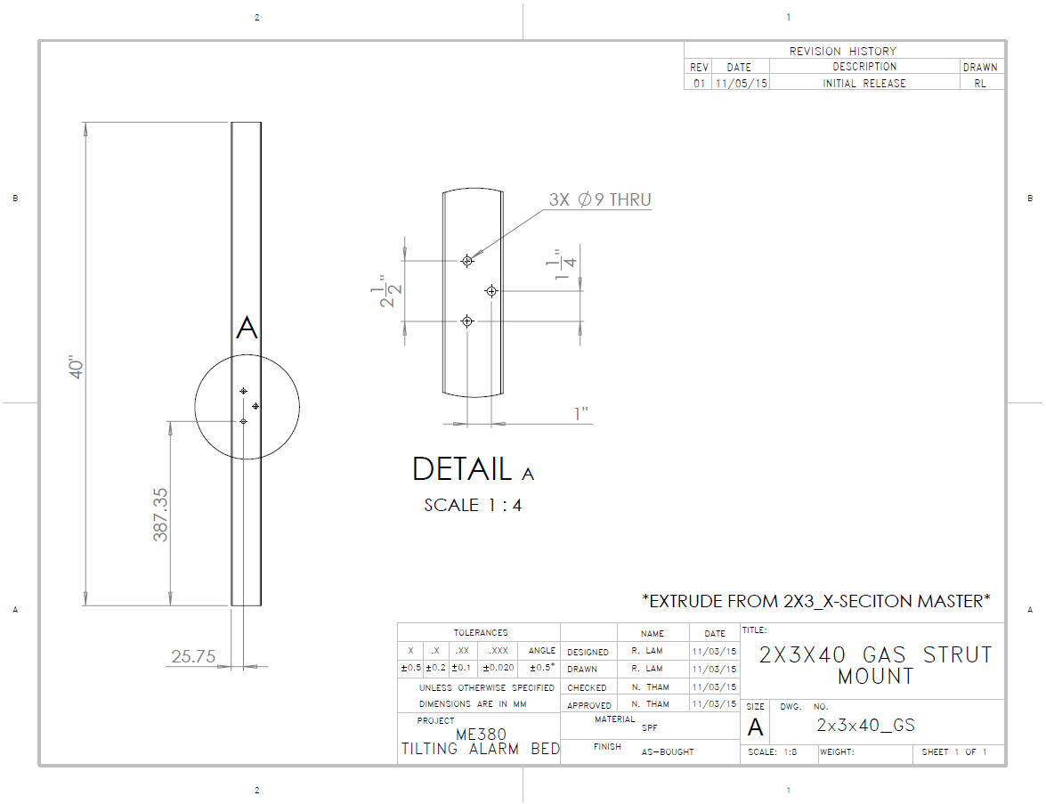

Figure 80: 2x3x40 Gas Strut Mount, v1

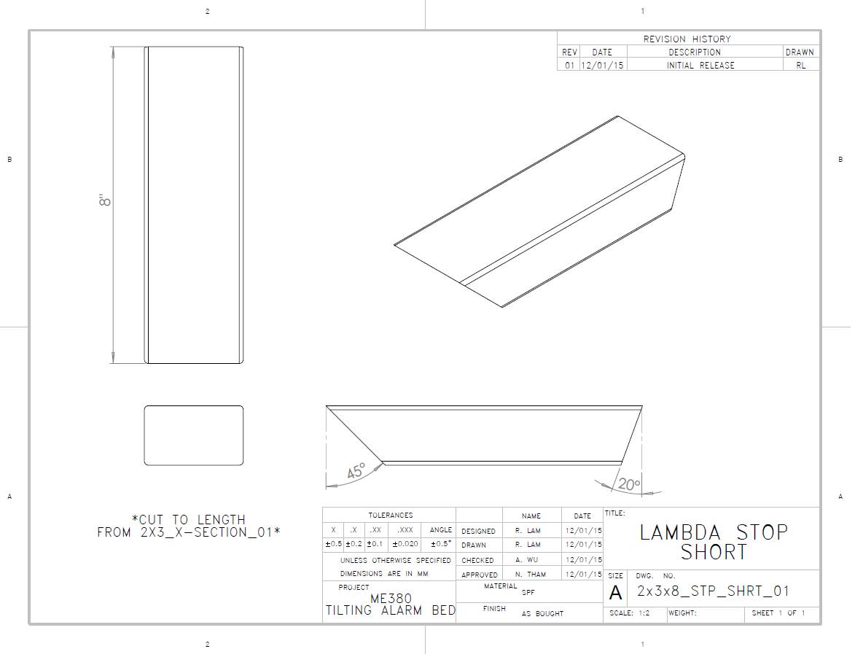

Figure 81: 2x3x8 Lambda Stop Short, v1

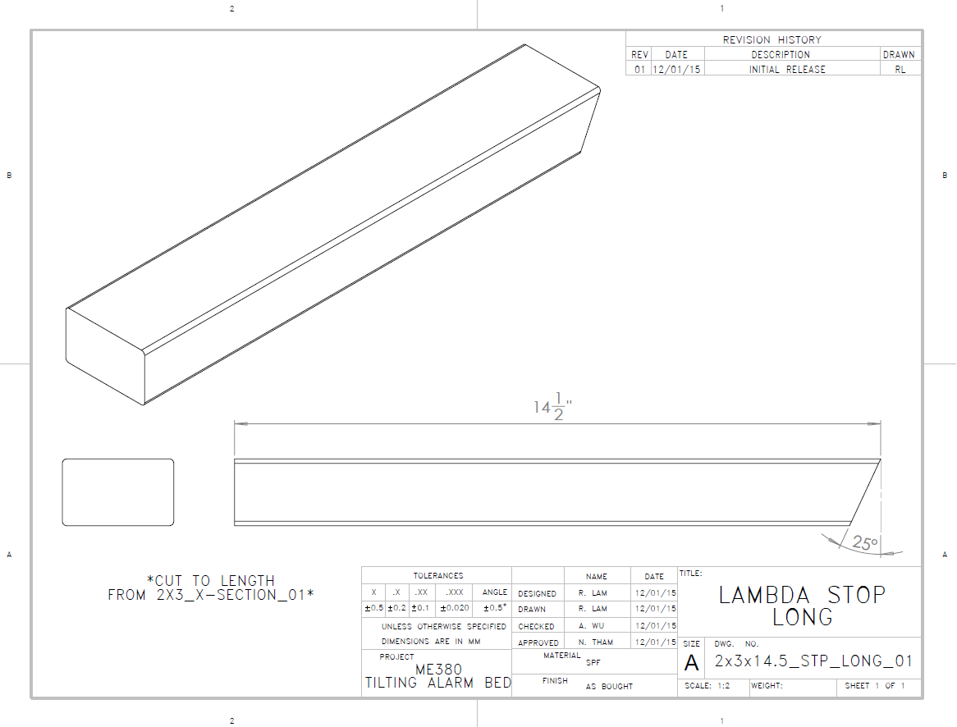

Figure 82: 2x3x14.5 Lambda Stop Long, v1

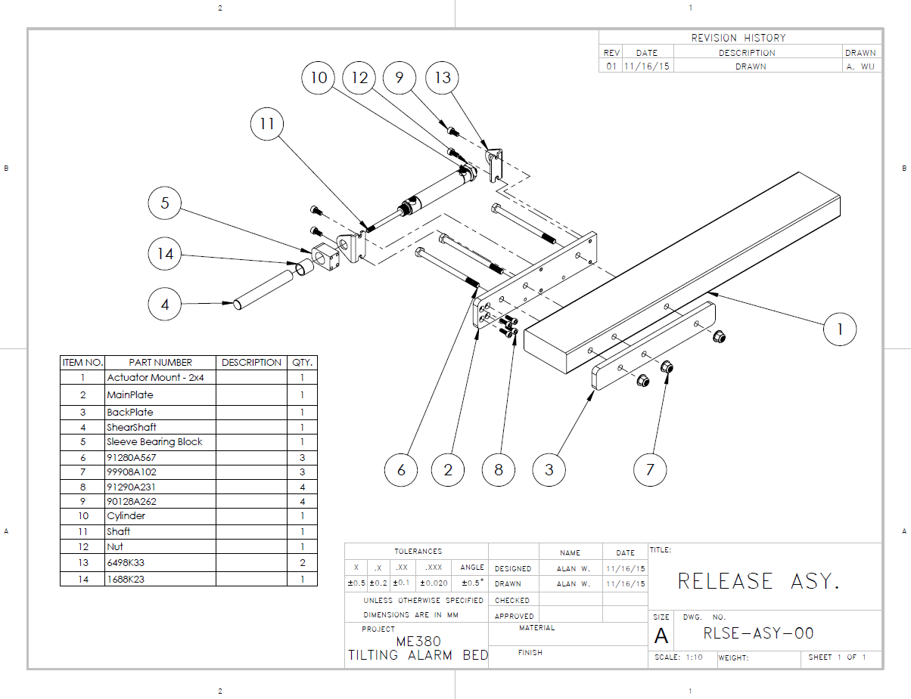

Figure 83: Release Assembly v1, Assembly Drawing

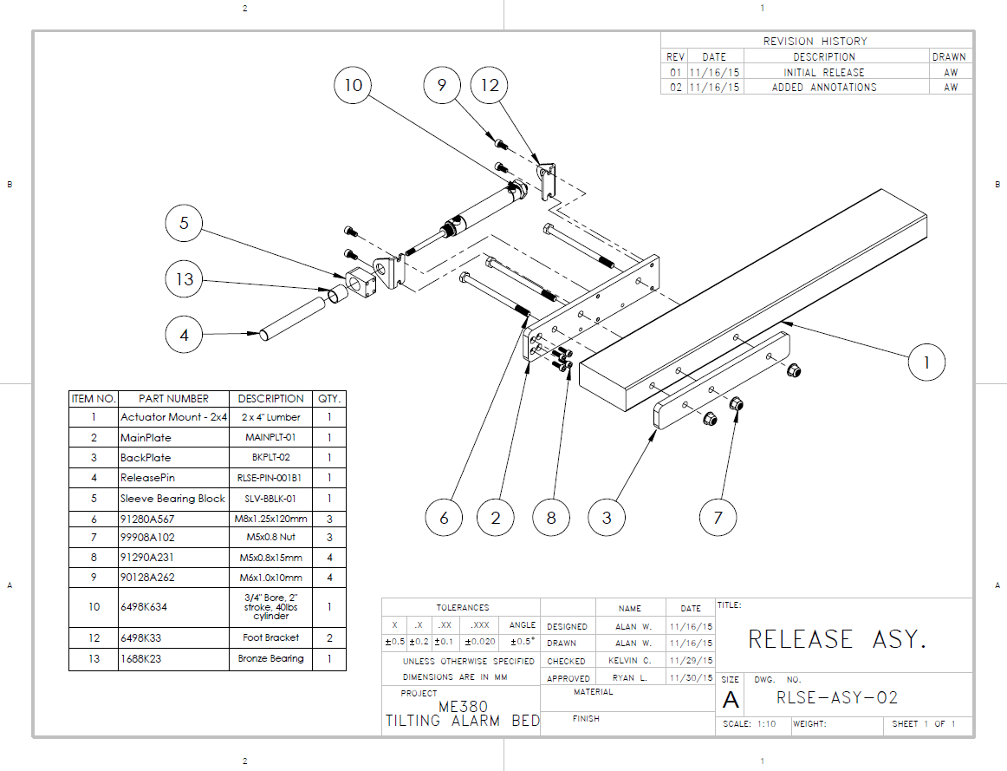

Figure 84: Release Assembly, v2 Assembly Drawing

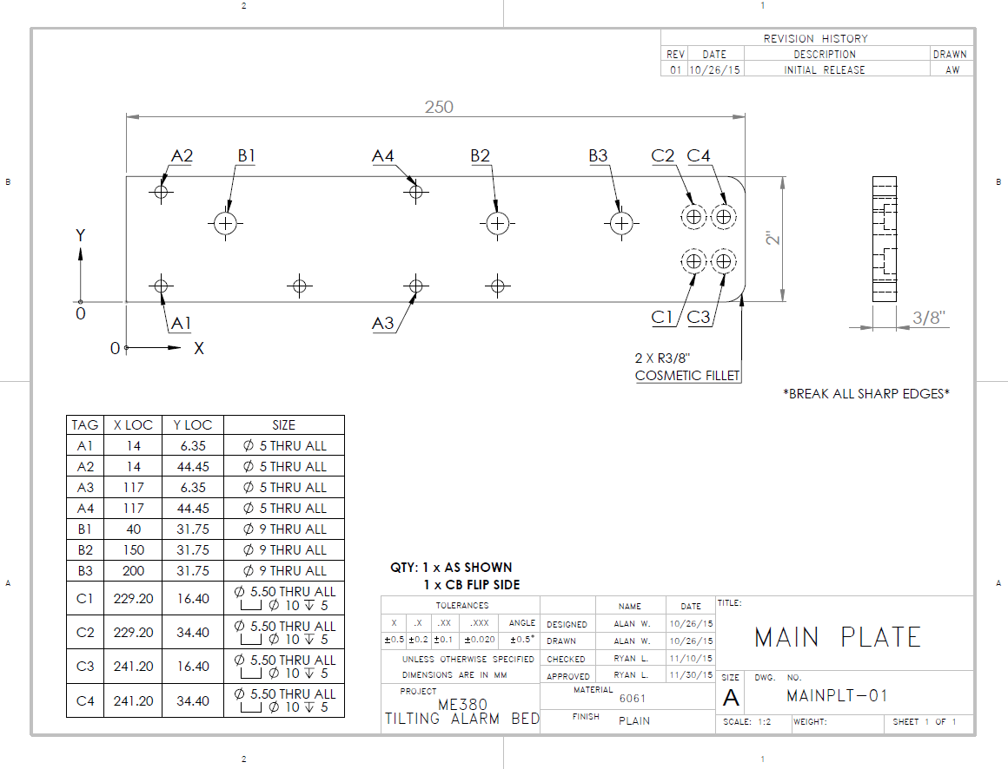

Figure 85: Main Plate, v1

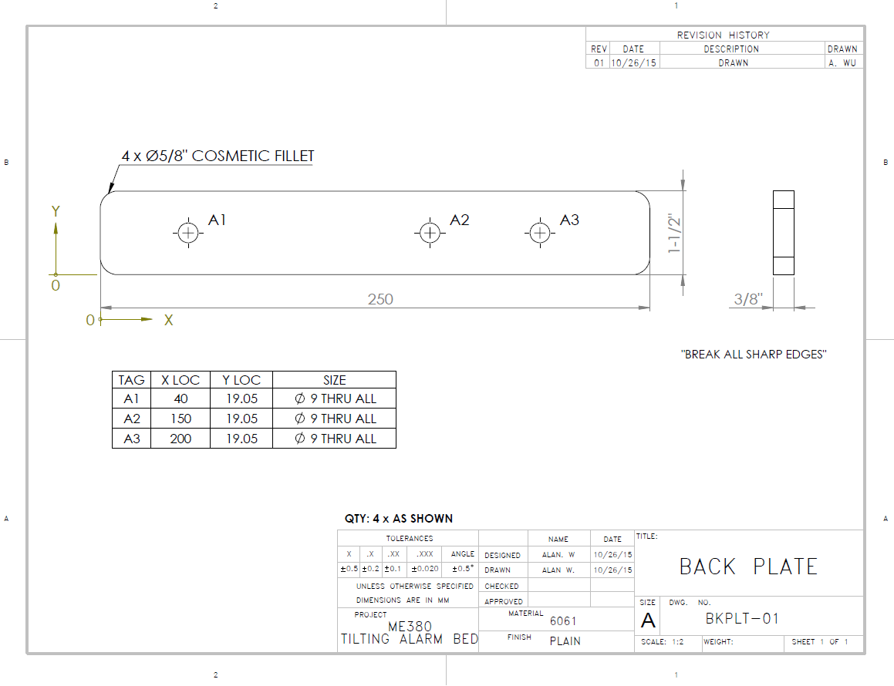

Figure 86: Back Plate, v1

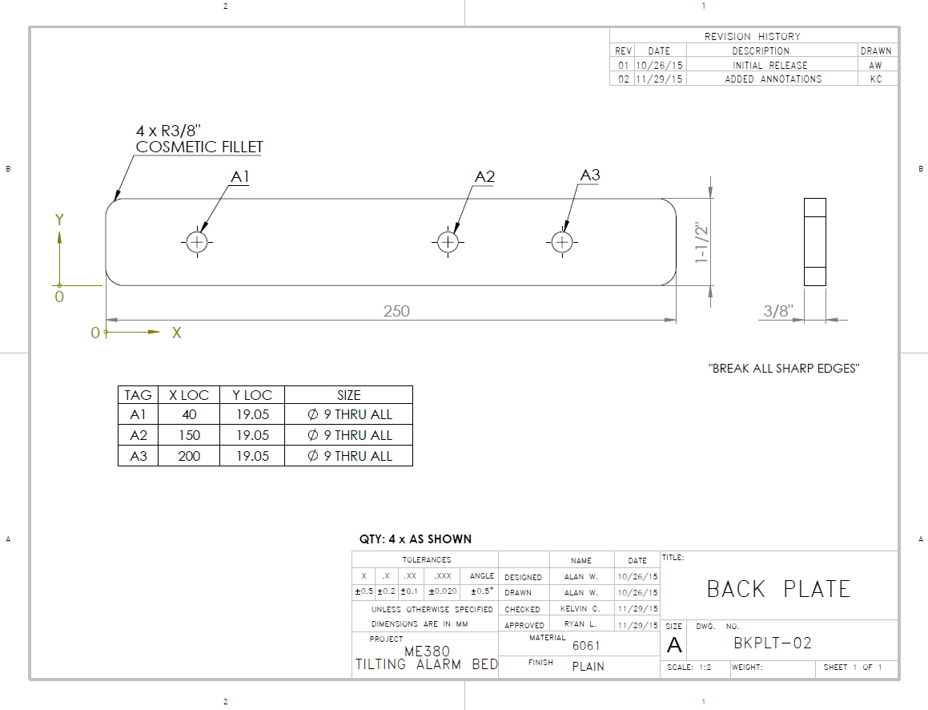

Figure 87: Back Plate, v2

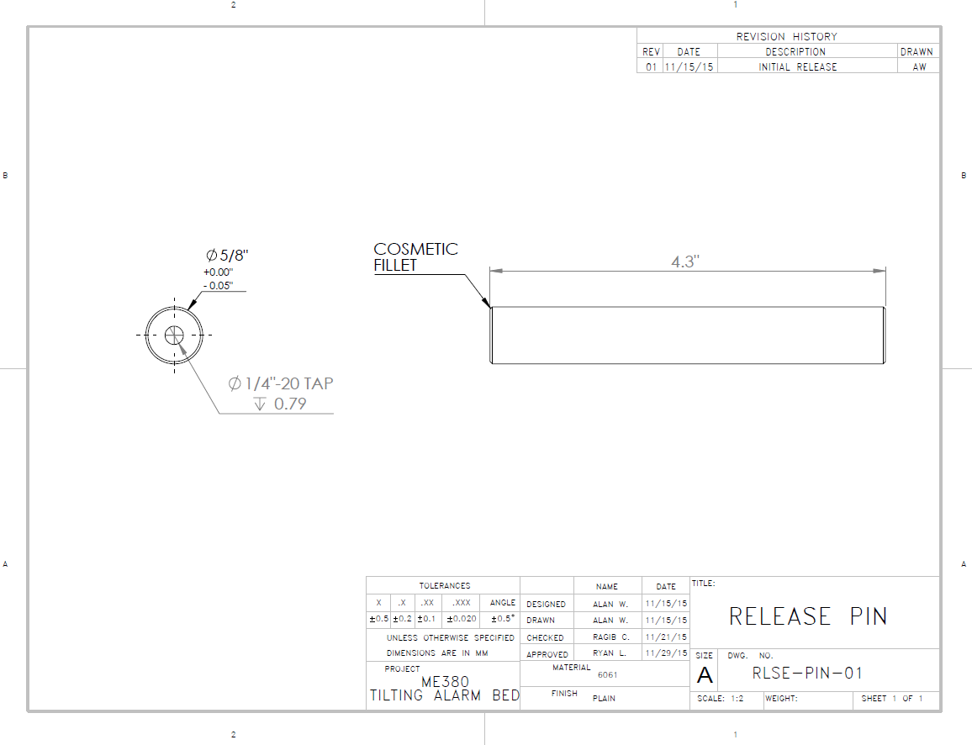

Figure 88: Release Pin, v1

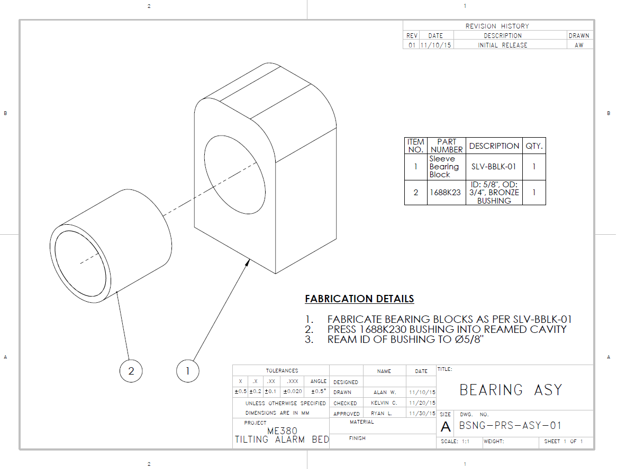

Figure 89: Bearing Assembly, v1 Assembly Drawing

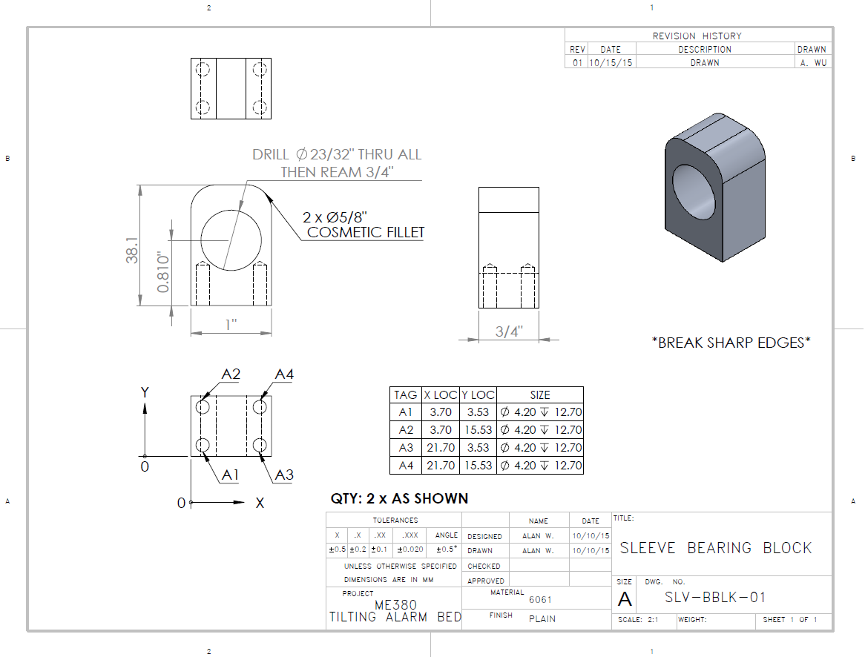

Figure 90: Sleeve Bearing Block, v1

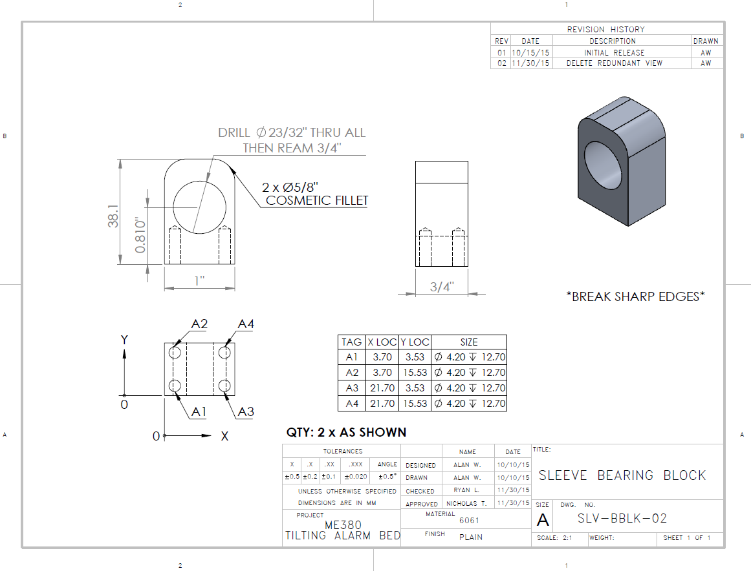

Figure 91: Sleeve Bearing Block, v2

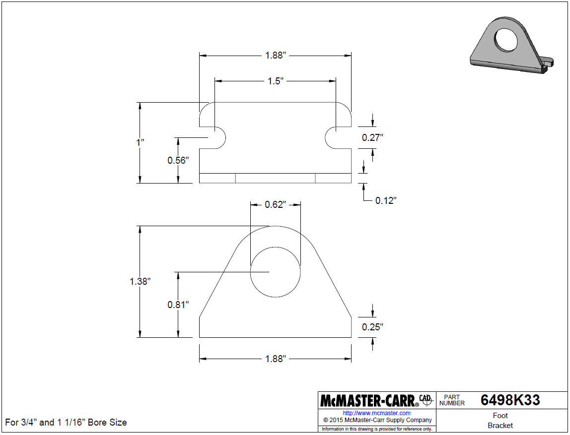

Figure 92: Foot Bracket, McMaster-Carr 6498K33

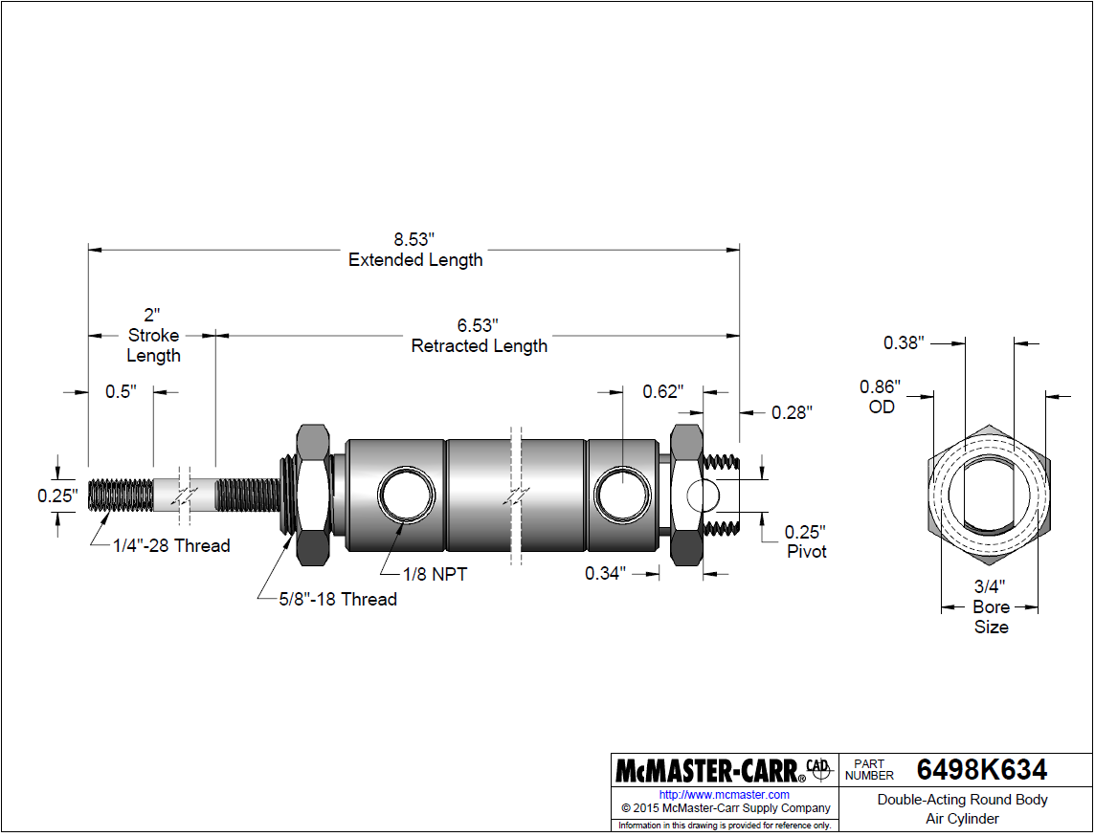

Figure 93: Double-Acting Cylinder, McMaster-Carr 6498K634

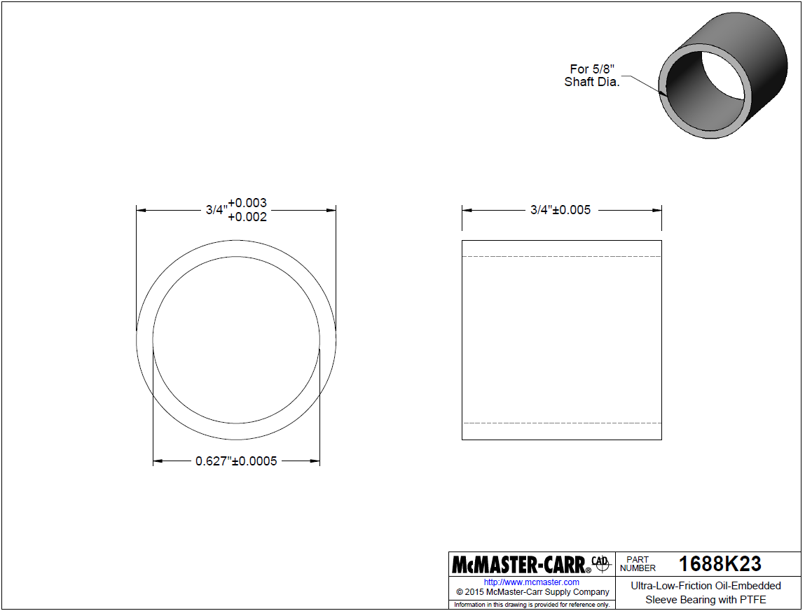

Figure 94: Oil-Embedded Sleeve Bearing, McMaster-Carr 1688K23

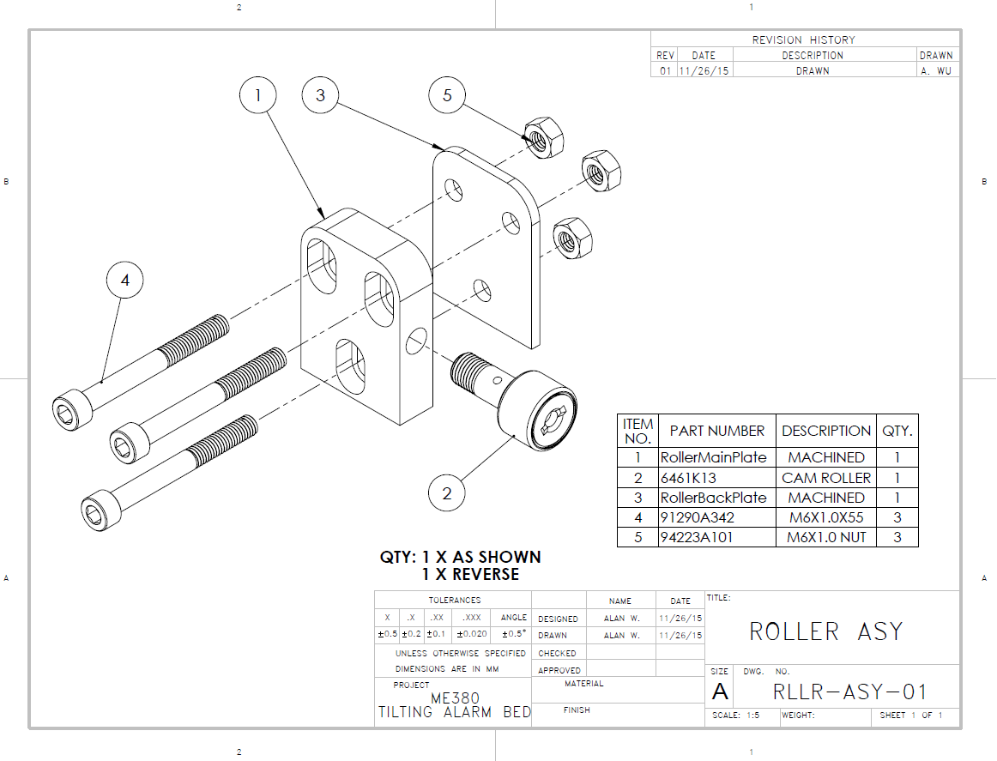

Figure 95: Roller Assembly v1, Assembly Drawing

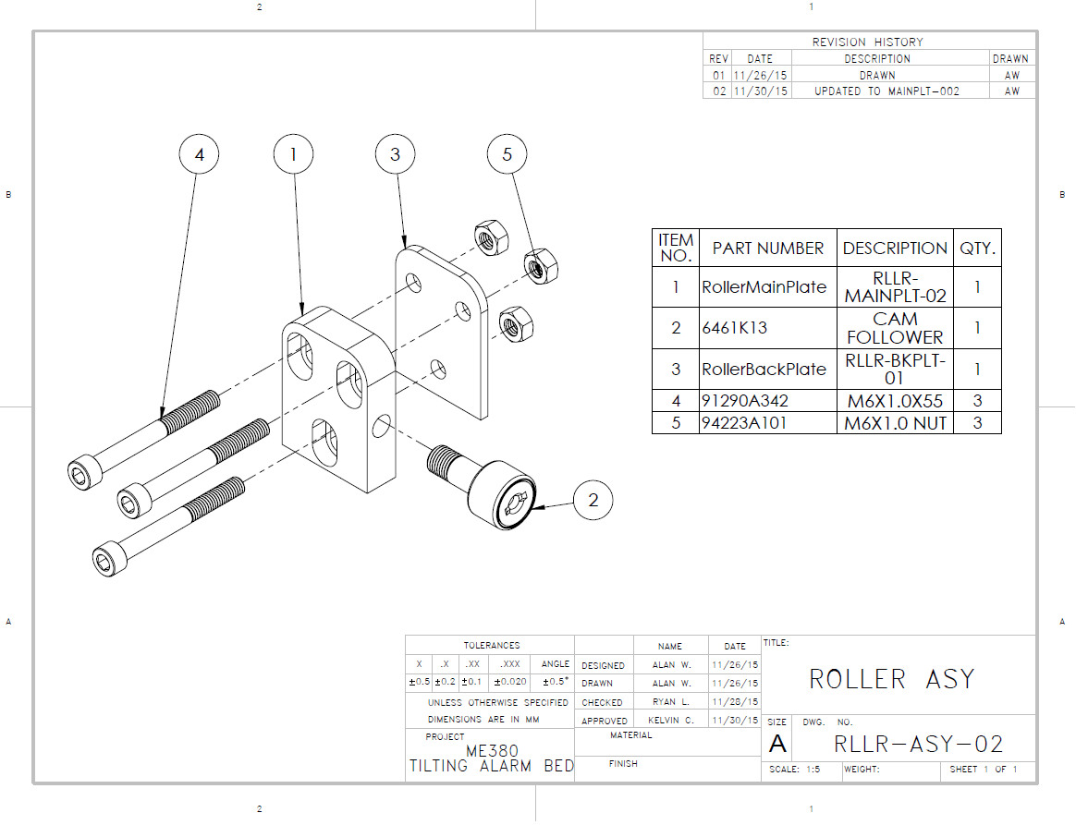

Figure 96: Roller Assembly v2, Assembly Drawing

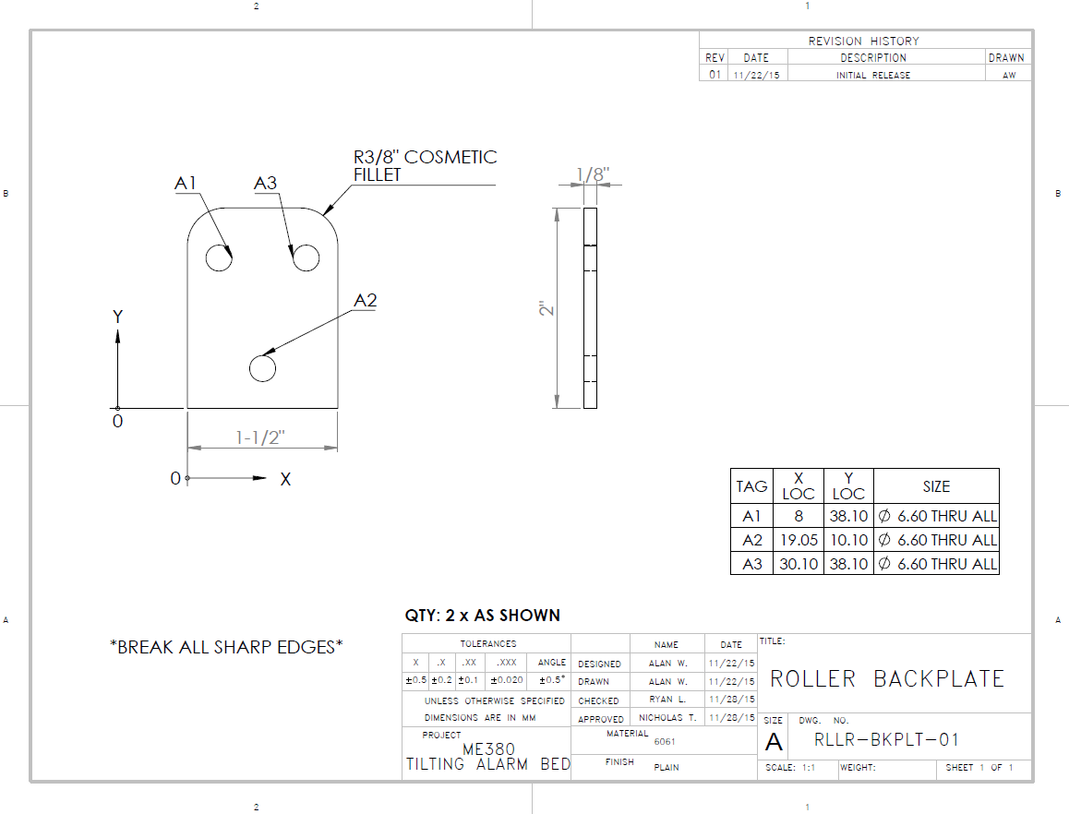

Figure 97: Roller Backplate, v1

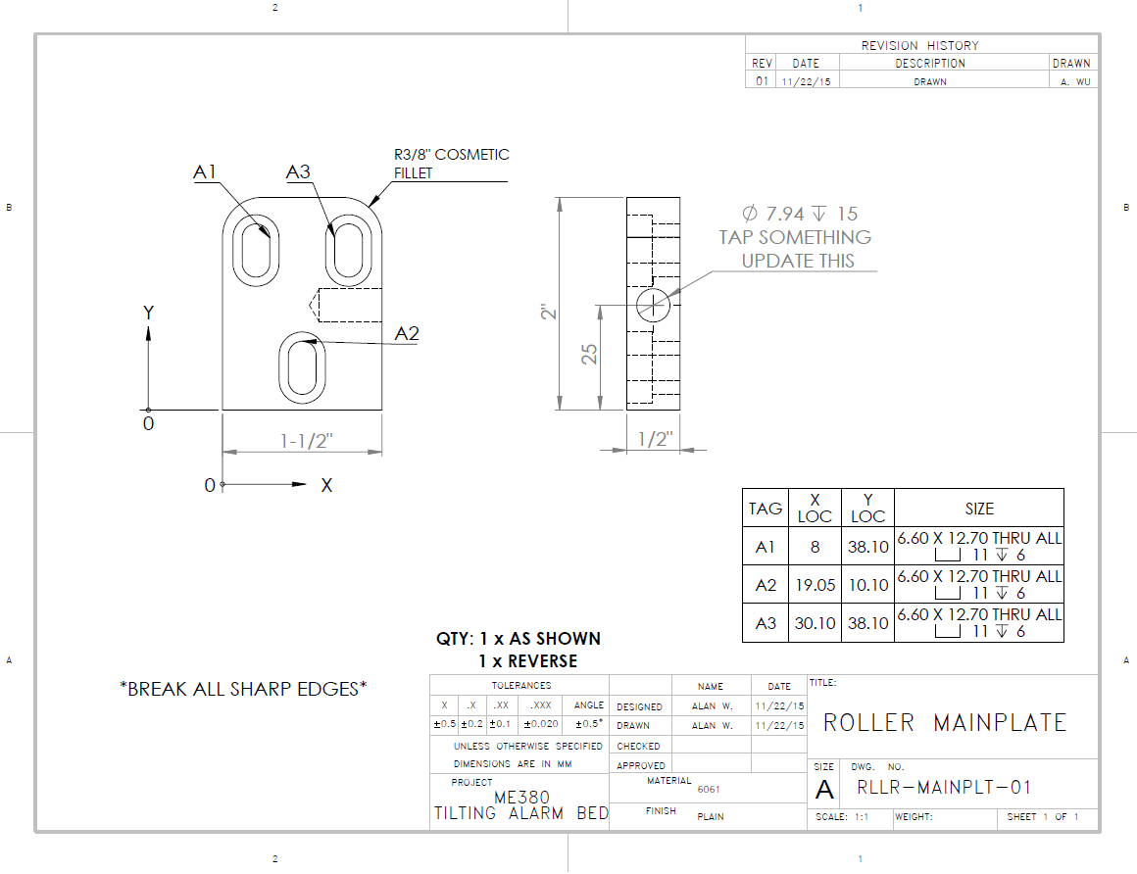

Figure 98: Roller Mainplate, v1

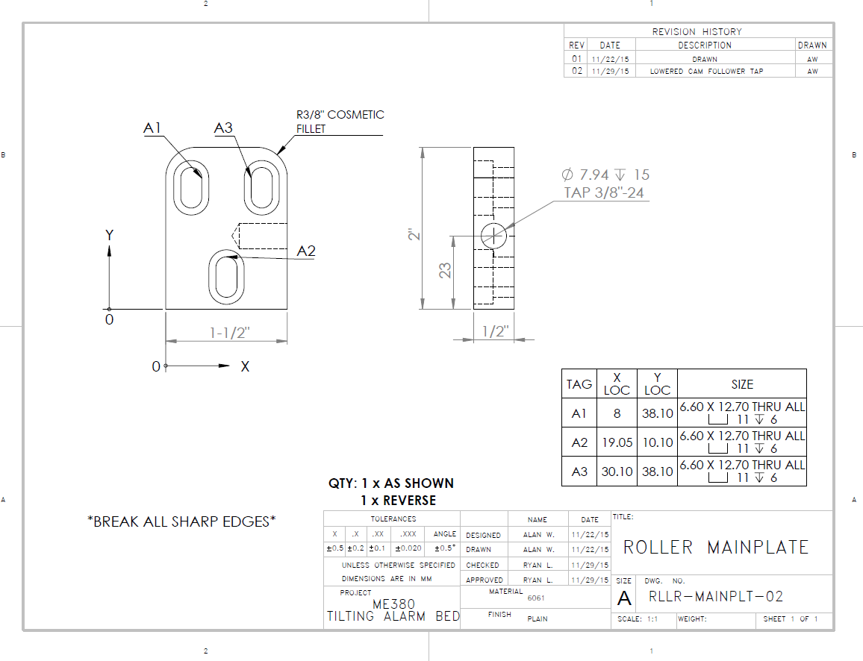

Figure 99: Roller Mainplate, v2

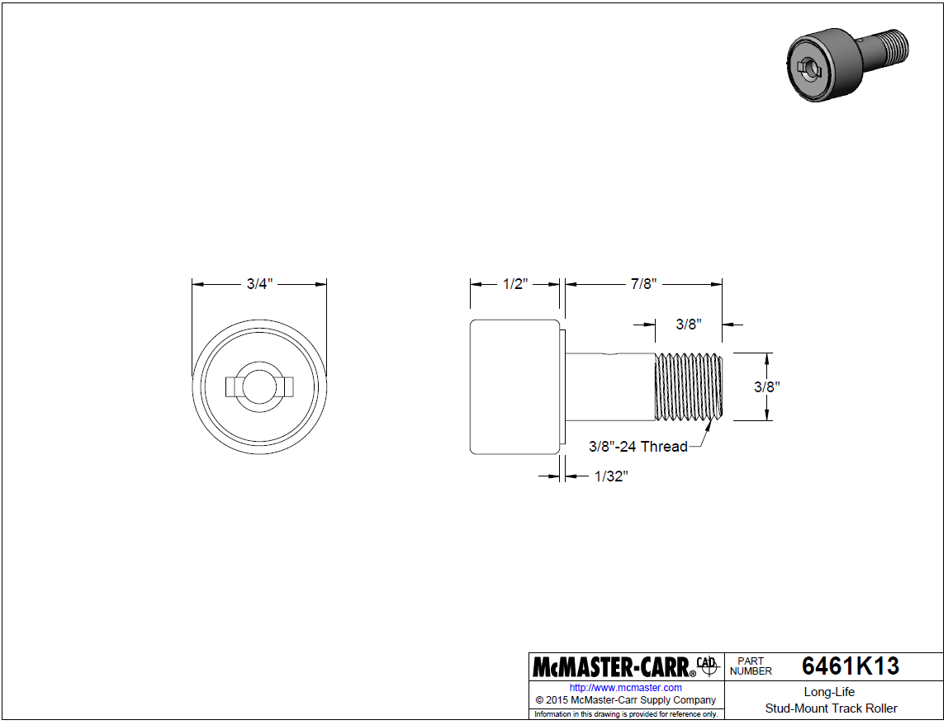

Figure 100: Track Roller, McMaster-Carr 6461K13

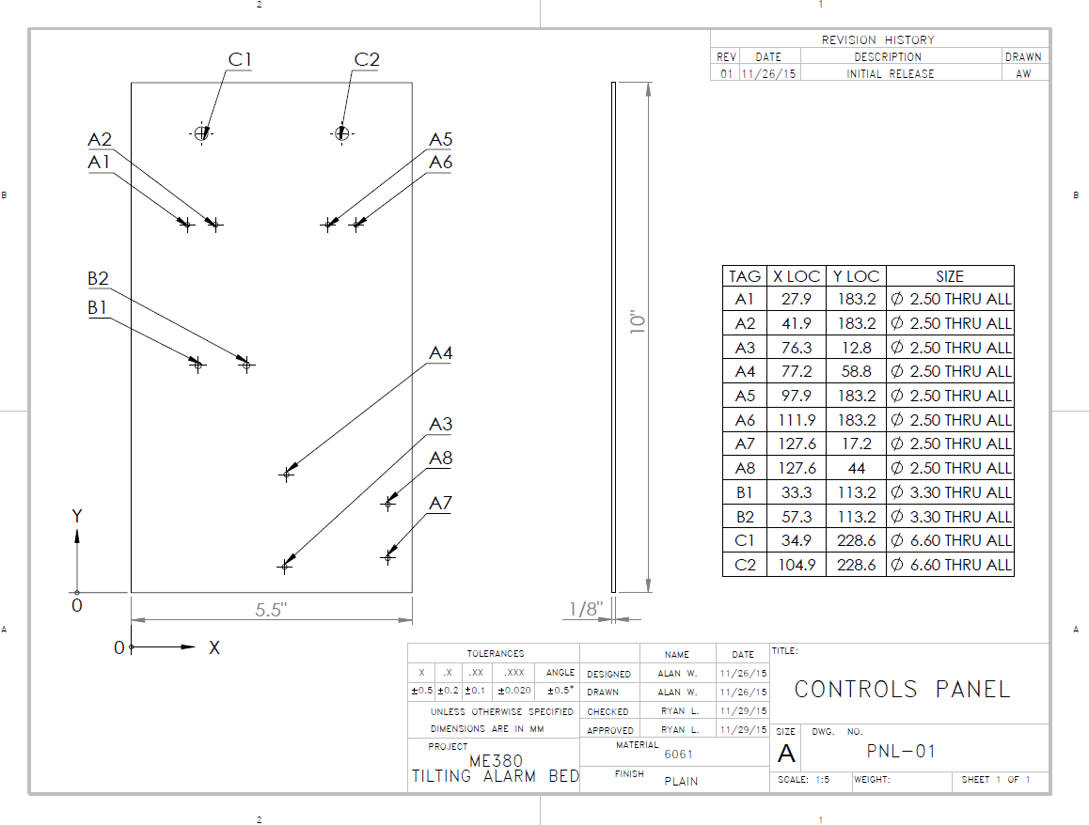

Figure 101: Controls Panel, v1

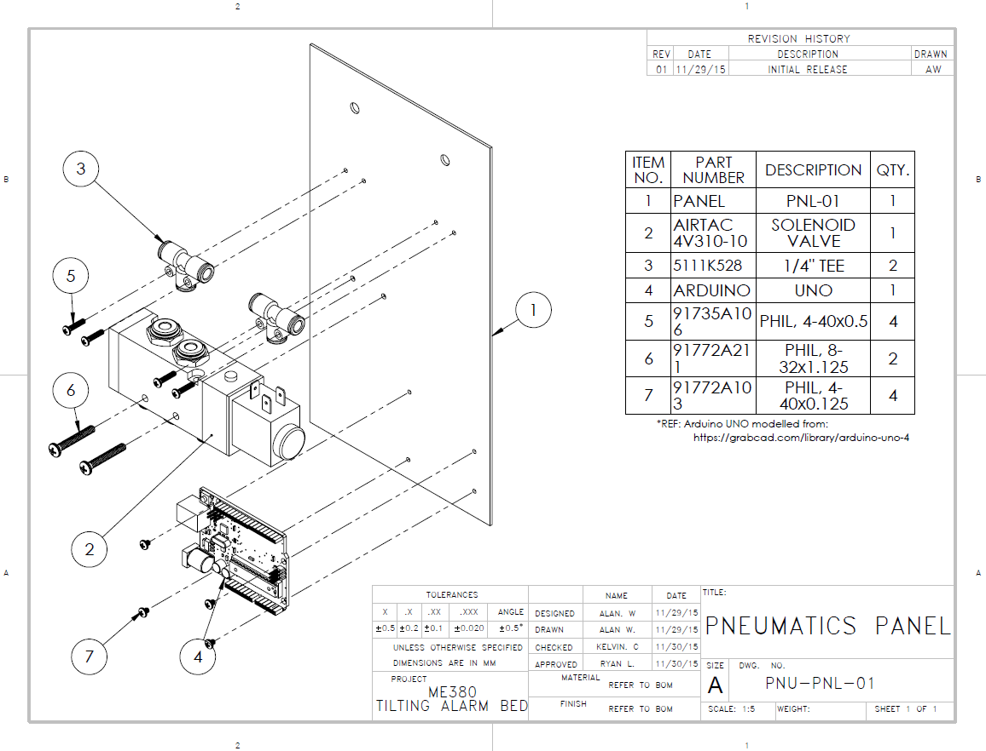

Figure 102: Pneumatics Panel, v1 Assembly Drawing

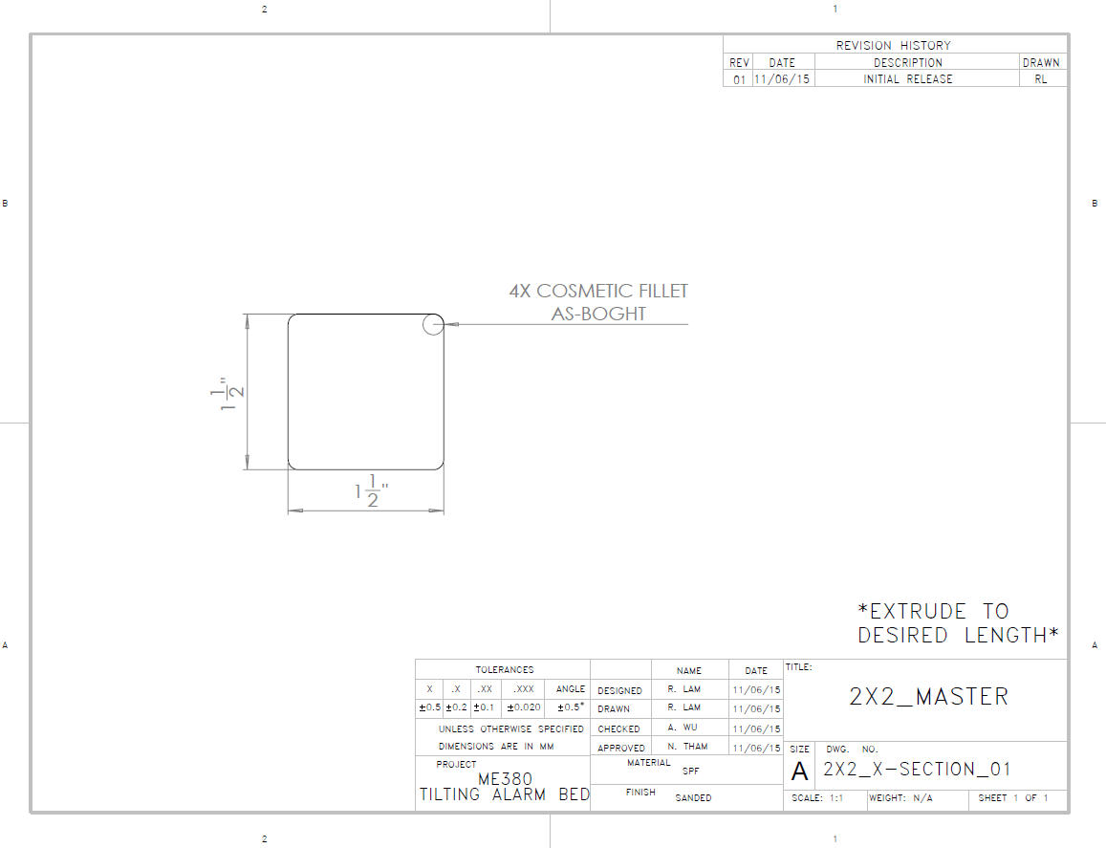

Figure 103: 2x2 Master Drawing

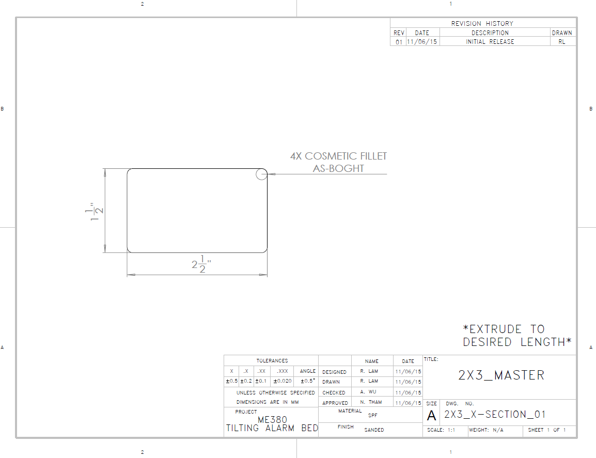

Figure 104: 2x3 Master Drawing

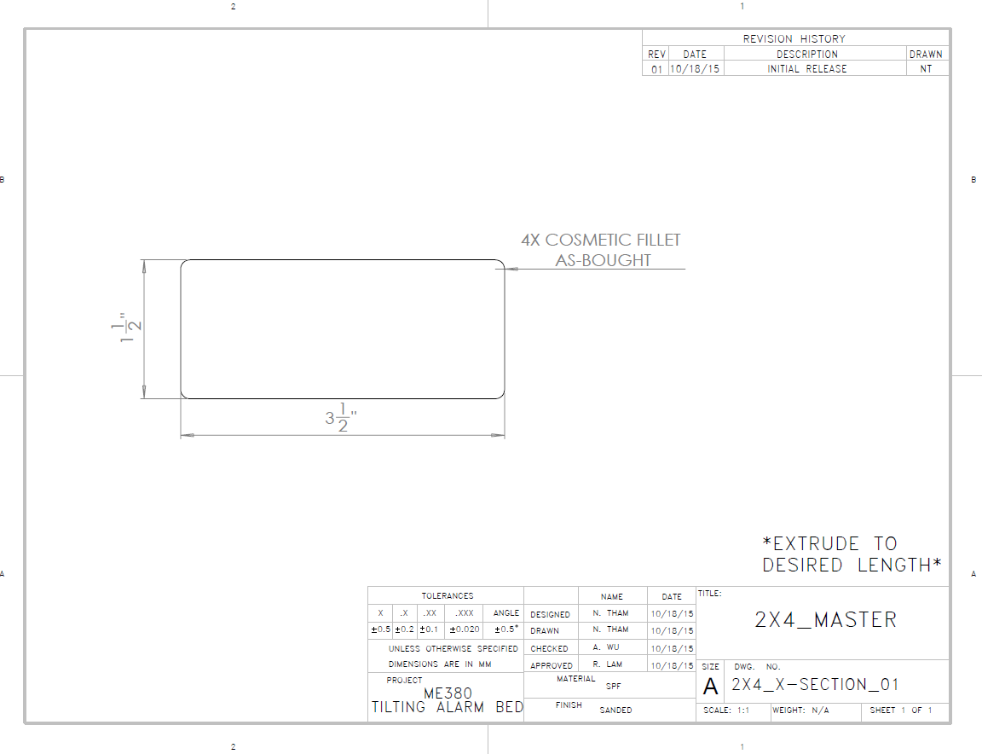

Figure 105: 2x4 Master Drawing

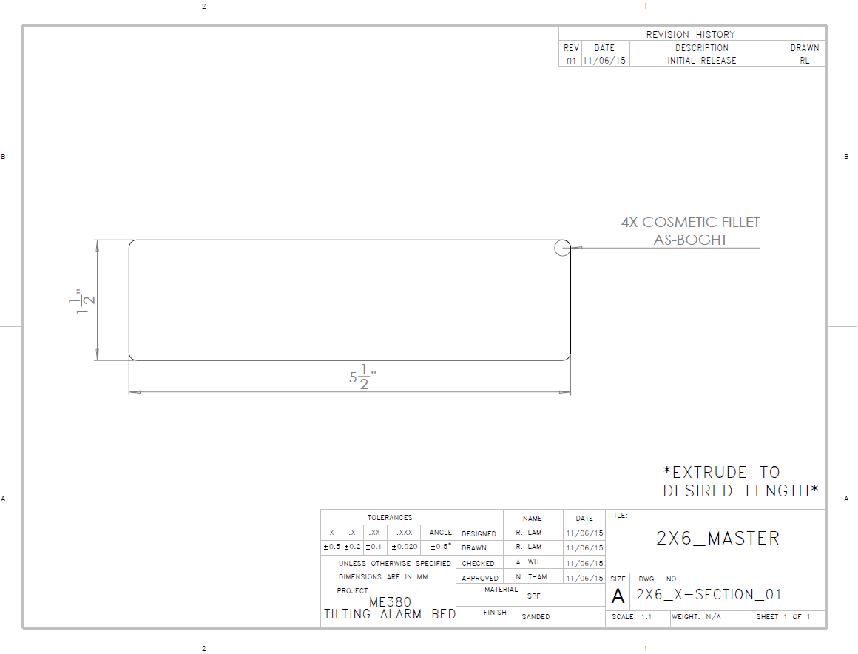

Figure 106: 2x6 Master Drawing

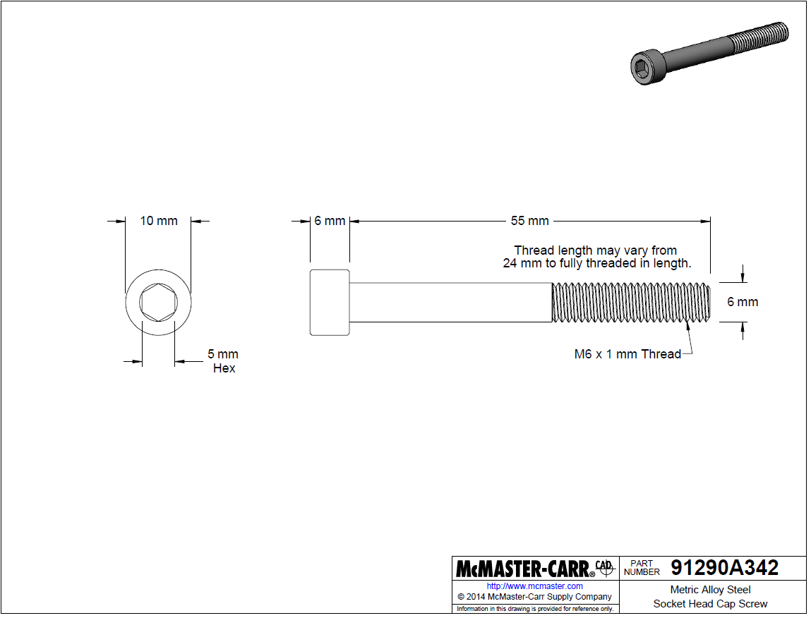

Figure 107: Socket Head Cap Screw M6x1x55, McMaster-Carr 91290A342

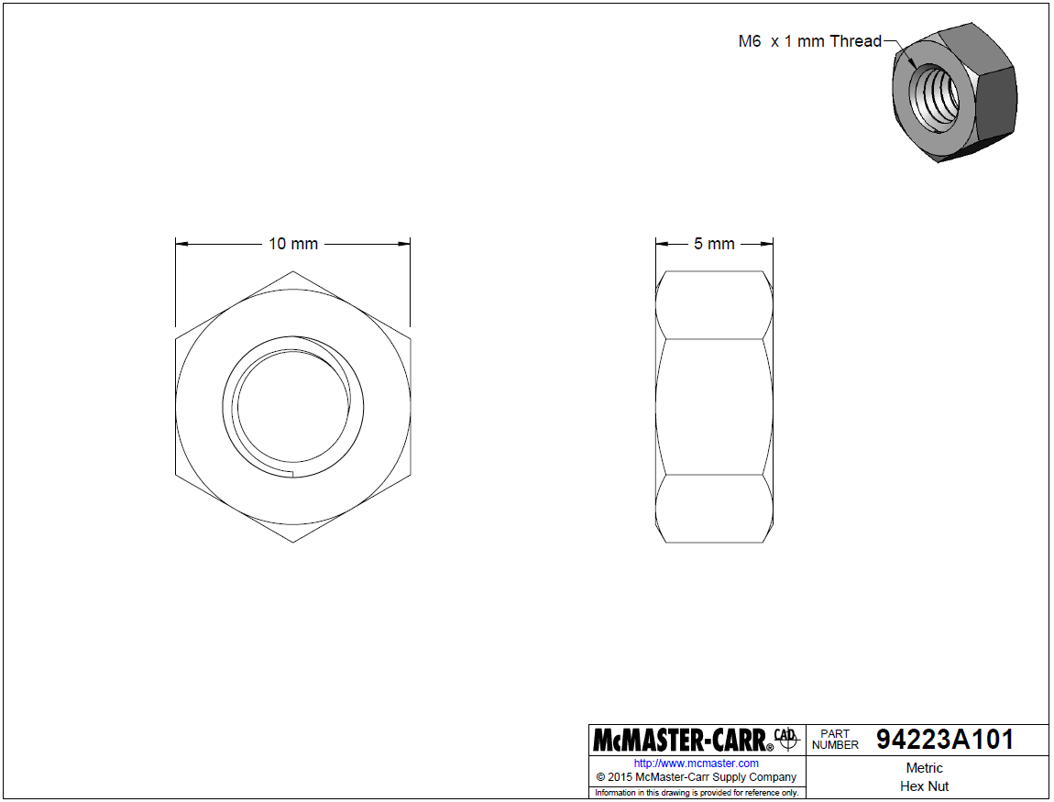

Figure 108: Hex Nut M6x1x5, McMaster-Carr 94223A101

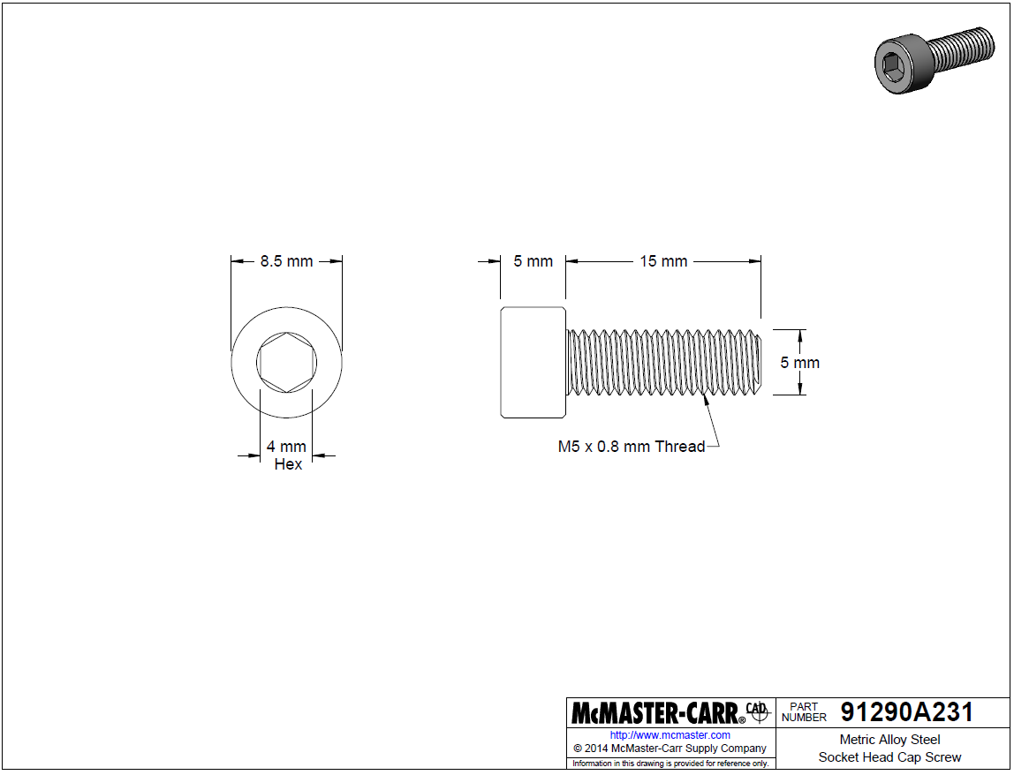

Figure 109: Socket Head Cap Screw M5x0.8x15, McMaster-Carr 91290A231

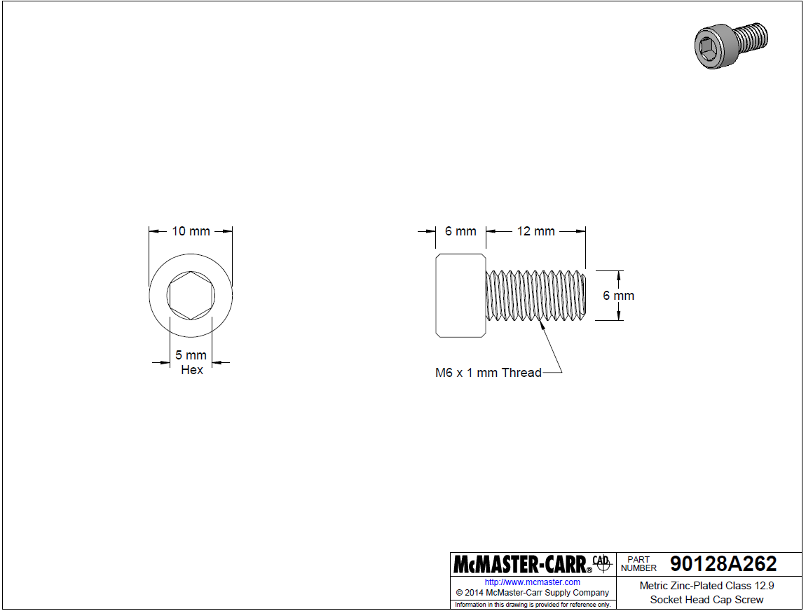

Figure 110: Socket Head Cap Screw M6x1x12, McMaster-Carr 90128A262

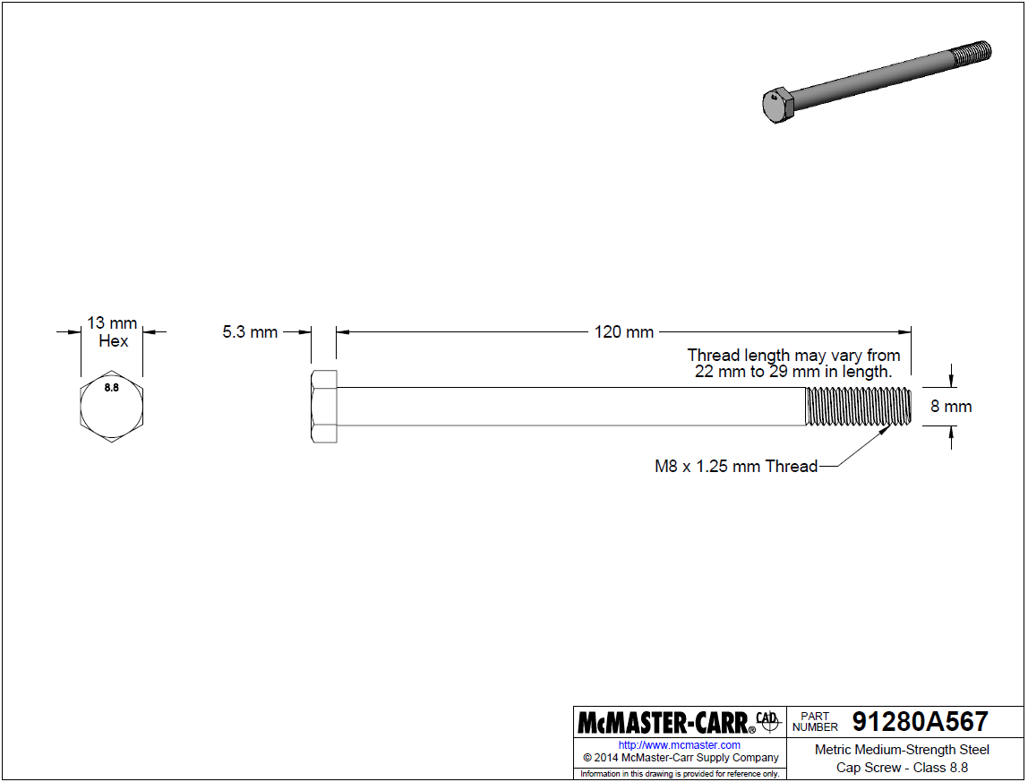

Figure 111: Cap Screw M8x1.25x120, McMaster-Carr 91280A567

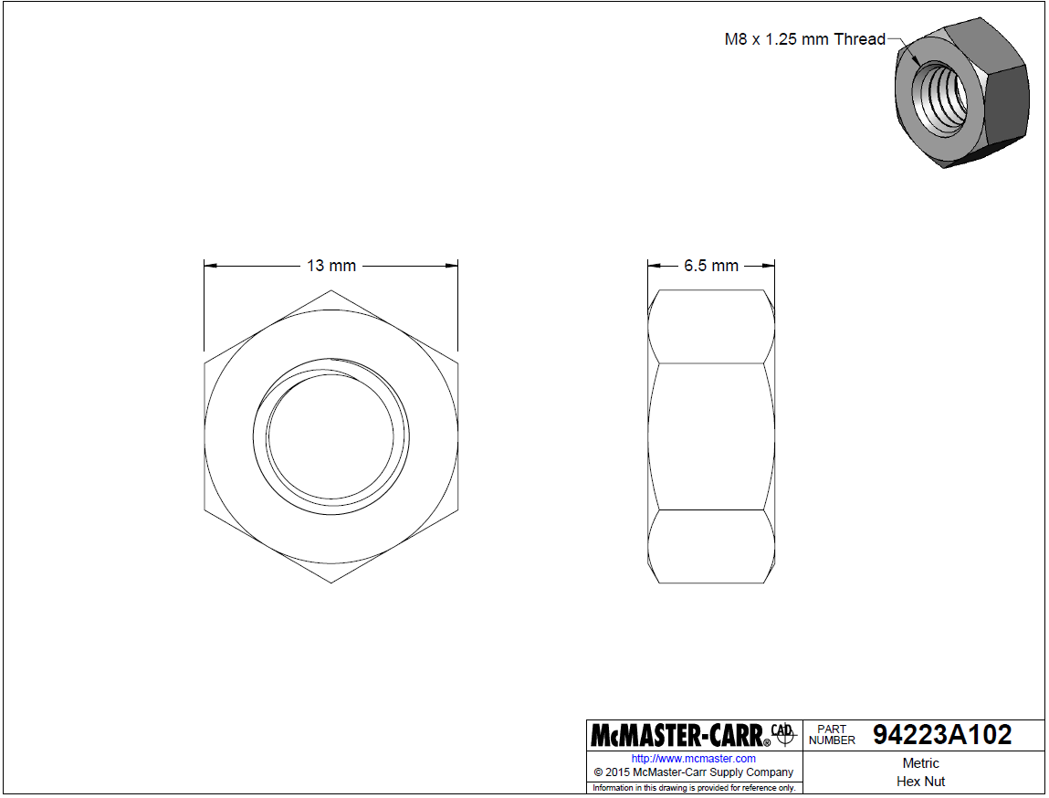

Figure 112: Hex Nut M8x1.25x6.5, McMaster-Carr 94223A102

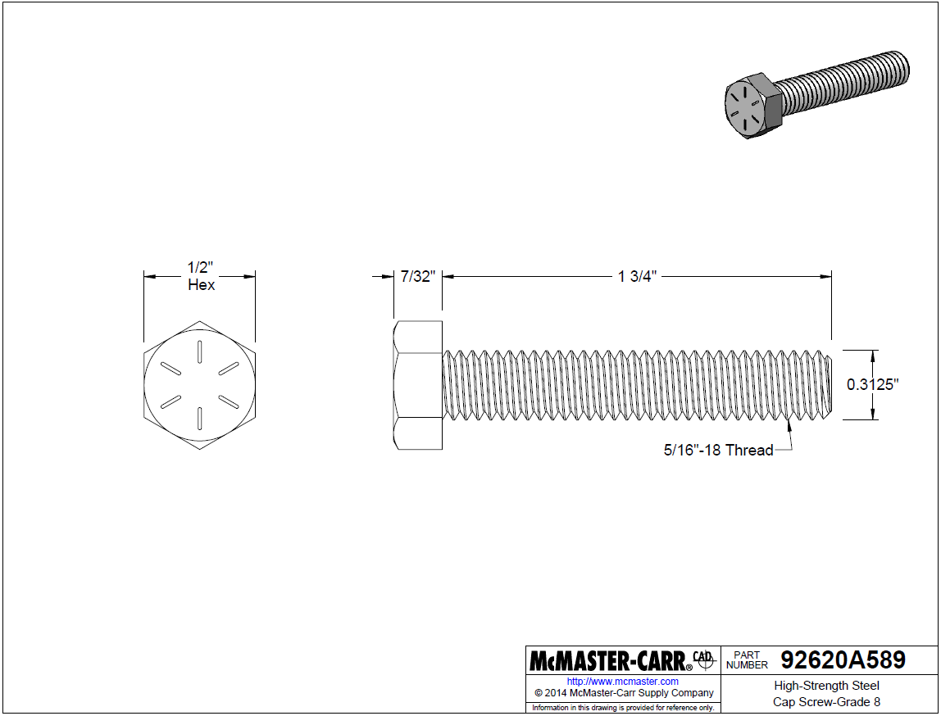

Figure 113: Cap Screw 5/16-18x1-3/4, McMaster-Carr 92620A589

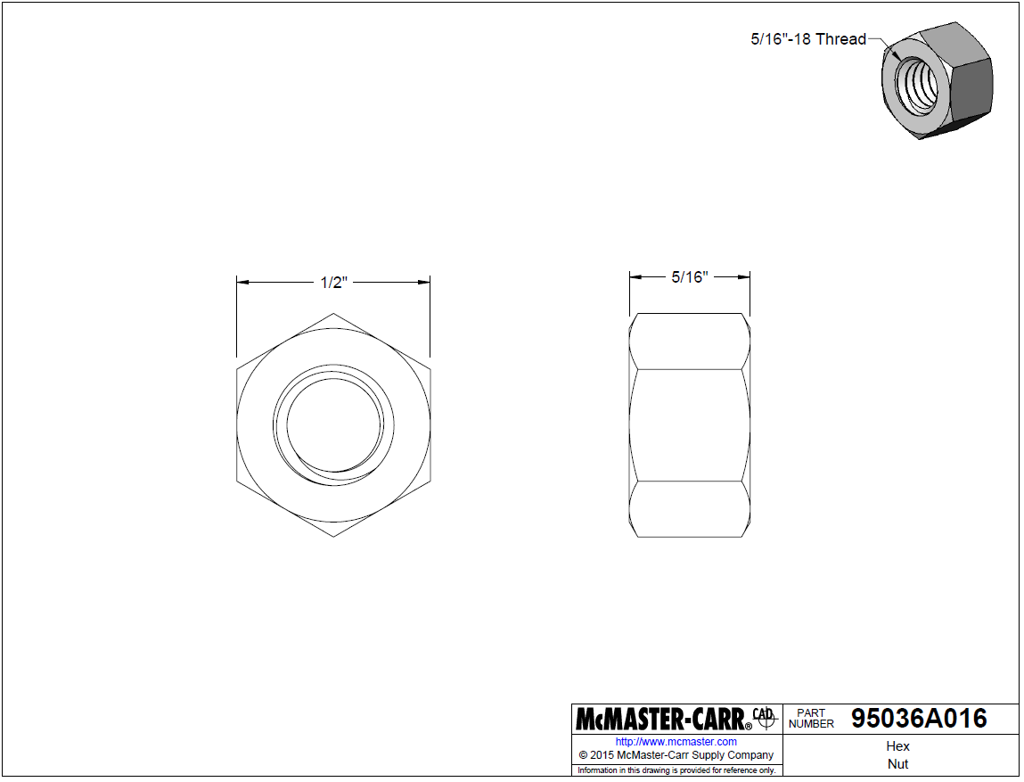

Figure 114: Hex Nut 5/16-18x5/16, McMaster-Carr 95036A016

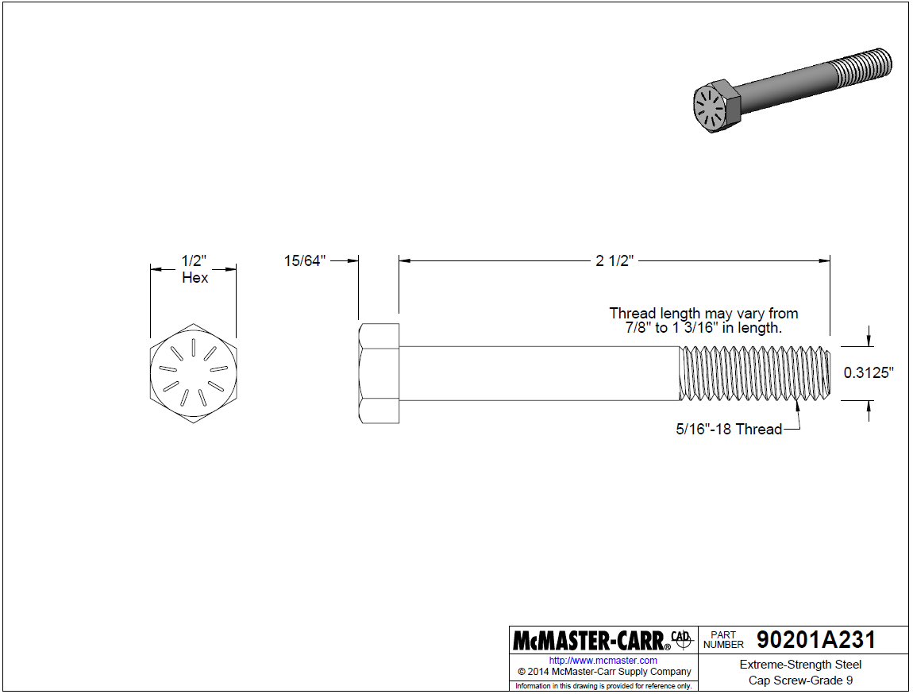

Figure 115: Cap Screw 5/16-18x2-1/2, McMaster-Carr 90201A231

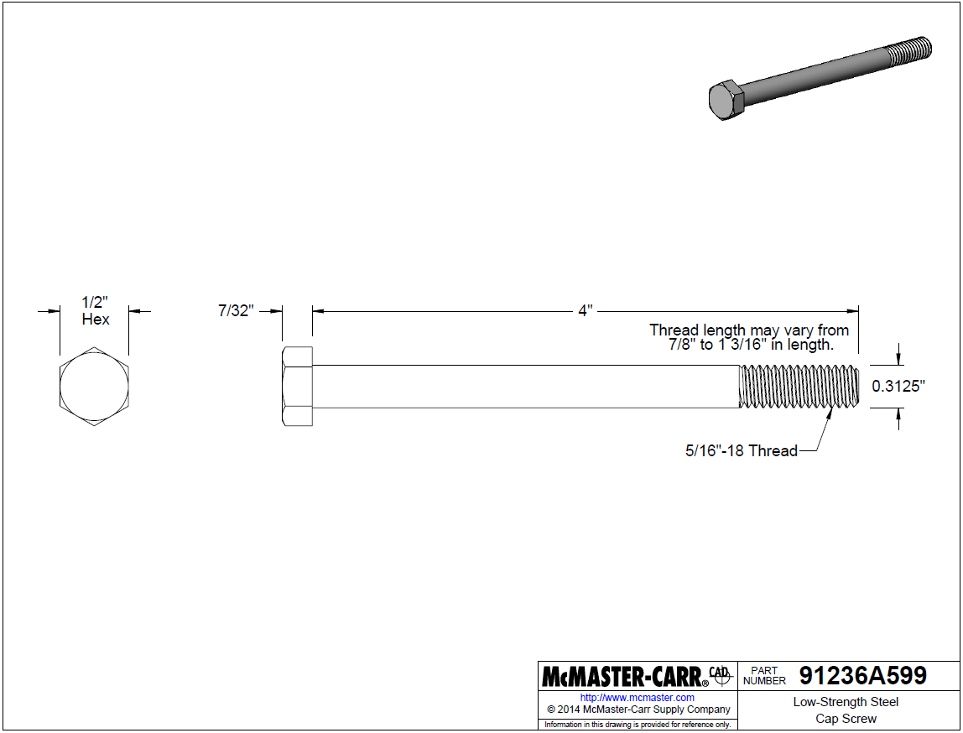

Figure 116: Cap Screw 5/16-18x4, McMaster-Carr 91236A599

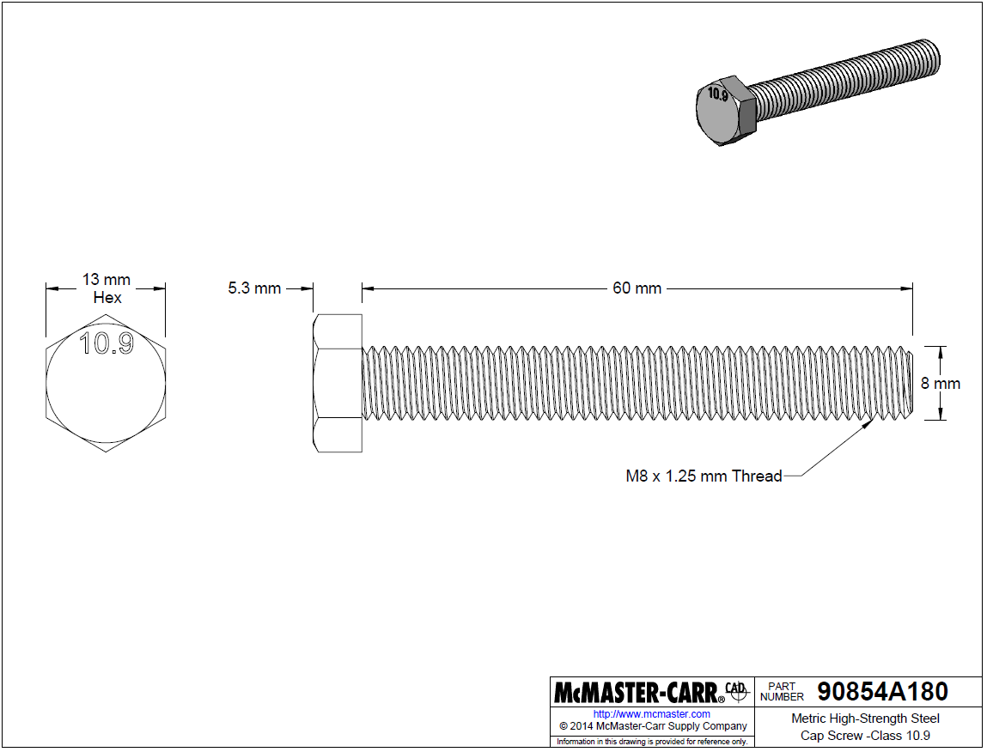

Figure 117: Cap Screw M8x1.25x60, McMaster-Carr 90854A180

# Part Specification Sheets

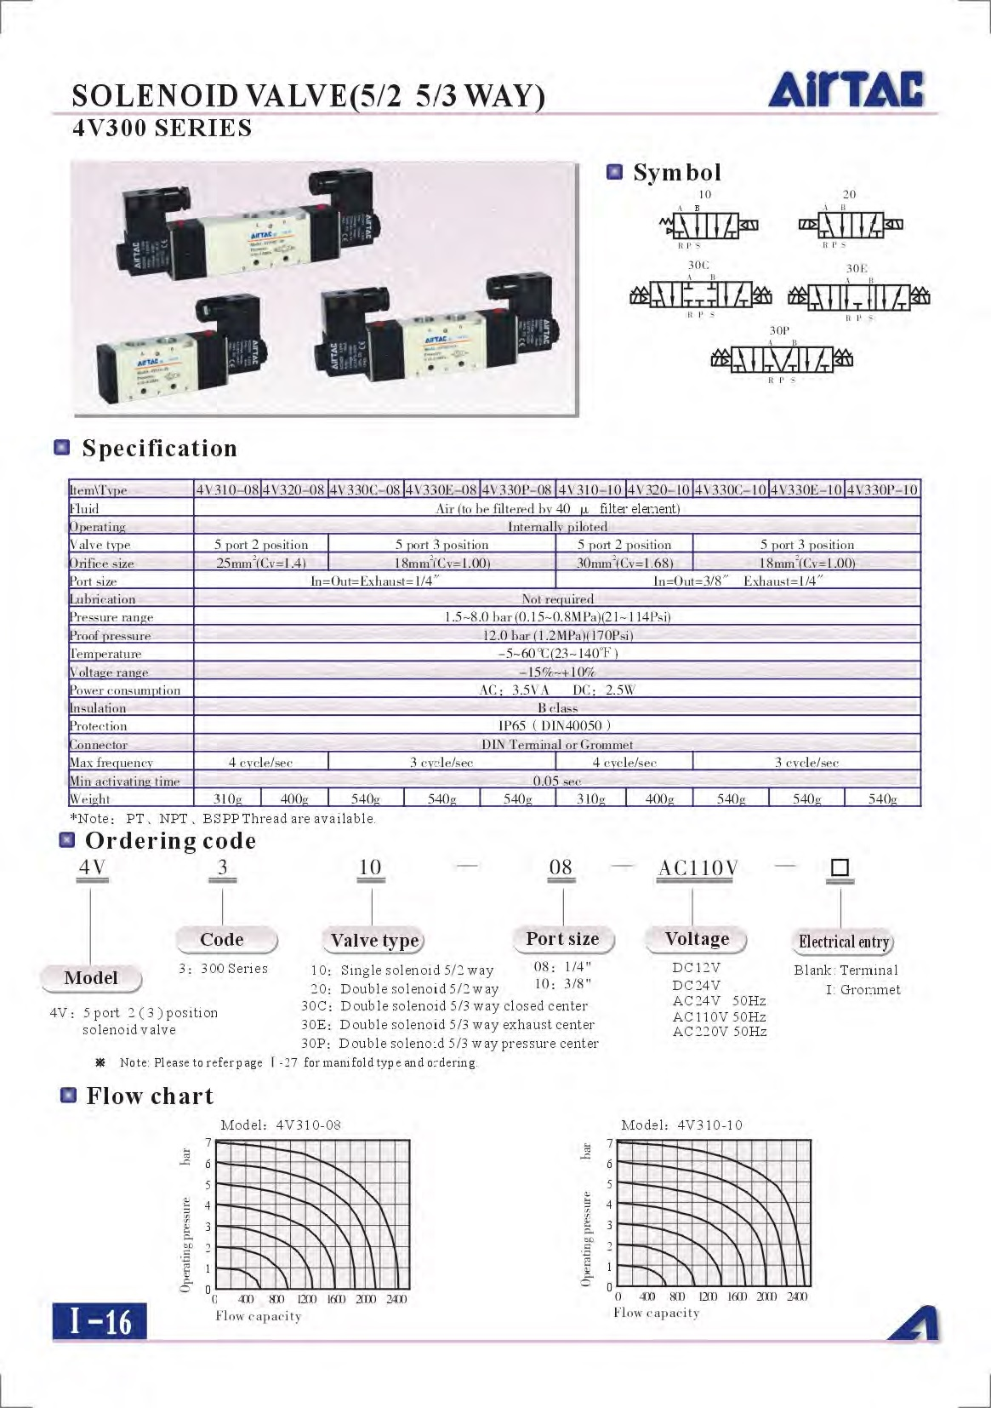

Figure 118: Airtac 5/2 Solenoid Valve Specifications Datasheet

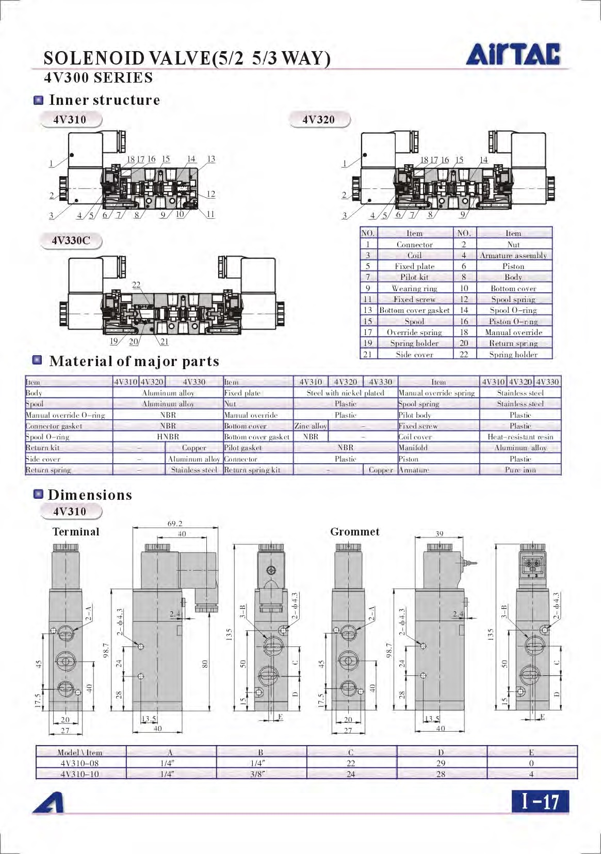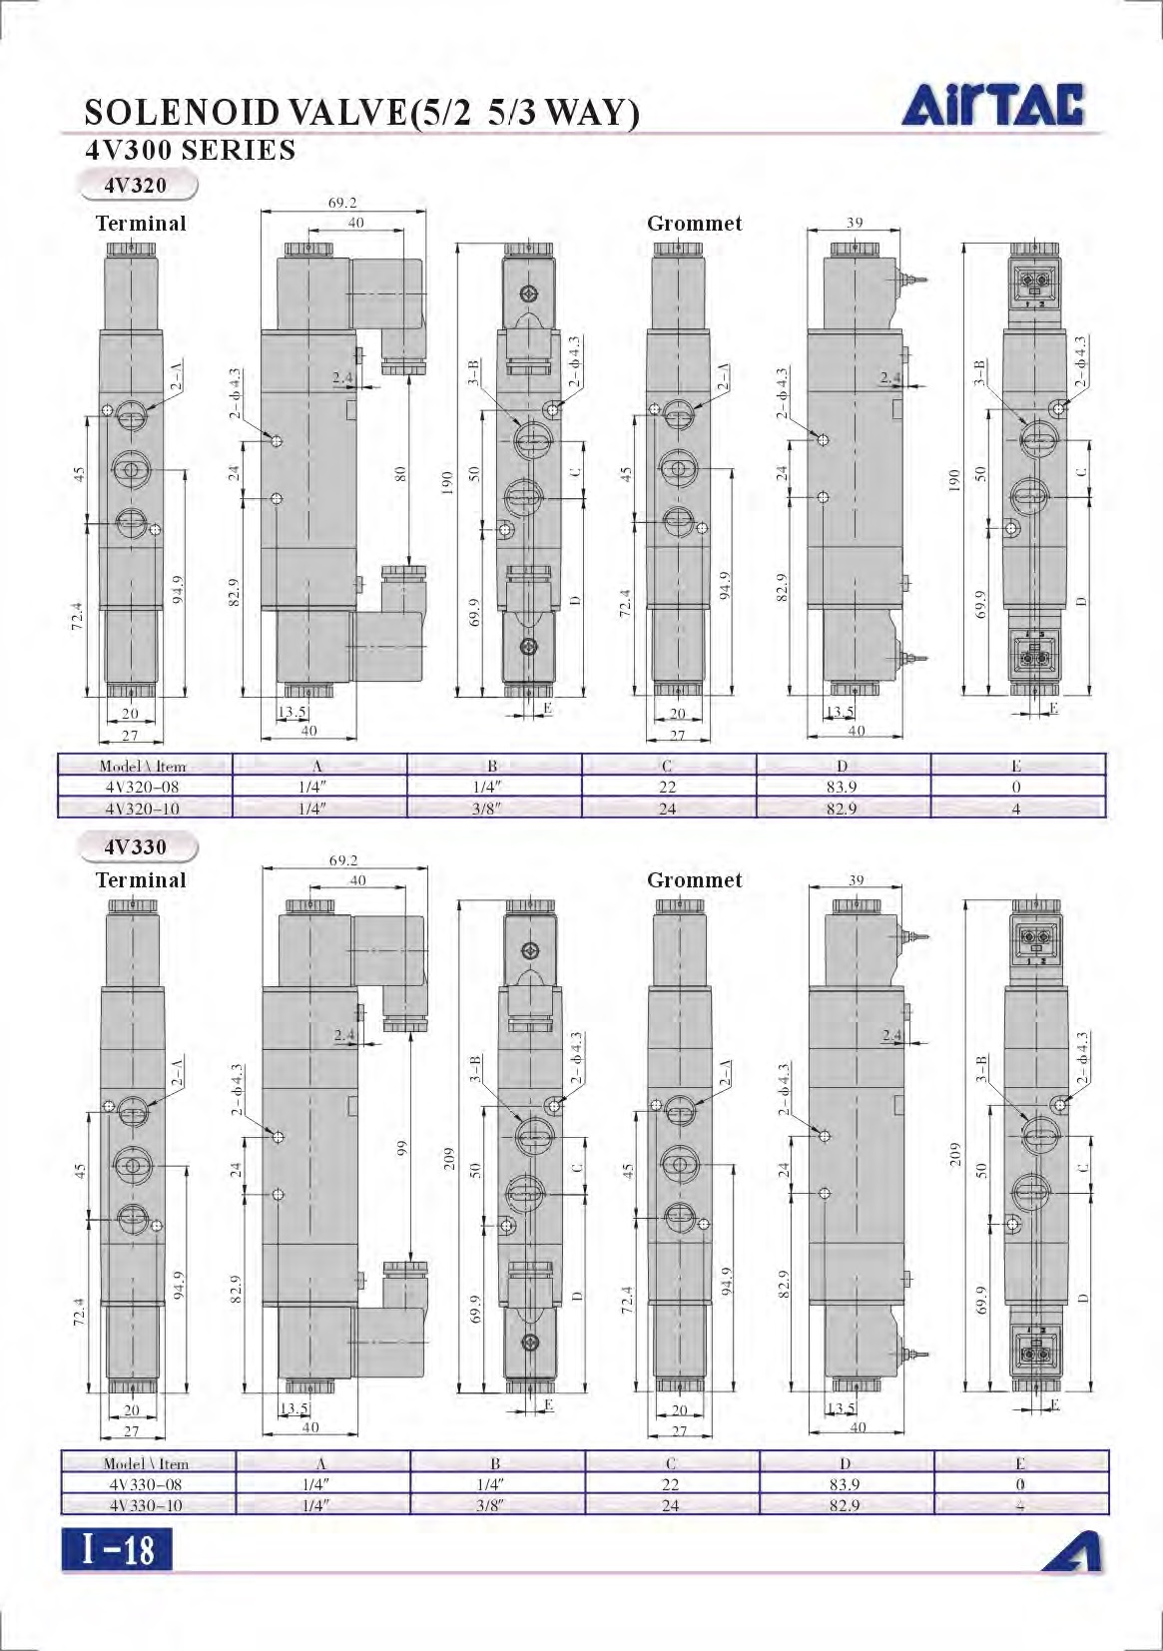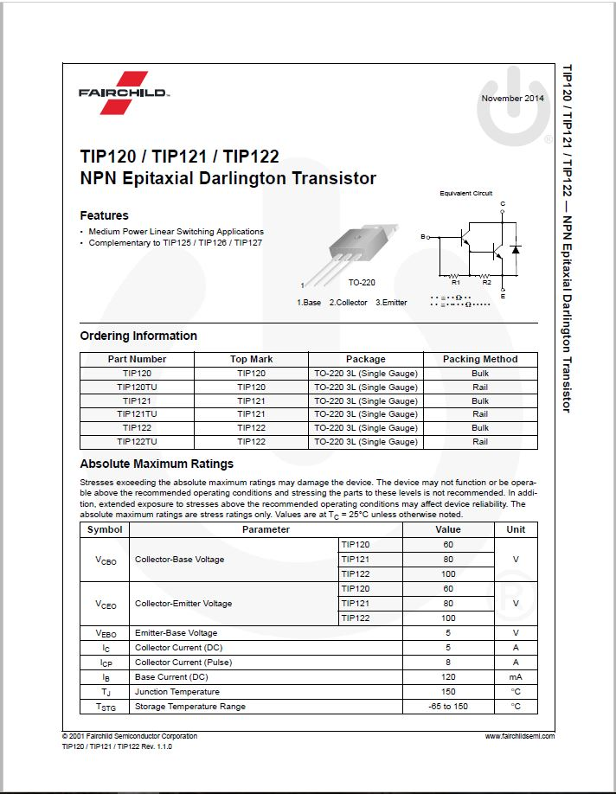

Figure 119: Fairchild Semiconductor TIP120 Specification Datasheet

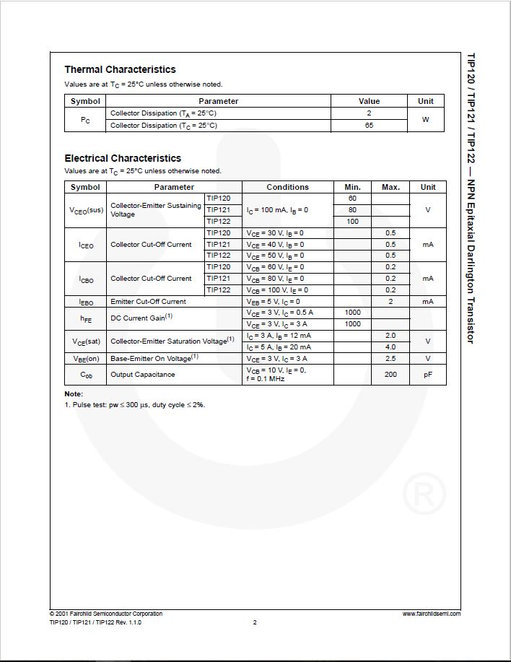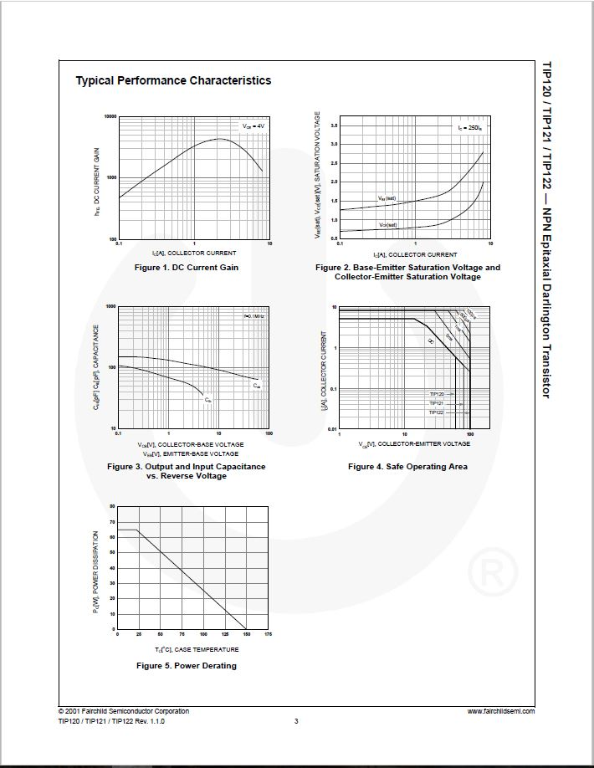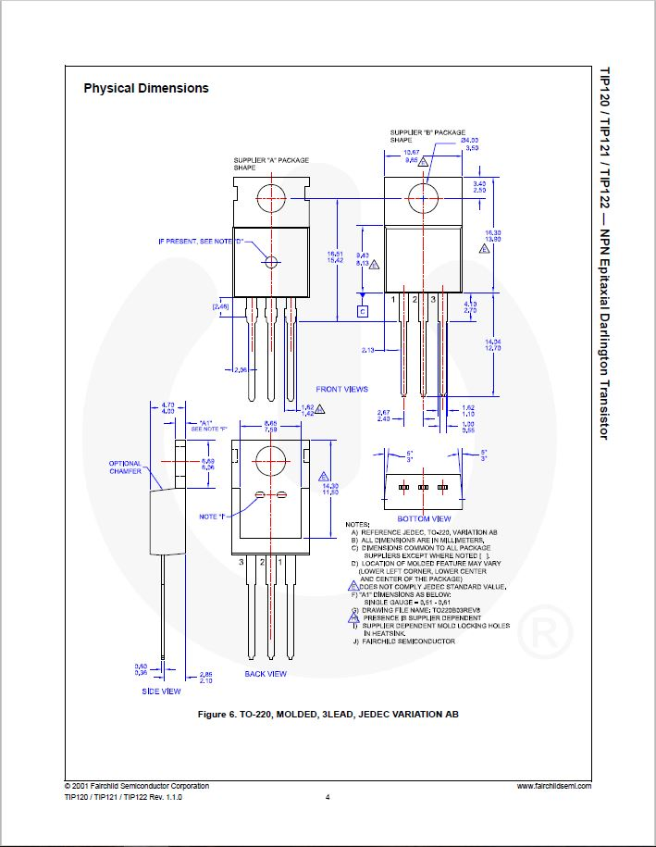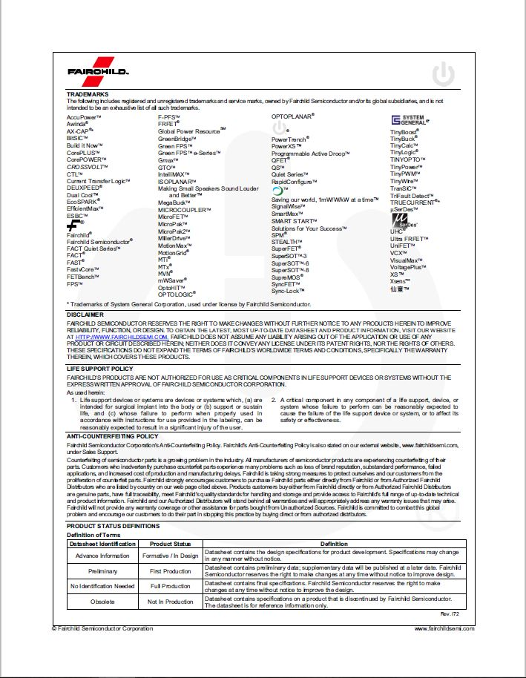

# Arduino Code



Figure 120: Arduino Microcontroller Program for the Prototype

# Assembly Procedure

1. Assemble sub-assemblies as per respective drawings. The figure below shows all required sub-assemblies. Refer to drawings for required fasteners.



**Figure 121: All Sub-Assemblies**

1. Begin by placing both floor beams on the floor and elevating them, as shown in figure below.

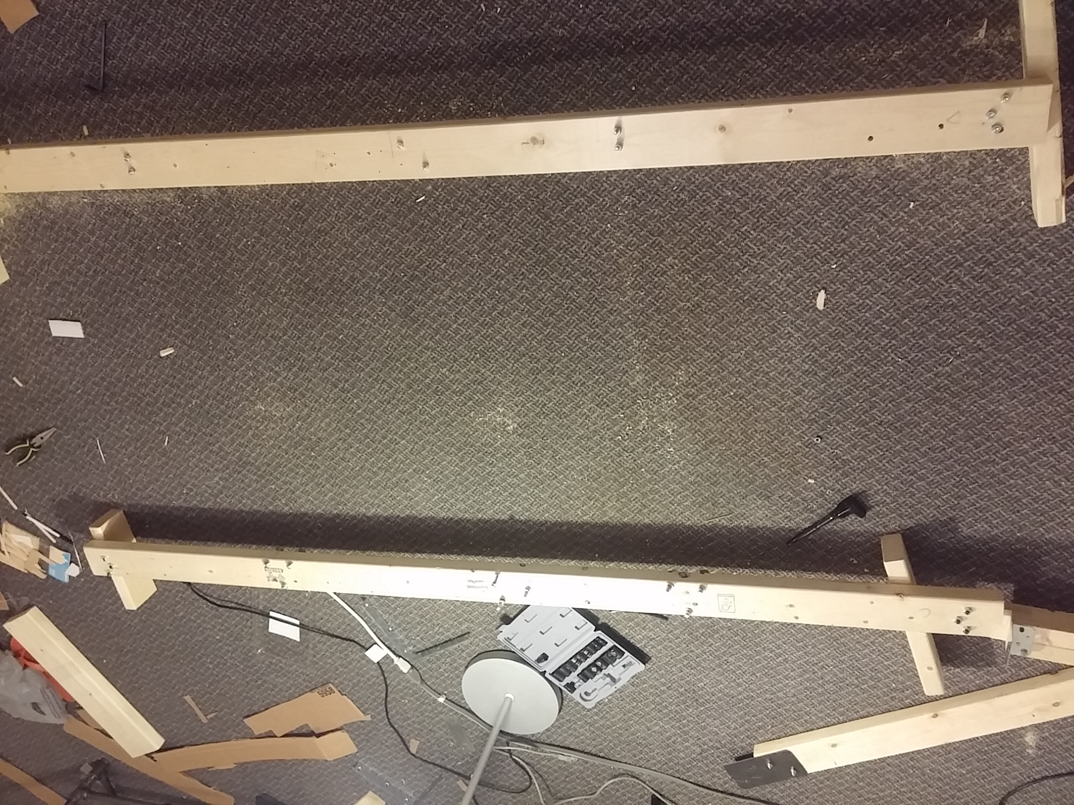

Figure 122: Floor Beams

1. Fasten foot and head boards to the ends of the floor beams. Spine beam slot on the boards is on the same side as the hinge. Refer to Figure 123.

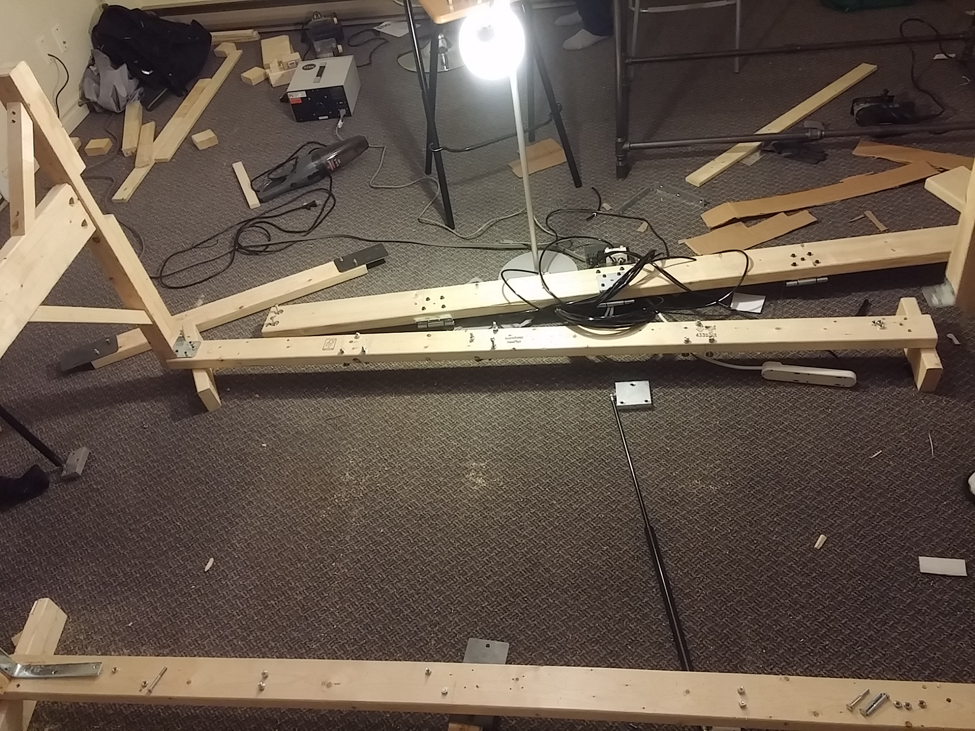

Figure 123: Attaching Boards to Floor Beams

1. Bolt spine beam to foot and head board with hinge side inside the bed frame. Refer to Figure 124

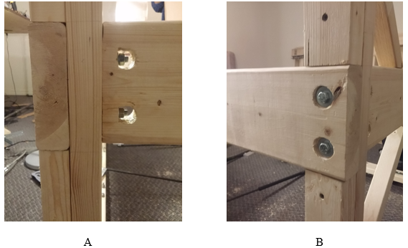

Figure 124: Spine Fastening - A: Board View, B: Angle View

1. Fasten floor cross beams to current assembly and fasten gas struts onto floor beams. Gas struts are ordered 50lbs, 100lbs, 50lbs. Refer to Figure 125. Hole locations are symmetric

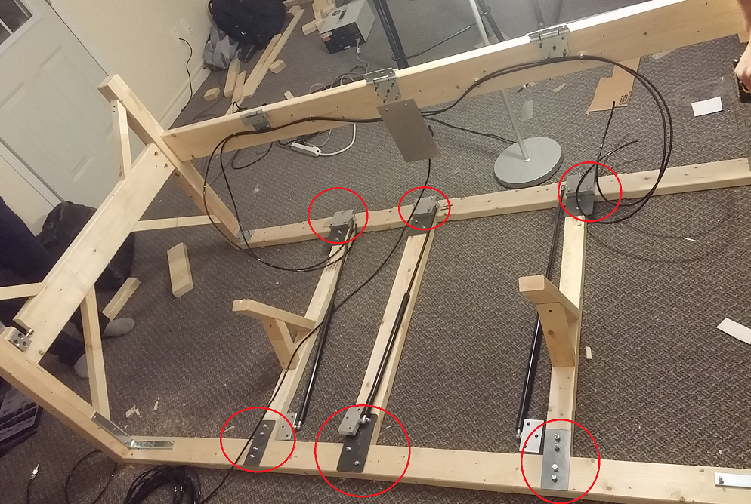

Figure 125: Mounting Locations for Floor Cross Beams/Gas Struts Circled in Red

1. Place top frame sub-assembly onto bed frame and bolt to the frame’s hinges via holes on top frame. Refer to Figure 126. All hole locations are similar for all three hinges. Ensure to use back plate when fastening, see Figure 127.

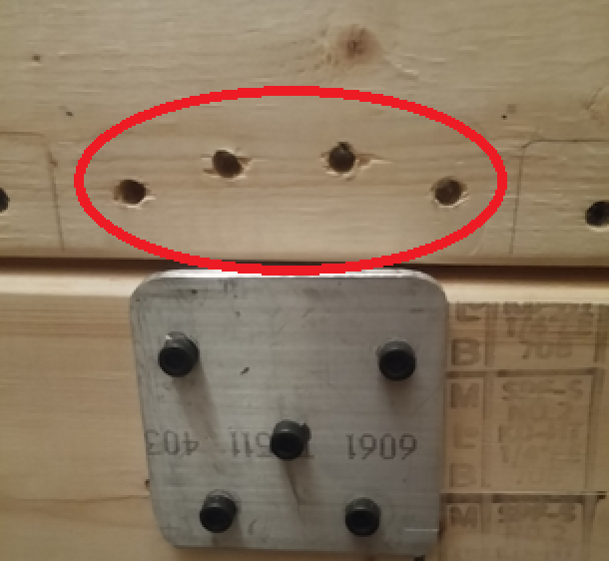

Figure 126: Top Frame Hinge Bolt Location

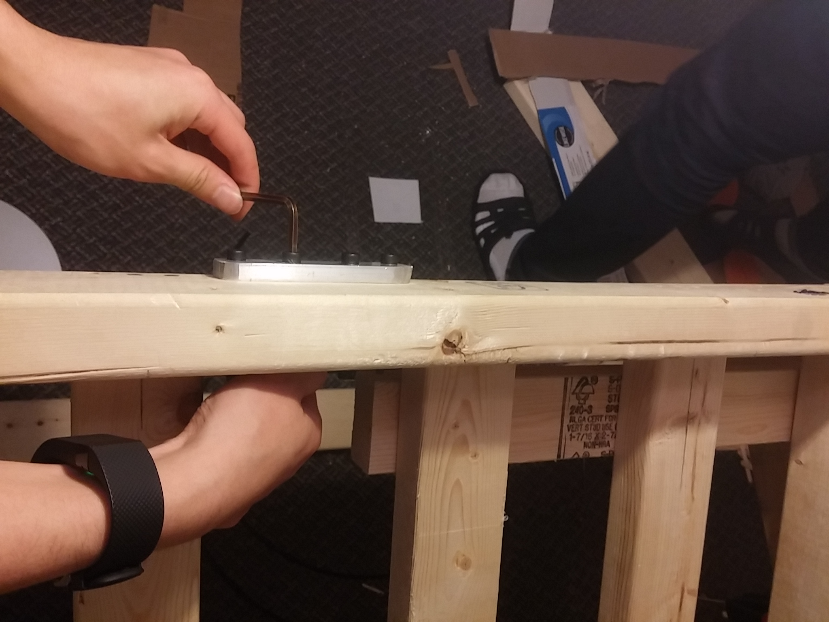

Figure 127: Fastening Top Frame to Bottom Frame

1. Bolt gas struts to top frame holes. Ensure top frame is secure in its upright position when securing the gas struts. See Figure 128.

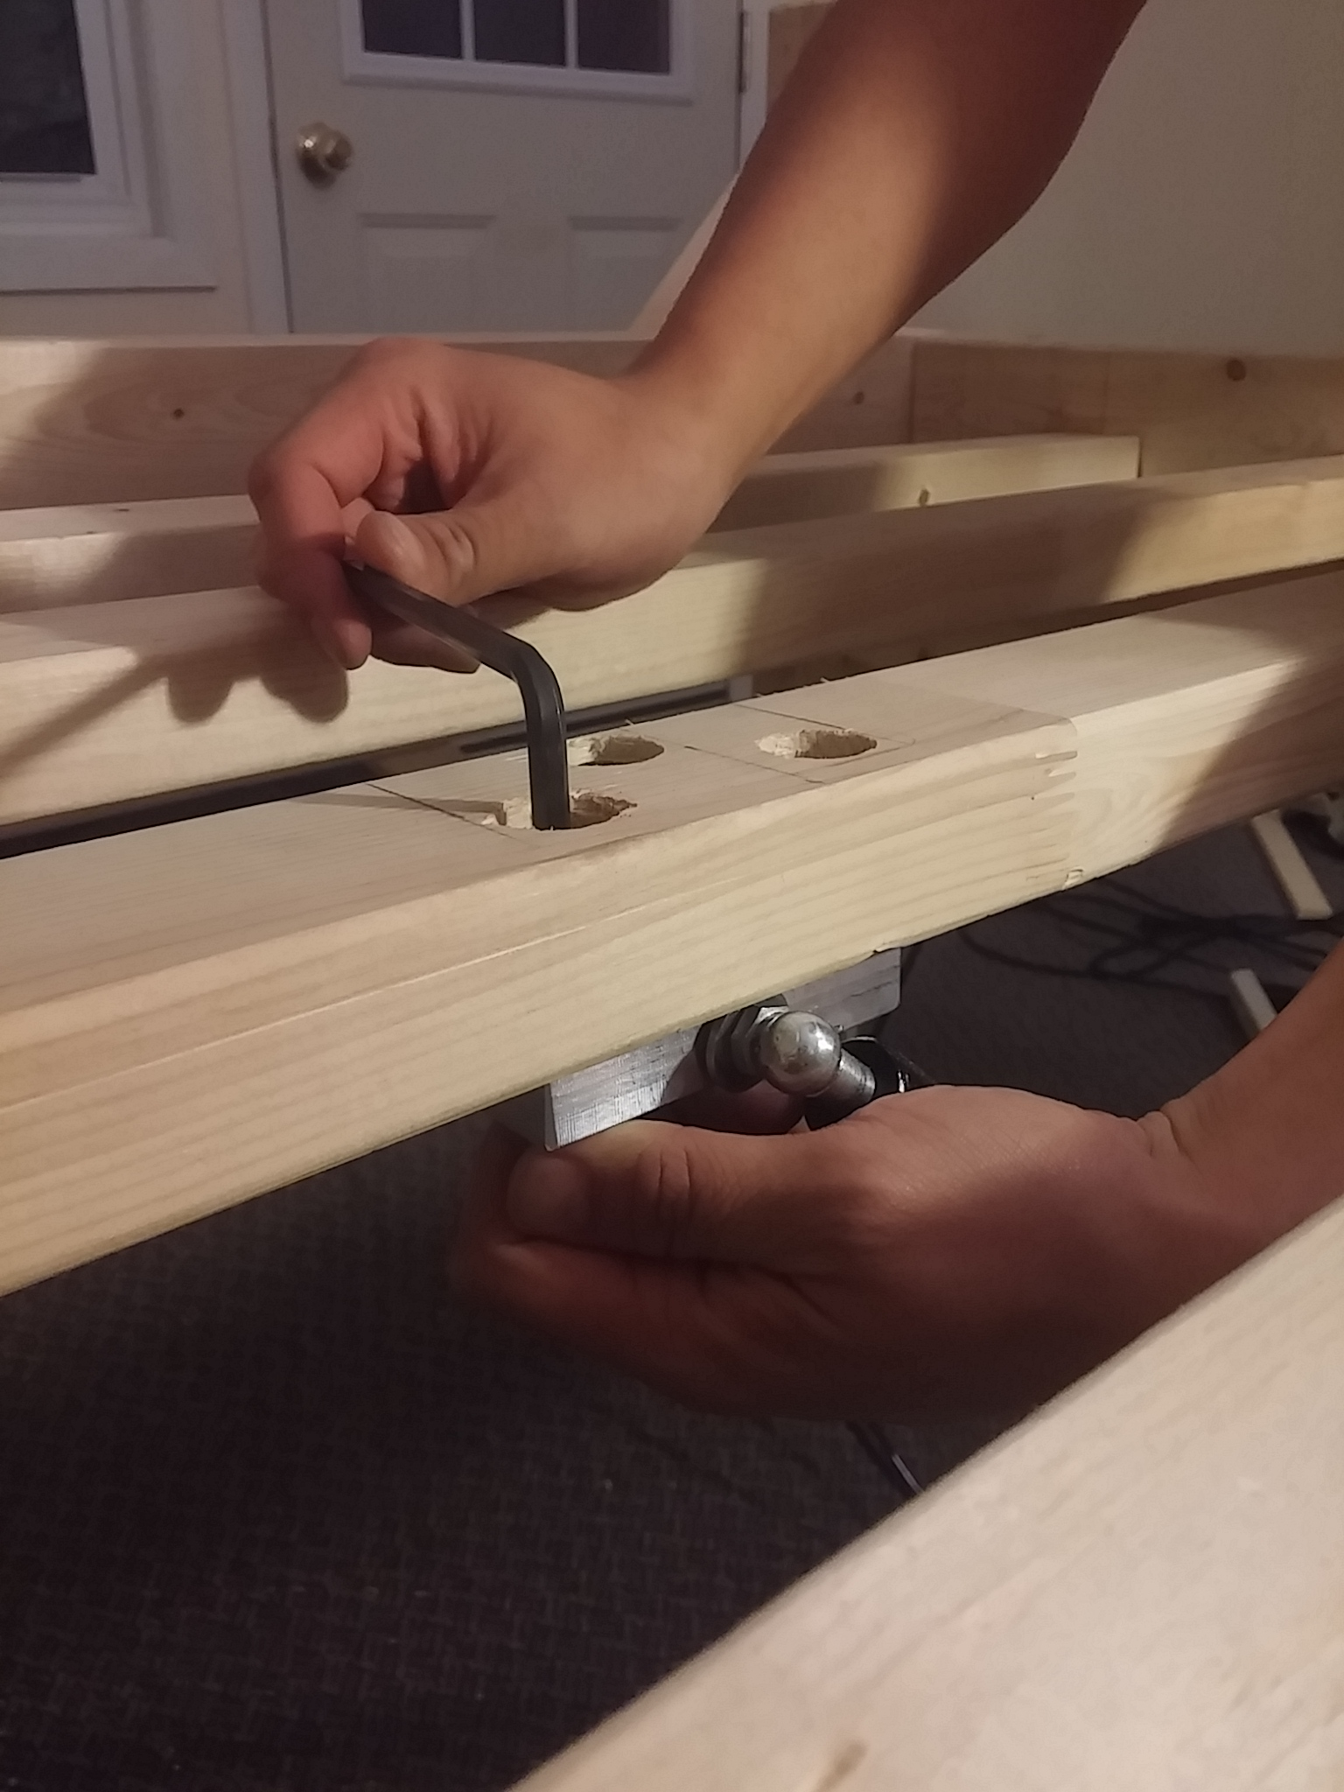

Figure 128: Fastening Gas Strut Mounts to Top Frame

1. Wire pneumatic hoses to both cylinders at the corners of the top frame. Refer to Figure 129, Figure 130, and Figure 131.

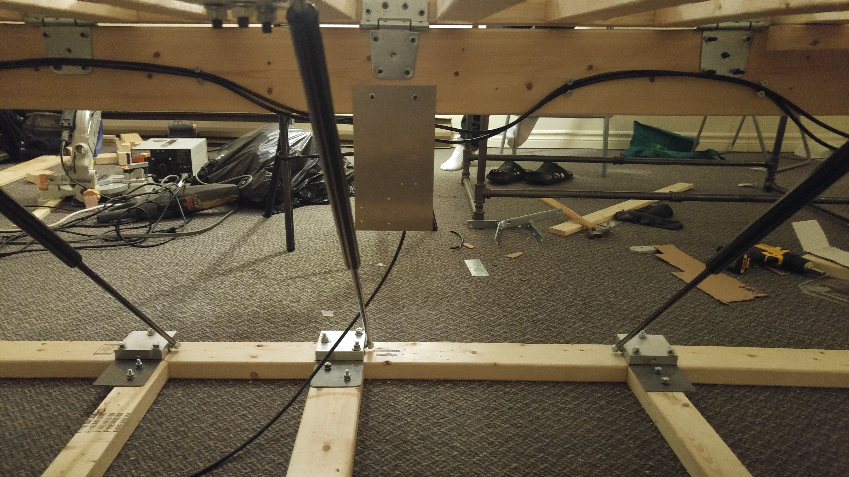

Figure 129: Pneumatic Wiring on Spine Beam

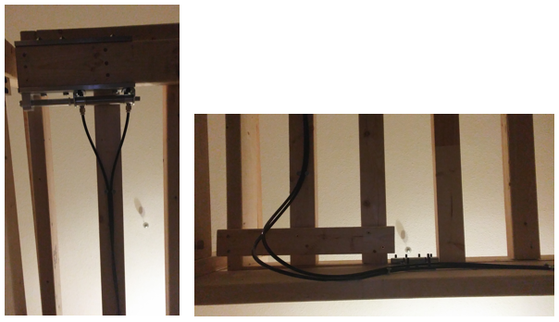

Figure 130: Pneumatic Wiring on Underside of Top Frame



Figure 131: Pneumatic Wiring - Underside, Side View

1. Hook up pneumatic hoses to cylinders and input hose to air supply. Refer to Figure 132.

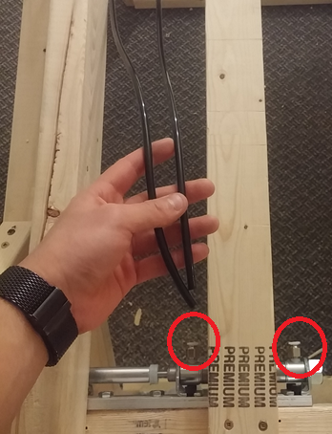

Figure 132: Pneumatic Hookups to Cylinder

1. Attach Arduino to solenoid valve and limit switch. Refer to Figure 133.

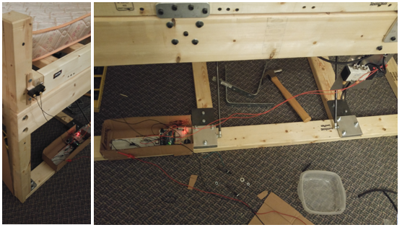

Figure 133: Arduino Wiring

# **Appendix B – Design Project Management Data**

## Scheduling and Work Breakdown Structure (WBS)

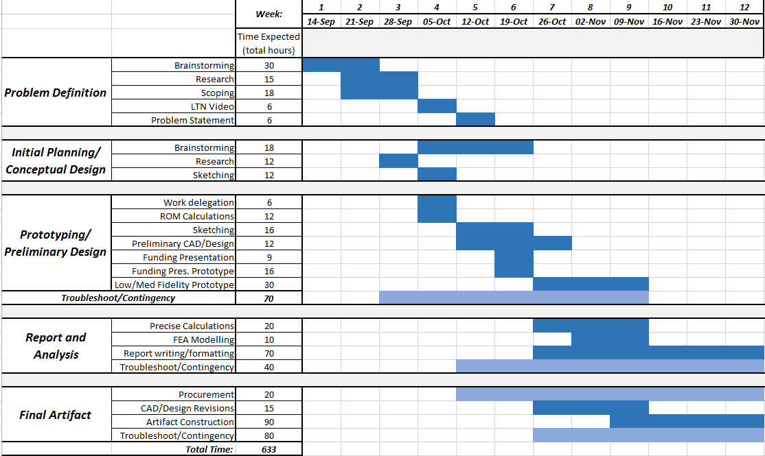

Figure 134: Overall Work Breakdown Structure Estimate

## Team Organizational Chart and Roles

During week one of this project, roles were established for each member of the team, as shown in Figure 135. This will establish expectations and responsibilities for each group member, helping ensure that all work is divided as equally as possible; however this does not necessarily restrict any member of the team from working or helping on an aspect of the project that they themselves are not responsible for. This chart is meant to be used as a guideline for the majority of work related to this project.

**Ryan Lam**

Team Lead

**Kelvin Chow**

Testing, Controls

**Alan Wu**

Manufacturing, Design

**Jame Sun**

Analysis

**Nicholas Tham**

Design Lead

**Ragib Chowdhury**

Procurement, finance, documentation

Figure 135: Team Organization and Roles

## Budget

## Risk Register

Table 13: Risk Register

|  |  |  |  |  |  |
| --- | --- | --- | --- | --- | --- |
| ***Risk*** | ***Description*** | ***Risk Type*** | ***Probability*** | ***Severity*** | ***Mitigation Plan*** |
| Safety | Drop of the bed must be safe for person sleeping | Technical | M | H | Strict analysis to ensure drop meets appropriate specification |
| Manufacturing | Manufacturing of parts may go wrong or be too difficult for us to complete | M | M | Allow more time in the WBS for machining and manufacturing of parts |
| Testing Failure | Parts may break during testing | M | L | Contingency time to allow for repairs or rebuilding |
| Parts Delivery Late | Ordered parts may arrive late due to circumstances | Non-Technical | L | L | Order parts early; readjust timeline/redistribute work if parts are late |
| Personal Emergency | Group members may have higher priorities | M | L | Contingency hours; other members will take over extra work if one member is absent |
| Over-budget | Expenses may exceed established budget | H | L | Ensure materials are exactly what is needed before purchasing |
| Unknown | Risks not accounted for | Other | M | M | Since we cannot account for these risks, it is left to contingency time to allow us to work around any unknown risks that may present themselves throughout the project |

# **Appendix C – Conceptual Design Sketches Generated and Developed**

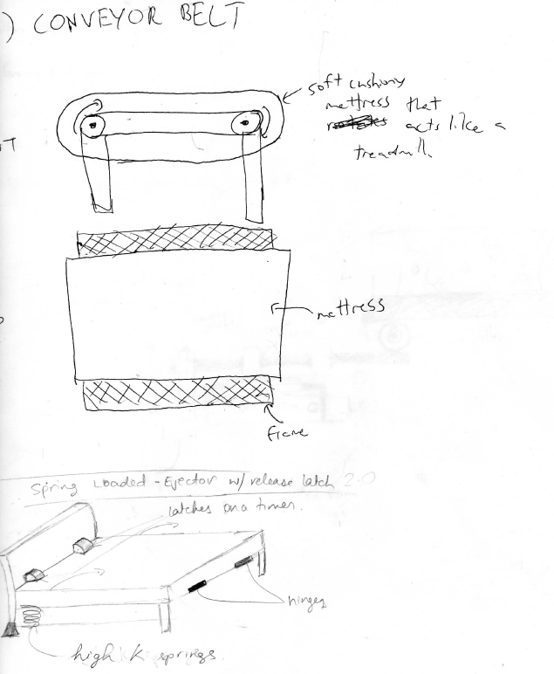

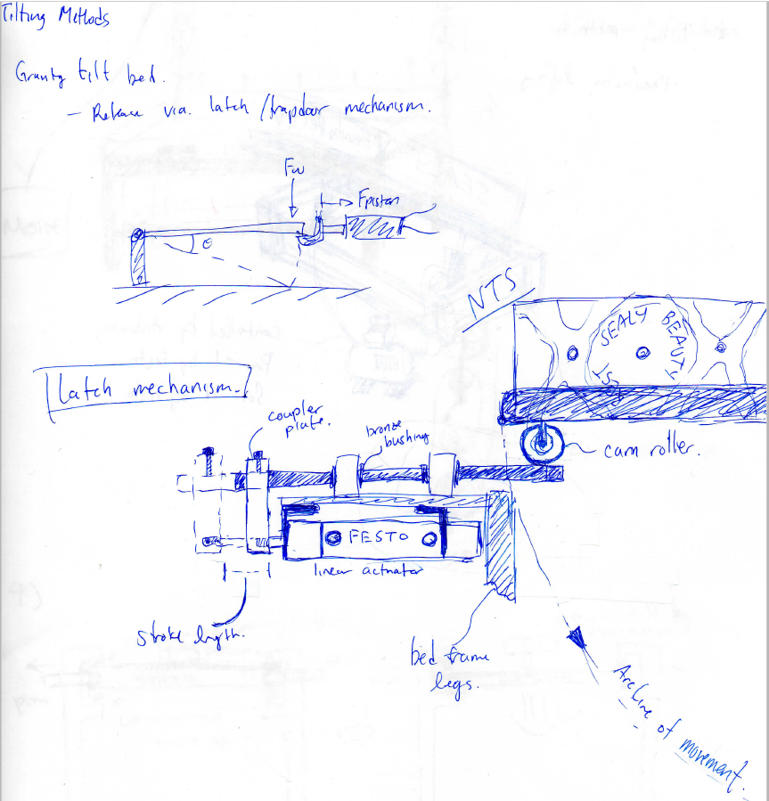

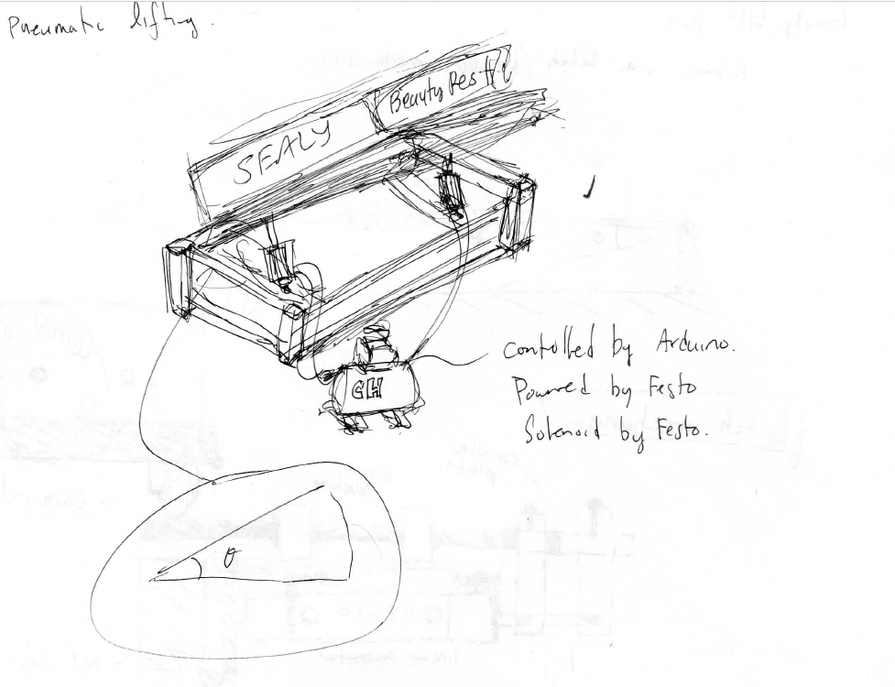

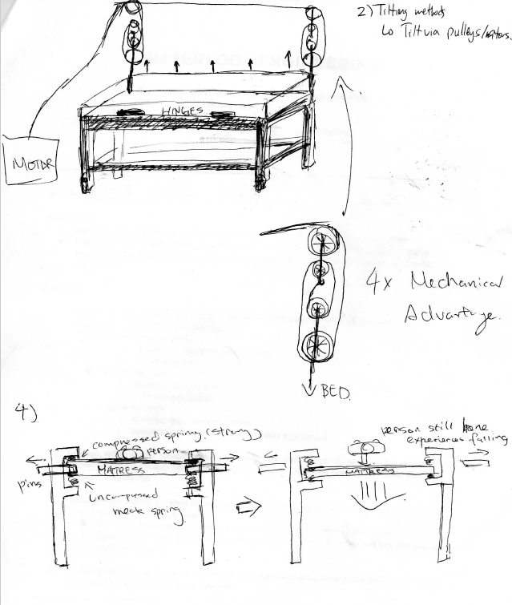

Figure 136: Conceptual Design Sketches

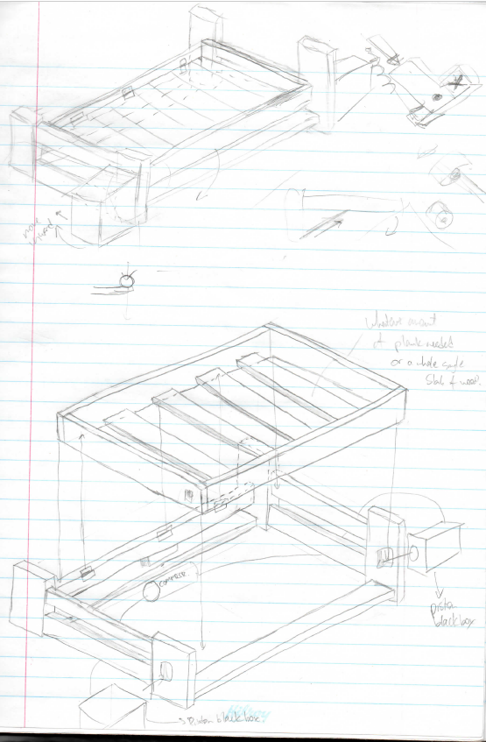

Figure 137: Preliminary Sketch

# **Appendix D – Engineering Calculations, Analyses, Simulations, Testing**

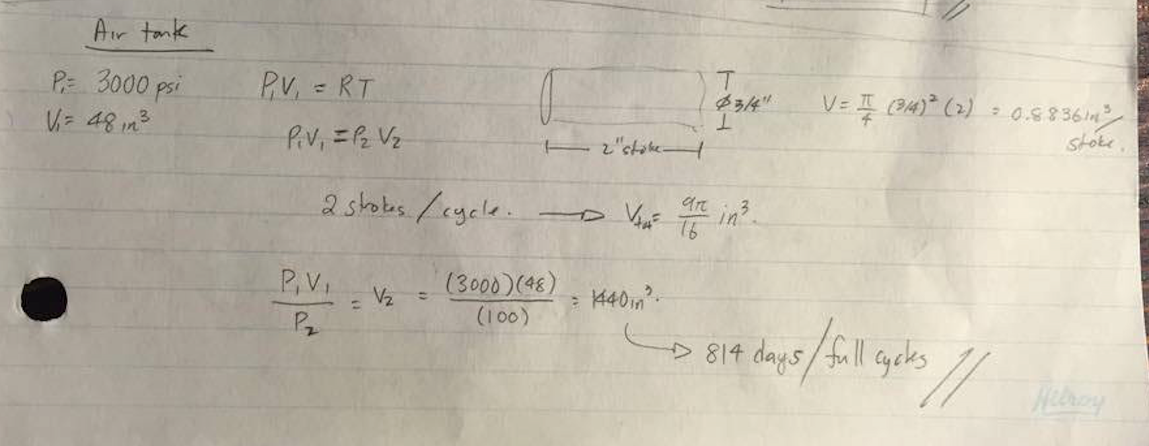

Figure 138 Hand calculation: number of cycles per air tank charge

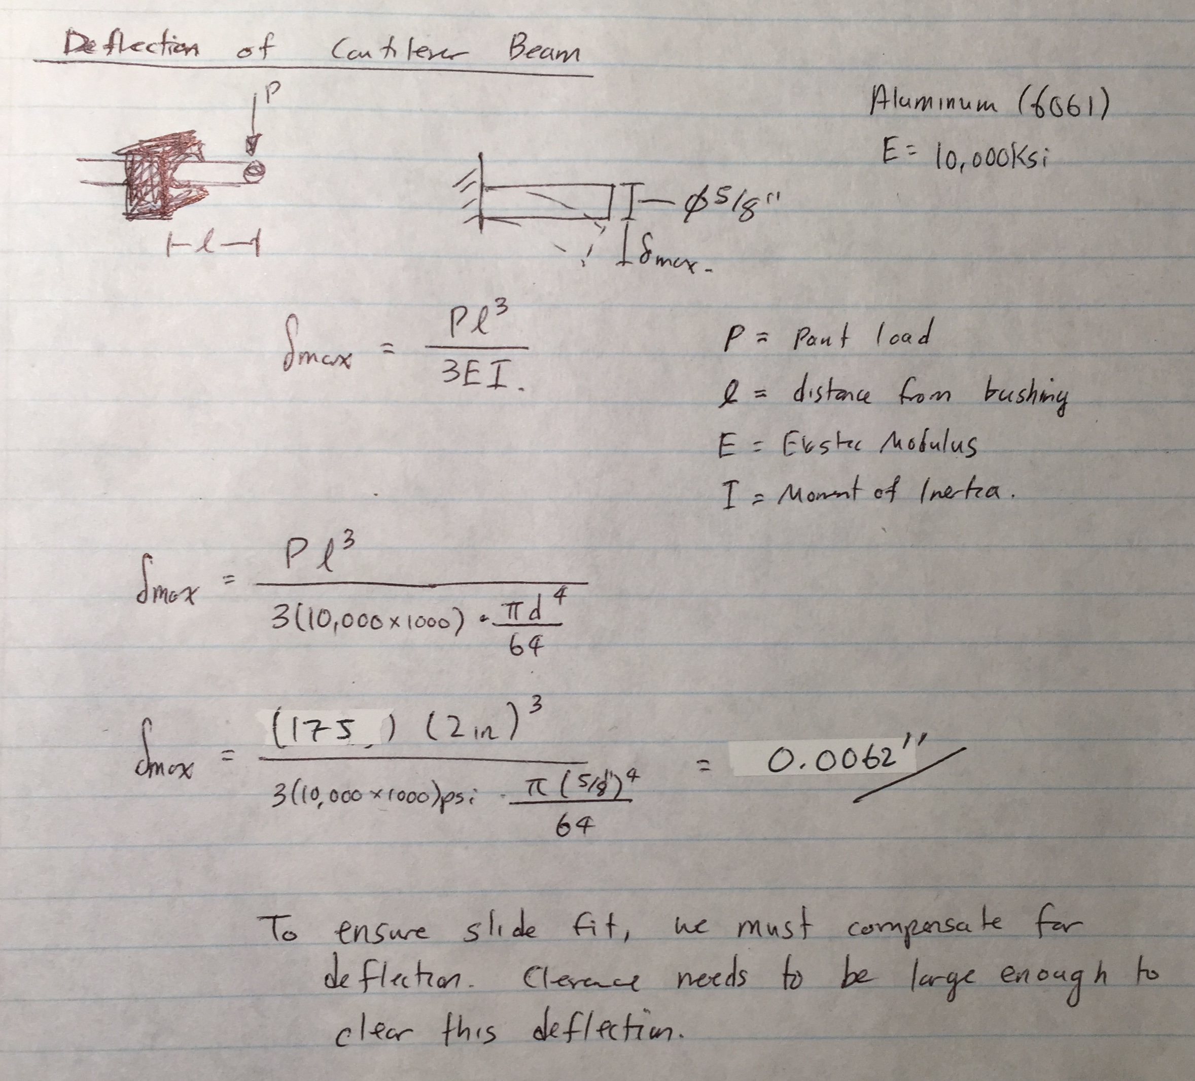

Figure 139: Hand calculations of deflection of shaft

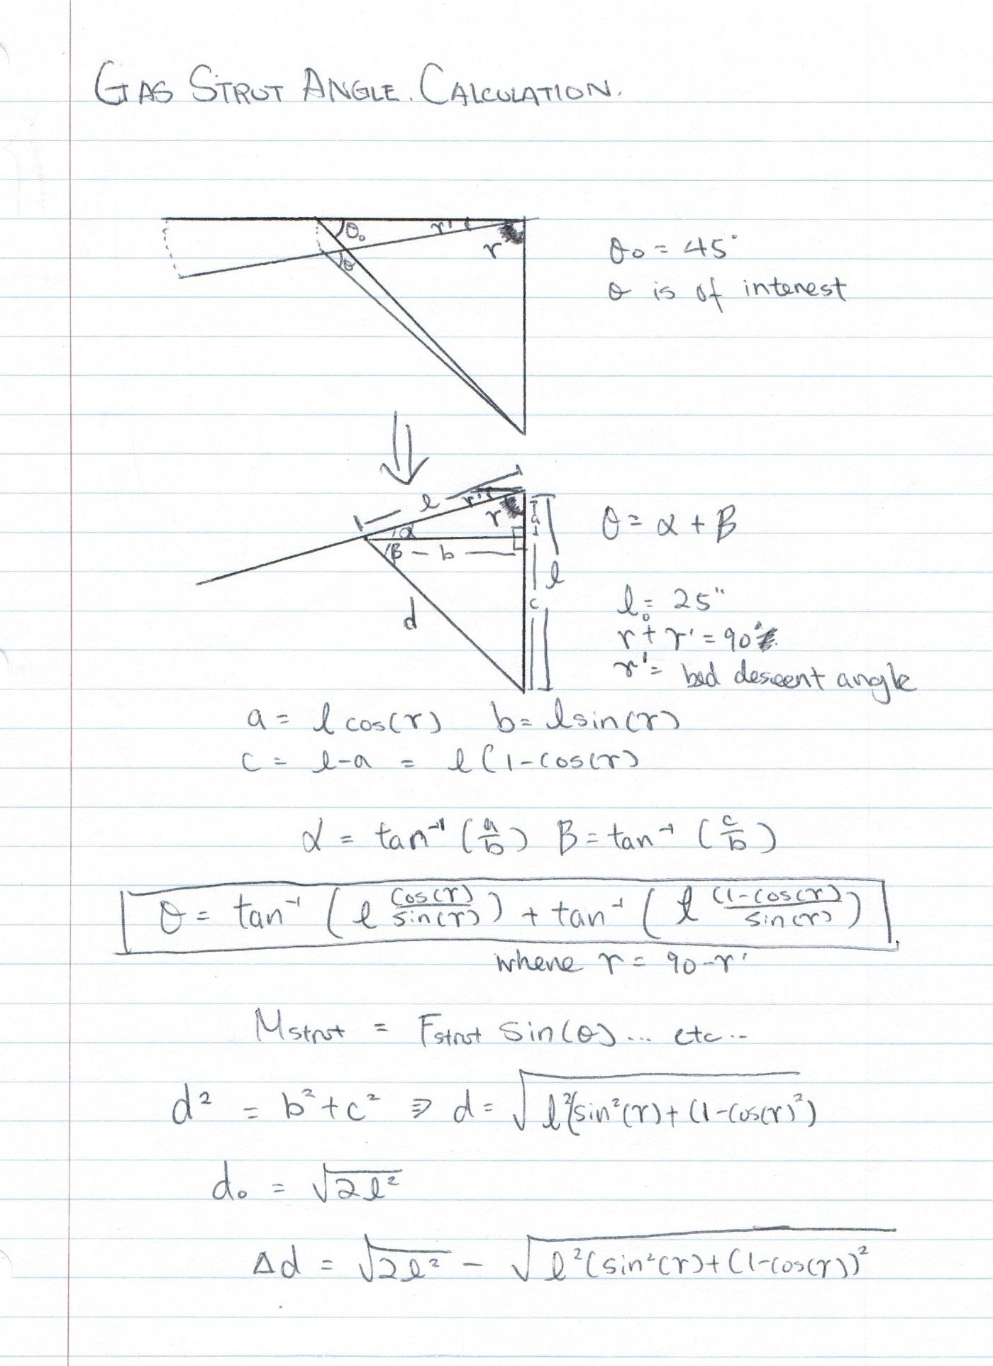

Figure 140: Hand calculation: gas strut force angle

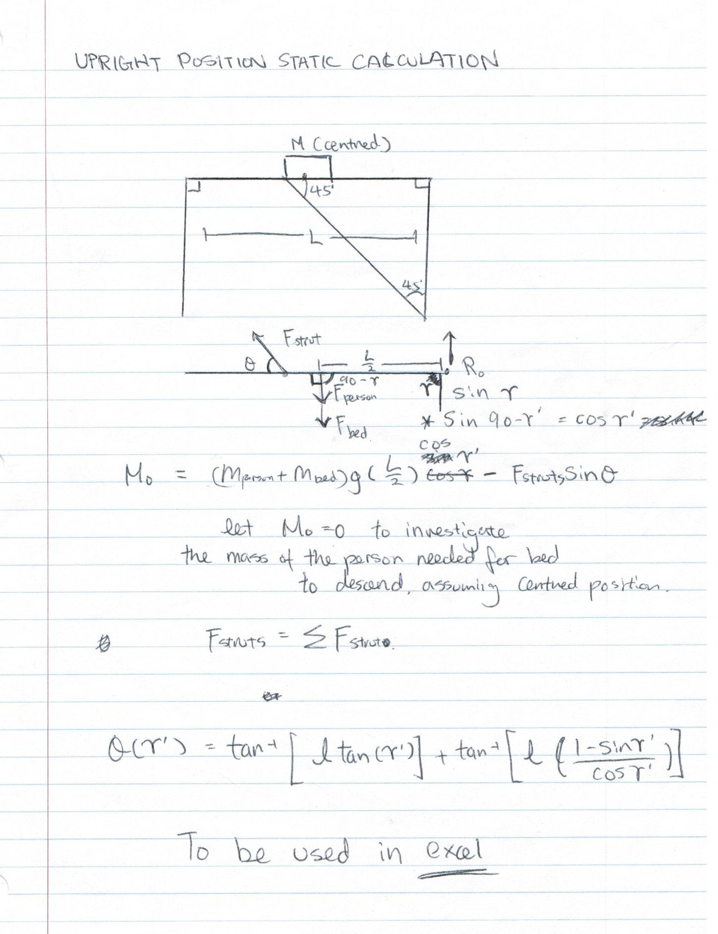

Figure 141: Hand calculation: upright position equilibrium calculation

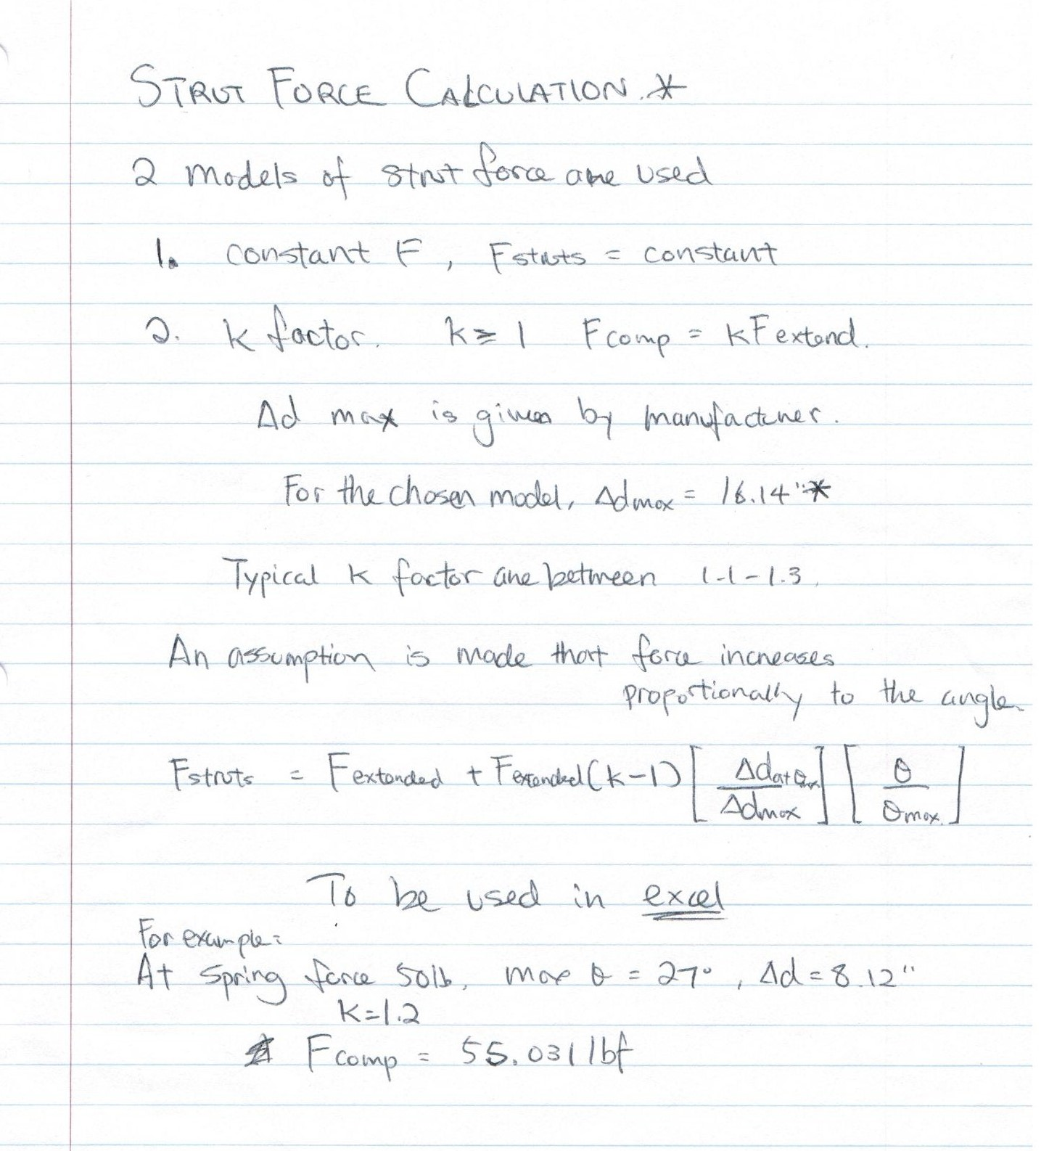

Figure 142: Hand calculation: gas strut dynamic force

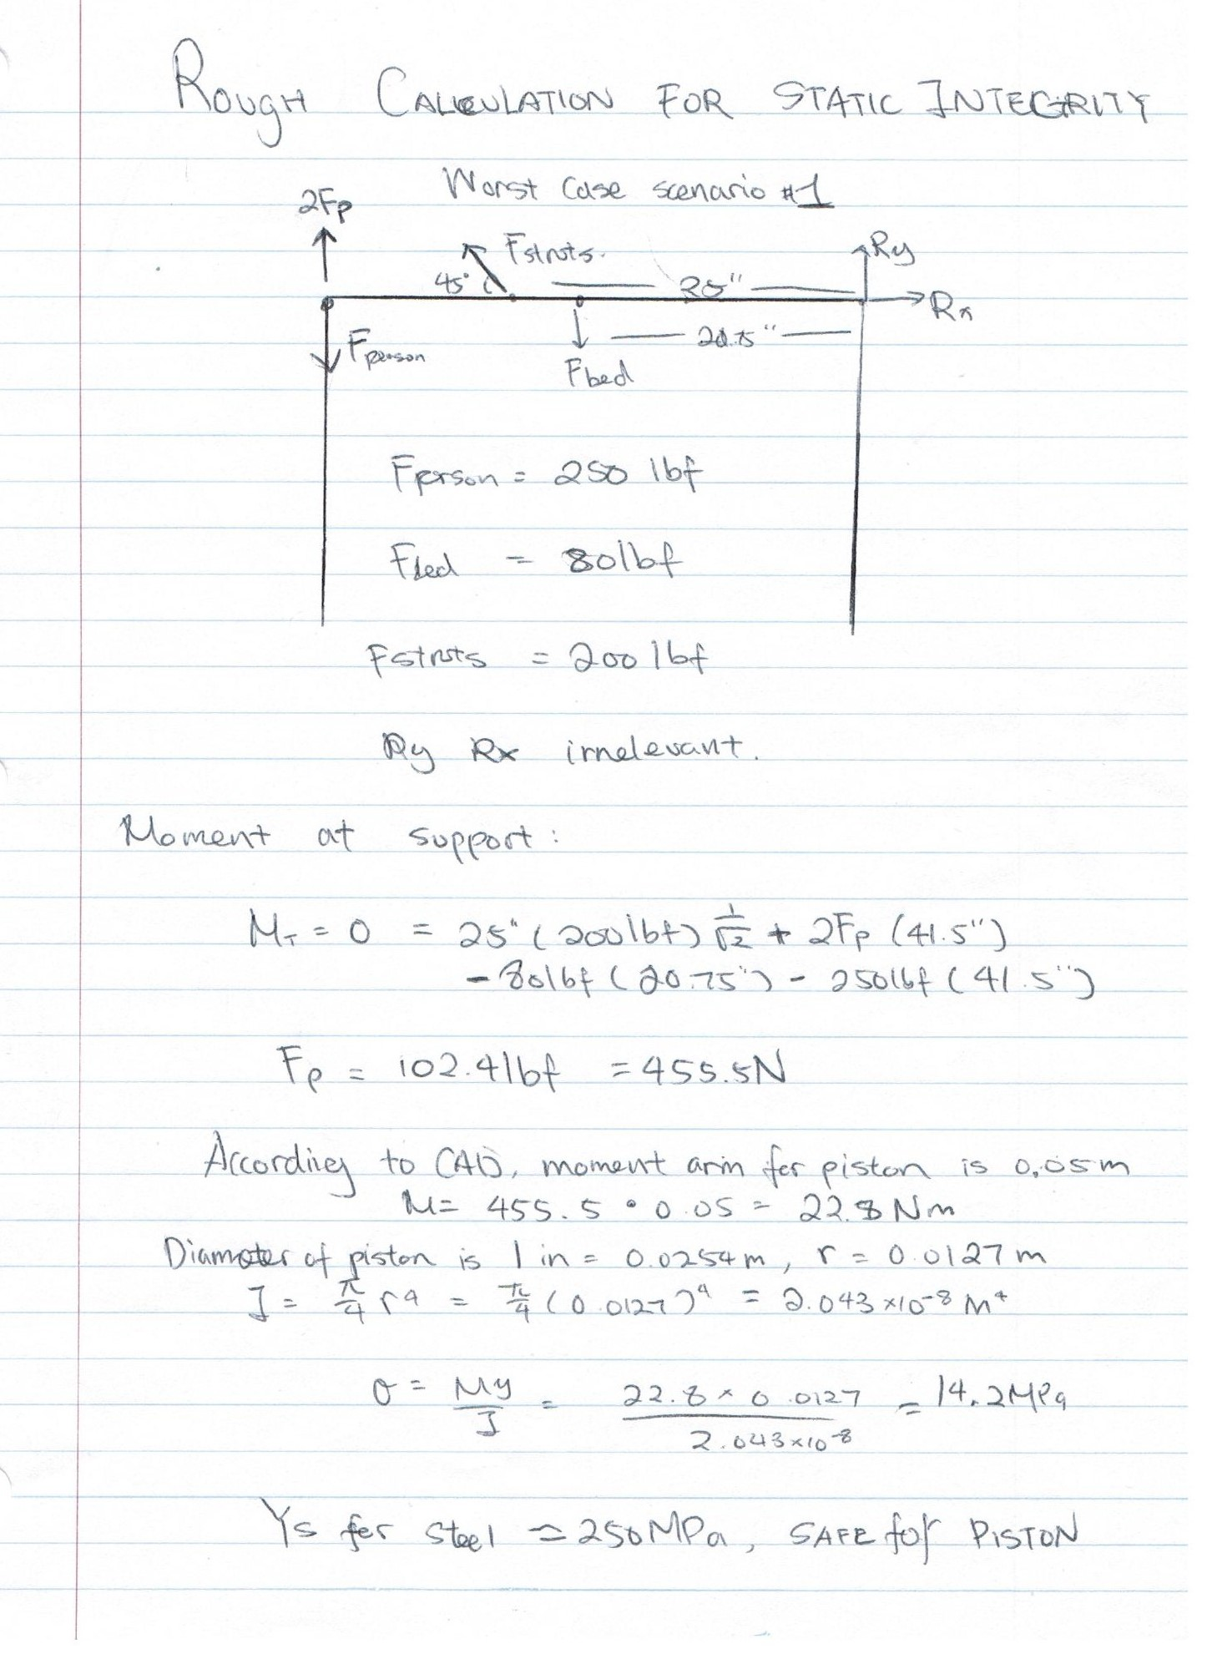

Figure 143: Hand calculation: static top frame support integrity – scenario 1

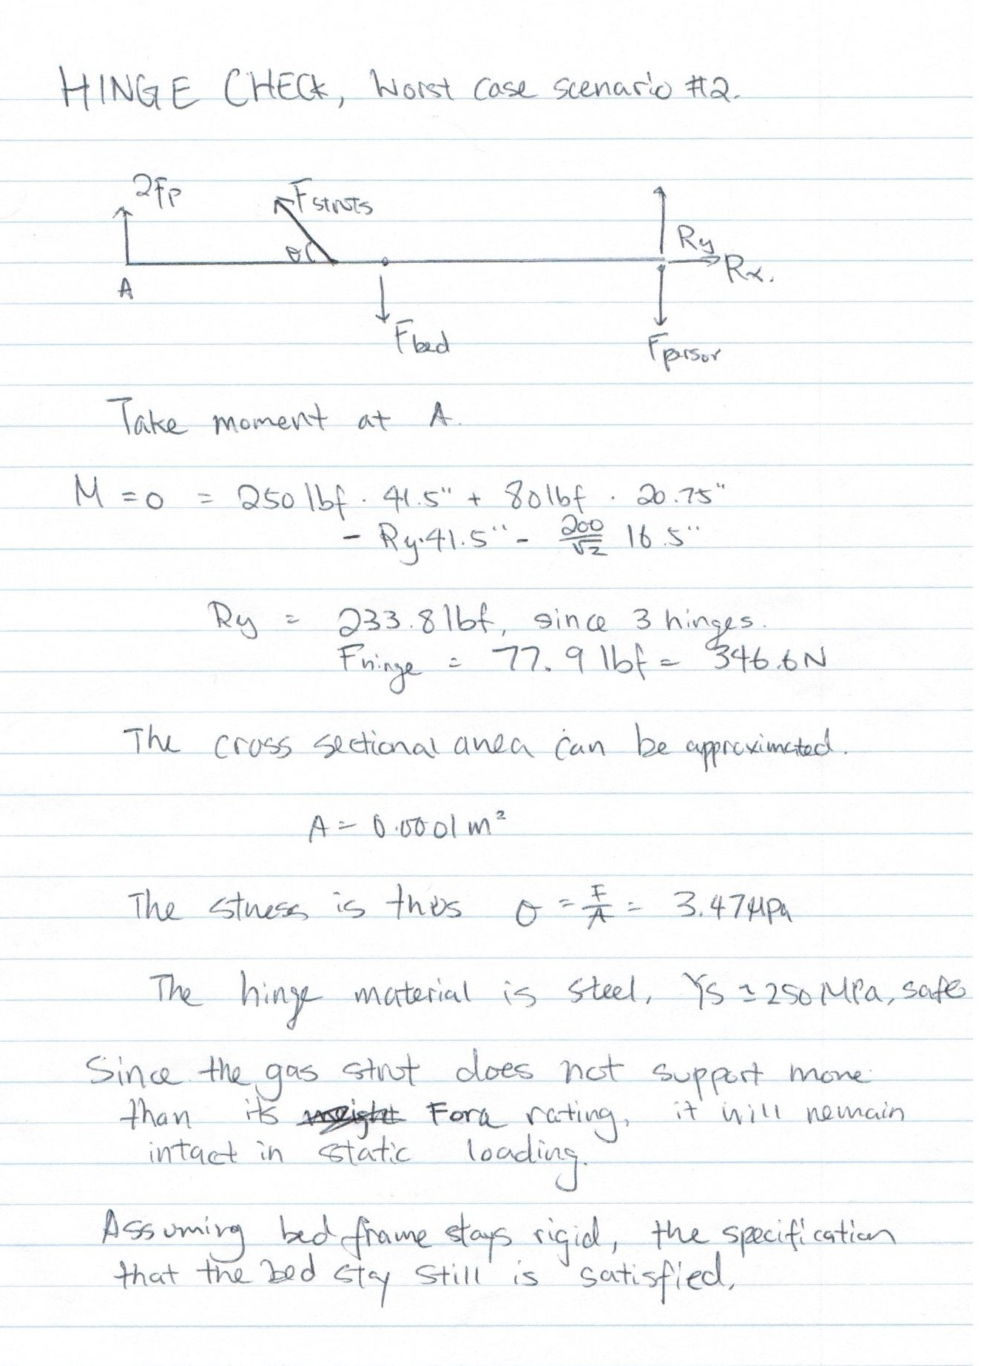

Figure 144: Hand calculations: static top frame support integrity – scenario 2

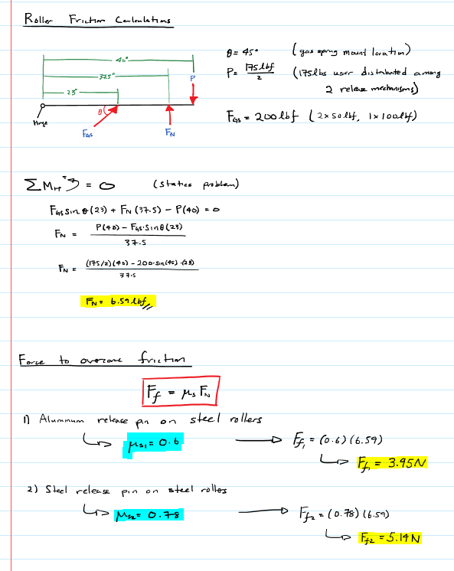

Figure 145: Hand calculation: roller friction

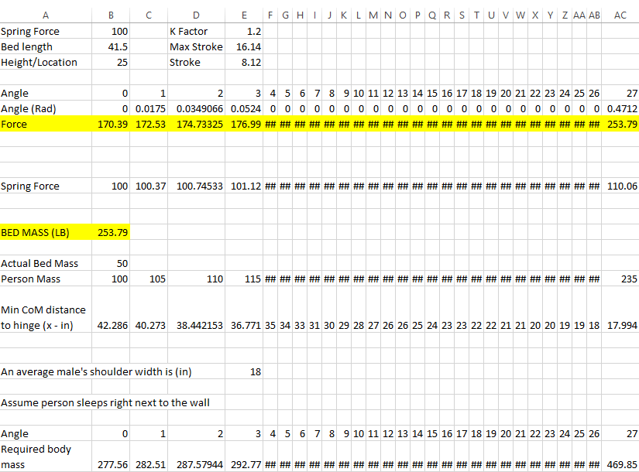

Figure 146: Excel spreadsheet of equilibrium calculation

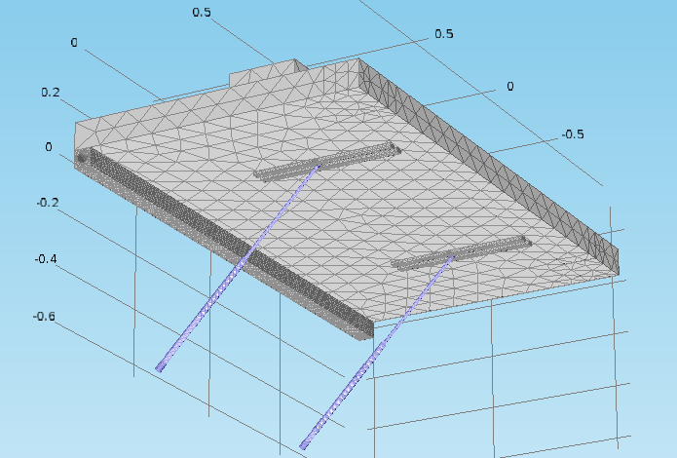

Figure 147: Bed geometry - Ideal mesh density / 20000 elements

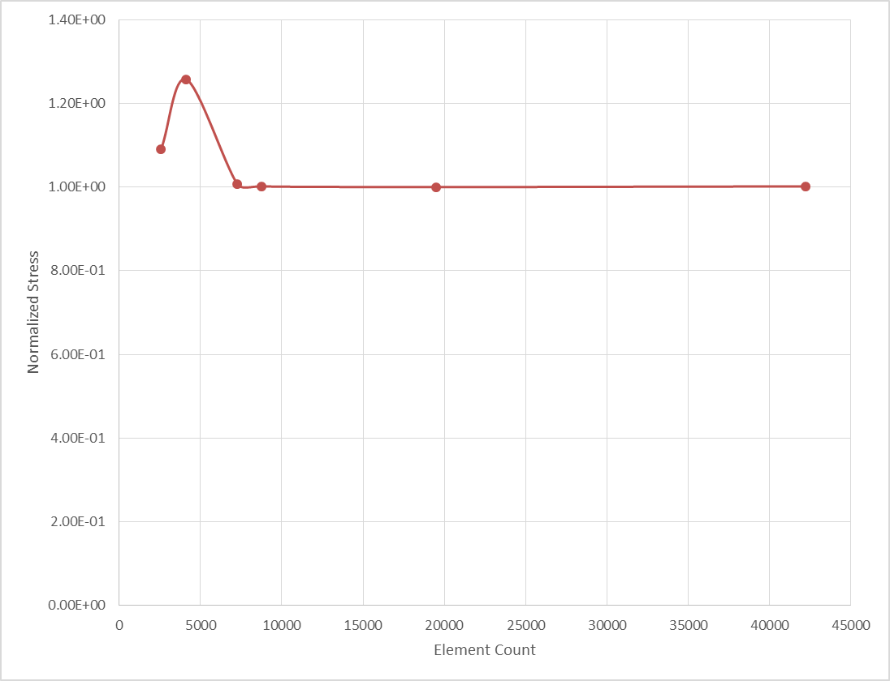

Figure 148: Mesh independent study

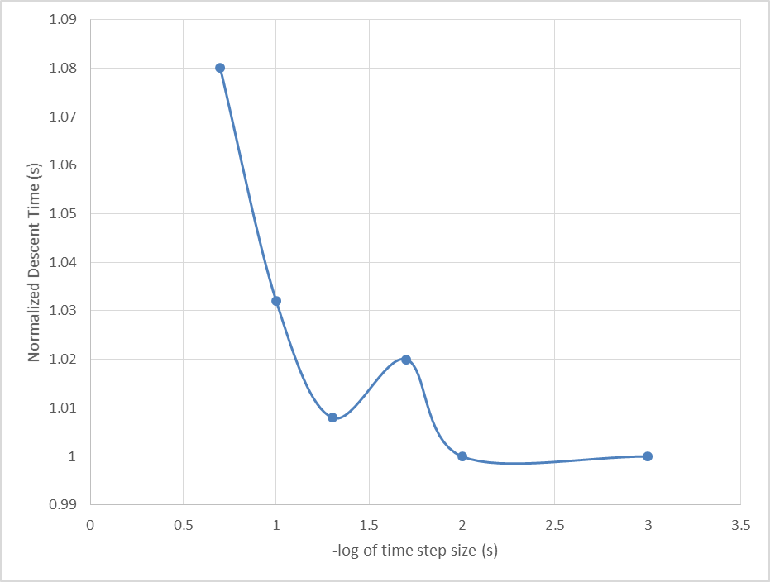

Figure 149: Timestep independent study

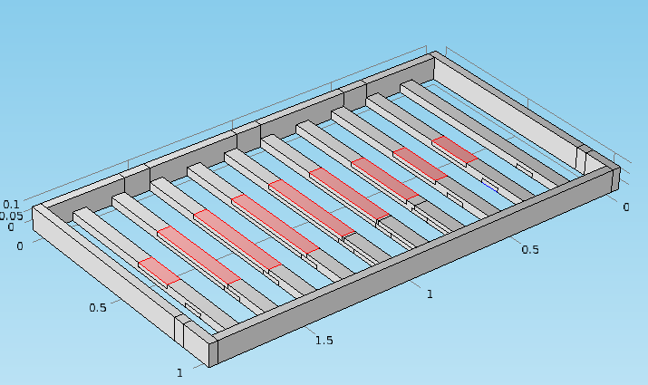

Figure 150: Loading scenario 1

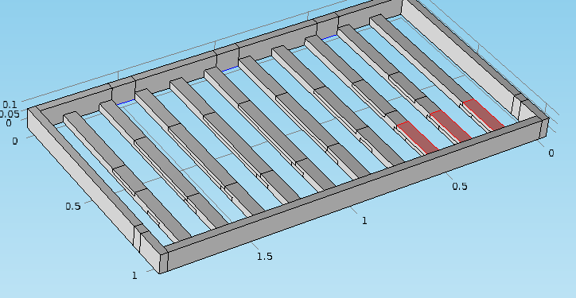

Figure 151: Loading scenario 2

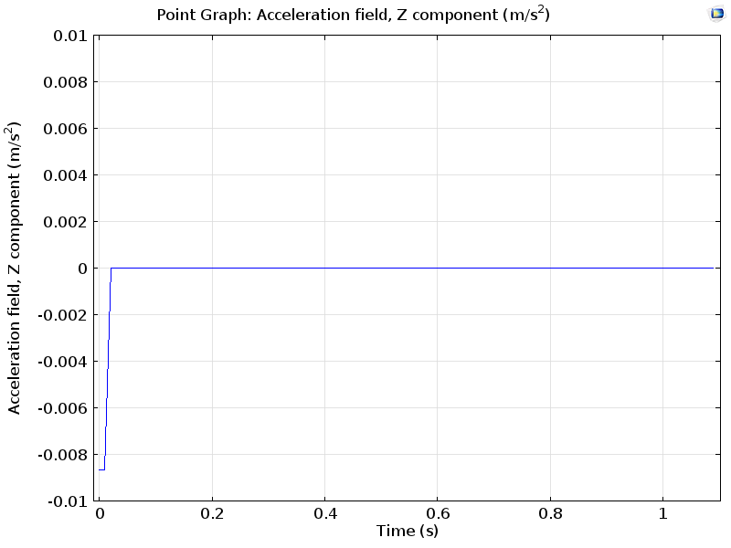

Figure 152: Zero acceleration graph

# **Appendix E – Lessons Learned**

|  |  |
| --- | --- |
| **Student Name: Alan Wu** | **Student ID: 20421526** |

**Design**

* Identify, represent and communicate a mechanical engineering problem or opportunity
* Design a mechanical engineering system, product and/or process
* Implement, verify and refine a design
* Identify and address safety, regulatory, sustainability society and professional ethics requirements

|  |  |  |  |
| --- | --- | --- | --- |
| **Performance Indicator** | **List the specific deliverables you produced that demonstrated your performance**  (i.e. Reports, assignments, engineering specification, CAD Model, Analyses etc.) | **What challenges were presented to you in achieving this learning outcome?** | **What is the value of this learning outcome for a future design project task?** |
| Identify needs, function, criteria and constraints for a given design, considering engineering economic, health and safety, environmental and ethical specifications | - CAD Model: Bedframe 2  - Machining: Gas Spring plates, release pin lathe, release mechanism assembly, bearing blocks.  - Peer review presentations  - Pneumatic mechanism  (Solenoid, actuators, Arduino) | - Machining requires a significant amount of time  - Can’t fully rely on some suppliers (data sheets, cost, conversion rates, etc.) | - Had DFM in mind when designing release mechanism, but need to put more effort into DFM and reducing the number of machining steps  - Allocate more money for unexpected costs (administration, USD conversion, wrong parts)  - Try to source parts locally |
| Identify a solution that satisfies the needs analysis | - Release mechanism (doesn’t wake up user until actuated)  - Construction and design of bed frame  - Construction and design of bed frame | - Difficult to relieve pinch points | - Use larger cylinders to actuate the pivot. The cylinders and solenoids will have 3 states, so that in the case of a detected obstruction, the cylinders will be able to stay in a e-stop mode  - Easier to control speed and angle of bed with cylinders actuating the bed (Dump truck analogy) |
| Consider safety, society and sustainability issues in selecting a solution | - Reduce pinch points  - Failsafe of the pneumatic system | - Pinch points were difficult to mitigate | - If more time is provided, design sensors to lock out mechanism (increased safety) |
| Generate detailed implementation specifications, including drawings, tolerances, components, etc. as required | - Drafted drawings (release assembly components, assembly drawings, detailed machine drawings  - Tolerancing for bushing block. Machine drawings for reaming of bushing blocks | - Bushing tolerance was difficult to ensure with lathes in the student machine shop | - Use precision grounded rods in place of aluminum shaft stock (better precision and tolerancing, less machining) |
| Verify the design by implementation, prototype production, bench test validation of key elements, and/or acceptance opinion by recognized expert | - Verify with real test  - Test the pneumatics with cylinder pulling on release pin  - Prototype build revealed that headboard and footboards flex when under load. Suggested and implemented a solution | - Tight tolerances (slide fit) had to be ensured for the cylinder to smoothly pull on the release pin  - Introduced the “Monarch Frame” design for headboard and footboard | - Use precision grounded rods in place of aluminum shaft stock (better precision and tolerancing, less machining) |

**Project Management**

* Apply project management skills and techniques, appropriately

|  |  |  |  |
| --- | --- | --- | --- |
| **Performance Indicator** | **List the specific deliverables you produced that demonstrated your performance**  (i.e. Reports, assignments etc.) | **What challenges were presented to you in achieving this learning outcome?** | **What is the value of this learning outcome for a future design project task?** |
| Decompose a project into a manageable set of objectives and/or tasks | - initial planning/brainstorming  - Feasibility analysis: cost driven, manufacturability, time constraints | - time constraints and cost | - Increased contingency along with better financial planning  - Try to source parts very early on in the process to save money and leave room for possible errors |
| Develop and track a schedule with milestones | - machine shop scheduling  - manufacturing milestones  - parts ordering milestones | - Sometimes streamlined, but roadblocks often presented | - Schedule in more time for contingency – get things done earlier to leave more time for problem solving |
| Manage financial, human and/or physical resources | - Sourcing components and parts  - machine shop task delegation | - More than scheduled time was required at the machine shop | - further simplify designs by DFM  - Start fabrication process earlier to take into account possible errors |
| Identify and manage risks | - Safety analysis  - cost analysis  - manufacturability/what I’ve seen in industry and what works  -pneumatics, frame, | - often don’t know what we don’t know  - Hard to manage risks that were not controlled by us (suppliers, etc.) | - increase time into feasibility analysis  - more CAD modelling to see potentials of risks |
| Apply change management | - Problem solving with machined components  - Problem solving with frame design: monarch frame (45 degree brackets), actuation system, lambda stops | - time constraints: some of these changes had to be made very quickly in order to meet deadlines | - Value of rapid prototyping and concise risk calculations early on in the process |

**Communication**

* Communicate accurately and effectively

|  |  |  |  |
| --- | --- | --- | --- |
| **Performance Indicator** | **List the specific deliverables you produced that demonstrated your performance**  (i.e. Reports, assignments etc.) | **What challenges were presented to you in achieving this learning outcome?** | **What is the value of this learning outcome for a future design project task?** |
| Write effective reports and design documentation | - Parts drawings  - Reports  - Engineering notebook | - Difficult to manage when dealing with many changes  - Difficult to manage formalities (uniform formatting) among different people | - Implement a formatting system to ensure all members are on the same page |
| Make effective presentations | - PowerPoint slides  - Verbal presentation of bed | - easy to go too far into details | - really understand the audience in which the presentations are going towards – tailor presentations to account for this |

**Professionalism**

* Act as a professional
* Identify and address safety, regulatory, sustainability, society and professional ethics requirements

|  |  |  |  |
| --- | --- | --- | --- |
| **Performance Indicator** | **List the specific deliverables you produced that demonstrated your performance**  (i.e. Reports, assignments etc.) | **What challenges were presented to you in achieving this learning outcome?** | **What is the value of this learning outcome for a future design project task?** |
| Comprehend issues of ethics, accountability and equity | - Receipt and cost tracking  - Feasibility analysis to determine which ideas are too costly (labor and/or parts costs) | - Lots of tracking involved | - Scan and copy receipts to ensure a copy is available in the event that something gets lost |
| Observe safety issues and practices in labs and workshops | - Enforced safety when using tools  - Enforced strict personal protective equipment (PPE) when working on prototype and machined parts | - none observed | - safety of operator and fabricator is incredibly important (built up from previous knowledge) |

**Other Lessons-Learned**

For example what new domain and procedural knowledge was identified and learned?

I really valued the needs analysis activity in this course. When we were asked to draw analogies to different designs in the real world, we already had a prototype idea in mind with CAD drawings, and was about to go ahead into the next phase of the project. During the activity, we took higher ground, and looked at the project from a higher level, which ultimately led to an overall redesign in our bed. In our case, we noticed that gravity could be used in our favor to reduce costs. If procedural planning was not enforced in this class, we would have went on with our original design.

What skills were identified and learned?

Immense machine shop experience was obtained. I developed knowledge in the amount of time it takes to machine a specific part and/or feature, and the limitations of the types of equipment that we have access to. I also learned a great deal about project planning and the difficulties that arise throughout the entire process as outlined in the lessons learned table. I learned a great deal in time and resource management, as well as purchasing and the importance of doing things early to ensure a stress free streamlined project schedule.

What new behaviors and attitudes were learned?

Through this project and the course, I learned to fully analyze situations as much as possible within a given time frame prior to making executive decisions in order to save cost and time. Through the external reviewer, I learned about the importance of planning early, and the significance of making sure all risks are accounted for. Although this project was not rocket science, much was learned, and there is much to be learned in terms of designing with several key ideas in mind: safety, feasibility, reliability, points of failure, etc.

|  |  |
| --- | --- |
| **Student Name: Ryan Lam** | **Student ID: 20473262** |

**Design**

* Identify, represent and communicate a mechanical engineering problem or opportunity
* Design a mechanical engineering system, product and/or process
* Implement, verify and refine a design
* Identify and address safety, regulatory, sustainability society and professional ethics requirements

|  |  |  |  |
| --- | --- | --- | --- |
| **Performance Indicator** | **List the specific deliverables you produced that demonstrated your performance**  (i.e. Reports, assignments, engineering specification, CAD Model, Analyses etc.) | **What challenges were presented to you in achieving this learning outcome?** | **What is the value of this learning outcome for a future design project task?** |
| Identify needs, function, criteria and constraints for a given design, considering engineering economic, health and safety, environmental and ethical specifications | -Brainstorming  -Conceptual Design  -Eng. Spec. Document  -Presentations  -Final Report | -Report writing formatting is easier with one person  -Coming up with an appropriate problem space and need can be difficult and time consuming | -Have one person responsible for formatting, or have everyone on board with exactly how everything should be formatted.  - Eng. Spec. Docs should be extremely specific |
| Identify a solution that satisfies the needs analysis | -Design of Preliminary Design 3 -Machining: Cross Beam Plates, bearing blocks | -DFM can be difficult if you are unsure about what you can or can’t do based on available resources. -Machining takes a very long time to complete | -Allocate more time and money to drawing generation and machining |
| Consider safety, society and sustainability issues in selecting a solution | -Reduce pinch points  -Offset from ground using mechanical stops | -Pinch points can be difficult to relieve and may require very intricate parts to do so; parts you may not have access to | -With moving parts, such as those in this project, pinch points may not be avoidable, and should simply call them out with warning labels. |
| Generate detailed implementation specifications, including drawings, tolerances, components, etc. as required | -CAD Model: Bed Frame 3, Prototype  -Drawings drafting (Wood, all bed frames, all wood subassemblies) | -2D Drawings take a very long time to complete | -Allocate more time and money to drawing generation and machining  -Always keep drawings up to date |
| Verify the design by implementation, prototype production, bench test validation of key elements, and/or acceptance opinion by recognized expert | -Real test verification  -Bed Frame construction/Design  -Prototype revision after testing | -You don’t always have the right tools to build a certain part (Some bed frame cuts were difficult)  -Unknown risks or unknown reactions of the structure can force you to rethink your design | -Know what tools you have at your disposal before designing something and design for manufacturability given your current situation  -Allocate time for any prototype revisions that may need to be done |

**Project Management**

* Apply project management skills and techniques, appropriately

|  |  |  |  |
| --- | --- | --- | --- |
| **Performance Indicator** | **List the specific deliverables you produced that demonstrated your performance**  (i.e. Reports, assignments etc.) | **What challenges were presented to you in achieving this learning outcome?** | **What is the value of this learning outcome for a future design project task?** |
| Decompose a project into a manageable set of objectives and/or tasks | -Initial planning of timeline  -Initial WBS | -Time constraints  -Difficult to determine how much time a task should and will take | -Contingency is key to padding unknown time constraints  -Parts sourcing should be done as early as possible |
| Develop and track a schedule with milestones | -Project timeline gantt chart with all milestones and individual task timelines | -Difficult to implement 20 mile march, especially with all the other work from five other courses | -More stringent planning of work days and work schedule to help streamline progress |
| Manage financial, human and/or physical resources | -Delegating tasks (design, controls, machining, report writing, analysis) | -Keep everyone in the loop with everyone else  -Machine shop may sometimes be full and you have to wait long periods of time | -Have backup plans for scheduling if something goes wrong that day  -Have people do updates for the group to keep everyone up to date |
| Identify and manage risks | -Safety  -Risk Register | -Preparing for unknown risks is key  -Some risks are out of our control | -Allocate more time for everything and have contingency. Start as early as possible |
| Apply change management | -Parts design change during machining or during prototype testing | -Time was a constraint when it came to building and finding out some part of the design needed to change. | -Prototype earlier and faster  -Be prepared for multiple design changes during manufacturing. |

**Communication**

* Communicate accurately and effectively

|  |  |  |  |
| --- | --- | --- | --- |
| **Performance Indicator** | **List the specific deliverables you produced that demonstrated your performance**  (i.e. Reports, assignments etc.) | **What challenges were presented to you in achieving this learning outcome?** | **What is the value of this learning outcome for a future design project task?** |
| Write effective reports and design documentation | -Final Report  -Parts drawings and CAD  -Eng. Spec. Documents  -Logbook | -Difficult to manage formatting among everyone  -Difficult to draft drawings quickly | -Implement universal formatting system for group reports  -More time for drafting drawings |
| Make effective presentations | -Funding Presentation  -Design Peer Review Presentation  -VoD Presentation | -Can go over time easily | -Keep talking points concise  -No need to elaborate unless a question is asked |

**Professionalism**

* Act as a professional
* Identify and address safety, regulatory, sustainability, society and professional ethics requirements

|  |  |  |  |
| --- | --- | --- | --- |
| **Performance Indicator** | **List the specific deliverables you produced that demonstrated your performance**  (i.e. Reports, assignments etc.) | **What challenges were presented to you in achieving this learning outcome?** | **What is the value of this learning outcome for a future design project task?** |
| Comprehend issues of ethics, accountability and equity | -Delegate tasks for all team members | -Keeping track of everyone’s progress | -Have people update you on progress or trust in their abilities to get it done and only get the final result |
| Observe safety issues and practices in labs and workshops | -When building outside of machine shop, gloves and safety glasses were worn when cutting the wood | -I got a splinter | -Observe your materials before working with them to ensure they are both good for your intended application and safe to handle |

**Other Lessons-Learned**

Needs Analysis and Conceptual Design both proved to be very valuable. One of the biggest hurdles in this project was simply picking a problem space to work in. After lengthy brainstorming, we had arrived at this “waking someone up” idea. Brainstorming different designs and ways to implement this idea, we were able to arrive at some preliminary design rather quickly and stayed well on or ahead of time; and had it not been for the team’s initial dive into our heavy brainstorming session, we would not have been able to arrive at the solution we have now and may not have even arrived at the same problem space.

Planning proved to be very important as time became more of a constraint. Nearing the end of the project, many deadlines were coming up, not only for this project, but for all out courses. Strict time management was needed to make sure everything that needed to be done was done.

Skills learned from this project include machining knowledge, project planning and management, and team organization. From the time spent machining, I’ve learned about the capabilities of the machines available for use and the different processes that go into creating a part. From organizing and planning this project, I’ve learned that an effective project plan and timeline is essential to achieving systematic progress and when assigning tasks to team members, I‘ve learned to play to everyone’s strengths and to keep a constant overview of the team’s progress and work and ensure that everyone is on task and on time as they should be.

An important behavior learned from this course came from the external peer review session – detailed and extensive analysis before making important design decisions. A simple gut feeling is not enough to justify any engineering decisions and stringent analysis is required to justify the decisions made, not only for the team, but for external partners and stakeholders who may not understand why some decisions were made. Essentially, everything must be covered and all risks must be ensured before proceeding with design or construction. Although this type of design process is more applicable to large scale and impactful projects, it is still nonetheless an important lesson in engineering design.

|  |  |
| --- | --- |
| **Student Name: Kelvin Chow** | **Student ID: 20466985** |

**Design**

* Identify, represent and communicate a mechanical engineering problem or opportunity
* Design a mechanical engineering system, product and/or process
* Implement, verify and refine a design
* Identify and address safety, regulatory, sustainability society and professional ethics equirements

|  |  |  |  |
| --- | --- | --- | --- |
| **Performance Indicator** | **List the specific deliverables you produced that demonstrated your performance**  (i.e. Reports, assignments, engineering specification, CAD Model, Analyses etc.) | **What challenges were presented to you in achieving this learning outcome?** | **What is the value of this learning outcome for a future design project task?** |
| Identify needs, function, criteria and constraints for a given design, considering engineering economic, health and safety, environmental and ethical specifications | -Engineering specifications  -Report writing  -Quizzes | -Having a plan for a design and knowing we have to sacrifice a lot of the design because of time and money constraints.  -Coming up with justifications for engineering specifications. | -The final prototype was still just an initial prototype. An initial prototype should be quick and dirty so that you can learn and build upon it for another prototype. A lot of time was spent on non-essential parts |
| Identify a solution that satisfies the needs analysis | Quizzes, brainstorming solutions | Finding a practical solution within the scope of this course | Designs for the given problem statement should seriously consider the constraints of the project. |
| Consider safety, society and sustainability issues in selecting a solution | Identifying safety hazards and brainstorming solutions  -report writing | Sometimes, safety designs are vague. Design for safety can be implemented, but people will always find a way to hurt themselves. | Taking precaution and make sure all hazards are listed. This is to limit the amount of liability for the designer |
| Generate detailed implementation specifications, including drawings, tolerances, components, etc. as required | -Checked drawings | Different people have different drawing standards. | I understood why companies stress the importance of the small details about drawings. Uniformity is key for nonverbal communication from drawings. |
| Verify the design by implementation, prototype production, bench test validation of key elements, and/or acceptance opinion by recognized expert | -Controls implementation  -Prototype verification  -justifying engineering specifications | Trying to put a numerical value for certain specs are hard.  -Difficulty in turning subjective points into objective points. | More research should be done into justifying specifications. |

**Project Management**

* Apply project management skills and techniques, appropriately

|  |  |  |  |
| --- | --- | --- | --- |
| **Performance Indicator** | **List the specific deliverables you produced that demonstrated your performance**  (i.e. Reports, assignments etc.) | **What challenges were presented to you in achieving this learning outcome?** | **What is the value of this learning outcome for a future design project task?** |
| Decompose a project into a manageable set of objectives and/or tasks | Quizzes: helped with preliminary project overview | Additional tasks come up as the project moves along | Prepare for unknowns. |
| Develop and track a schedule with milestones | Quizzes: helped with preliminary project schedule  Maintained updates of schedules | Hard to stick to a schedule (meeting times, etc.) | Have a more flexible schedule (i.e. work X number of hours a week instead of specific times) |
| Manage financial, human and/or physical resources | -tracking physical inventory | Minor components such as bolts and nuts were misplaced. Tools were hard to find while build, even though they were right there. | Have a better organization system when building |
| Identify and manage risks | -came up with risks and mitigation plans | Some risks don’t have mitigation plans under certain circumstances. | Always be aware of the worst case scenario |
| Apply change management | -documented build procedure  -kept revisions of documents | it’s one thing to keep revisions of documents, it’s another thing to know what changes were made to each revision | Document what changes were made to documents. |

**Communication**

* Communicate accurately and effectively

|  |  |  |  |
| --- | --- | --- | --- |
| **Performance Indicator** | **List the specific deliverables you produced that demonstrated your performance**  (i.e. Reports, assignments etc.) | **What challenges were presented to you in achieving this learning outcome?** | **What is the value of this learning outcome for a future design project task?** |
| Write effective reports and design documentation | -Report writing  -Keeping track of revisions | Writing a report with five other people. Hard not to overlap sections | have enough time to review each section before implementing into report |
| Make effective presentations | -Peer review presentations  -Funding presentation | Sticking to a time limit. 6 people presenting, easy for each of us to go through our allotted time | more rehearsing |

**Professionalism**

* Act as a professional
* Identify and address safety, regulatory, sustainability, society and professional ethics requirements

|  |  |  |  |
| --- | --- | --- | --- |
| **Performance Indicator** | **List the specific deliverables you produced that demonstrated your performance**  (i.e. Reports, assignments etc.) | **What challenges were presented to you in achieving this learning outcome?** | **What is the value of this learning outcome for a future design project task?** |
| Comprehend issues of ethics, accountability and equity | -active participation in group project | balancing different peoples’ schedules and personalities | Understand other people and what they are going through. |
| Observe safety issues and practices in labs and workshops | -Completed safety lab orientation  -Used PPE in machine shop | -nothing, safety practices should not be challenging to follow | Keep using safety equipment, operate machinery safely, and be aware of surroundings |

**Other Lessons-Learned**

I was able to gain a lot of exposure to areas of interest that were new to me in this project. I gained experience with programming, pneumatics, building wood, machining, and most importantly, the imperial system. Before this project, the majority of the areas listed above were all new to me and I was happy to have gained a lot of physical skills that I can take away from doing this project.

Another learning experience was teamwork. Teamwork isn’t something that was new, but this project was a completely different teamwork environment than I have experienced in the past. With many other people in a group, decisions are hard to make. So much time was spent on this project and the fact that we had to see each other everyday in class meant that this project was pretty much ongoing even when we weren’t working on it. I might need to find a relaxing hobby to reduce stress for situations like this.

Time management was also huge for this project. We had a schedule planned out and we could see that for November up until the beginning of December, it was going to be hectic. When the time came around, even though we could see it was going to be bad, it ended up being even worse than planned. How did that happen? I have no clue. Well, now I can expect it in the future.

Overall, doing a design project from start to finish in four months is a great learning experience. In work, rarely are you given the whole scope of a project to work on.

**Student Name:** Ragib Chowdhury **Student No.:** 20472003

**Design**

* Identify, represent and communicate a mechanical engineering problem or opportunity
* Design a mechanical engineering system, product and/or process
* Implement, verify and refine a design
* Identify and address safety, regulatory, sustainability society and professional ethics requirements

|  |  |  |  |
| --- | --- | --- | --- |
| **Performance Indicator** | **List the specific deliverables you produced that demonstrated your performance**  (i.e. Reports, assignments, engineering specification, CAD Model, Analyses etc.) | **What challenges were presented to you in achieving this learning outcome?** | **What is the value of this learning outcome for a future design project task?** |
| Identify needs, function, criteria and constraints for a given design, considering engineering economic, health and safety, environmental and ethical specifications | Contributed two of the shortlisted need ideas during a brainstorming session. | Coming up with a suitable need, that was not overly common and also fit the scope of this project | It conditions us to think about the world from a need point of view |
| Identify a solution that satisfies the needs analysis | Brainstormed a potential solution to our problem with the group | Solutions which are both effective and fit the scope of this project were difficult to come by. | Conditions us better to think about solutions to problems |
| Consider safety, society and sustainability issues in selecting a solution | Ensured that the design was user friendly and safe for consumer use | Various pinch points that needed to be addressed | Experience gained in thinking from a safety perspective |
| Generate detailed implementation specifications, including drawings, tolerances, components, etc. as required | Created and revised design specifications as necessary. Contributed design spec ideas during the brainstorming process, as well as sketches of potential solutions | Ensuring design specs were perfectly clear and left no room for ambiguity | Design specs are fundamental in any engineering design and thus it was good practice for future use |
| Verify the design by implementation, prototype production, bench test validation of key elements, and/or acceptance opinion by recognized expert | Final Prototype building – along with the whole group. | Changes had to be made to the prototype design, required extra time to be used from the contingency pool | Provided experience in time and project management and prototyping |

**Project Management**

* Apply project management skills and techniques, appropriately

|  |  |  |  |
| --- | --- | --- | --- |
| **Performance Indicator** | **List the specific deliverables you produced that demonstrated your performance**  (i.e. Reports, assignments etc.) | **What challenges were presented to you in achieving this learning outcome?** | **What is the value of this learning outcome for a future design project task?** |
| Decompose a project into a manageable set of objectives and/or tasks | Created a WBS with the whole group | Limited amount of available time had to be split between entire project | A better idea of time delegation in a project |
| Develop and track a schedule with milestones | Contributed to creating the project timeline | Milestones were not always met, as such we had to reschedule and work around certain things, i.e. midterms | Better time management skills were gained |
| Manage financial, human and/or physical resources | Procured parts from the Engineering Machine Shop, from Jorge. | Jorge was not always available or the exact necessary parts were not always available | Gained experience in procurement and learned better time management. |
| Identify and manage risks | One of the risks was the bed frame potentially splitting apart due to gas strut force, crossbeams and mounting plates were implemented – machined and mounted the mounting plates with the crossbeams | Learning to use new machines in the machine shop | Good experience gained from machining |
| Apply change management | Changes were made to bed frame design to include crossbeams on the bottom frame, as such mounting plates had to be implemented in with the preexisting gas strut mounting blocks, and so I designed the new ones to be compatible with the gas strut mounting blocks. | Alignment issues caused an offset in the mounting block setup versus the mounting plate, as such each plate had to be designed separately | Experience in change management, since everything doesn’t always go to plan, good experience for the future. |

**Communication**

* Communicate accurately and effectively

|  |  |  |  |
| --- | --- | --- | --- |
| **Performance Indicator** | **List the specific deliverables you produced that demonstrated your performance**  (i.e. Reports, assignments etc.) | **What challenges were presented to you in achieving this learning outcome?** | **What is the value of this learning outcome for a future design project task?** |
| Write effective reports and design documentation | Created bracket drawings and produced drawings for them, as well as writing various sections of the report including budget management, alternative designs, potential risks, and risk mitigation. | MS word continuously crashed while I was attempting to write a part of the report | Formal report writing is a critical skill in all situations, and design documentation is key in any design project, gained experience. |
| Make effective presentations | Helped create funding presentation, Peer Review Presentation – Budget and Time Management, Live the Need, and final presentation. | Time constraints – not always enough time | Presentations are a central part of any design project, and experience will help in the future |

**Professionalism**

* Act as a professional
* Identify and address safety, regulatory, sustainability, society and professional ethics requirements

|  |  |  |  |
| --- | --- | --- | --- |
| **Performance Indicator** | **List the specific deliverables you produced that demonstrated your performance**  (i.e. Reports, assignments etc.) | **What challenges were presented to you in achieving this learning outcome?** | **What is the value of this learning outcome for a future design project task?** |
| Comprehend issues of ethics, accountability and equity | Met the appropriate deadlines as necessary and finished my deliverables, i.e. presentation part, report part, machined part – brackets, mounting plates. | Managing time between design project and all other courses was very difficult | Time management skills improved extensively as a result of this project |
| Observe safety issues and practices in labs and workshops | Followed machine shop protocol as required | No noteworthy challenges | Machine shop protocol and etiquette will be important if I need to do more machining in the future |

**Other Lessons-Learned**

The living the need process was extremely valuable since it gave us a new way of thinking and provided us with a novel perspective, which is always valuable. Through using this technique we were able to come up with a relevant problem space for which to find a solution. Furthermore, the project timeline gave us a concrete method of measuring our work and staying on track with the project which was crucial, given our limited time this semester.

Extensive machining skills were gained, as well as experience in prototyping, prior to this project, I had limited hands on experience in prototyping and manufacturing items. Improved Time Management skills were also gained since there was an extensive quantity of work to be done and little time to do it in. Another beneficial skill learned in this project was procurement and how the process usually goes. This was learned through interacting with the staff from the Engineering Machine Shop and the Student Machine shop.

A critical behavior learned in this project was to be determined and on track right from the beginning of the project timeline, rather than a rush at the end.

**Student Name:** Jame Sun **Student No.:** 20464953

**Design**

* Identify, represent and communicate a mechanical engineering problem or opportunity
* Design a mechanical engineering system, product and/or process
* Implement, verify and refine a design
* Identify and address safety, regulatory, sustainability society and professional ethics requirements

|  |  |  |  |
| --- | --- | --- | --- |
| **Performance Indicator** | **List the specific deliverables you produced that demonstrated your performance**  (i.e. Reports, assignments, engineering specification, CAD Model, Analyses etc.) | **What challenges were presented to you in achieving this learning outcome?** | **What is the value of this learning outcome for a future design project task?** |
| Identify needs, function, criteria and constraints for a given design, considering engineering economic, health and safety, environmental and ethical specifications | -Static and dynamics analysis to better understand gas strut criteria  -Analysis to identify gas strut/piston and material strength requirements  -Hand calculations to verify functionality of proposed conceptual designs | -The analysis is often time consuming and time management was difficult  -The analysis results had to be cross-checked with other sources, difficult to confirm validity | -Time management is of essence during the designing phase  -Research of existing benchwork and paper can save a lot of time and effort and provide confirmation |
| Identify a solution that satisfies the needs analysis | -Identified the strength of gas strut required as well as ideal mounting angles  -Identified user mass range as a solution to the descent specifications | -It was hard to gather technical information about gas struts since it is not normally provided | -Sometimes it helps looking into documentations in other language and using google translate to translate them into English |
| Consider safety, society and sustainability issues in selecting a solution | -Used a safety factor for at least 2 in computations, calculations, and simulations | -Not much. Since the materials available were strong enough to easily allow a safety factor of 2. | -It is important to incorporate safety factor even in the conceptual design phase |
| Generate detailed implementation specifications, including drawings, tolerances, components, etc. as required | -Generated detailed calculations using simulation software to extract information required for procurement and building | -Some unknown factors are difficult to model and best approximate models have to be made | -Use documentations to justify approximate models |
| Verify the design by implementation, prototype production, bench test validation of key elements, and/or acceptance opinion by recognized expert | -Participated in bed building, gas strut testing and mounting position modification to get the specified descent time. | -A lot of unknown unknowns were encountered in building, some completely different from predicted calculations | -It is important to imagine the worst case scenario when performing preliminary analysis to be prepared for anything that can go wrong during implementation |

**Project Management**

* Apply project management skills and techniques, appropriately

|  |  |  |  |
| --- | --- | --- | --- |
| **Performance Indicator** | **List the specific deliverables you produced that demonstrated your performance**  (i.e. Reports, assignments etc.) | **What challenges were presented to you in achieving this learning outcome?** | **What is the value of this learning outcome for a future design project task?** |
| Decompose a project into a manageable set of objectives and/or tasks | -Took on most of the analysis to divide work load | -Some unknown parameters cannot be solved with analysis alone | -It is important to communicate with other “departments” so that everyone is on the same page during the design process |
| Develop and track a schedule with milestones | -Followed a planned schedule closely and delivered analysis results on time | -Hard to juggle between different tasks during midterm period | -Instead of spreading tasks out evenly, plan for known events like exams and work more before/after it |
| Manage financial, human and/or physical resources | -Managed computational resources available to complete simulation | -Some simulations took longer than other, time was not used most efficiently | -Plan out possible simulations and use a table to find the best machine and times for it |
| Identify and manage risks | -Identified technical risks, used analysis to find ways to prevent by safety factor | -Some risks were unknown | -Unknown risks are now known, learning is a process of making mistakes. |
| Apply change management | -When gas struts under performed researched for possible change to amend | -Some documentations regarding gas struts were lost | -Very very important to document and save everything |

**Communication**

* Communicate accurately and effectively

|  |  |  |  |
| --- | --- | --- | --- |
| **Performance Indicator** | **List the specific deliverables you produced that demonstrated your performance**  (i.e. Reports, assignments etc.) | **What challenges were presented to you in achieving this learning outcome?** | **What is the value of this learning outcome for a future design project task?** |
| Write effective reports and design documentation | -Documented the analysis in details and in chronological order | -Time consuming to extract figures and graphs | -Should output graphs and figures as analysis is conducted not after |
| Make effective presentations | -Presented in peer reviews and ungraded VoD with main focus on analysis | -Some presented figures were not of interest of audience | -presented figures should be something the audience can understand and relate to |

**Professionalism**

* Act as a professional
* Identify and address safety, regulatory, sustainability, society and professional ethics requirements

|  |  |  |  |
| --- | --- | --- | --- |
| **Performance Indicator** | **List the specific deliverables you produced that demonstrated your performance**  (i.e. Reports, assignments etc.) | **What challenges were presented to you in achieving this learning outcome?** | **What is the value of this learning outcome for a future design project task?** |
| Comprehend issues of ethics, accountability and equity | -Accounted for error made in analysis as well as analysis assumptions | -Again, unknown unknowns were predicted lightly but turned out to be a problem | -Do not make assumptions on unknown parameters that have important outcomes, predict conservatively |
| Observe safety issues and practices in labs and workshops | -Wore safety equipment during building and woodworking | -None, since safety equipment were worn | -Always wear safety equipment |

**Other Lessons-Learned**

From a technical standpoint, I learned a whole lot this project about structures made out of wood, how gas struts work, as well as things like simulating in Excel, which although did not work in our favor, was still a learning experience. I also picked up multi-body dynamics modelling for the purpose of this project, but I find these lessons-learned rather trivial compared to their non-technical counterparts.

From this project, I realized that there was much more that went into a design process than I could ever imagine. I learned that there were things a designer needed to consider by putting themselves in an objective point of view rather than the point of view of themselves in order to understand what the masses would really want to use or want to purchase.

This course also gave me an idea of what the analysis process is like when it was a part of a design process. I had been a chain, or a part of an analysis process many times for many different projects, but being the person who is doing most of the analysis is certainly a different dynamic from working in a team. Not only is there more responsibility, but there are much information from other disciplines or departments of the project to consider.

The most important lesson I learned from this course is that besides planning for known unknowns, it is more important to plan for unknown unknowns. We practiced contingency in our scheduling and budgeting processes, but I can only say the poor contingency was exercised during the preliminary design phase, which caused unnecessary work during building. I could never appreciate the idea of contingency before, but I certainly can now.

Student Name: Nicholas Tham Student No.: 20481593

**Design**

* Identify, represent and communicate a mechanical engineering problem or opportunity
* Design a mechanical engineering system, product and/or process
* Implement, verify and refine a design
* Identify and address safety, regulatory, sustainability society and professional ethics requirements

|  |  |  |  |
| --- | --- | --- | --- |
| **Performance Indicator** | **List the specific deliverables you produced that demonstrated your performance**  (i.e. Reports, assignments, engineering specification, CAD Model, Analyses etc.) | **What challenges were presented to you in achieving this learning outcome?** | **What is the value of this learning outcome for a future design project task?** |
| Identify needs, function, criteria and constraints for a given design, considering engineering economic, health and safety, environmental and ethical specifications | - needs analysis  - engineering specifications  - design for safety | -coming up with a useful project  -coming up with and defining crucial engineering specifications | -Procedure and requirements for creating a refined product in the future |
| Identify a solution that satisfies the needs analysis | -idea generation.  -Conceptual design & sketches  -embodiment design | -coming up with ideas that were actually feasible and within our scope | -Beneficial to throw out as many ideas as possible and refining them later, rather than only suggesting pre-refined ideas |
| Consider safety, society and sustainability issues in selecting a solution | -considered the element of safety in the entire concept of the device  -designed and implemented guards to eliminate pinch points on device | -some safety issues are subjective | -address ALL safety risks for any product created |
| Generate detailed implementation specifications, including drawings, tolerances, components, etc. as required | -CAD model for frame 1  -assembly drawings for frame with BOM etc.  -Sketches to convey concepts | -following a fixed standard for drawings etc. | -attention to detail  -creating material that others can understand |
| Verify the design by implementation, prototype production, bench test validation of key elements, and/or acceptance opinion by recognized expert | -Medium-fidelity prototype mechanism to simulate behavior of full scale model | Making use of the limited resources we had, to create a small scale version of the device that simulates the functions of the actual product | Prototyping for proof of concept is essential to design. Shows the key operating features without having to build the actual product. |

**Project Management**

* Apply project management skills and techniques, appropriately

|  |  |  |  |
| --- | --- | --- | --- |
| **Performance Indicator** | **List the specific deliverables you produced that demonstrated your performance**  (i.e. Reports, assignments etc.) | **What challenges were presented to you in achieving this learning outcome?** | **What is the value of this learning outcome for a future design project task?** |
| Decompose a project into a manageable set of objectives and/or tasks | -personal notebook for objectives | -keeping track of everything | -Large scale project would be a lot more complex. Breaking it into smaller more manageable tasks is often useful |
| Develop and track a schedule with milestones | -follow a schedule | -time | -time management skills |
| Manage financial, human and/or physical resources | -planning  -purchasing material | -Staying within budget | -Being able to manage resources is important when it involves significant elements |
| Identify and manage risks | -Contingency | -unknown risks | -Managing risks is important in the case of unforeseen circumstances |
| Apply change management | -revising drawings and designs | Documenting changes | In a large scale project, there are bound to be many revisions |

**Communication**

* Communicate accurately and effectively

|  |  |  |  |
| --- | --- | --- | --- |
| **Performance Indicator** | **List the specific deliverables you produced that demonstrated your performance**  (i.e. Reports, assignments etc.) | **What challenges were presented to you in achieving this learning outcome?** | **What is the value of this learning outcome for a future design project task?** |
| Write effective reports and design documentation | -drawings  -conceptual sketches  -report | -using elaborate vocabulary to describe the design | A good way of conveying your design is through complete documentation |
| Make effective presentations | -DPR presentations | - Worrying about what other people think | -With presentations, constructive feedback is received to improve design |

**Professionalism**

* Act as a professional
* Identify and address safety, regulatory, sustainability, society and professional ethics requirements

|  |  |  |  |
| --- | --- | --- | --- |
| **Performance Indicator** | **List the specific deliverables you produced that demonstrated your performance**  (i.e. Reports, assignments etc.) | **What challenges were presented to you in achieving this learning outcome?** | **What is the value of this learning outcome for a future design project task?** |
| Comprehend issues of ethics, accountability and equity | -being responsible and delivering what I agreed to deliver | Being ethical regardless if the situation | -Good ethics are crucial in the working world |
| Observe safety issues and practices in labs and workshops | -ESMS safety orientation | -staying safe in an unsafe environment | -safety is important |

**Other Lessons-Learned**

For example what new domain and procedural knowledge was identified and learned?

The procedure that goes into a typical engineering design project. Needs analysis> Conceptual design, Embodiment Design> DFMA> Building> Documentation.

What skills were identified and learned?

Machining, pneumatics

What new behaviors and attitudes were learned?

Respect for others. Time management skills. Sometimes having to listen to others